**Goals:**

* Get data generator
* Script login procedure
* Get experience of test data preparation
* Get estimated time needed for data generation

**Description:**

Create the script and the scenario to generate test data (posts) with any text (like Loren ipsum…) of random length between 50 and 1000 characters.

The number of the posts should be parametrized and consist at least 3 values:

100, 1000, 2000

For 100 posts dates should be set from the list of particulate dates which will be used in following regular tests (at least 10 values). For other posts dates can be generated randomly within particular range.

Also, get measured time for generation 100 posts, and is possible for 1000 and 2000 posts.

Number of users: up to 2

User role: editor

**Results:**

For 100 post requests with date from the list of particulate dates:

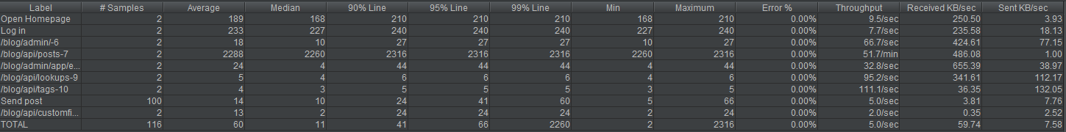

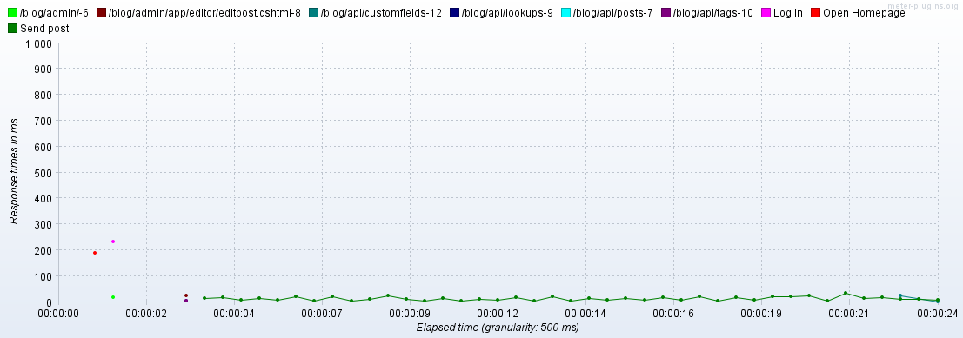

**Conclusion:** % of error is 0, so all requests finished with response code 200 and there is no problem with it.

Response time isn`t so different for all requests. It varies from 5 to 66, that is good result, system is stable for such amount of posts.

For 1000 post requests with date, that generated randomly within particular range:

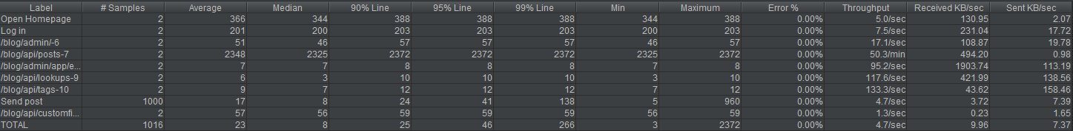

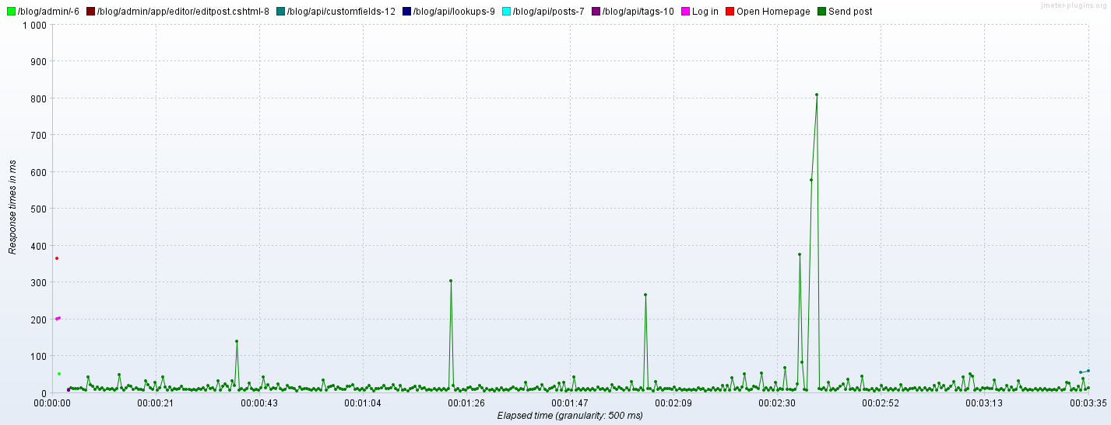

**Conclusion:** % of error is 0, so all requests finished with response code 200 and there is no problem with it.

On the graphic we can see, that they are some peaks in time response. They are not similar and such delays are happened with no regularity. It makes us think, that the problem was with network connection.

For 2000 post requests with date, that generated randomly within particular range:

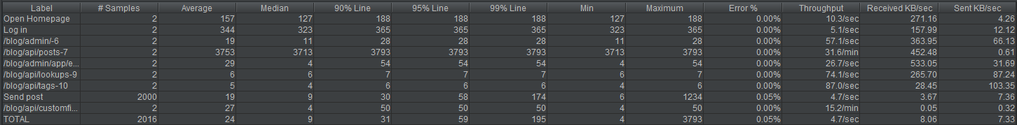

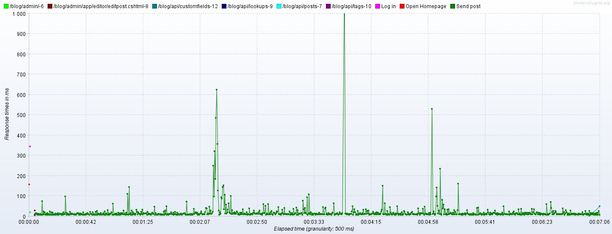

**Conclusion:** % of error is 0.05, so one of requests finished with error.

On the graphic we can see, that they are some peaks in time response, but only one of them reaches more than 1000 ms, other high peaks are in approximately 630 and 530 ms, so they are not similar. Also such delays are happened with no regularity.

Error in one response and not regular rare delays make us think, that the problem was with network connection.