**Description:**

Implement Anonymous user scenario (see Main script, Anonymous script, Open post script algorithms).

* Perform Smoke testing.
* Perform Capacity testing.
* Document results.

The number of the posts: 100

To search transactions use the list of particular dates (see description Task 2).

User role: anonymous

**Goals:**

* Design anonymous script and scenario
* Get first documented results of Capacity testing

**Scripts:**

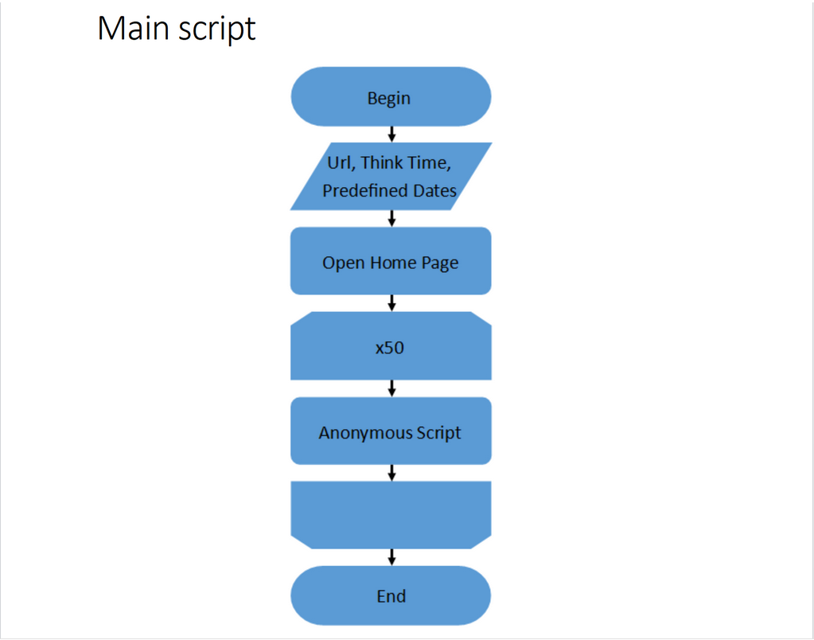

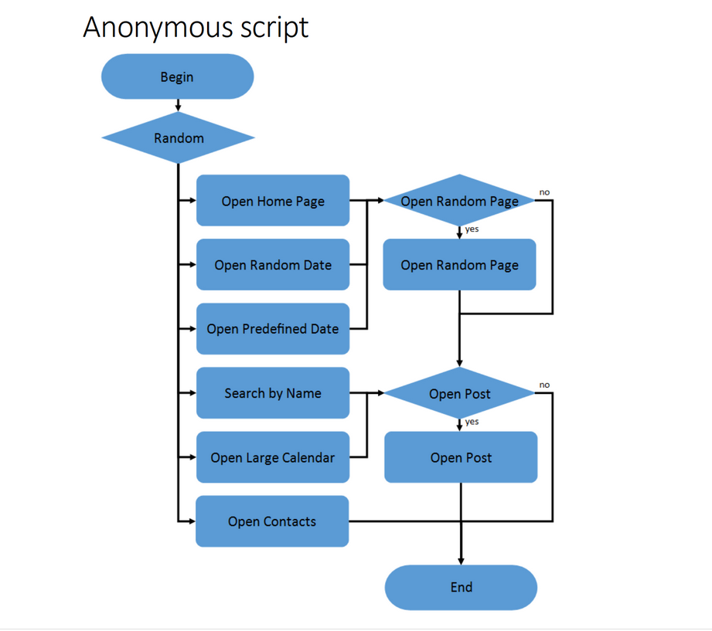

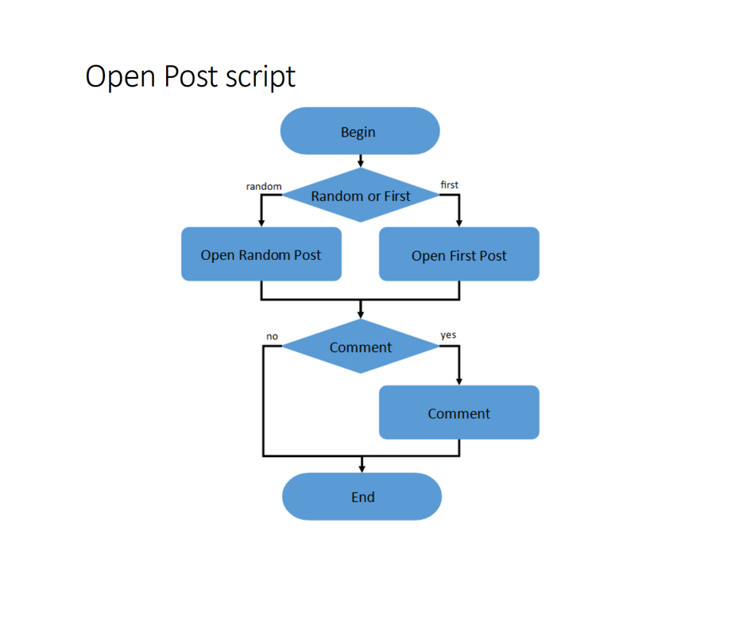

**Results:**

For measuring capacity of the application were used parameters with such values:

Number of users = 200

Rampup = 600 sec

Duration = 600 sec

**After running several tests we have such results:**

From 0:00 till approximately 5:40 there is a comfort zone. Throughput is growing fast, response time is stable enough, CPU is overall doesn`t reach more than 80 %. From 5:40 till 09:42 response time start growing faster with spikes, throughput continue growing but not so fast, some errors occurring. CPU also start growing till 90 or even 100 %. It is degradation zone. At 5:40 capacity point was reached. So, capacity of the web application is 115 users. Saturation point was reached at approximately 09:42, when 57 transactions were performed at the second. From this moment amount of successful operations starts falling, and response time starts rapidly growing. CPU is 100 %. Several runs were performed and all of them led to similar results, that don`t differ a lot one from another. Results of some runs showed on graphics below.

**First run:**

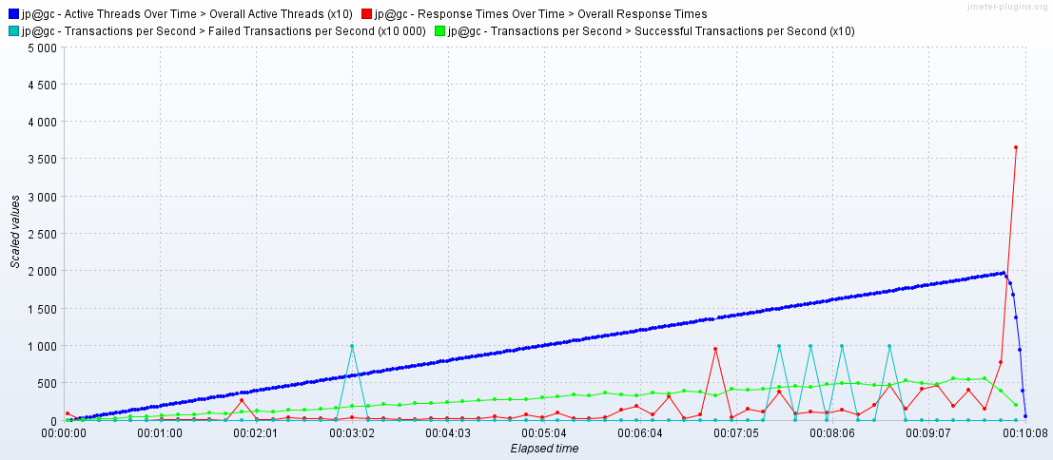

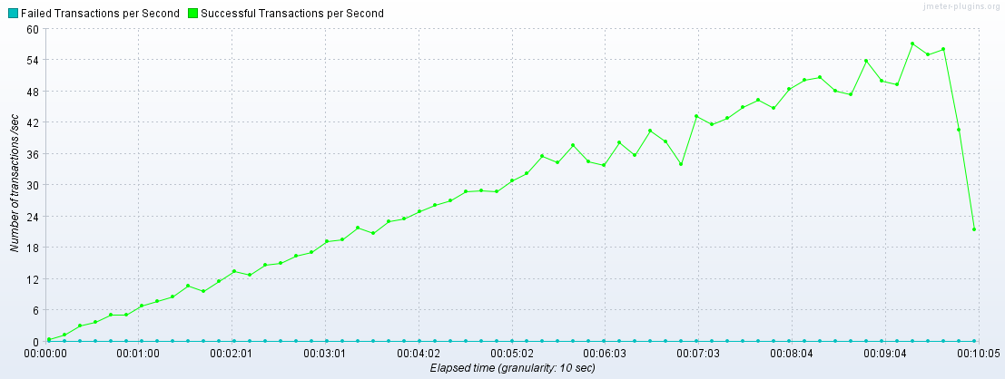

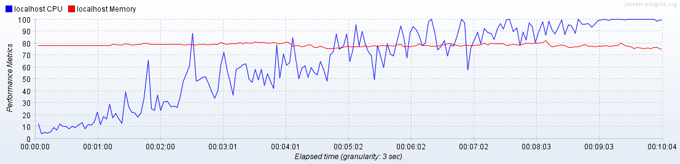

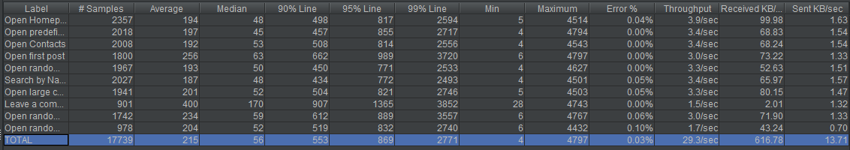

**Second run:**

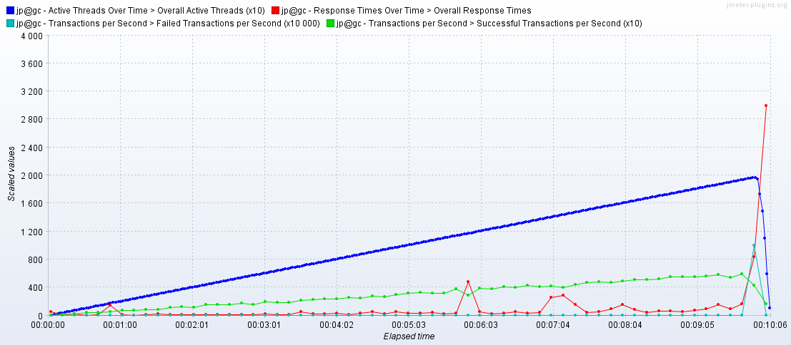

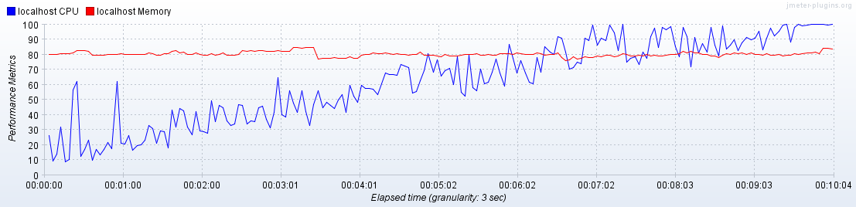

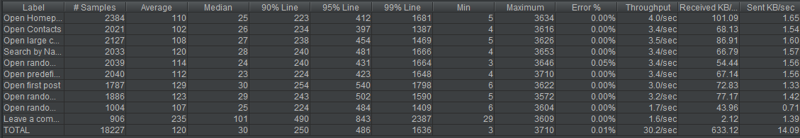

**Third run:**

