**Prerequisites:**

None

**Description:**

Implement Admin user scenario (see Admin script algorithm).

* Perform Smoke testing.
* Perform load test with 2 admin users.
* Document results.

Names of created users: User_*nn* (e.g. User_15, User_07)

User role: admin

**Goals:**

* Design admin script and scenario
* Get base line on performance of particular admin’s actions.

**Algorithm:**

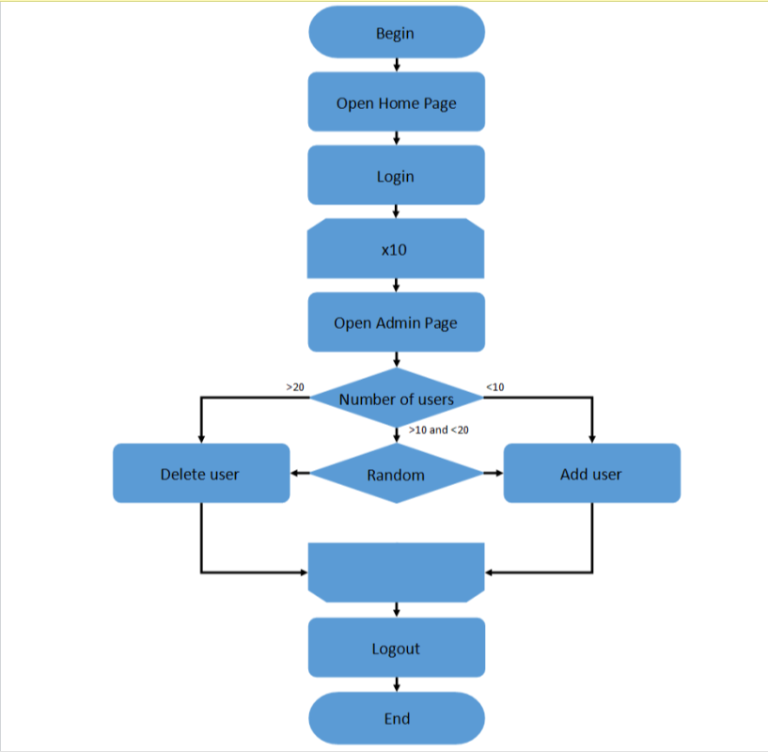

**Results:**

Test was performed for 2 admin users with duration in 1 hour. Admin users performed such queue of actions as: open home page - log in - open admin page – open users page – receive list of existing users – delete or create user 10 times – log out. Scenario was executed with several delays in form of timers, that are expected to be in real life. Since 1 hour of test system continues to work stable. We don`t see from graphics any errors or critical load of CPU, response time is stable enough, also in every 15 minutes memory cache got cleared. So, system can handle with such load for this time. Also, due to this fact, duration of the test can be decreased, because since lower time we will receive the same result. Detailed metrics by requests are displayed in the table below.

