**Prerequisites:**

* Created 2 Editors
* Generated 100 posts

**Description:**

Implement Editor user scenario (see Editor script algorithm).

* Perform Smoke testing.
* Perform load test with 2 editor users.
* Document results.

User role: editor

**Goals:**

* Design editor script and scenario
* Get base line on performance of particular editors’ regular actions.

**Algorithm:**

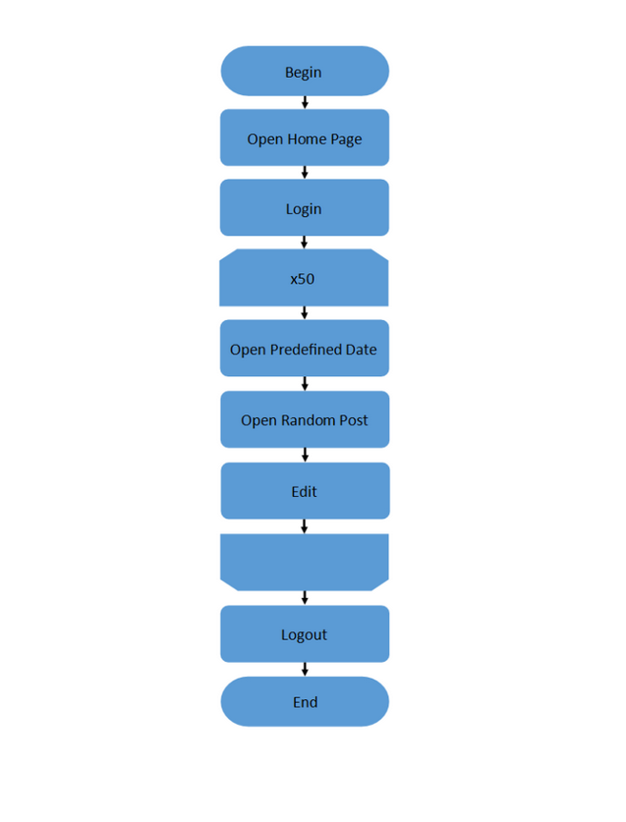

**Results:**

Test was performed for 2 editor users with duration in 1 hour. They performed such scenario: Open Homepage > Log in > (Open Predefined date > Open Random post > Edit post) x50 > Log out. Also, timers, that are expected to be in real case scenarios, were used.

Since this 1 hour system continue to work stable. From the graphics and aggregate report we can see, that the hardest requests for system are Open predefined date and Open random post, but first one is performed more stable, because average response time not quite different from 90% line and 95 % line, while second one has a big enough response time for 99 % line and less. CPU also not critically overloaded during all test, except of some peaks, memory get cleared from time to time.

For load test – duration of test can be decreased, and it was done for second and third run to 30 minutes from 1 hour, because for such amount of users and for such amount and types of operations system works stable.

Test was performed 3 times, that led to the similar results. Detailed info one by one run described below:

**1st Run:**

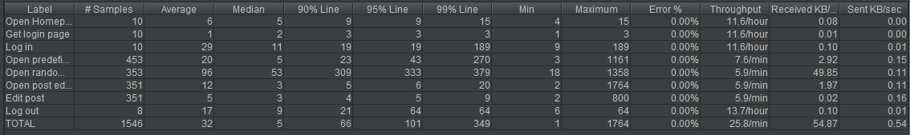

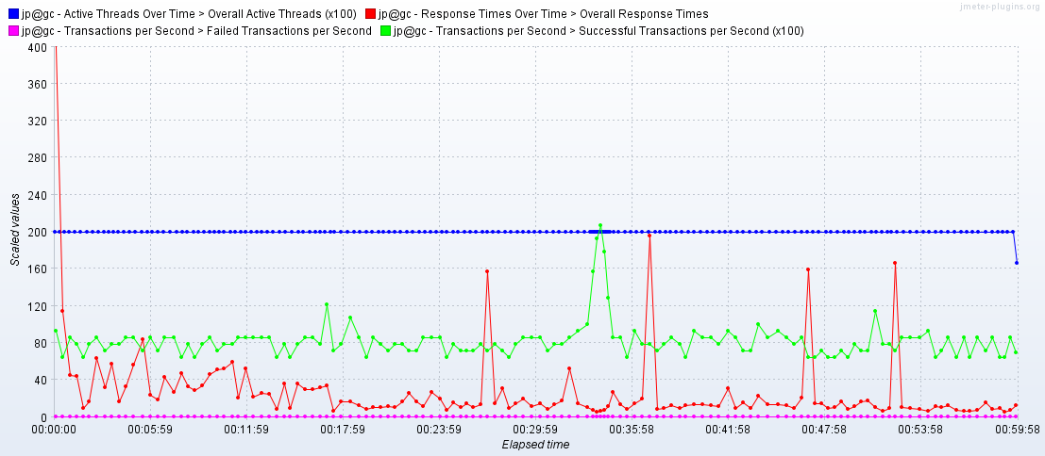

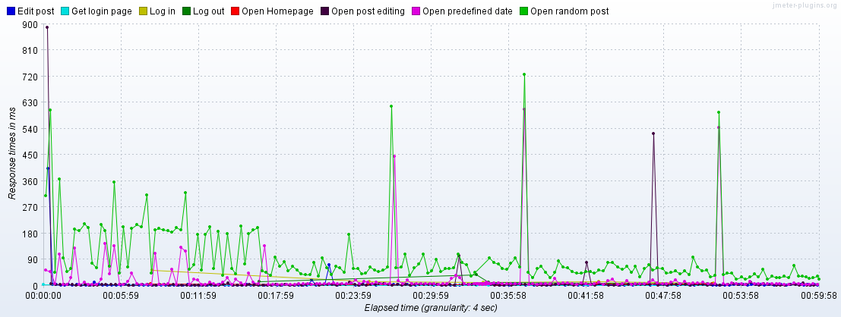

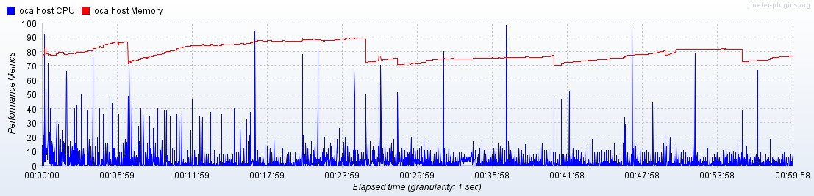

**2nd Run:**

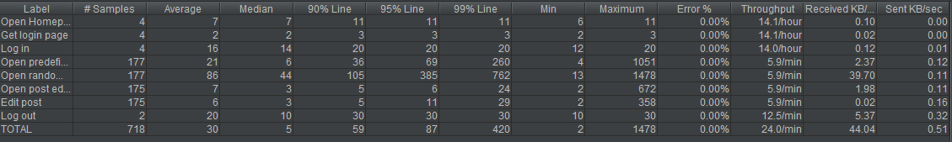

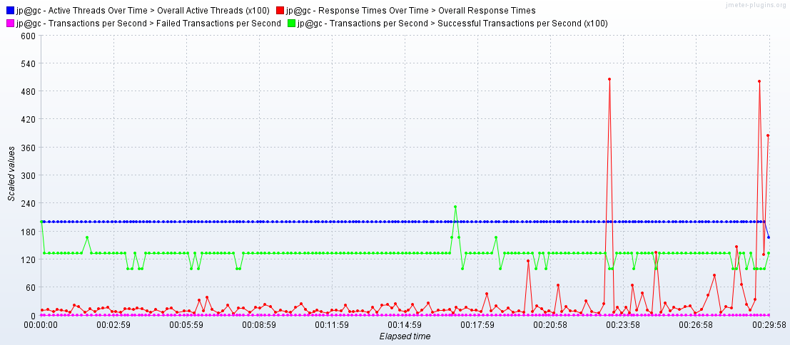

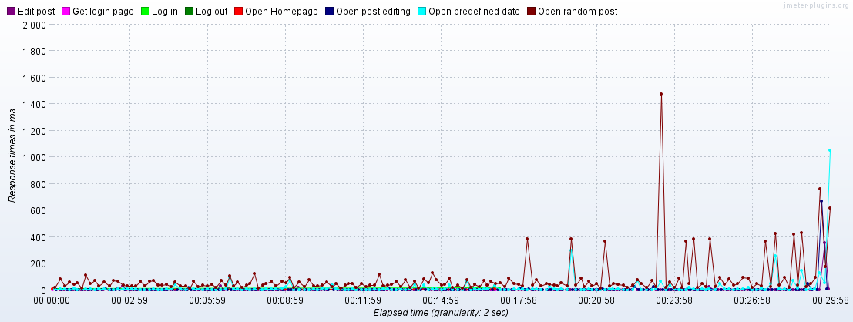

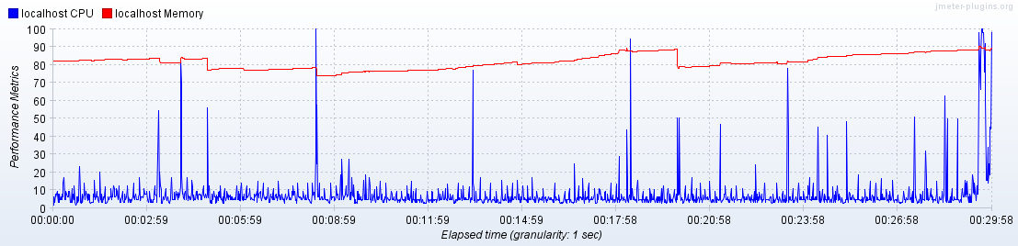

**3rd Run:**

