**Prerequisites:**

Generated 1000 posts.

**Description:**

Prepare combined scenario which is to include the scripts:

* Task 4 (admin)
* Task 5 (editor)
* Task 6 (anonymous)

Implement Anonymous user scenario (see Main script, Anonymous script, Open post script algorithms).

* Perform Smoke testing.
* Perform Capacity testing.
* Document results.

The number of the posts: 1000

**User role:**  
                admin  
                editor  
                anonymous

**Goals:**

* Design combined script and scenario
* Get an experience of combined testing with different user roles

**Scenarios:**

**Anonymous scenario:**

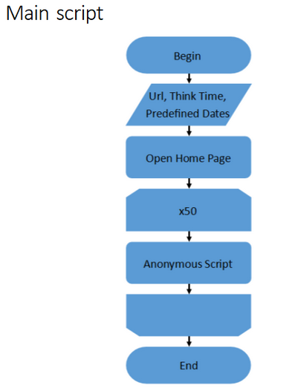

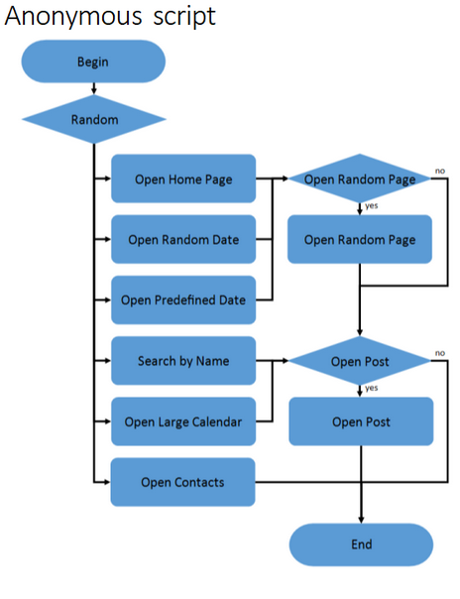

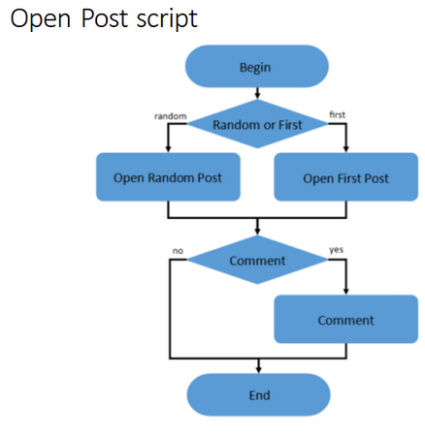

**Admin scenario:**

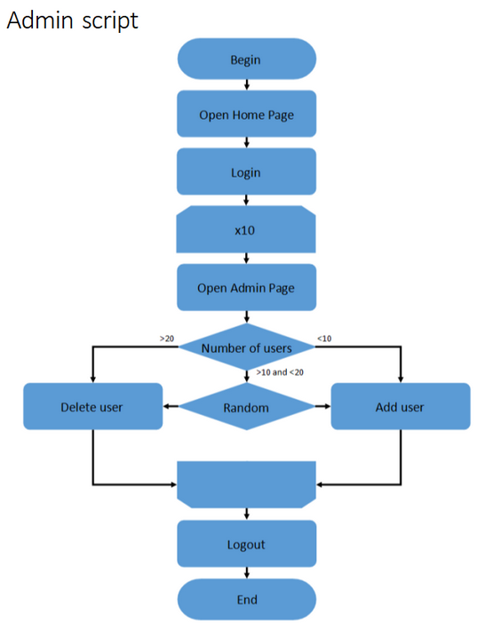

**Editor scenario:**

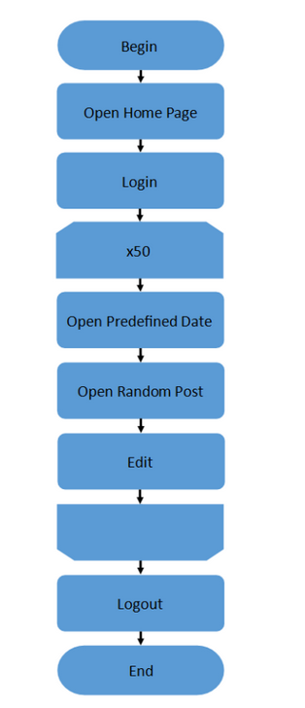

**Results:**

In this script 3 thread groups with different scenarios were used. Workload of this script is 200 users for anonymous scenario, and 2 users for editor and admin scenarios separately. Rampup and duration is 600 ms for all script. Workload profiles are displayed above in form of algorithms.

From graphics below we can see, that till approximately 05:05-05:10 system(dependent from run to run) is in comfort zone. In this period of time system reaches its capacity point, because after this CPU starts growing till 100% and don`t get down till the end of test. Also errors start occurring. Amount of transaction falling, and response time starts growing. At this time approximately 104 users are using the site: 2 editors, 2 admins and 100 anonymous, and approximately 36 transactions at the same time are performed. Several runs were executed and all of them led to the similar results, that are described below run by run:

**1st run:**

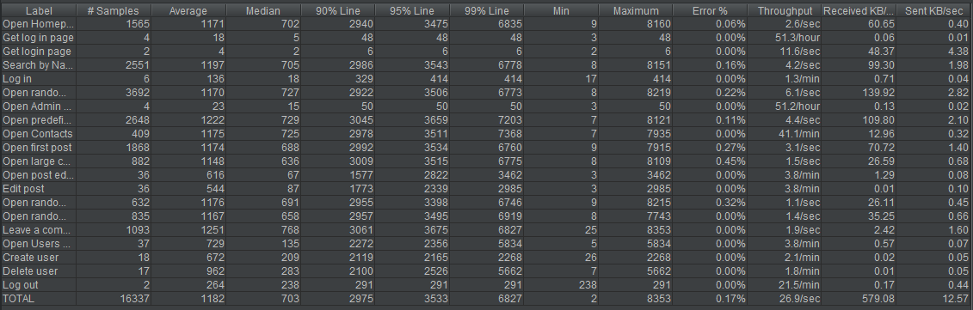

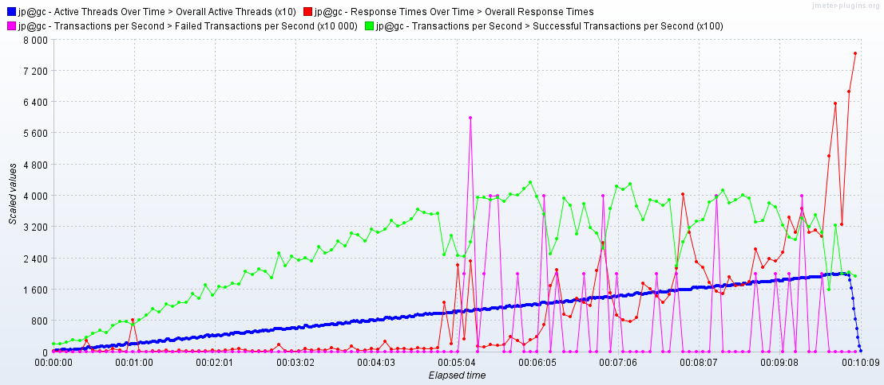

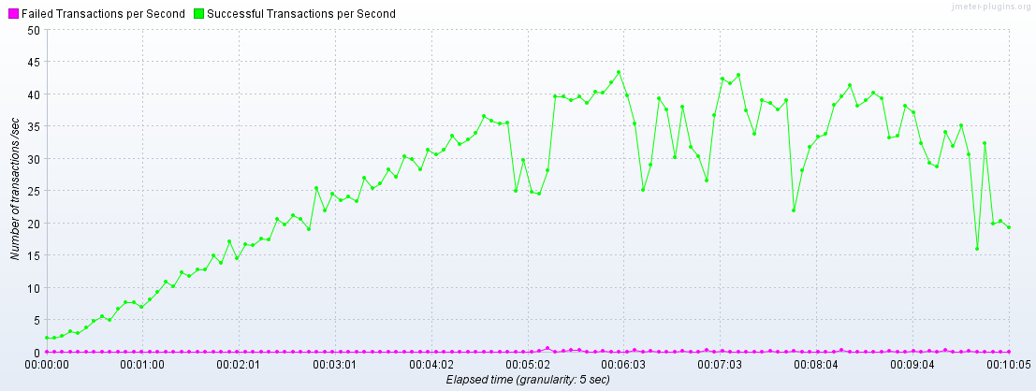

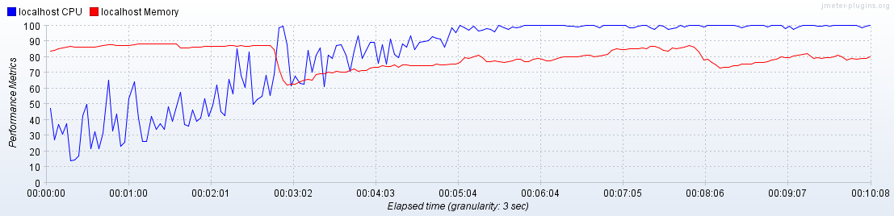

**2nd run:**

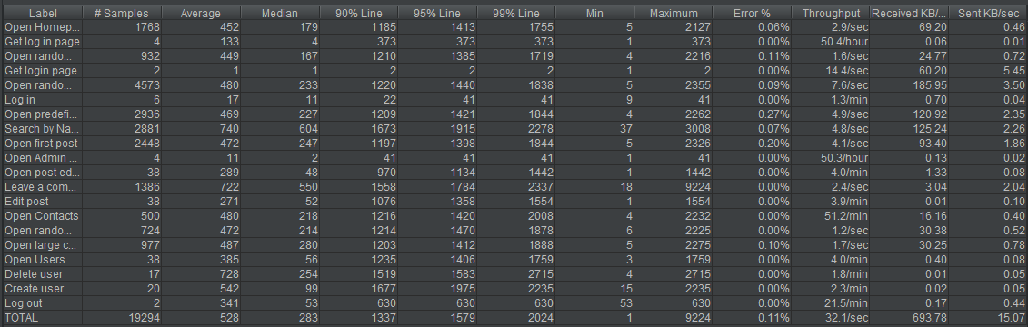

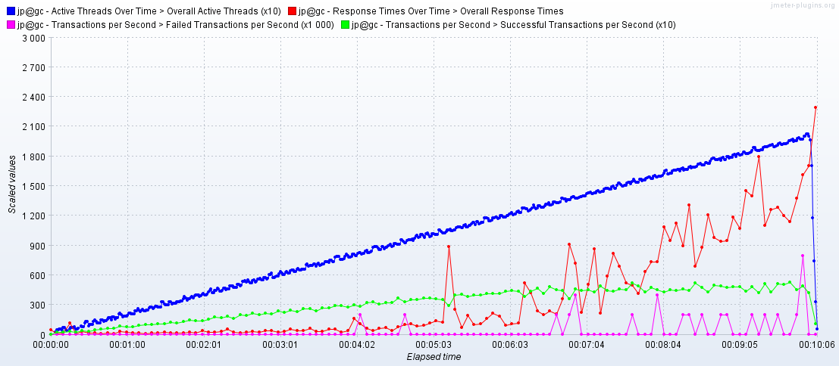

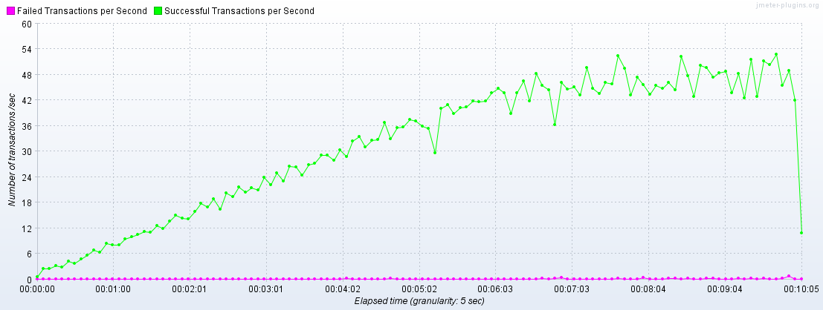

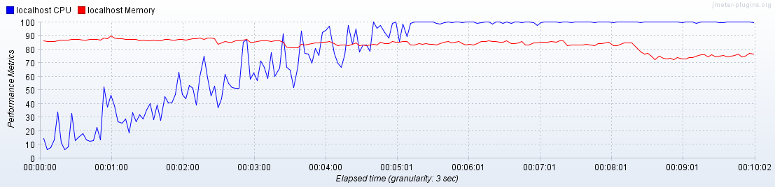

**3rd run:**

