**Prerequisites:**

Generated 1000 posts.

Results of Capacity testing from Task 7.

**Description:**

1. Using results of the testing from Task 7 define regular load.
2. Define general Key Performance Indicators (KPI), and get their basic value using the results from Task 7.
3. Set the size of the memory as bigger as possible for the virtual machine.
4. Scaling CPU:
   1. Perform load testing for different number of CPUs: 1, 2, 3 (if possible), 4, 6 (if possible).
   2. For each test gather all needed metrics.
   3. Calculate KPI.
   4. Calculate multiplier for scaling CPU.
5. Set the number of CPU as big as possible.
6. Scaling RAM:
   1. Perform load testing for different size of RAM: 2Gb, 3Gb, 4Gb (if possible), 6Gb (if possible).
   2. For each test gather all needed metrics.
   3. Calculate KPI.
   4. Calculate multiplier for scaling RAM.
7. Prepare the report on scalability testing.

The number of the posts: 1000

**User role:**  
                admin  
                editor  
                anonymous

**Goals:**

* Get an experience on regular load definition.
* Get an experience on KPI definition and calculation.
* Get an experience of scalability testing.

**Scenarios:**

**Anonymous scenario:**

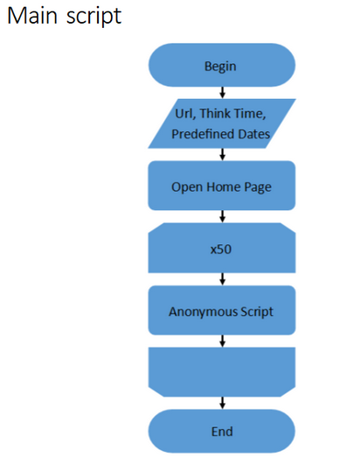

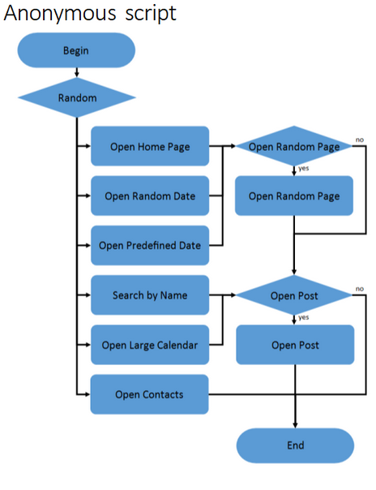

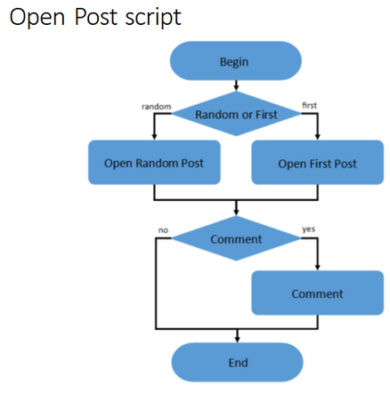

**Admin scenario:**

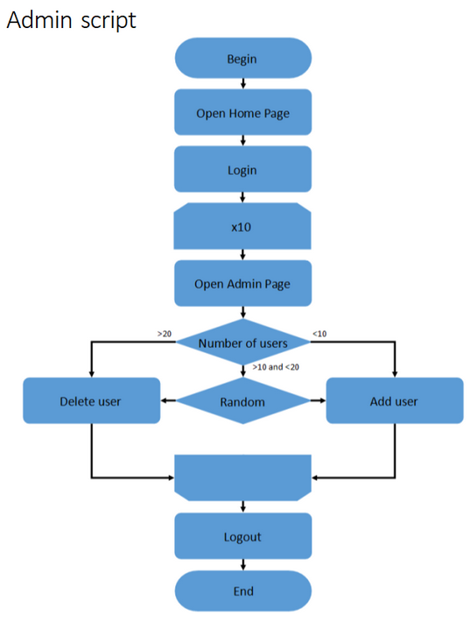

**Editor scenario:**

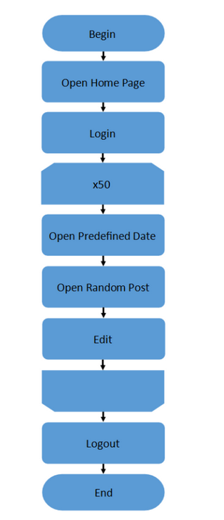

**Defining regular load:**

In script from 7 task thread groups with different scenarios were used. Workload of this script was 200 users for anonymous scenario, and 2 users for editor and admin scenarios separately. Ramp up and duration was 600 ms for all script.

After performing capacity test was found, that from approximately 05:10 system starts behaving not stable, CPU starts growing till 100% and don`t get down till the end of test. Also errors start occurring. Amount of transaction falling, and response time starts growing. So, capacity of the system with mentioned workload model and workload profile is 104 users.

For performing load test was decided to use such workload model:

* number of threads: 70 anonymous + 2 admins + 2 editors;
* ramp up: 210 ms;
* duration: 420 ms.

After performing the test we have such input values before changing amount of RAM/CPU

**CPU: 1, RAM:2048 MB**

* **Max throughput:** 28 tps;
* **Response time:** 30-40 ms, up to 132 ms;
* **CPU:** 50-80 % load; up to100 %;
* **Memory:** 85-90%
* **Test issues:** Yes

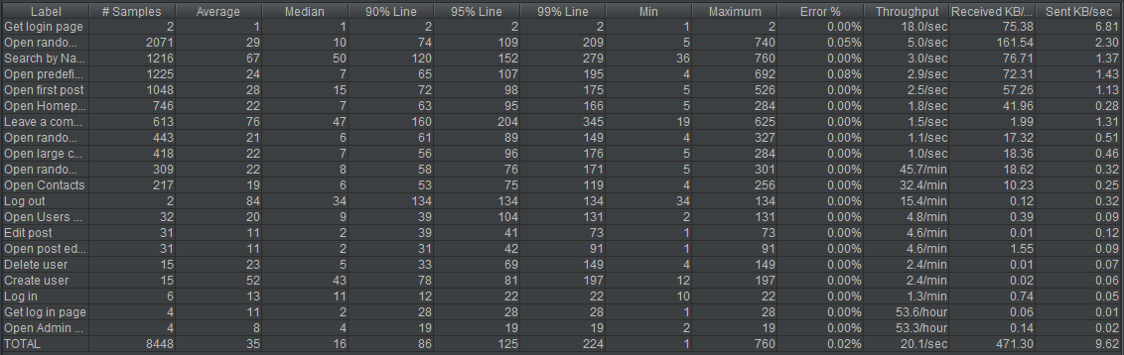

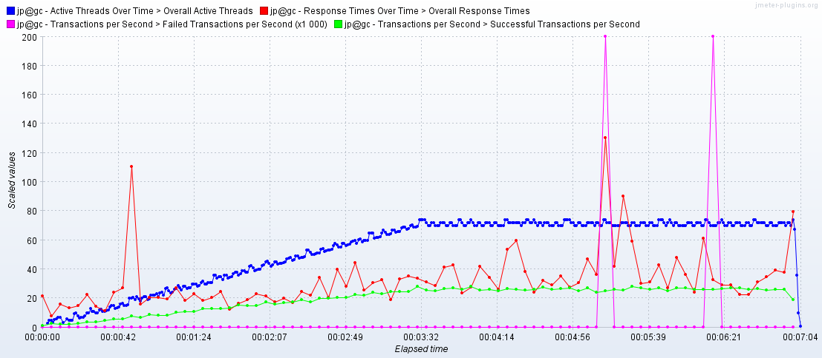

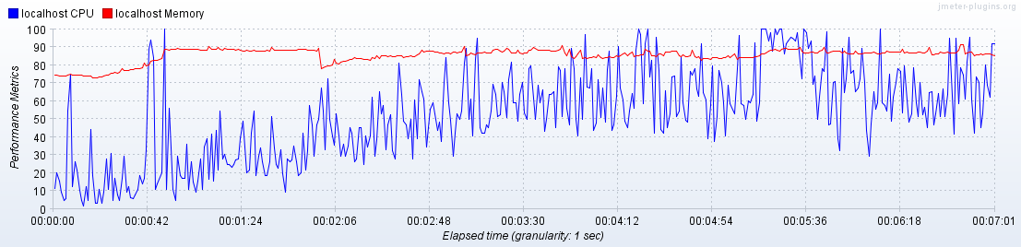

**Results:**

**Scaling CPU Results:**

Before scaling CPU due to precondition memory was changed to the maximum for virtual machine – 2TB. Then amount of CPU was changed and script for different amount of CPU(1,2,3,4 CPU) was run.

Table with KPI`s for each combination is displayed below. We can see, that starting from 2 CPU errors started occurring. Except of this also from graphics we can see, that for 2 CPU and more system sometimes stops to respond, because CPU get overloaded by IIS Worker Process. Looks like IIS is not able to operate properly with transactions for 2 and more CPU.

So, we may say, that system is not scalable by CPU.

|  |  |  |  |  |
| --- | --- | --- | --- | --- |
|  | 1 CPU, 2048 RAM | 2 CPU, 2048 RAM | 3 CPU, 2048 RAM | 4 CPU, 2048 RAM |
| Maxthroughput | 30 tps | 29 tps | 32 tps | 30 tps |
| Response time | 11-28 ms, up to 44 ms | 7-13 ms | 7-10 ms | 7-13 ms |
| CPU | 26-52 % load; up to 83 %; | 15-30 % load; up to 62 %; | 9-27 % load; up to 60 %; | 7-25 % load; up to 47 %; |
| Memory | 86-90% | 85-90% | 79-88% | 88-93% |
| Test issues | 0% | 0.24% | 0.13% | 0.18 % |

Detailed info run by run with graphics is described on the next pages.

**Scaling RAM Results:**

Before scaling RAM due to precondition CPU amount should be changed to the maximum value, but due to previous scaling CPU results it was decided to use 1 CPU, because system is not scalable by CPU. Then size of RAM was changed and script for different size(2Gb, 3Gb, 4Gb, 6Gb) was run.

Table with KPI`s for each combination is displayed below. From these results we can understand, that throughput isn`t changed at all as well as CPU load, but response time starts falling from run to run. Memory load also get less with growing size of RAM, what is expected. What is perfect is that for all of runs no error occurred. Also was calculated multiplier and it is approximately 0.8(sometimes it`s 0.74, sometimes – 0.82, also depends from the run to run with the same configuration).

So, due to all mentioned above we can say, that system is scalable by RAM and it is possibly may be scaled even more (8Gb for the beginning), because there is no degradation.

|  |  |  |  |  |  |
| --- | --- | --- | --- | --- | --- |
|  | 1 CPU, 2048 RAM | 1 CPU, 3072 RAM | 1 CPU, 4096 RAM | 1 CPU, 6144 RAM | Multiplier |
| Maxthroughput | 31 tps | 30 tps | 29 tps | 29 tps | - |
| Response time | 14-35 ms, up to 302 ms | 13-26 ms, up to 442 ms | 13-22 ms, up to 310 ms | 8-20 ms, up to 270; | ≈ 0.8 |
| CPU | 32-53 % load; up to 100 %; | 30-54 % load; up to 100 %; | 30-53 % load; up to 87 %; | 30-50 % load; up to 100 %; | - |
| Memory | 86-90% | 69-73% | 50-55% | 42-44% | ≈ 0.8 |
| Test issues | 0% | 0% | 0% | 0% | - |

Detailed info run by run with graphics is described on the next pages.

**Scaling CPU graphics and results:**

**CPU: 1, RAM 2048 MB:**

* **Max throughput:** 30 tps;
* **Response time:** 11-28 ms, up to 44;
* **CPU:** 26-52 % load; up to 83 %;
* **Memory:** 86-90 %
* **Test issues:** No

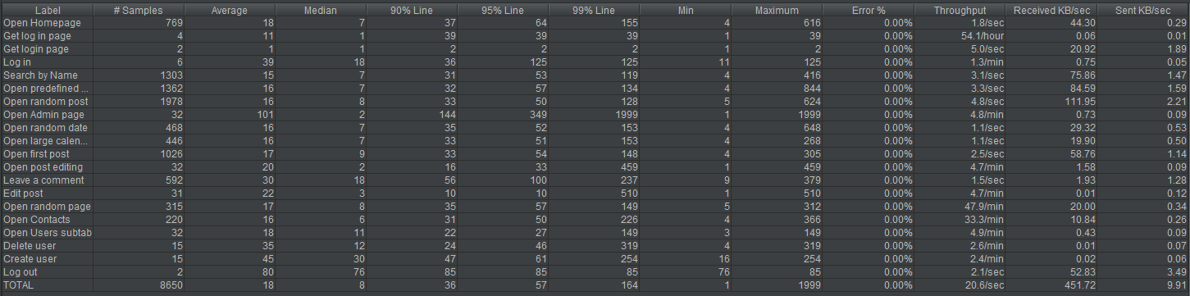

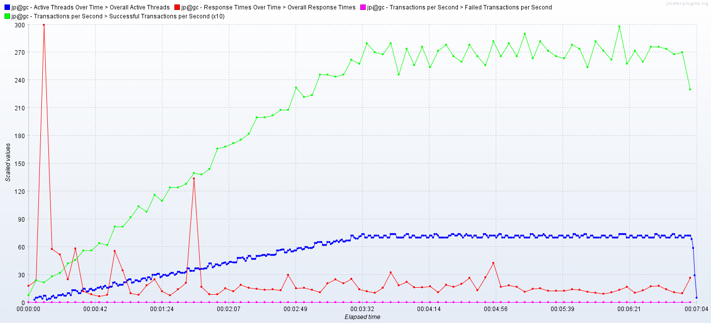

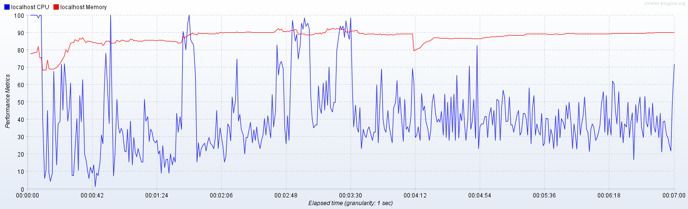

**CPU: 2, RAM 2048 MB:**

* **Max throughput:** 29 tps;
* **Response time:** 7-13 ms;
* **CPU:** 15-30 % load; up to 62 %;
* **Memory:** 85-90%
* **Test issues:** Yes, 0.24%

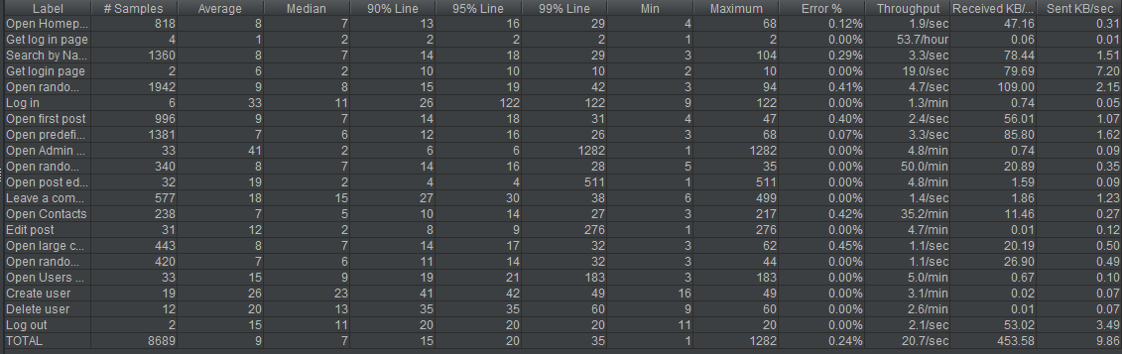

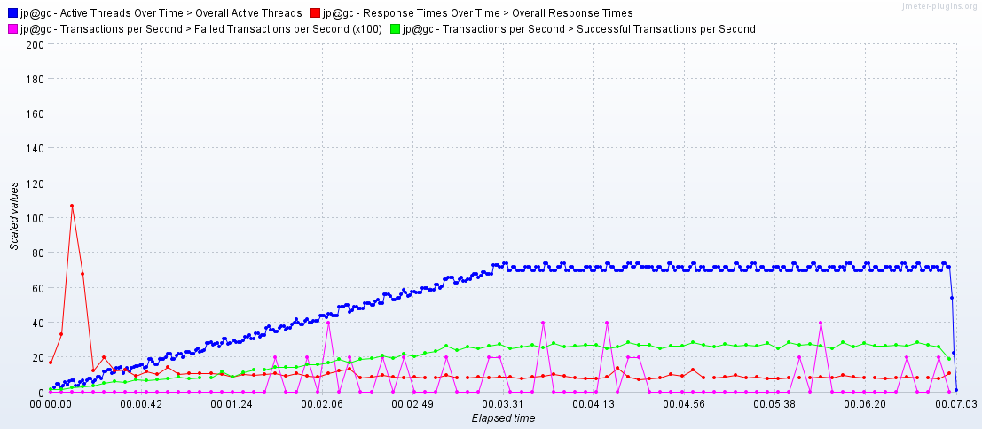

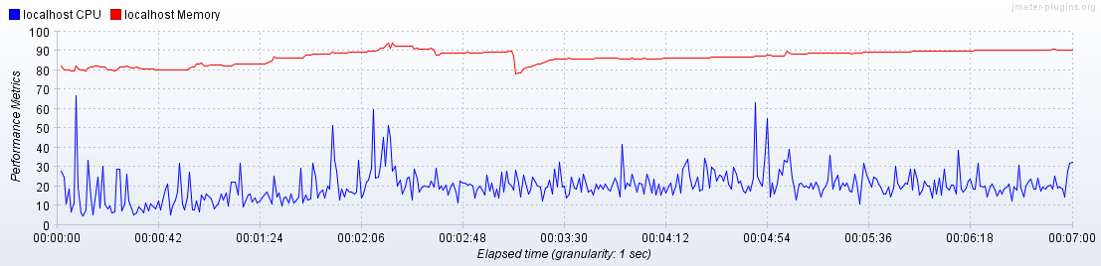

**Next results show us, that system got overloaded since some time from start of the test:**

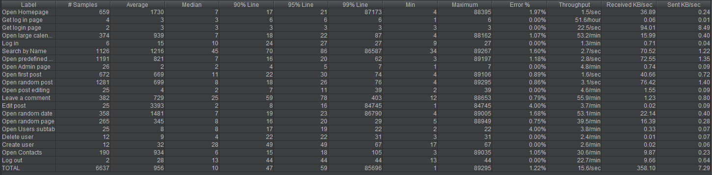

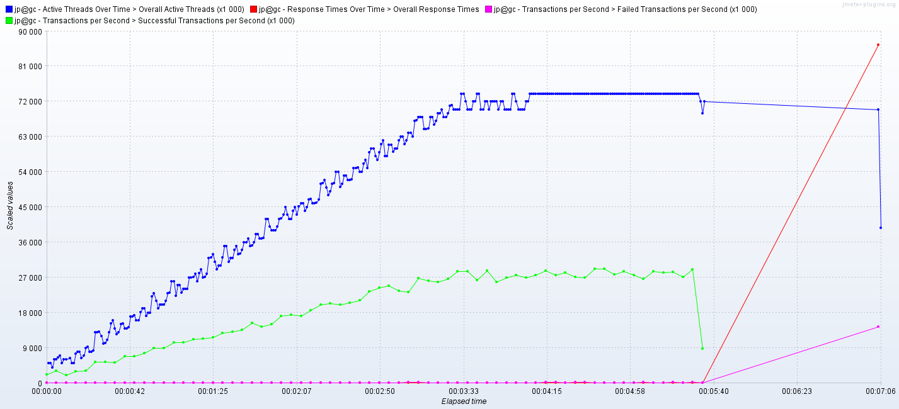

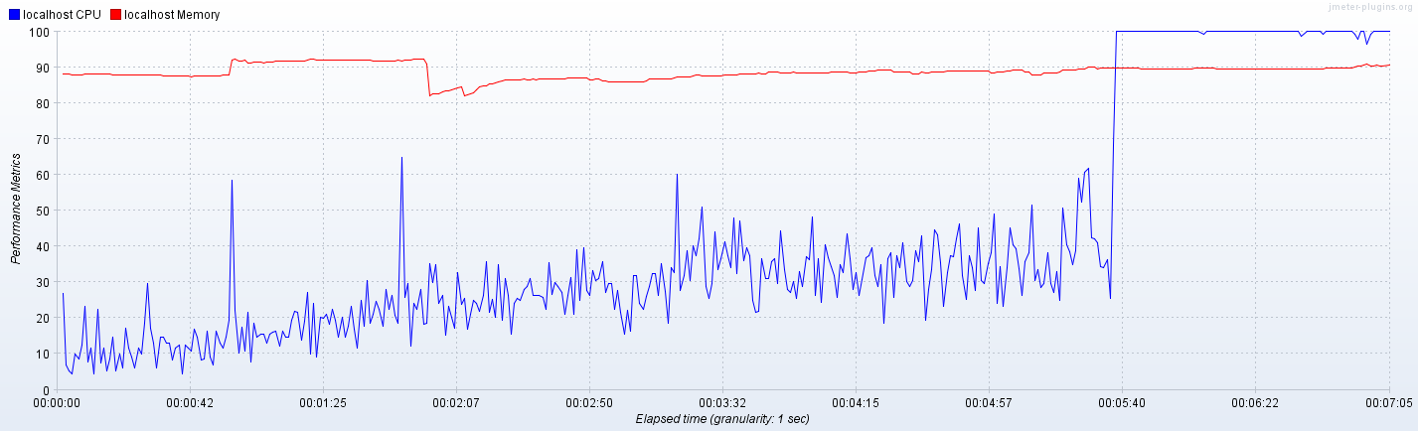

**CPU: 3, RAM:** **2048MB:**

* **Max throughput:** 32 tps;
* **Response time:** 7-10 ms;
* **CPU:** 9-27% load; up to 60 %;
* **Memory:** 79-88%
* **Test issues:** Yes, 0.13%

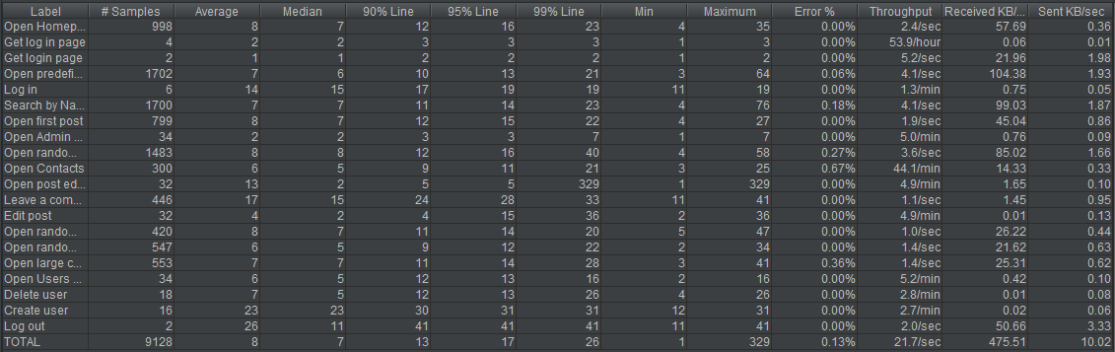

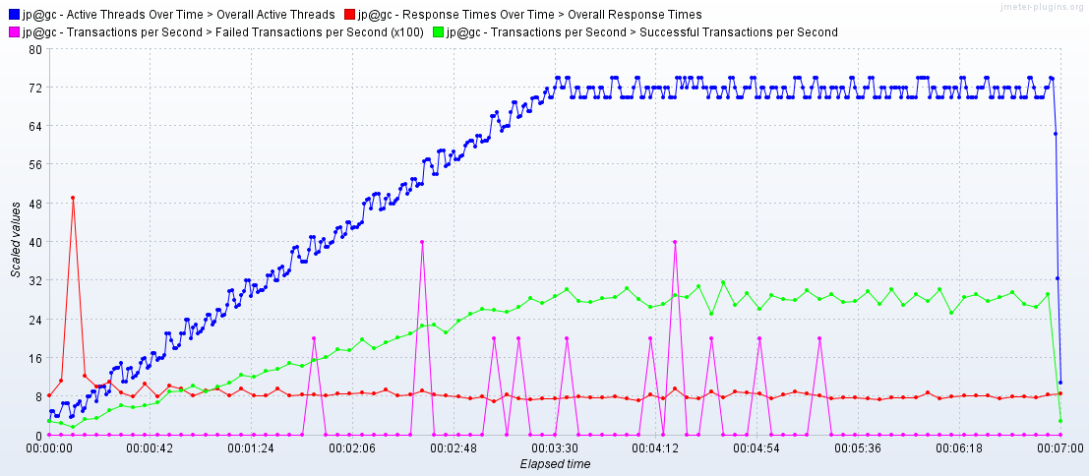

**CPU: 4, RAM:** **2048MB:**

* **Max throughput:** 30 tps;
* **Response time:** 7-13 ms;
* **CPU:** 7-25 % load; up to 47 %;
* **Memory:** 88-93%
* **Test issues:** Yes, 0.18%

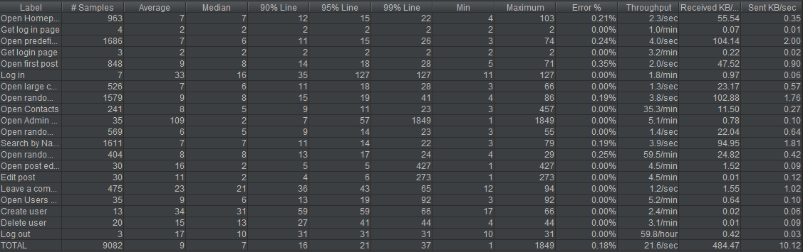

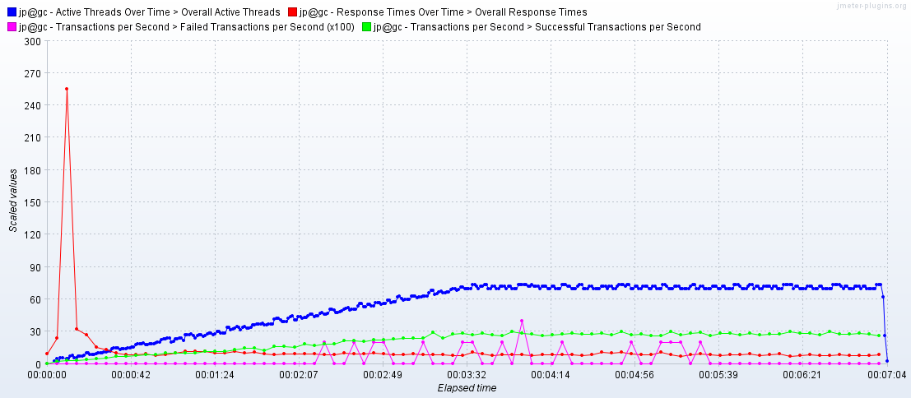

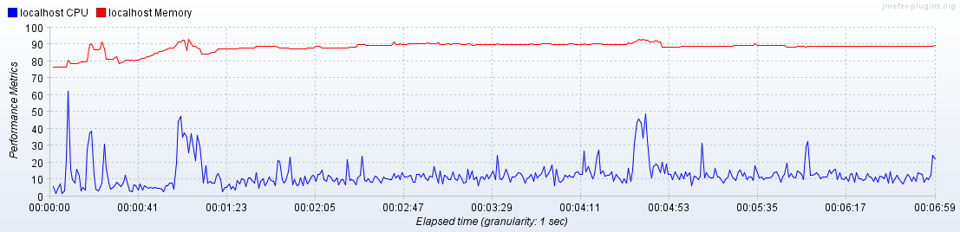

**Scaling RAM graphics and results:**

**CPU: 1, RAM 2048 MB:**

* **Max throughput:** 31 tps;
* **Response time:** 14-35 ms, up to 302;
* **CPU:** 32-53 % load; up to 100 %;
* **Memory:** 86-90 %
* **Test issues:** No

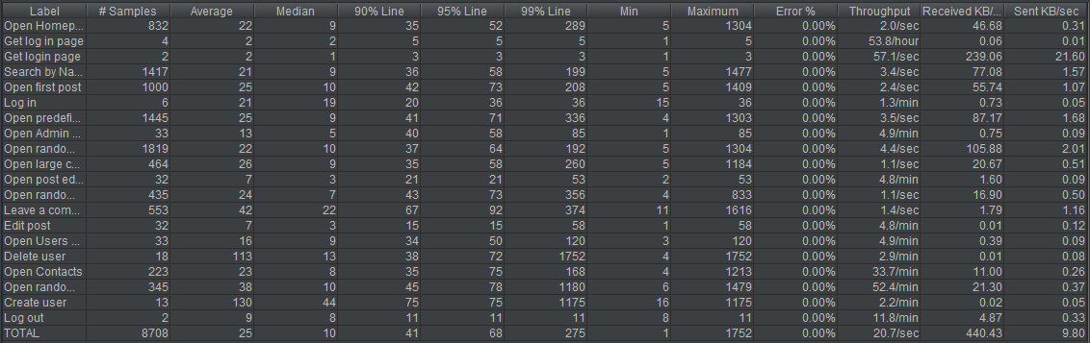

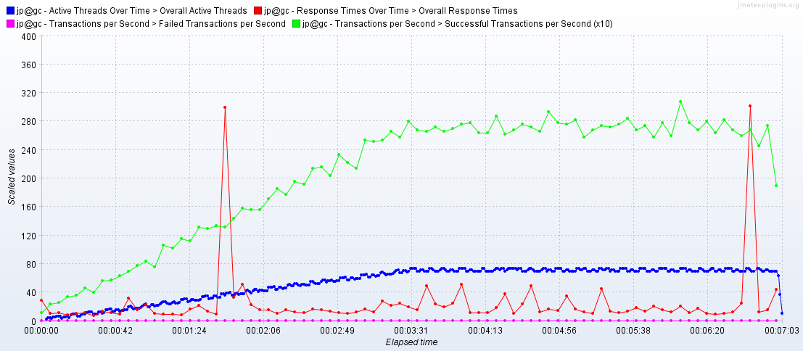

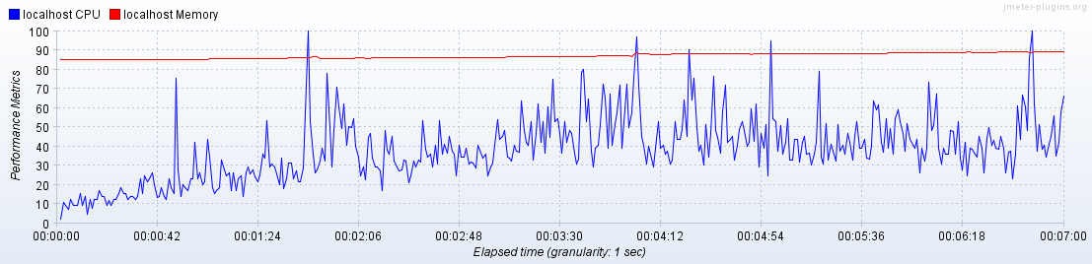

**CPU: 1, RAM 3072 MB:**

* **Max throughput:** 30 tps;
* **Response time:** 13-26 ms, up to 442;
* **CPU:** 30-54 % load; up to 100 %;
* **Memory:** 69-73 %
* **Test issues:** No

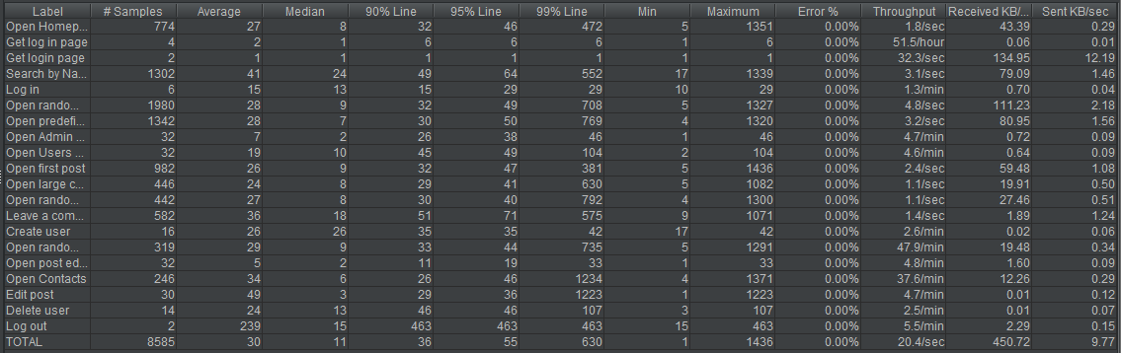

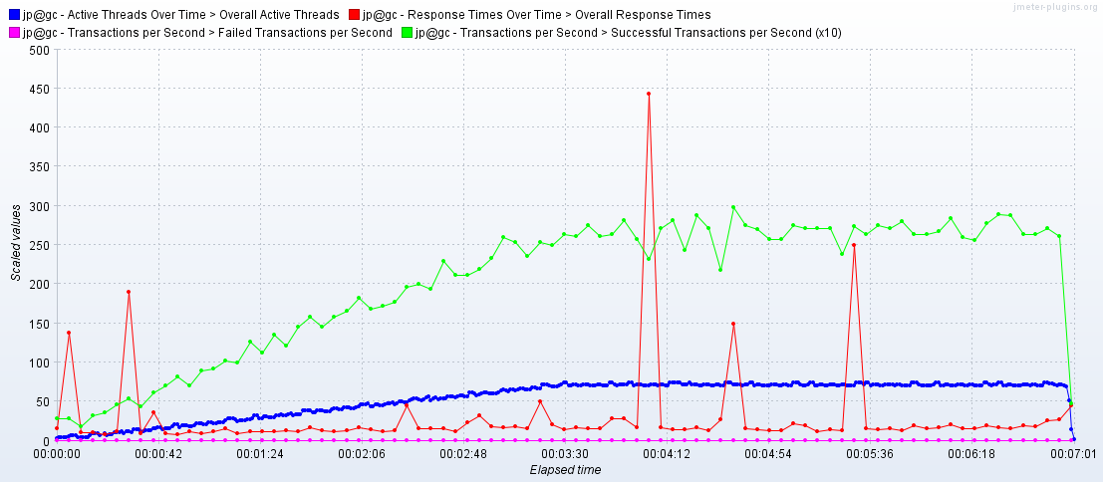

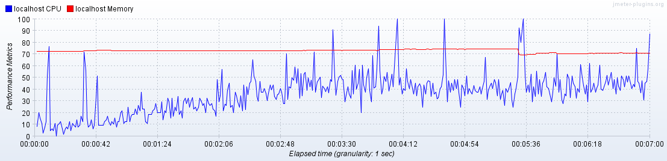

**CPU: 1, RAM 4096 MB:**

* **Max throughput:** 29 tps;
* **Response time:** 13-22 ms, up to 310;
* **CPU:** 30-53 % load; up to 87 %;
* **Memory:** 50-55 %
* **Test issues:** No

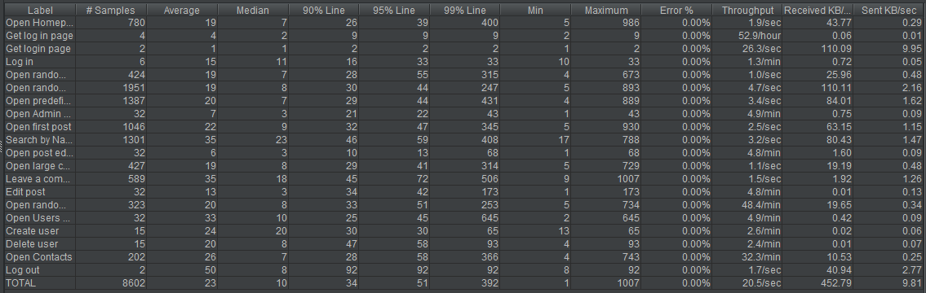

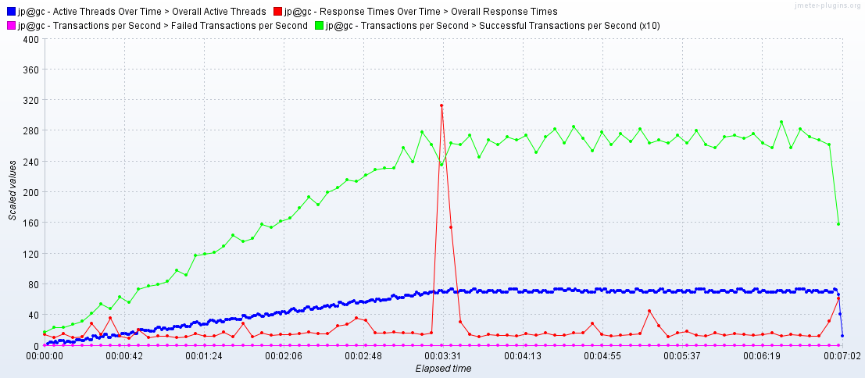

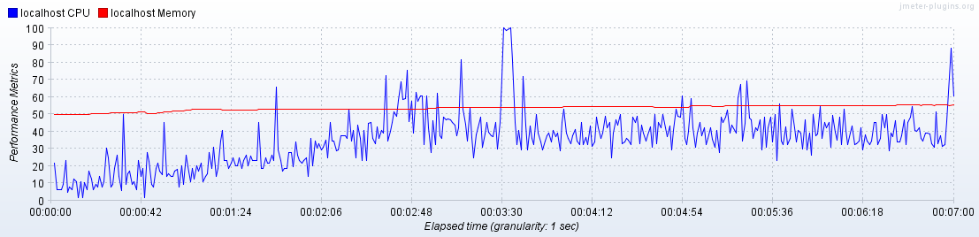

**CPU: 1, RAM 6144 MB:**

* **Max throughput:** 29 tps;
* **Response time:** 8-20 ms, up to 270;
* **CPU:** 30-50 % load; up to 100 %;
* **Memory:** 42-44 %
* **Test issues:** No

