**Prerequisites:**

Defined regular load.

**Description:**

1. Testing with different number of the text posts:
   1. Perform combined testing with different number of the posts:
      * 100
      * 1000
      * 2000
      * 5000
   2. Gather all needed metrics
   3. Calculate KPI.
   4. Compare the results
   5. Define the threshold for degradation depending on the quantity of the posts
2. Testing with media information
   1. Prepare 1000 text posts
   2. Prepare 1000 posts with a text and attached 1Mb photo
   3. Run the regular load test
   4. Gather all needed metrics
   5. Calculate KPI
   6. Compare the results between the results of the testing with 2000 pure text posts and the results of the testing with 2000 mixed posts
3. Prepare complex report on volume testing

**User role:**  
                admin  
                editor  
                anonymous

**Goals:**

* Get an experience of advanced volume testing.
* Get an experience on preparation the different kinds of test data.

**Scenarios:**

**Anonymous scenario:**

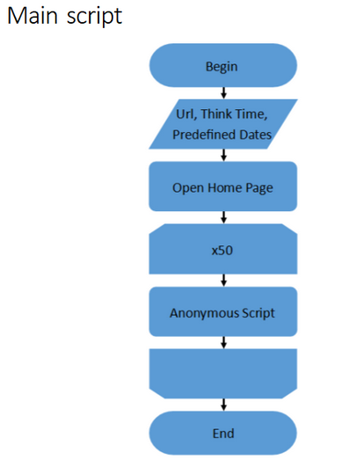

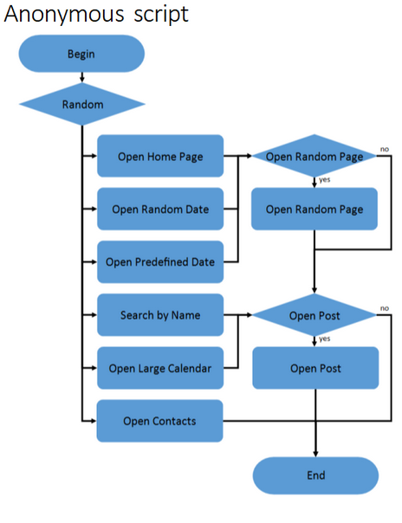

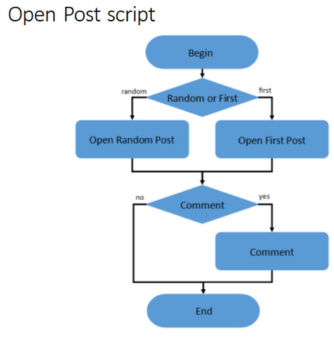

**Admin scenario:**

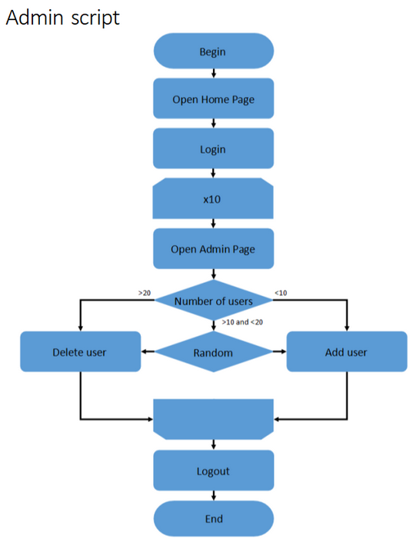

**Editor scenario:**

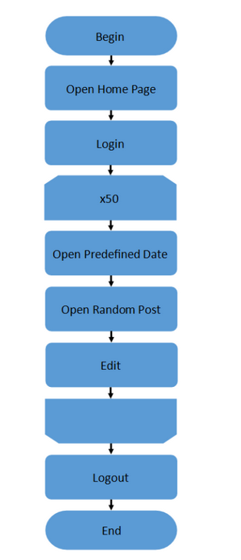

**Results:**

In the previous task regular load was defined. For performing load test was decided to use such workload model:

* number of threads: 70 anonymous + 2 admins + 2 editors;
* ramp up: 210 ms;
* duration: 420 ms.

Then different tests were performed due to conditions.

* 1. **Testing with different number of the text posts**

For performing tests with different amount of posts such amount of posts was generated (100, 1000, 2000 and 5000). Below KPI`s of each of run are displayed in form of table.

We can see, that maximum throughput isn`t changing for different amount of posts, but response time as well as CPU load is changing. From this KPI`s we see, that already on 2000 posts run degradation was started. Of course, results of 5000 posts run are much worse, both for response time and CPU load, but for failed transactions too. It`s 0.10 % for all run, while it`s 0% for all others.

So, looks like system is not able to operate such amount of data and actions on it.

|  |  |  |  |  |
| --- | --- | --- | --- | --- |
|  | 100 posts | 1000 posts | 2000 posts | 5000 posts |
| Maxthroughput | 30 tps | 29 tps | 29 tps | 29 tps |
| Response time | 10-20 ms, up to 49 ms | 11-19 ms, up to 44 ms | 13-28 ms, up to 270 ms | 30-51 ms, up to 136 ms |
| CPU | 30-50% load; up to 81%; | 30-50% load; up to 79%; | 39-59% load, up to 100% | 50-73% load, up to 100% |
| Memory | 77-83% | 85-88% | 81-87% | 82-88% |
| Test issues | 0% | 0% | 0% | 0.10% |

Detailed info run by run with graphics and aggregated report are displayed below.

* 1. **Testing with media information**

For performing tests with different type posts such amount of posts was generated (2000 pure posts and 2000 mixed (1000 pure and 1000 with 1MB media). Below KPI`s of each of run are displayed in form of table.

From these results we see, that maximum throughput isn`t changing for different collections of posts, but all other metrics are changing. We see degradation on 2000 mixed posts run: response time jumped up in more than two times, CPU load also grown up and some errors occurred.

So, seems, that for system it`s harder to operate more heavy data, performance is falling.

|  |  |  |
| --- | --- | --- |
|  | 2000 pure posts | 2000 mixed posts with photos |
| Maxthroughput | 29 tps | 29 tps |
| Response time | 13-28 ms, up to 270 ms | 29-75 ms, up to 186 ms |
| CPU | 39-59% load, up to 100% | 48-77% load, up to 100% |
| Memory | 81-87% | 87-91% |
| Test issues | 0% | 0.05% |

Detailed info run by run with graphics and aggregated report are displayed below.

**Testing with different number of the text posts graphics and results**

**100 posts test results**

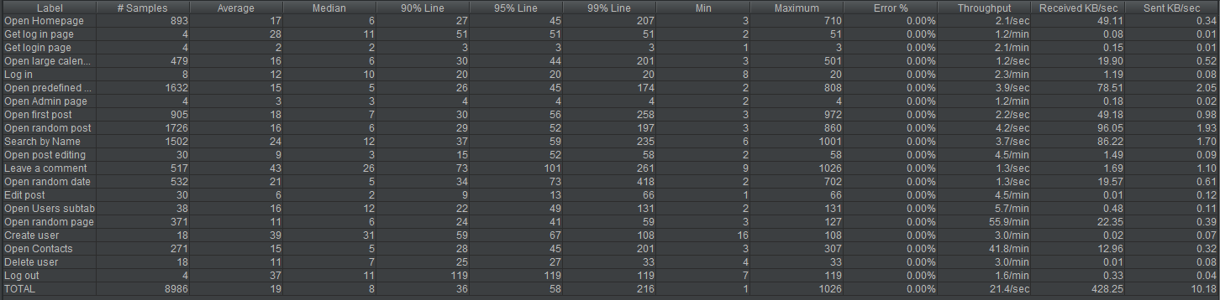

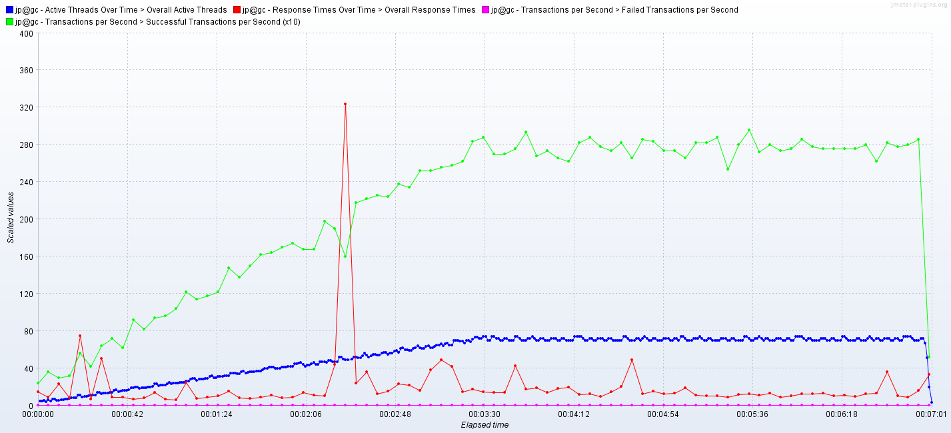

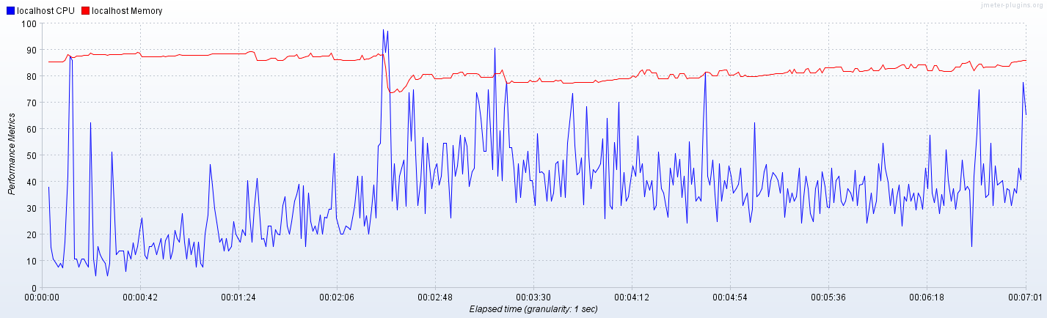

**1000 posts test results**

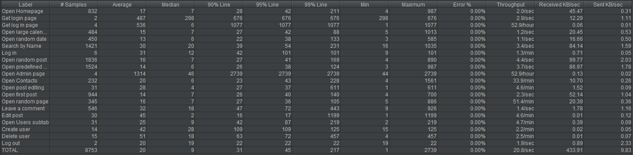

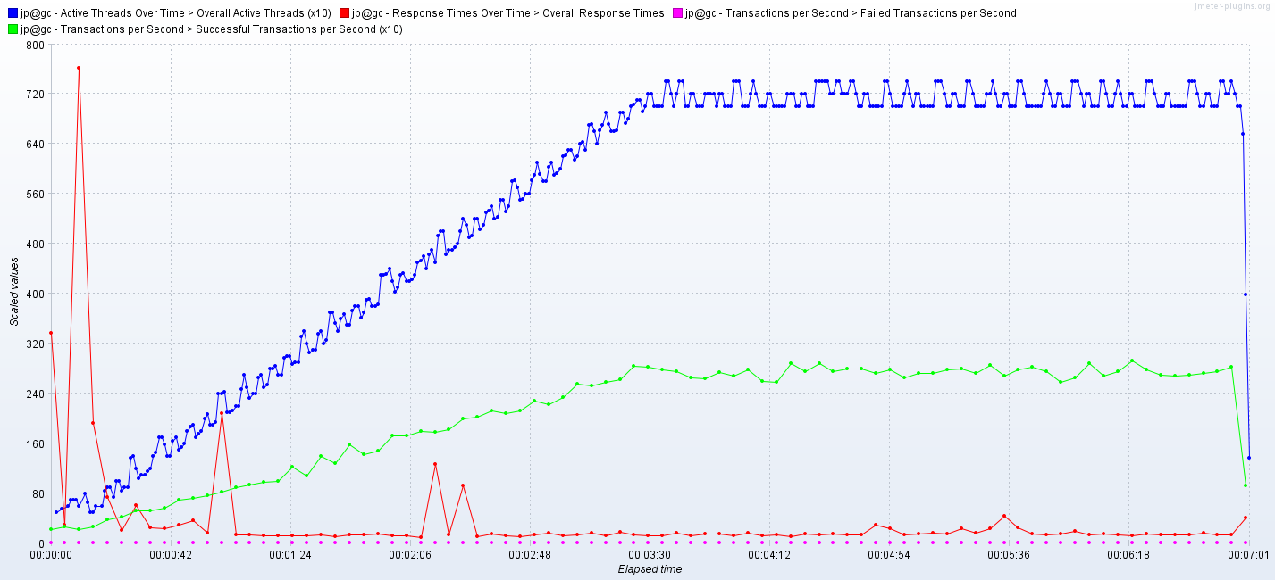

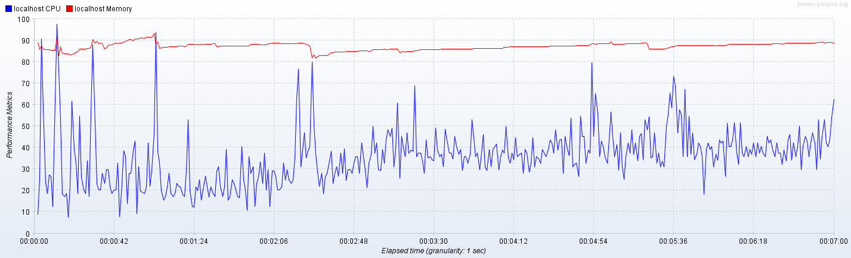

**2000 posts test results**

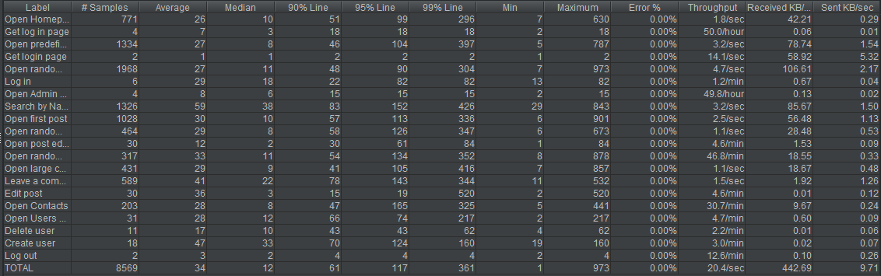

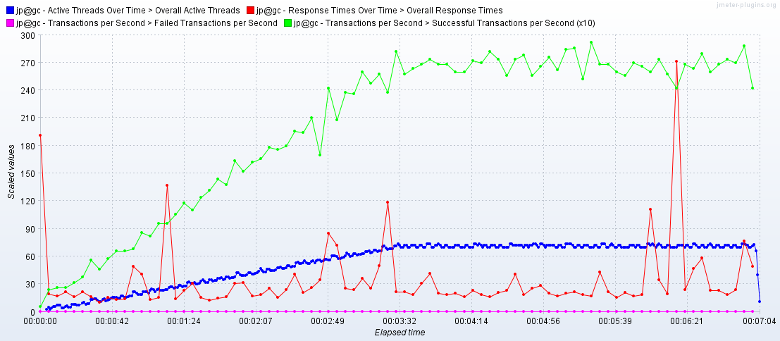

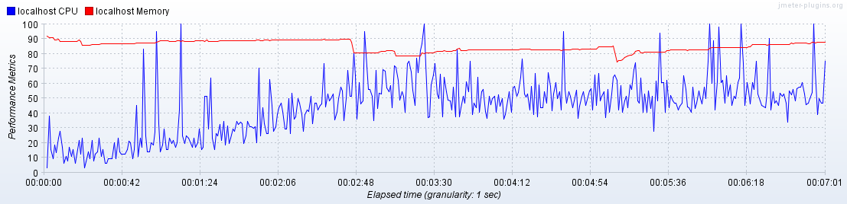

**5000 posts test results**

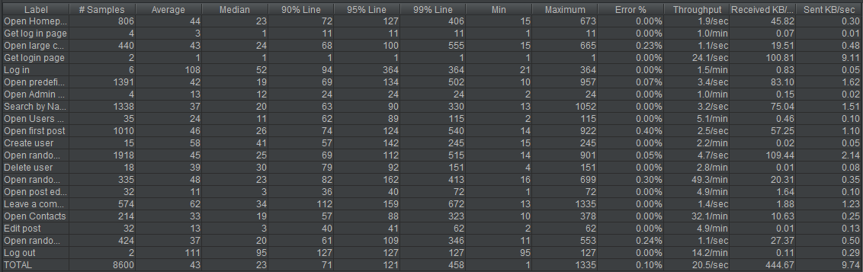

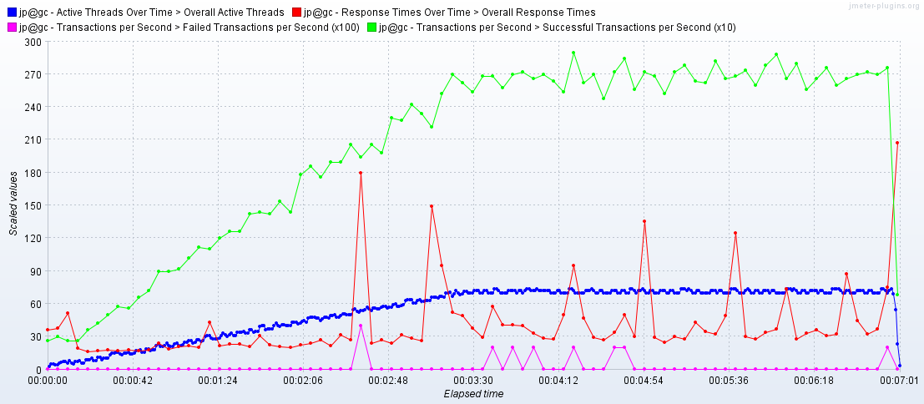

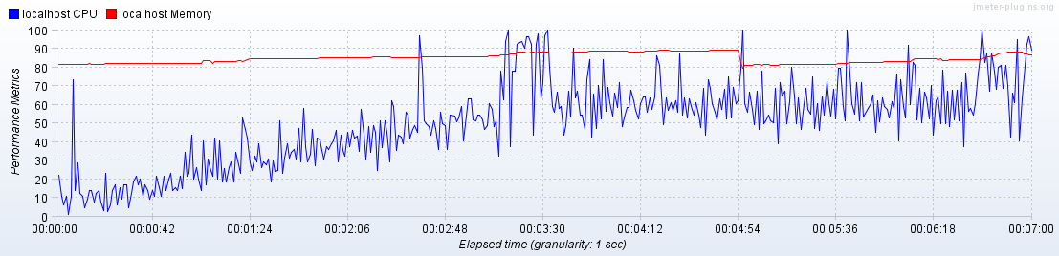

1. **Testing with media information graphics and results**

**2000 pure posts test results**







**2000 mixed posts test results**

