**Pizza Sales SQL Queries**

**A. KPI’s**

**1. Total revenue:**

SELECT SUM(total_price) AS total_revenue FROM pizza_sales;



**2. Average Order Value:**

SELECT SUM(total_price)/ COUNT(DISTINCT order_id) AS Average_Order_Value FROM pizza_sales;

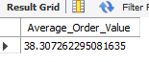

**3. Total Pizzas Sold:**

SELECT SUM(quantity) AS Total_Pizzas_Sold FROM pizza_sales;

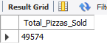

**4. Total Orders Placed:**

SELECT COUNT(DISTINCT order_id) AS Total_Orders FROM pizza_sales;



**5. Average Pizzas per order:**

SELECT SUM(quantity) / COUNT(DISTINCT order_id) avg_pizzas_per_order FROM pizza_sales;



**B. Charts Requirement:**

**1. Total Orders trend by Month:**

SELECT monthname(order_date) as order_month, count(Distinct order_id) as total_orders from pizza_sale group by monthname(order_date);

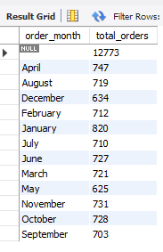

**2. Total Orders trend by Day (In descending order):**

SELECT dayname(order_date) as order_day, count(Distinct order_id) as total_orders from pizza_sale group by dayname(order_date) order by count(Distinct order_id) DESC;

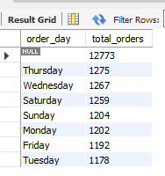

**3. Percentage of sales by Pizza caregory:**

SELECT pizza_categ ory, SUM(total_price)*100/(SELECT SUM(total_price) from pizza_sale) as pct_of_total_sales from pizza_sale group by pizza_category;

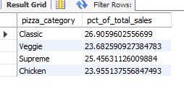

**4. Percentage of sales by Pizza caregory including totals sales column:**

SELECT pizza_category, SUM(total_price) as total_sales, SUM(total_price)*100/(SELECT SUM(total_price) from pizza_sale) as pct_of_total_sales from pizza_sale group by pizza_category;

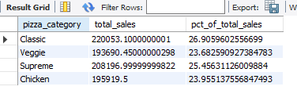

**5. Percentage of sales by Pizza caregory including totals sales column (Only for January):**

SELECT pizza_category, SUM(total_price) as total_sales, SUM(total_price)*100/(SELECT SUM(total_price) from pizza_sale where month(order_date) = 1) as pct_of_total_sales from pizza_sale where month(order_date) = 1 group by pizza_category;

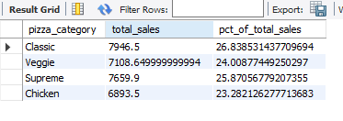

**6. Percentage of sales by Pizza size including totals sales column:**

SELECT pizza_size, SUM(total_price) as total_sales, SUM(total_price)*100/(SELECT SUM(total_price) from pizza_sale) as pct_of_total_sales from pizza_sale group by pizza_size;

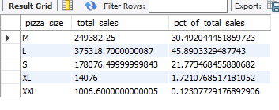

**7. Percentage of sales by Pizza size including totals sales column (Rounding up):**

SELECT pizza_size, Round(SUM(total_price),2) as total_sales, round(SUM(total_price)*100/(SELECT SUM(total_price) from pizza_sale),2) as pct_of_total_sales from pizza_sale group by pizza_size;

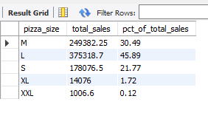

**8. Top 5 revenue by pizza name:**

SELECT pizza_name, round(sum(total_price),2) as total_revenue from pizza_sale group by pizza_name order by total_revenue DESC limit 5;

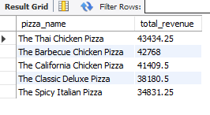

**9. Bottom 5 quantity by pizza name:**

SELECT pizza_name, sum(quantity) as total_quantity from pizza_sale group by pizza_name order by total_quantity limit 5;

