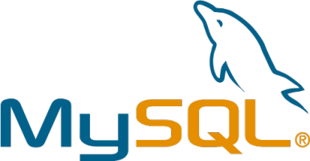



**SHAREKHAN: A STOCK MARKET INVESTMENT SYSTEM**

**-Soham Joshi**

**XII-E 12517**



ACKNOWLEDGEMENT

I would like to thank our institution and principal ma’am for giving me the opportunity to work on and explore such a topic and improve my understanding of data science

I would also like to express my gratitude to our IP teacher Ms. Vibhavari ma’am for constant guidance and encouragement throughout this process even during these testing times.

I am also grateful to my parents and my friends for giving their priceless inputs in this project



1. Python(IDLE 3.8.3):

SOFTWARES USED

IDLE (short for Integrated Development and Learning Environment) is an [integrated development environment](https://en.wikipedia.org/wiki/Integrated_development_environment) for [Python](https://en.wikipedia.org/wiki/Python_(programming_language)), which has been bundled with the default implementation of the language since 1.5.2b1. It is packaged as an optional part of the Python packaging with many [Linux distributions](https://en.wikipedia.org/wiki/Linux_distributions). It is completely written in Python and the [Tkinter](https://en.wikipedia.org/wiki/Tkinter" \o "Tkinter) GUI toolkit ([wrapper](https://en.wikipedia.org/wiki/Wrapper_function) functions for [Tcl](https://en.wikipedia.org/wiki/Tcl" \o "Tcl)/[Tk](https://en.wikipedia.org/wiki/Tk_(framework))).

IDLE is intended to be a simple [IDE](https://en.wikipedia.org/wiki/Integrated_development_environment) and suitable for beginners, especially in an educational environment. To that end, it is cross-platform, and avoids feature clutter.

According to the included [README](https://en.wikipedia.org/wiki/README), its main features are:

* Multi-window text editor with [syntax highlighting](https://en.wikipedia.org/wiki/Syntax_highlighting), autocompletion, smart indent and other.
* Python shell with syntax highlighting.
* Integrated debugger with [stepping](https://en.wikipedia.org/wiki/Program_animation), persistent [breakpoints](https://en.wikipedia.org/wiki/Breakpoint), and call stack visibility.

Author [Guido van Rossum](https://en.wikipedia.org/wiki/Guido_van_Rossum) says IDLE stands for "Integrated DeveLopment Environment",[[5]](https://en.wikipedia.org/wiki/IDLE#cite_note-GvR_IDLE_email-5) and since Van Rossum named the language Python after the British comedy group [Monty Python](https://en.wikipedia.org/wiki/Monty_Python), the name IDLE was probably also chosen partly to honor [Eric Idle](https://en.wikipedia.org/wiki/Eric_Idle), one of Monty Python's founding members.

2.MYSQL(8.0):

MySQL is an [open-source](https://en.wikipedia.org/wiki/Open-source_software) [relational database management system](https://en.wikipedia.org/wiki/Relational_database_management_system) (RDBMS). Its name is a combination of "My", the name of co-founder [Michael Widenius](https://en.wikipedia.org/wiki/Michael_Widenius)'s daughter, and "[SQL](https://en.wikipedia.org/wiki/SQL)", the abbreviation for [Structured Query Language](https://en.wikipedia.org/wiki/Structured_Query_Language). A [relational database](https://en.wikipedia.org/wiki/Relational_database) organizes data into one or more data tables in which data types may be related to each other; these relations help structure the data. SQL is a language programmers use to create, modify and extract data from the relational database, as well as control user access to the database. In addition to relational databases and SQL, an RDBMS like MySQL works with an [operating system](https://en.wikipedia.org/wiki/Operating_system) to implement a relational database in a computer's storage system, manages users, allows for network access and facilitates testing database integrity and creation of backups.

MySQL is [free and open-source software](https://en.wikipedia.org/wiki/Free_and_open-source_software) under the terms of the [GNU General Public License](https://en.wikipedia.org/wiki/GNU_General_Public_License), and is also available under a variety of [proprietary](https://en.wikipedia.org/wiki/Proprietary_software) licenses. MySQL was owned and sponsored by the [Swedish](https://en.wikipedia.org/wiki/Sweden) company [MySQL AB](https://en.wikipedia.org/wiki/MySQL_AB), which was bought by [Sun Microsystems](https://en.wikipedia.org/wiki/Sun_Microsystems) (now [Oracle Corporation](https://en.wikipedia.org/wiki/Oracle_Corporation)). In 2010, when Oracle acquired Sun, Widenius [forked](https://en.wikipedia.org/wiki/Fork_(software_development)) the [open-source](https://en.wikipedia.org/wiki/Open-source) MySQL project to create [MariaDB](https://en.wikipedia.org/wiki/MariaDB).

MySQL has stand-alone clients that allow users to interact directly with a MySQL database using SQL, but more often MySQL is used with other programs to implement applications that need relational database capability. MySQL is a component of the [LAMP](https://en.wikipedia.org/wiki/LAMP_(software_bundle)) [web application](https://en.wikipedia.org/wiki/Web_application) [software stack](https://en.wikipedia.org/wiki/Software_stack) (and [others](https://en.wikipedia.org/wiki/List_of_AMP_packages)), which is an acronym for [Linux](https://en.wikipedia.org/wiki/Linux), [Apache](https://en.wikipedia.org/wiki/Apache_HTTP_Server), MySQL, [Perl](https://en.wikipedia.org/wiki/Perl)/[PHP](https://en.wikipedia.org/wiki/PHP)/[Python](https://en.wikipedia.org/wiki/Python_(programming_language)). MySQL is used by many database-driven web applications, including [Drupal](https://en.wikipedia.org/wiki/Drupal), [Joomla](https://en.wikipedia.org/wiki/Joomla), [phpBB](https://en.wikipedia.org/wiki/PhpBB" \o "PhpBB), and [WordPress](https://en.wikipedia.org/wiki/WordPress).

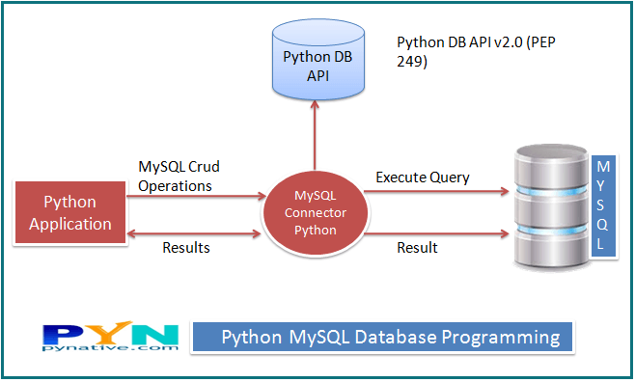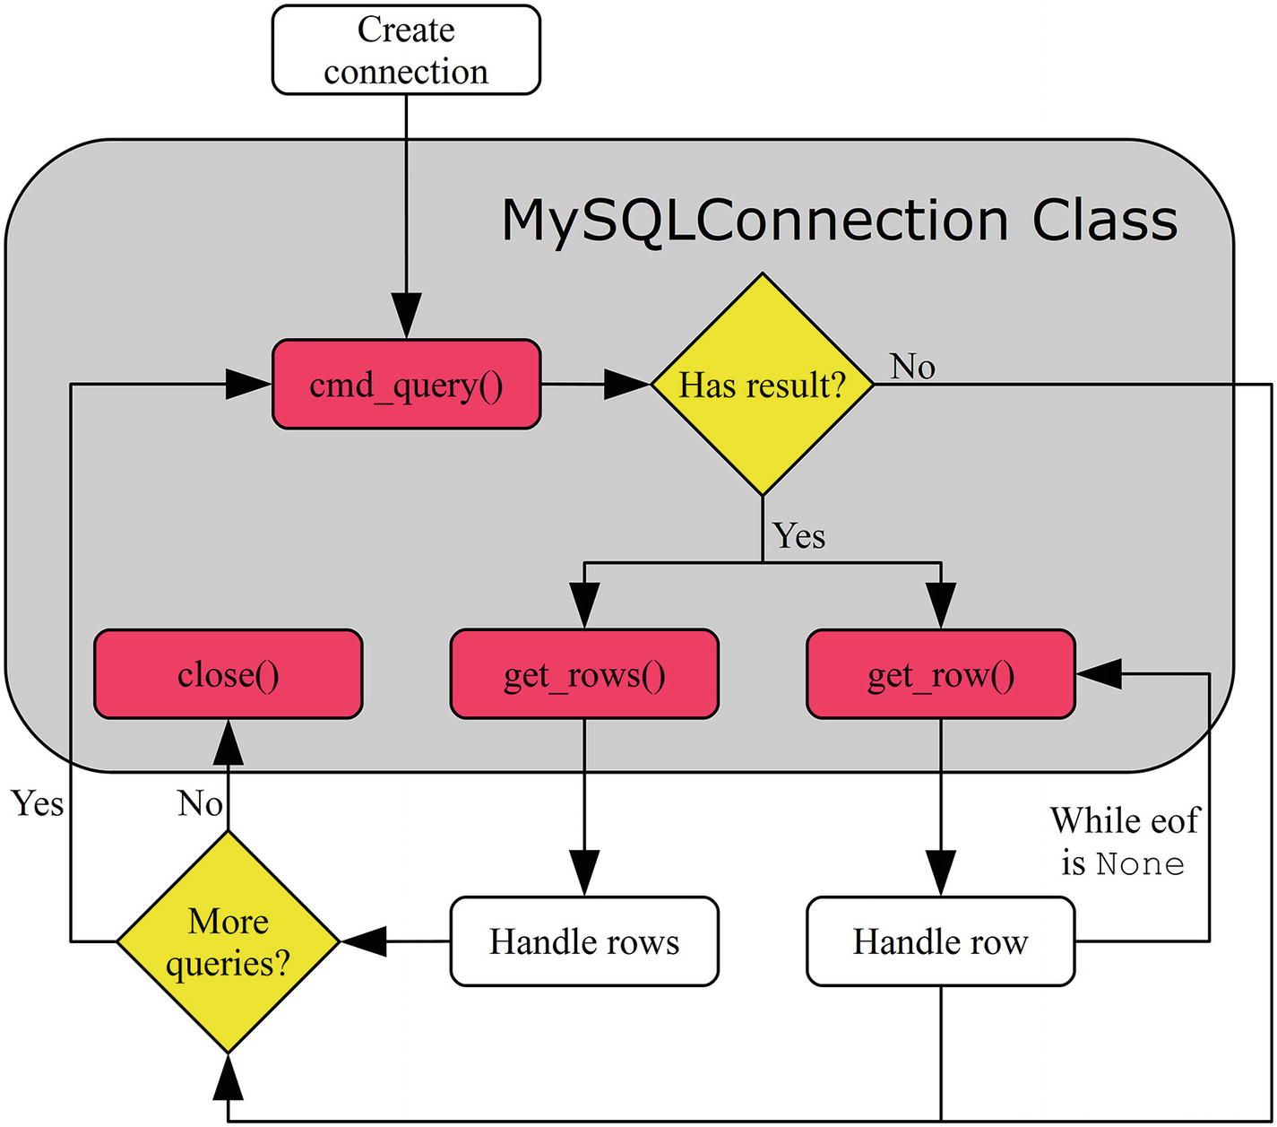3.Python-mysql-connector:

FLOWCHART

INVESTMENT CAPITAL

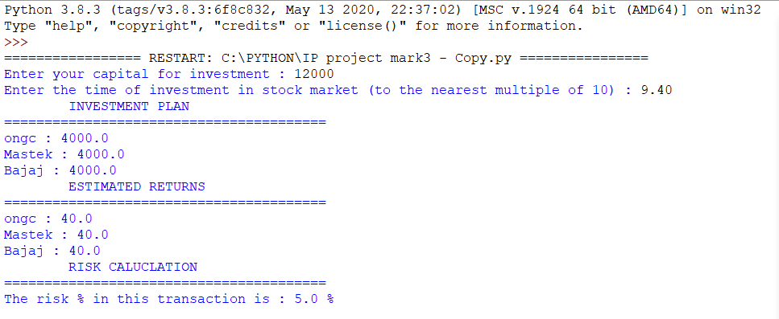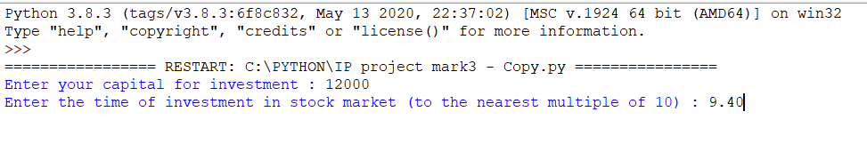

Time of investment

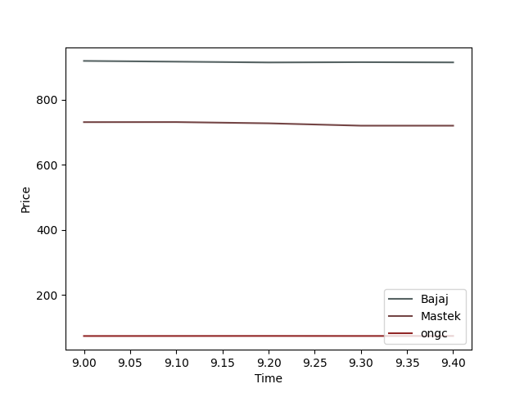

Customized investment plan and estimated returns

MECHANISM(LOGIC)

Slice the Df from 9.00 to time_input-0.1 and take avg. Then make Df of values at time_input-0.1 and time_input

Df containing all stocks(indexes) and their corresponding values at times(columns) till time input

For appropriate slicing in Df, N=(Int-9)*6+float(rounded to 1st decimal)/0.10

Separation of float and int parts i.e 10+0.45

Fetch data from MySql through connection object and form a corresponding Df

Time input

Eg: 10.45

Plot the growth curve of top 3 stocks using matlplotlib where color is determined using hex-strings

Obtain number of overpriced stocks and investment in overpriced stocks=capital/3 and calculate % risk by a similar algorithm

Take the difference of price of each stock at time_input and time_input+0.10 and form a Df of increase in price

Now sort the Df in descending values and use head(3) to obtain top 3 stocks

Make a new Df of predicted values of each stock from list

Now estimate value at time_input+0.10 by applying arithmetic progression



PROJECT CODE

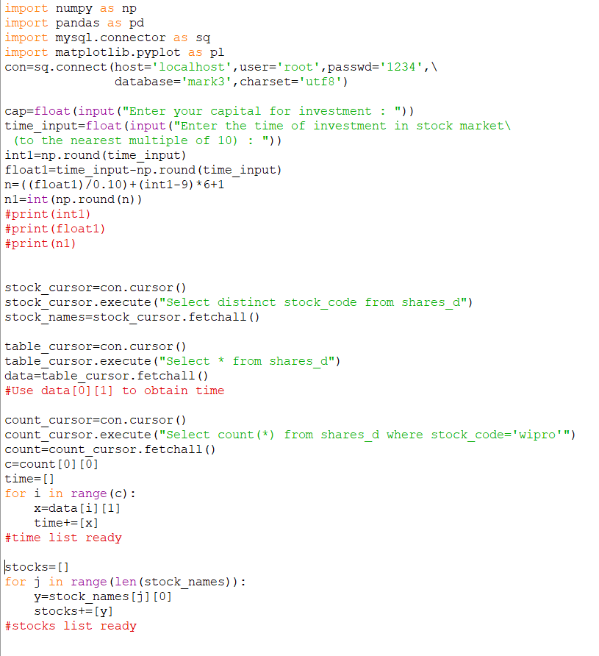



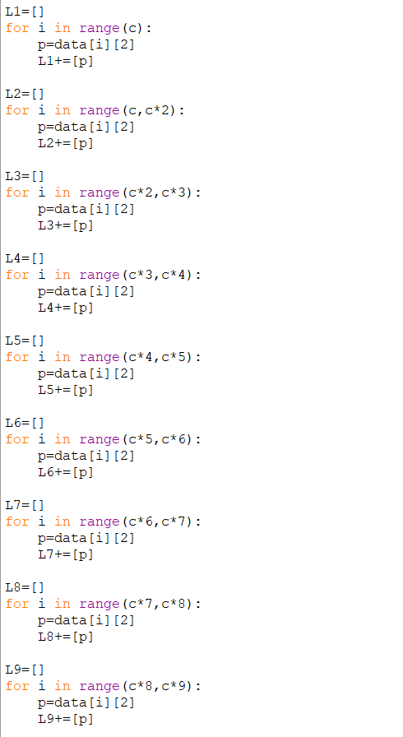

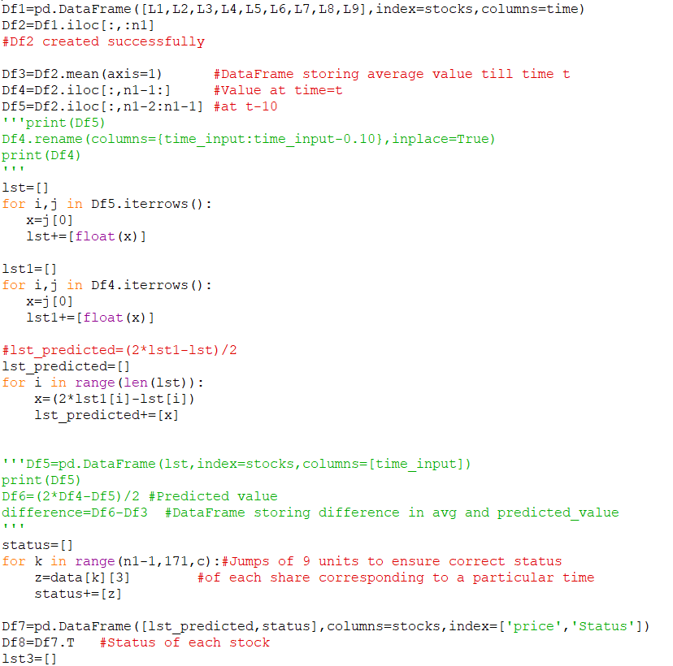

The price of stocks is evaluated using its history at 10 minute intervals



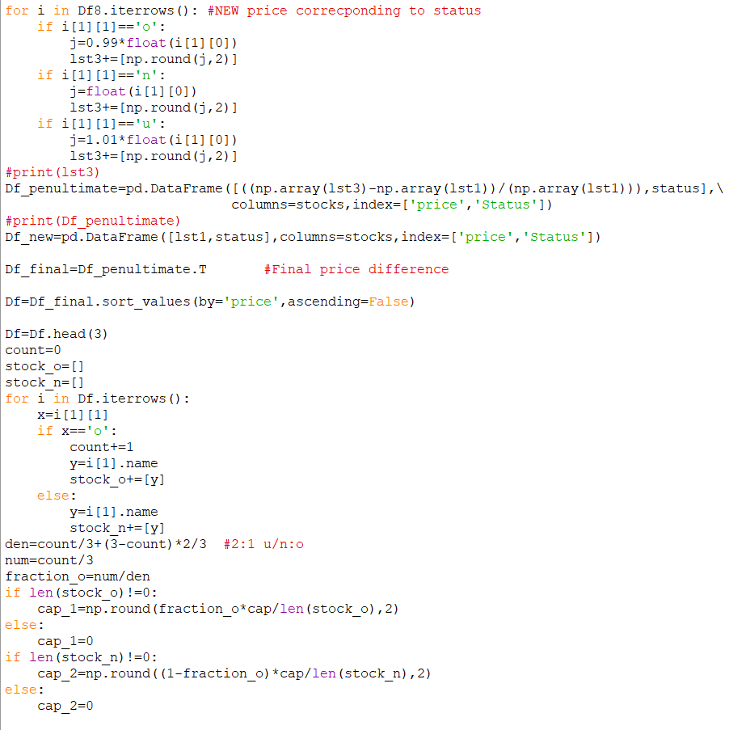

Investment in overpriced stocks is maintained in 1:2 ratio to ensure minimum risk



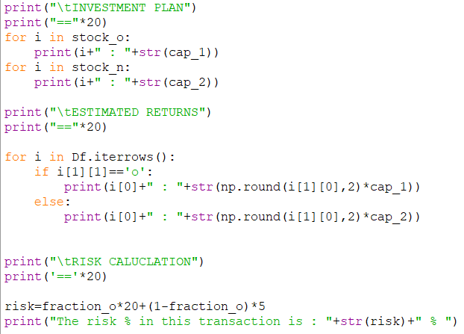

Here 20% risk has been assigned to each overpriced stock and 5% to other stocks

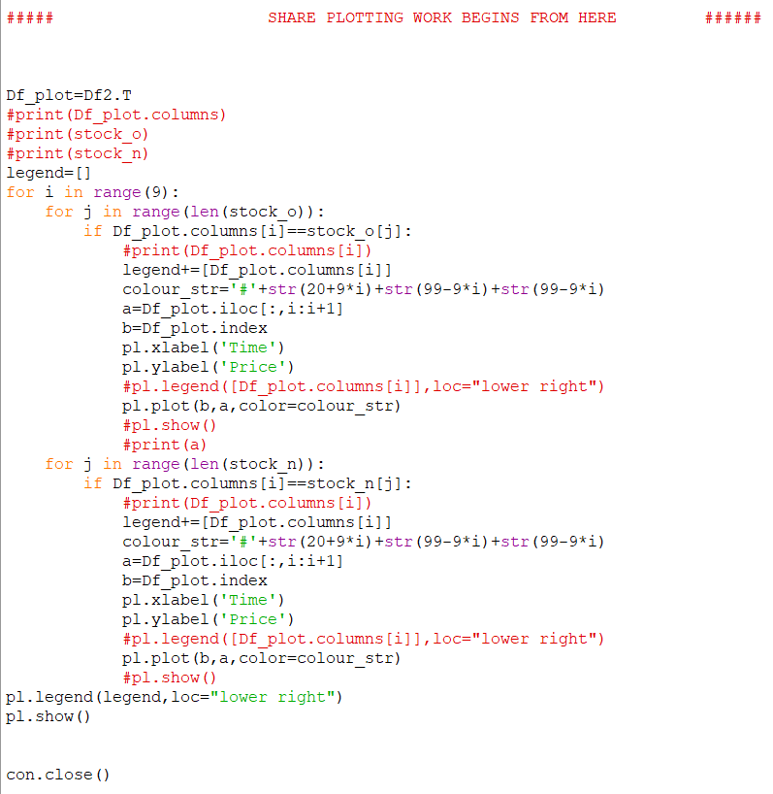

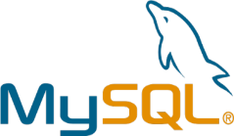

MYSQL TABLE

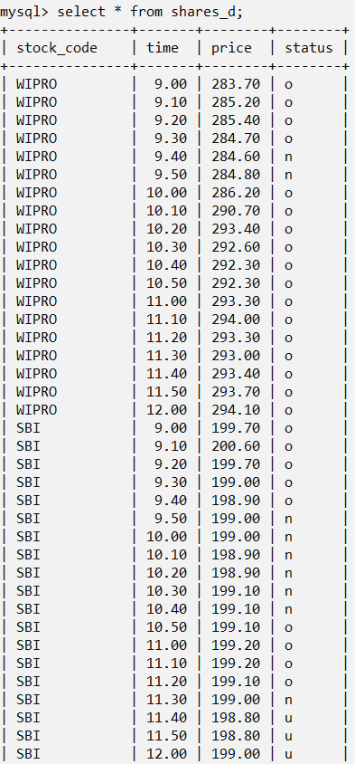

U: underpriced

N:normal

O:overpriced

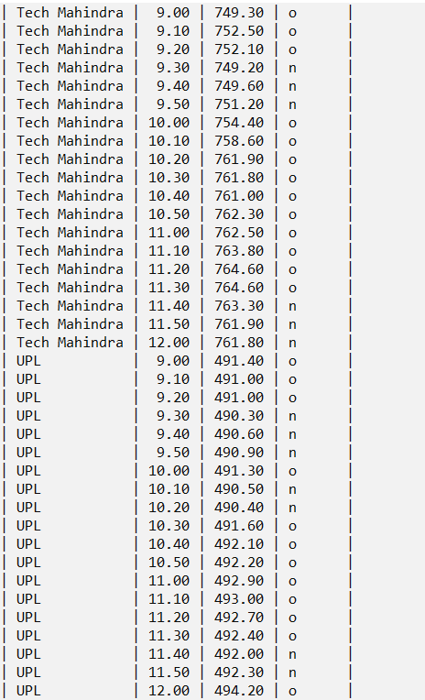

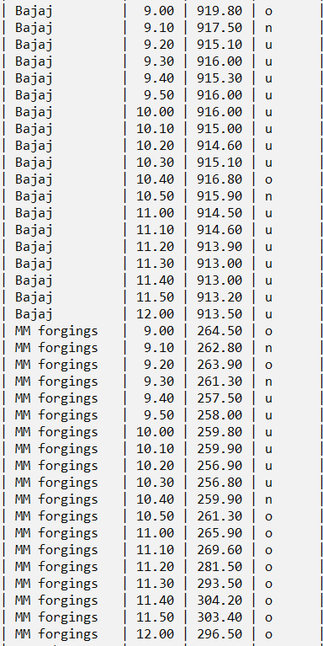

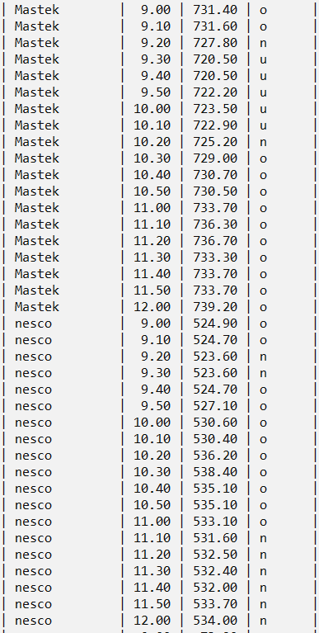

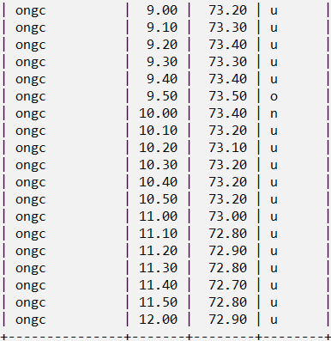

BIBLIOGRAPHY

1. [www.wikipedia.org](http://www.wikipedia.org)

2. class 12 informatics practices textbook(by Sumita Arora)

3. [www.lucidchart.com](http://www.lucidchart.com)

4. [www.shutterstock.com](http://www.shutterstock.com)

CD