📱 PRACTICE EXAMINATION TEST – UI IMPLEMENTATION
Course: Flutter Application Development
Duration: 90 minutes
Total Marks: 100 points

🎯 Project Title
“E-Commerce UI Implementation App”
You are required to build a Flutter application that reproduces exactly 4 screens based on the provided design.

🖼️ DESIGN REQUIREMENT
You must implement the following 4 screens:
- Home (Product List)
- Product Detail
- Favorites
- Cart

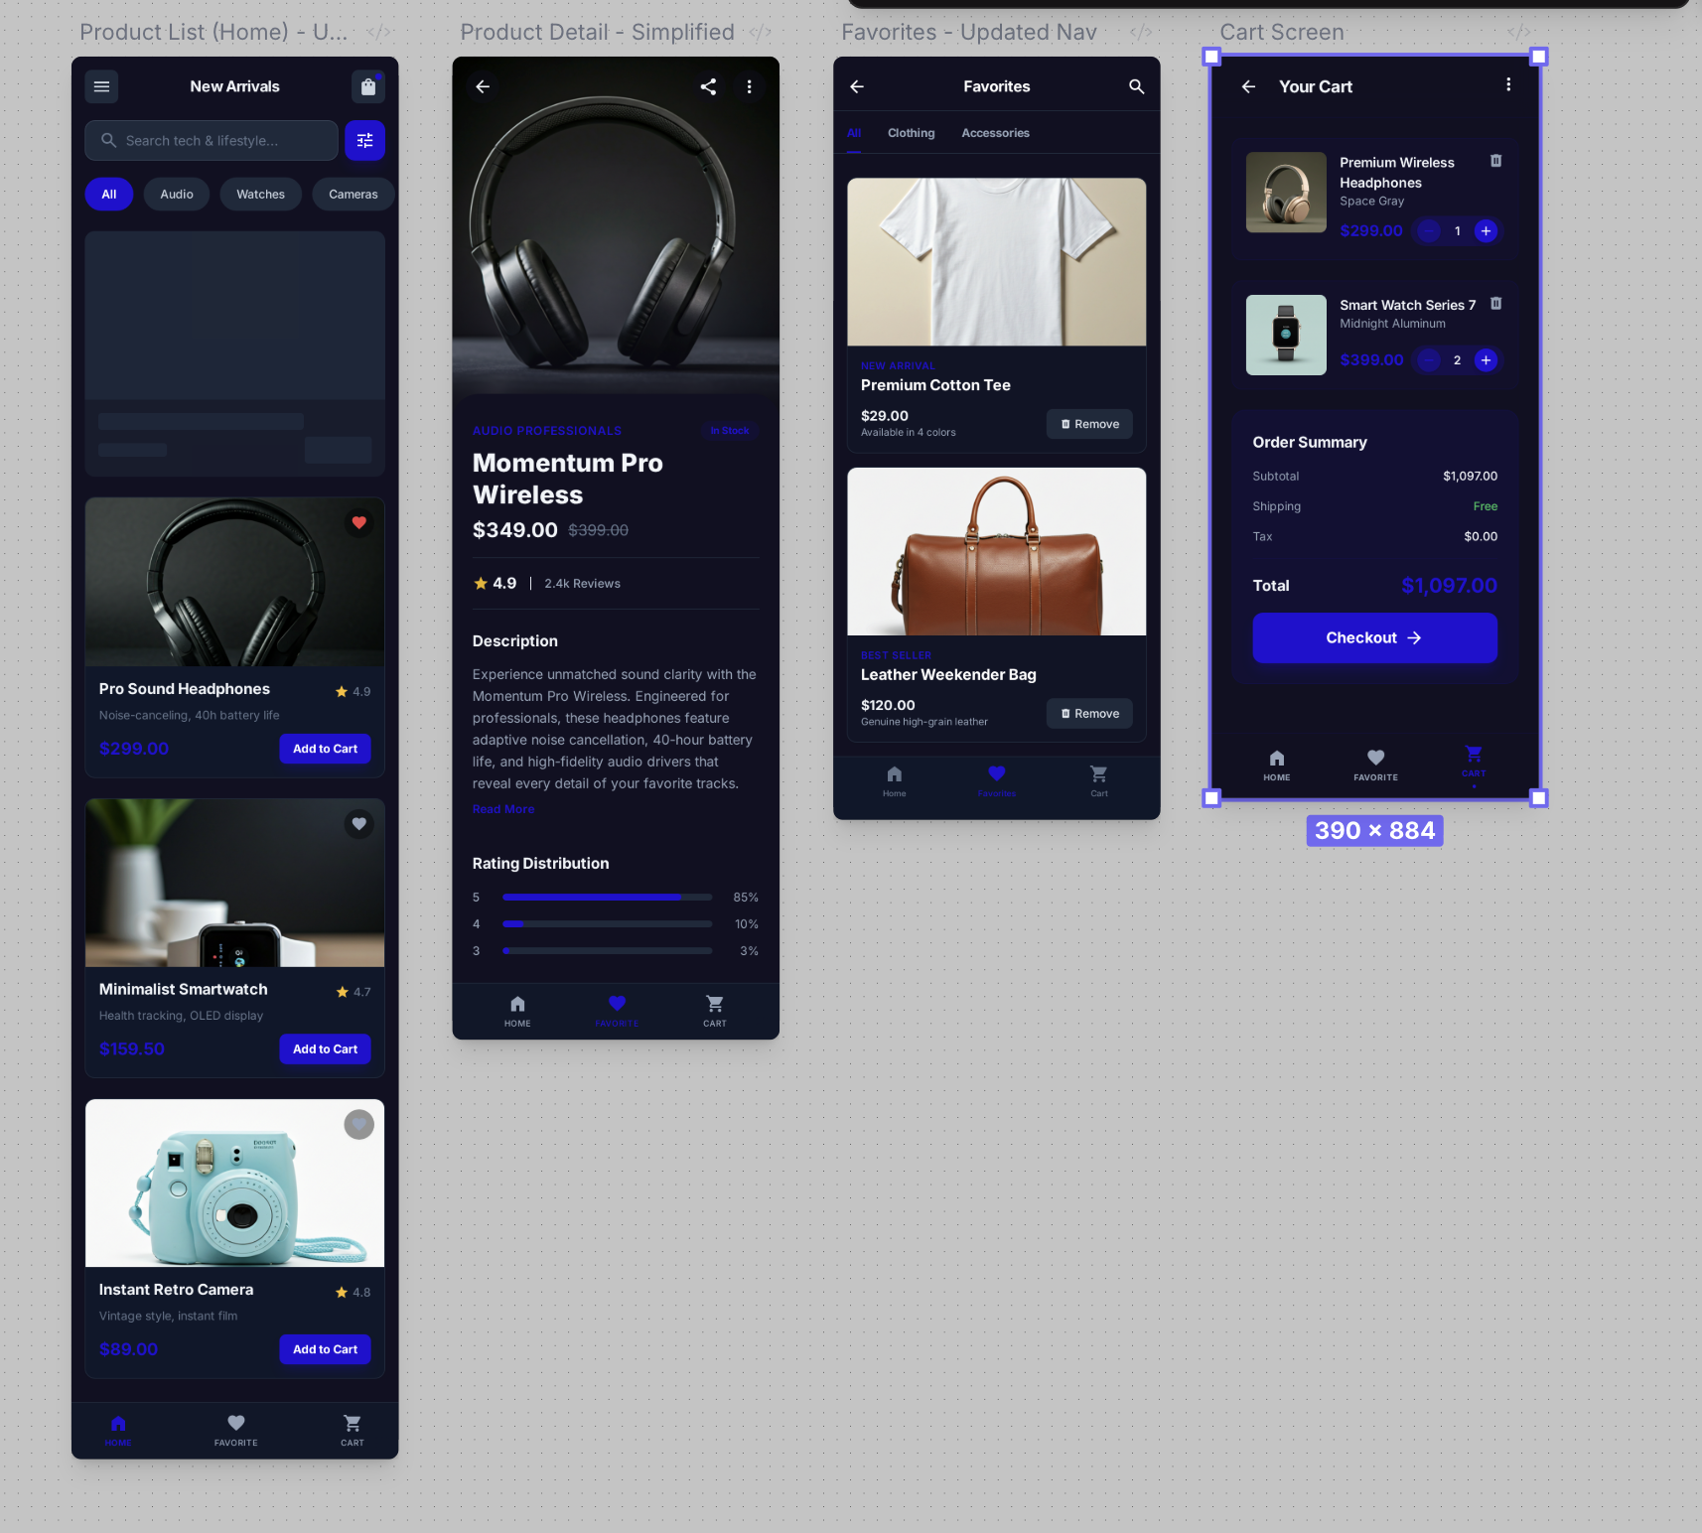

Link Design: https://stitch.withgoogle.com/projects/2831377615506800311
👉 UI must closely match the given design (layout, spacing, hierarchy).

⚠️ IMPORTANT RULES

❗ Rule 1 – UI Fidelity
- Layout must match the design structure
- Random or generic UI = heavy penalty

❗ Rule 2 – Code Understanding
You must explain your implementation (see Part 8)

🔹 Functional Requirements

🟢 Part 1 – Source Code Architecture (10 points)

Requirements:
The project must be structured using a well-defined, layered architecture with clear separation of responsibilities. You can apply any architecture like Clean Architecture, MVVM, MVP, MVC…

Mandatory Rules:
- The codebase must be divided into distinct layers:
  - Presentation layer
  - Domain layer
  - Data layer
- Each layer must have clear and independent responsibilities
- The Presentation layer must not directly access:
  - API services
  - Local storage
- All data operations must go through:
  - Domain abstractions
  - Repository interfaces
- The Domain layer must:
  - Be independent of frameworks
  - Contain business logic only
- The Data layer must:
  - Handle API communication
  - Handle local persistence
  - Implement repository interfaces

🟢 Part 2 – Home Screen (15 points)

UI Requirements:
- Search bar (UI only or functional)
- Category filter (UI only acceptable)
- Product list (scrollable)

API:
https://dummyjson.com/products

Behavior:
- Tap item → navigate to Detail Screen
- Tap favorite → toggle favorite
- Tap “Add to Cart” → add item

🟢 Part 3 – Product Detail Screen (15 points)

Requirements:
- Large product image
- Title
- Price
- Rating
- Description
- “Add to Cart” button

Optional:
- Image carousel (if multiple images available)

🟢 Part 4 – Favorites Screen (10 points)

Requirements:
- Display favorite products
- Remove from favorites

Empty state:
- Must display proper UI

🟢 Part 5 – Cart Screen (10 points)

Requirements:
- Implement UI like above
- Display added products
- Show:
  - quantity
  - price
- Allow:
  - increase/decrease quantity
- Show total price

🟢 Part 6 – State Management (10 points)

Must manage:
- Product list
- Favorites
- Cart
- Quantity

Requirements:
- UI updates reactively
- No business logic inside UI

🟢 Part 7 – Testing (15 points)

You must implement:
- At least 3 tests:

Required:
- Widget Test
- Navigation Test
- Integration Test

Scope:
- UI rendering
- Navigation correctness

🟢 Part 8 – AI Creative Feature (10 points) ⭐

Requirements:
You must design and implement one AI-powered feature that enhances the product experience in a meaningful way.
The feature must:
- Be integrated into the existing application flow
- Demonstrate clear value to the user
- Go beyond static or rule-based logic
- Show evidence of intelligent behavior or data-driven decision making

Constraints:
- The feature must be fully functional within the app
- The implementation must be non-trivial
- The behavior must be observable through the UI

🟢 Part 9 – Performance Optimization (10 points) ⭐

Requirements:
Your app must:
- Scroll smoothly
- Avoid unnecessary rebuilds
- Efficiently render list items

Evaluation based on:
- UI responsiveness
- Rendering efficiency

🔹 Technical Constraints
- Must use null safety
- Must compile and run
- Must load image from URL
- No direct API calls in UI
- Avoid duplicated UI

🔹 Evaluation Rubric
Criteria | Poins | Your points
Source Architecture | 10 | 0
Home Screen | 15 | 0
Detail Screen | 15 | 0
Favorites Screen | 10 | 0
Cart Screen | 10 | 0
State Management | 10 | 0
Testing | 10 | 0
AI Feature | 10 | 0
Performance | 10 | 0
Total | 100 | 0

📌 Deliverables and Capturing your screenshots

1. Source Code
- GitHub or zip post to edunext, with the name likes NguyenVanA.zip

2. Screenshots
- Home
- Detail
- Favorites
- Cart

3. Test Result
flutter test

