**PL/SQL PROGRAMMING**

**Exercise 1: Control Structures**

**Code:**

CREATE TABLE Customers (

CustomerID INT PRIMARY KEY AUTO_INCREMENT,

Name VARCHAR(100) NOT NULL,

Age INT,

Balance DECIMAL(15, 2),

IsVIP BOOLEAN DEFAULT FALSE

);

CREATE TABLE Loans (

LoanID INT PRIMARY KEY AUTO_INCREMENT,

CustomerID INT,

LoanAmount DECIMAL(15, 2) NOT NULL,

InterestRate DECIMAL(5, 2) NOT NULL,

DueDate DATE NOT NULL,

FOREIGN KEY (CustomerID) REFERENCES Customers(CustomerID)

);

INSERT INTO Customers (Name, Age, Balance, IsVIP) VALUES

('Alice Smith', 35, 5000.00, FALSE),

('Bob Johnson', 62, 12000.00, FALSE),

('Charlie Brown', 58, 8000.00, FALSE),

('Diana Prince', 65, 15000.00, FALSE),

('Eve Adams', 40, 3000.00, FALSE),

('Frank White', 70, 9000.00, FALSE);

INSERT INTO Loans (CustomerID, LoanAmount, InterestRate, DueDate) VALUES

(1, 25000.00, 5.00, '2025-09-15'),

(2, 50000.00, 4.50, '2025-07-01'),

(3, 10000.00, 6.00, '2025-10-20'),

(4, 75000.00, 4.00, '2025-07-25'),

(5, 5000.00, 7.00, '2025-08-05'),

(6, 30000.00, 4.75, '2025-11-01');

DELIMITER //

CREATE PROCEDURE ApplyInterestDiscount()

BEGIN

DECLARE v_customerID INT;

DECLARE v_age INT;

DECLARE done INT DEFAULT FALSE;

DECLARE cur_old_customers CURSOR FOR

SELECT CustomerID, Age

FROM Customers

WHERE Age > 60;

DECLARE CONTINUE HANDLER FOR NOT FOUND SET done = TRUE;

OPEN cur_old_customers;

read_loop: LOOP

FETCH cur_old_customers INTO v_customerID, v_age;

IF done THEN

LEAVE read_loop;

END IF;

UPDATE Loans

SET InterestRate = GREATEST(0.00, InterestRate - 1.00)

WHERE CustomerID = v_customerID;

SELECT CONCAT('Applied 1% discount for CustomerID: ', v_customerID, ', Age: ', v_age) AS Status;

END LOOP;

CLOSE cur_old_customers;

END //

DELIMITER ;

CALL ApplyInterestDiscount();

SELECT * FROM Customers;

DELIMITER //

CREATE PROCEDURE PromoteToVIP()

BEGIN

DECLARE v_customerID INT;

DECLARE v_balance DECIMAL(15, 2);

DECLARE done INT DEFAULT FALSE;

DECLARE cur_high_balance_customers CURSOR FOR

SELECT CustomerID, Balance

FROM Customers

WHERE Balance > 10000.00;

DECLARE CONTINUE HANDLER FOR NOT FOUND SET done = TRUE;

OPEN cur_high_balance_customers;

read_loop: LOOP

FETCH cur_high_balance_customers INTO v_customerID, v_balance;

IF done THEN

LEAVE read_loop;

END IF;

UPDATE Customers

SET IsVIP = TRUE

WHERE CustomerID = v_customerID;

SELECT CONCAT('Promoted CustomerID: ', v_customerID, ' to VIP status. Balance: $', v_balance) AS Status;

END LOOP;

CLOSE cur_high_balance_customers;

END //

DELIMITER ;

CALL PromoteToVIP();

DROP PROCEDURE IF EXISTS SendLoanReminders;

DELIMITER //

CREATE PROCEDURE SendLoanReminders()

BEGIN

-- Declare variables

DECLARE v_loanID INT;

DECLARE v_customerID INT;

DECLARE v_name VARCHAR(100);

DECLARE v_dueDate DATE;

DECLARE done INT DEFAULT FALSE;

DECLARE future_date DATE;

DECLARE cur_due_loans CURSOR FOR

SELECT

L.LoanID,

C.CustomerID,

C.Name,

L.DueDate

FROM

Loans L

JOIN

Customers C ON L.CustomerID = C.CustomerID

WHERE

L.DueDate BETWEEN CURDATE() AND DATE_ADD(CURDATE(), INTERVAL 30 DAY);

DECLARE CONTINUE HANDLER FOR NOT FOUND SET done = TRUE;

SET future_date = DATE_ADD(CURDATE(), INTERVAL 30 DAY);

OPEN cur_due_loans;

read_loop: LOOP

FETCH cur_due_loans INTO v_loanID, v_customerID, v_name, v_dueDate;

IF done THEN

LEAVE read_loop;

END IF;

SELECT CONCAT(

'Reminder: Dear ', v_name, ' (CustomerID: ', v_customerID,

'), your loan (ID: ', v_loanID,

') is due on ', DATE_FORMAT(v_dueDate, '%Y-%m-%d'),

'. Please ensure timely payment.'

) AS ReminderMessage;

END LOOP;

CLOSE cur_due_loans;

END //

DELIMITER ;

CALL SendLoanReminders();

**Output:**

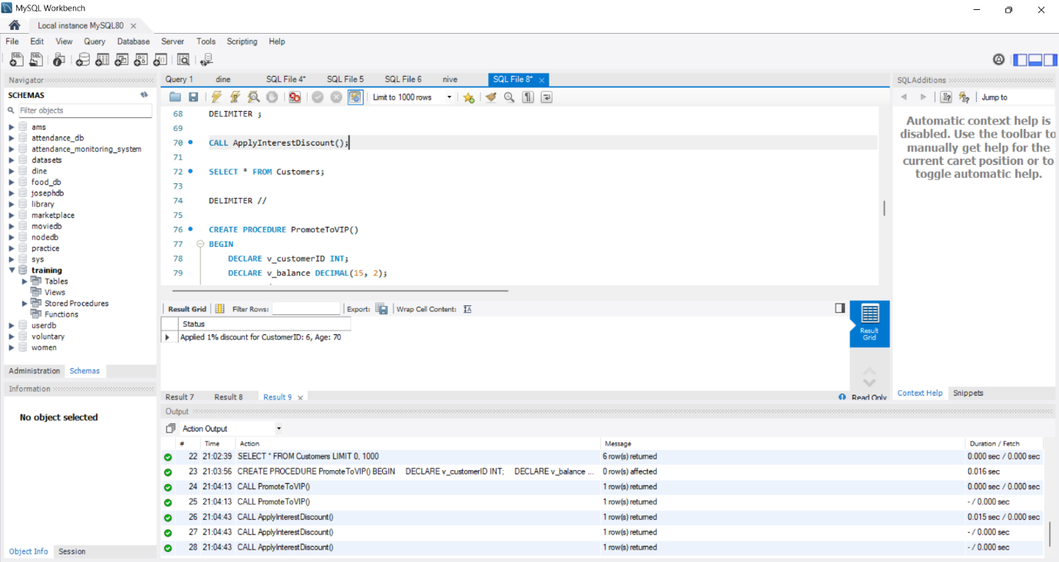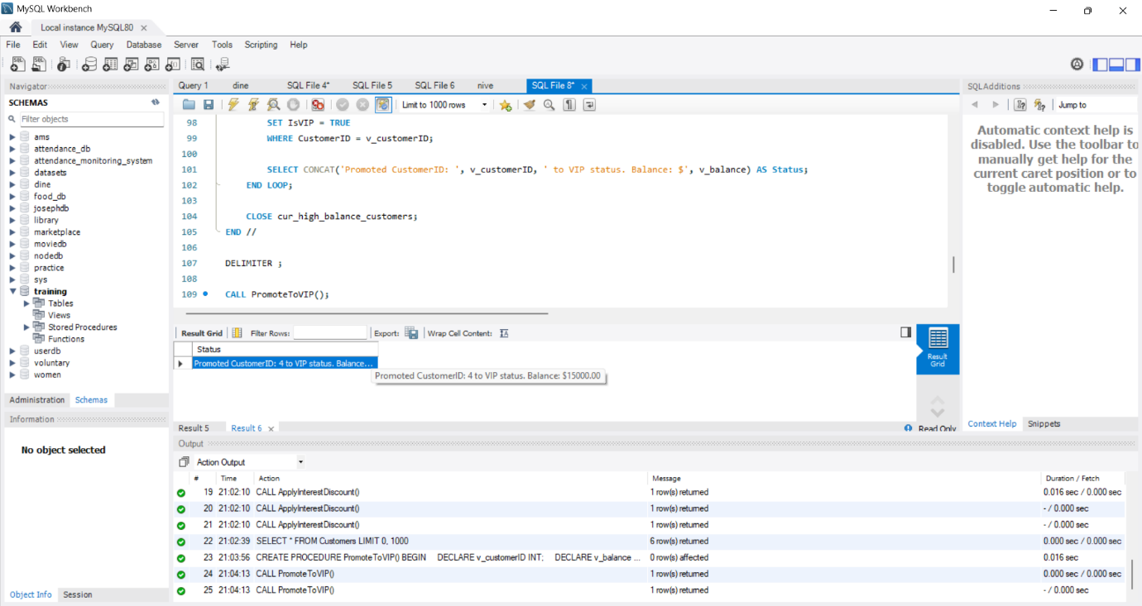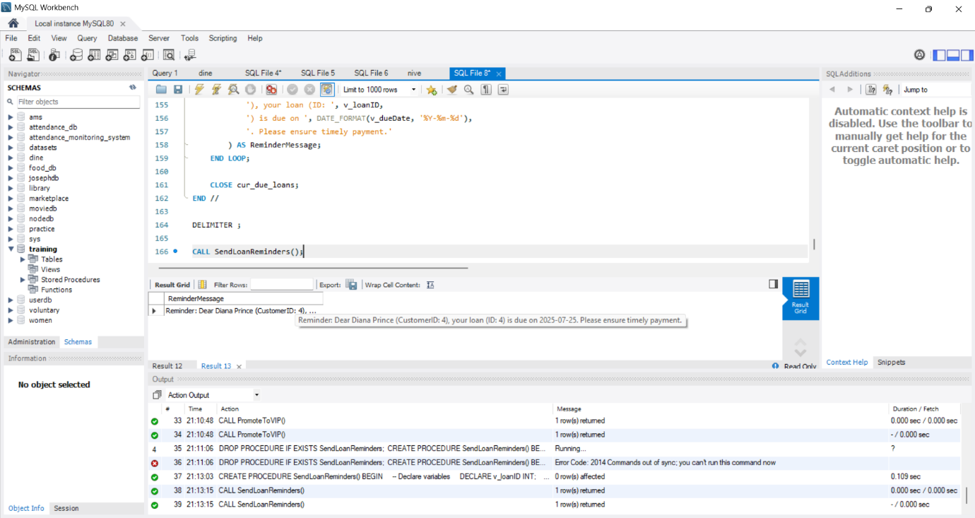

**Exercise 3: Stored Procedures**

**Code:**

DROP TABLE IF EXISTS Accounts;

CREATE TABLE Accounts (

AccountID INT PRIMARY KEY AUTO_INCREMENT,

CustomerID INT,

AccountType VARCHAR(50),

Balance DECIMAL(15,2)

);

-- Dummy Values

INSERT INTO Accounts (CustomerID, AccountType, Balance) VALUES

(1, 'Savings', 10000.00),

(2, 'Savings', 20000.00),

(3, 'Checking', 15000.00),

(4, 'Savings', 5000.00),

(5, 'Checking', 8000.00);

DROP TABLE IF EXISTS Employees;

CREATE TABLE Employees (

EmployeeID INT PRIMARY KEY AUTO_INCREMENT,

Name VARCHAR(100),

Department VARCHAR(100),

Salary DECIMAL(15,2)

);

-- Dummy Values

INSERT INTO Employees (Name, Department, Salary) VALUES

('Alice', 'IT', 50000.00),

('Bob', 'HR', 45000.00),

('Charlie', 'IT', 55000.00),

('Diana', 'Finance', 60000.00),

('Eve', 'HR', 47000.00);

DELIMITER //

CREATE PROCEDURE ProcessMonthlyInterest()

BEGIN

UPDATE Accounts

SET Balance = Balance * 1.01

WHERE AccountType = 'Savings';

SELECT 'Interest applied to all savings accounts.' AS Status;

END //

DELIMITER ;

-- Execute

SET SQL_SAFE_UPDATES = 0;

CALL ProcessMonthlyInterest();

SET SQL_SAFE_UPDATES = 1;

DELIMITER //

CREATE PROCEDURE UpdateEmployeeBonus(

IN dept_name VARCHAR(100),

IN bonus_percent DECIMAL(5,2)

)

BEGIN

UPDATE Employees

SET Salary = Salary + (Salary * bonus_percent / 100)

WHERE Department = dept_name;

SELECT CONCAT('Bonus of ', bonus_percent, '% applied to ', dept_name, ' department.') AS Status;

END //

DELIMITER ;

SET SQL_SAFE_UPDATES = 0;

CALL UpdateEmployeeBonus('IT', 10);

SET SQL_SAFE_UPDATES = 1;

DELIMITER //

CREATE PROCEDURE TransferFunds(

IN sourceAccountID INT,

IN targetAccountID INT,

IN amount DECIMAL(15,2)

)

BEGIN

DECLARE source_balance DECIMAL(15,2);

-- Get source account balance

SELECT Balance INTO source_balance

FROM Accounts

WHERE AccountID = sourceAccountID;

-- Check for sufficient balance

IF source_balance IS NULL THEN

SIGNAL SQLSTATE '45000'

SET MESSAGE_TEXT = 'Source account does not exist.';

ELSEIF source_balance < amount THEN

SIGNAL SQLSTATE '45000'

SET MESSAGE_TEXT = 'Insufficient funds in source account.';

ELSE

-- Deduct from source

UPDATE Accounts

SET Balance = Balance - amount

WHERE AccountID = sourceAccountID;

-- Add to target

UPDATE Accounts

SET Balance = Balance + amount

WHERE AccountID = targetAccountID;

SELECT CONCAT('Transferred ₹', amount, ' from Account ', sourceAccountID, ' to Account ', targetAccountID) AS Status;

END IF;

END //

DELIMITER ;

CALL TransferFunds(1, 2, 2000.00);

**Output:**

