**Spring Data JPA with Spring Boot, Hibernate**

**Spring Data JPA - Quick Example**

**Code:**

OrmLearnApplication.java

package com.cognizant.orm_learn;

import java.util.List;

import org.slf4j.Logger;

import org.slf4j.LoggerFactory;

import org.springframework.boot.SpringApplication;

import org.springframework.boot.autoconfigure.SpringBootApplication;

import org.springframework.context.ApplicationContext;

import com.cognizant.orm_learn.model.Country;

import com.cognizant.orm_learn.service.CountryService;

@SpringBootApplication

public class OrmLearnApplication {

private static CountryService *countryService*;

private static final Logger *LOGGER* = LoggerFactory.*getLogger*(OrmLearnApplication.class);

public static void main(String[] args) {

ApplicationContext context = SpringApplication.*run*(OrmLearnApplication.class, args);

*countryService* = context.getBean(CountryService.class);

*testGetAllCountries*();

}

private static void testGetAllCountries() {

*LOGGER*.info("Start");

List<Country> countries = *countryService*.getAllCountries();

*LOGGER*.debug("countries={}", countries);

*LOGGER*.info("End");

}

**}**

Country.java

**package** com.cognizant.orm_learn.model;

**import** jakarta.persistence.Column;

**import** jakarta.persistence.Entity;

**import** jakarta.persistence.Id;

@Entity

**public** **class** Country {

@Id

@Column(name="code")

**private** String code;

@Column(name="co_name")

**private** String name;

**public** String getCode() {

**return** code;

}

**public** **void** setCode(String code) {

**this**.code = code;

}

**public** String getName() {

**return** name;

}

**public** **void** setName(String name) {

**this**.name = name;

}

@Override

**public** String toString() {

**return** "Country [code=" + code + ", name=" + name + "]";

}

}

CountryRepository.java

package com.cognizant.orm_learn.repository;

import org.springframework.data.jpa.repository.JpaRepository;

import org.springframework.stereotype.Repository;

import com.cognizant.orm_learn.model.Country;

@Repository

public interface CountryRepository extends JpaRepository<Country, String>{

}

**Output:**

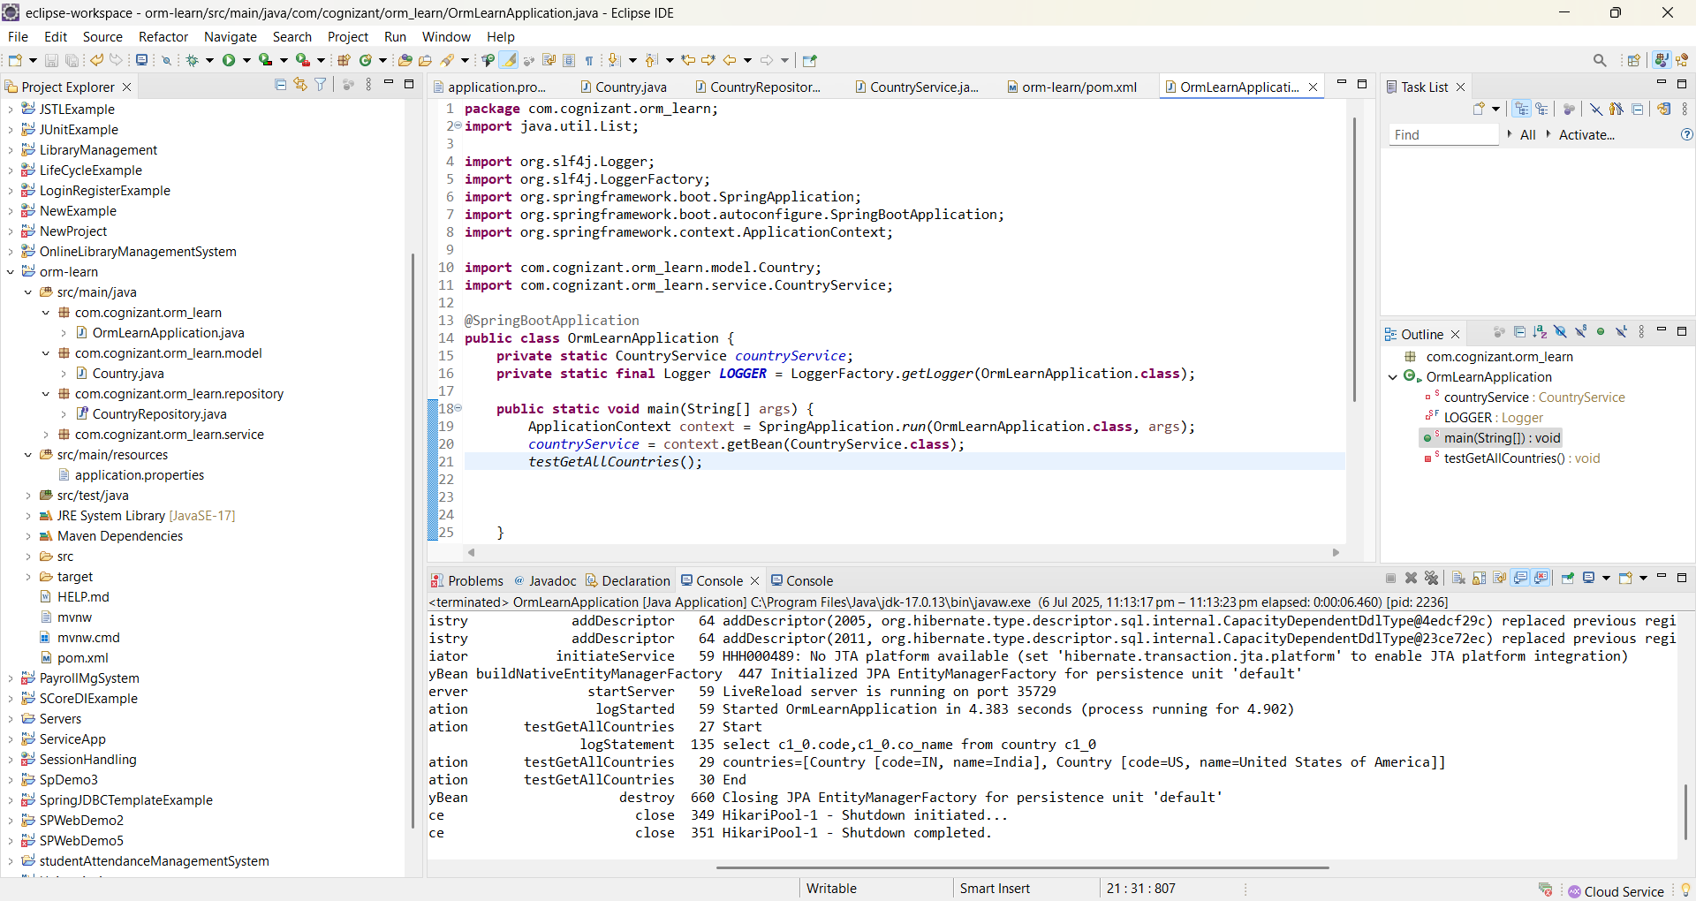

**Difference between JPA, Hibernate and Spring Data JPA**   
  
Java Persistence API (JPA)

* JSR 338 Specification for persisting, reading and managing data from Java objects
* Does not contain concrete implementation of the specification
* Hibernate is one of the implementation of JPA

Hibernate

* ORM Tool that implements JPA

Spring Data JPA

* Does not have JPA implementation, but reduces boiler plate code
* This is another level of abstraction over JPA implementation provider like Hibernate
* Manages transactions

**Code:**

Main.java

   public Integer addEmployee(Employee employee){

      Session session = factory.openSession();

      Transaction tx = null;

      Integer employeeID = null;

      try {

         tx = session.beginTransaction();

         employeeID = (Integer) session.save(employee);

         tx.commit();

      } catch (HibernateException e) {

         if (tx != null) tx.rollback();

         e.printStackTrace();

      } finally {

         session.close();

      }

      return employeeID;

   }

EmployeeRespository.java

public interface EmployeeRepository extends JpaRepository<Employee, Integer> {

}

EmployeeService.java

@Autowire

  private EmployeeRepository employeeRepository;

@Transactional

public void addEmployee(Employee employee) {

  employeeRepository.save(employee);

  }

**Output:**

