**Spring REST using Spring Boot 3**

**Output:**

Exercise-1

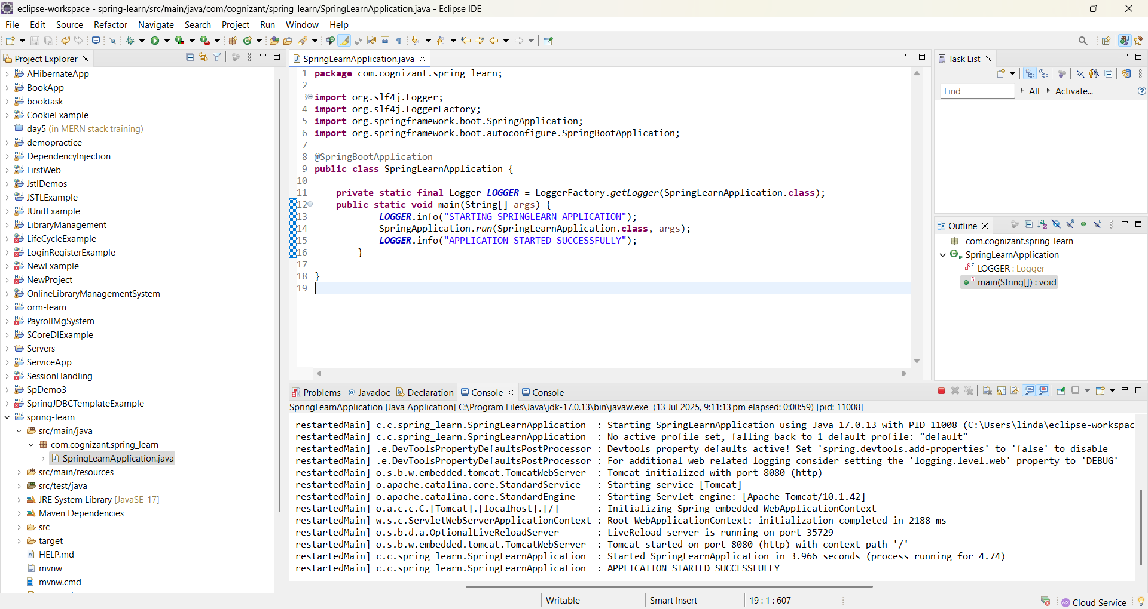

Exercise-2

