DESIGN DOCUMENT
UART
8-N-1 Full-Duplex Universal Asynchronous Receiver/Transmitter
VHDL RTL Implementation and Verification
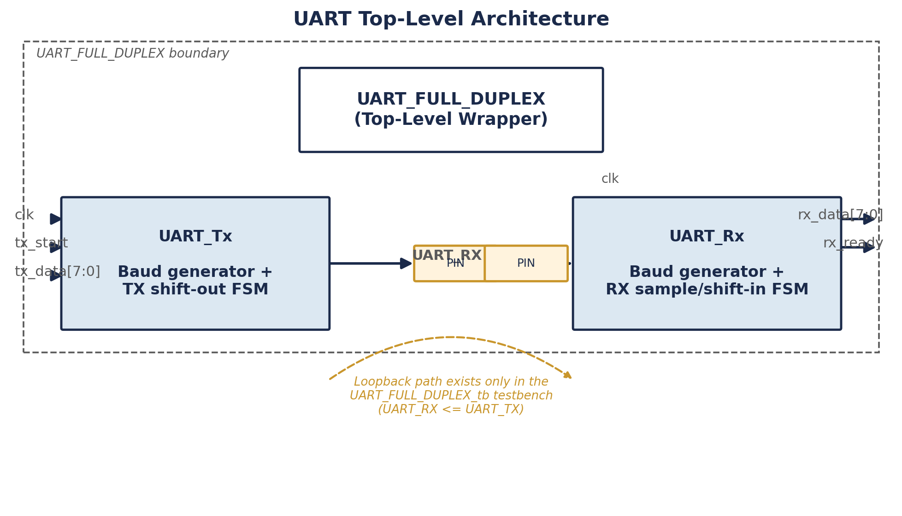
Prepared for: Muhammad Ijaz
Senior FPGA / RTL Engineer
Document Date: 1 August 2026
Revision: 1.0

Table of Contents

1. Introduction

1.1 Purpose
This document describes the design, architecture, and verification of a Universal Asynchronous Receiver/Transmitter (UART) implemented in VHDL. It captures the module hierarchy, port definitions, timing behaviour, finite state machine operation, and the test benches used to validate the design, based on a review of the six VHDL source files listed in Section 1.3.

1.2 Scope
The design provides a full-duplex, 8 data bit, no parity, 1 stop bit (8-N-1) UART core operating at a fixed baud rate of 9600 bps from a 100 MHz system clock. It is organised as two independent sub-modules, a transmitter and a receiver, combined under a single top-level wrapper. This document covers the RTL as written; it does not extend the design or propose an alternative implementation beyond the recommendations captured in Section 9.

1.3 Source Files Reviewed
File | Description
UART_FULL_DUPLEX.vhd | Top-level wrapper instantiating the transmitter and receiver
UART_Tx.vhd | UART transmitter: baud generator and shift-out finite state machine
UART_Rx.vhd | UART receiver: baud generator and sample/shift-in finite state machine
UART_FULL_DUPLEX_tb.vhd | Self-checking loopback test bench for the top-level wrapper
UART_RX_TB.vhd | Self-checking test bench for the receiver in isolation
UART_TX_TB.vhd | Stimulus-only test bench for the transmitter in isolation

2. System Overview
The UART core exposes a simple byte-wide parallel interface on one side and a two-wire serial interface (UART_TX, UART_RX) on the other. A single free-running system clock drives both the transmit and receive paths; each path derives its own baud-rate timing from that clock using an internal cycle counter, so the two directions operate completely independently and can transmit and receive at the same time (true full duplex).

Figure 1. Top-level architecture of UART_FULL_DUPLEX.
There is no shared state, arbitration, or FIFO buffering between the transmit and receive paths; each is a self-contained sub-module connected only through the shared clock and the top-level port map.

3. Module Architecture

3.1 UART_FULL_DUPLEX (Top-Level Wrapper)
UART_FULL_DUPLEX is a structural wrapper with no internal logic of its own. It instantiates one copy of UART_Tx and one copy of UART_Rx and connects their ports directly to the top-level entity ports, giving the design a single point of integration for downstream logic or a top-level constraints file.
Port | Direction | Width | Description
clk | in | 1 | System clock, shared by the transmitter and receiver
UART_TX | out | 1 | Serial transmit pin, driven by UART_Tx
UART_RX | in | 1 | Serial receive pin, sampled by UART_Rx
tx_start | in | 1 | Pulses the transmitter to send the byte on tx_data
tx_data | in | 8 | Parallel byte to be transmitted, latched on tx_start
rx_data | out | 8 | Parallel byte most recently received
rx_ready | out | 1 | One-clock pulse indicating rx_data is valid

3.2 UART_Tx (Transmitter)
UART_Tx converts an 8-bit parallel value into a serial bit stream on the Tx output. It is built from two synchronous processes: a baud-rate tick generator and a two-state transmit finite state machine (IDLE, SEND).

3.2.1 Baud Rate Generation
A constant CLK_FREQ of 100,000,000 Hz and a constant BAUD of 9600 define BAUD_DIV, the number of clock cycles per bit period (100,000,000 divided by 9600, truncated to 10,416 cycles). A counter free-runs only while the FSM is in the SEND state, incrementing every clock cycle and producing a single-cycle baud_tick pulse each time it reaches BAUD_DIV minus 1. The counter is held at zero whenever the transmitter is idle, so each new transmission starts its bit timing from a clean baseline.

3.2.2 Transmit Finite State Machine
State | Behaviour
IDLE | Holds Tx high (mark/idle level). When tx_start is asserted, the transmitter latches a 10-bit shift word (stop bit, the 8 data bits, start bit), drives Tx low immediately as the start bit, resets the bit counter, and moves to SEND.
SEND | On every baud_tick, advances the bit counter and drives out the next bit of the shift word (data bits, then the stop bit). Once all 10 bits have been sent, Tx returns to the idle high level and the FSM returns to IDLE.
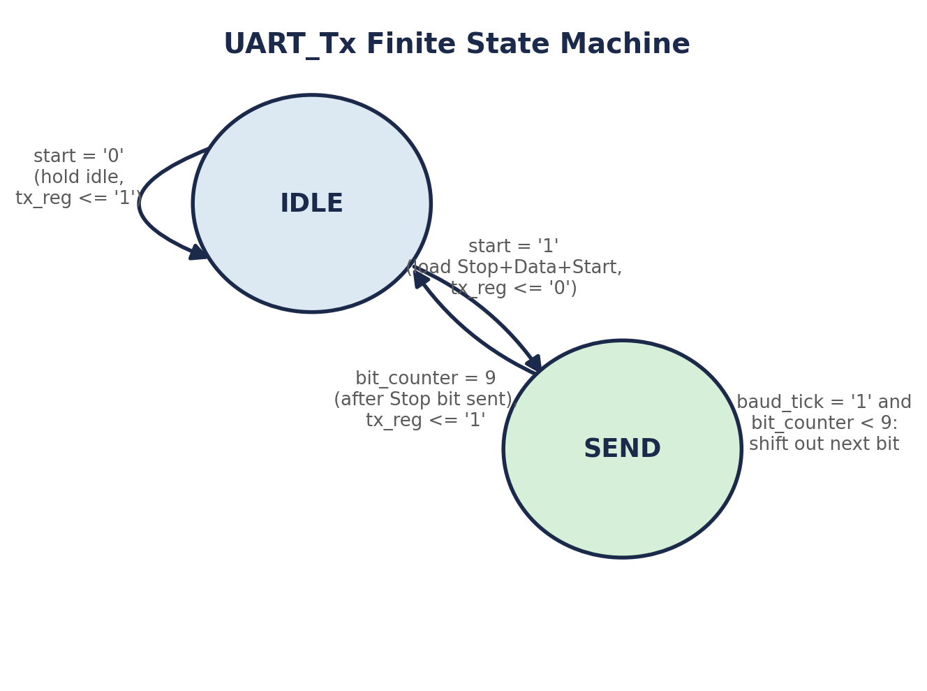
Figure 2. UART_Tx finite state machine.
Data bits are shifted out least-significant-bit first, so a byte such as 0xA5 is transmitted as bit 0 (LSB) through bit 7 (MSB), followed by the stop bit.

3.3 UART_Rx (Receiver)
UART_Rx recovers a serial byte from the Rx input using a four-state finite state machine (IDLE, START_BIT, DATA_BITS, STOP_BIT) with mid-bit sampling, which improves noise immunity compared with sampling immediately at the bit edge.
State | Behaviour
IDLE | Watches Rx for a falling edge (logic 0), which is treated as the start of a frame, and moves to START_BIT.
START_BIT | Waits half a bit period, then re-samples Rx. If Rx is still low, the start bit is confirmed and the FSM proceeds to DATA_BITS; if Rx has returned high, the transition is treated as noise and the FSM returns to IDLE.
DATA_BITS | Samples Rx once per full bit period for eight bit periods, storing each sample into rx_buffer least-significant-bit first, then moves to STOP_BIT.
STOP_BIT | Waits one further bit period and samples Rx. If Rx reads high (a valid stop bit), rx_buffer is copied to data_out and data_ready is pulsed for one clock cycle. The FSM then returns to IDLE regardless of whether the stop bit was valid.
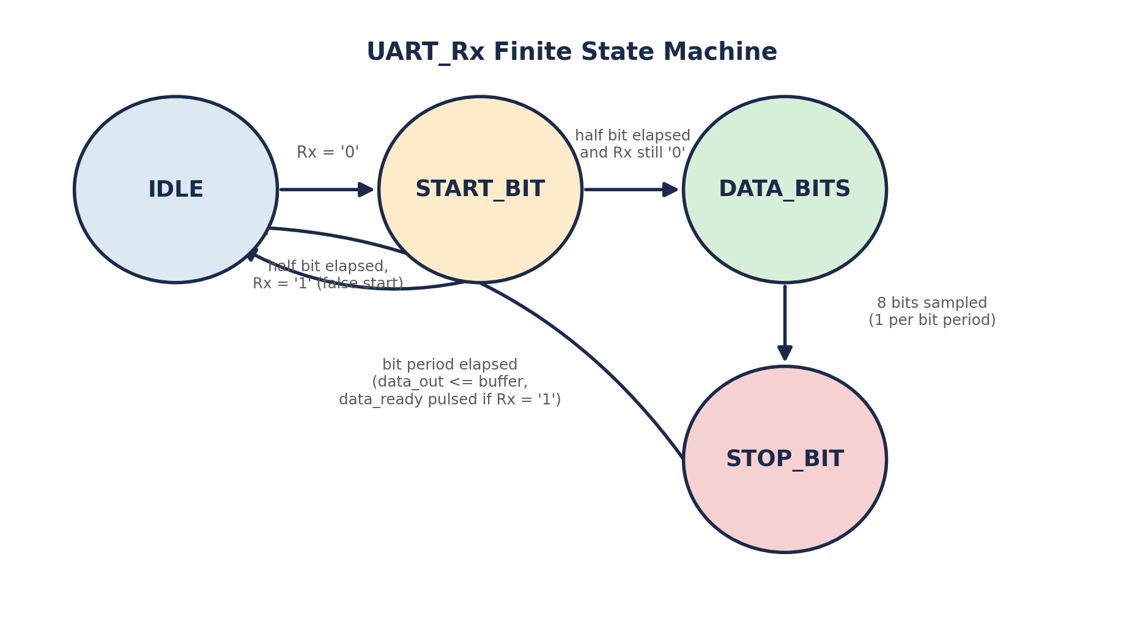
Figure 3. UART_Rx finite state machine.

4. Frame Format
Both the transmitter and receiver implement the same fixed 8-N-1 serial frame: one start bit, eight data bits (least-significant bit first), and one stop bit, with no parity bit. The line idles high between frames, and a frame begins when the line is driven low for the start bit.
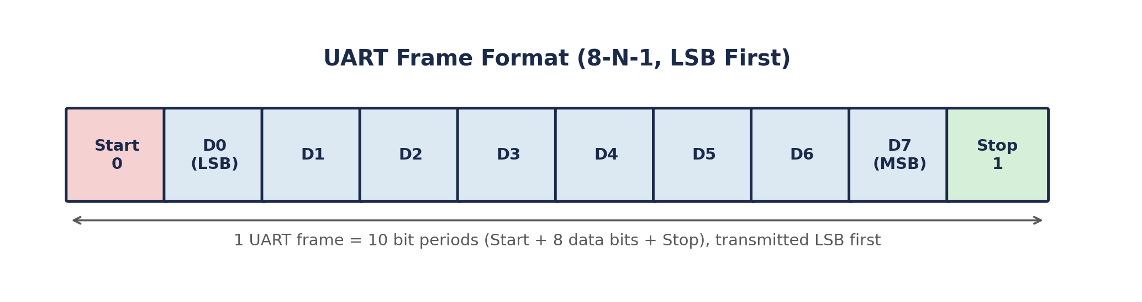
Figure 4. UART frame structure (10 bit periods per byte).
Parameter | Value
System clock frequency | 100 MHz (fixed constant CLK_FREQ)
Baud rate | 9600 bps (fixed constant BAUD)
Clock cycles per bit period | 10,416 (BAUD_DIV = CLK_FREQ / BAUD)
Data bits | 8, least-significant bit first
Parity | None
Stop bits | 1
Frame duration | 10 bit periods (approximately 1.04 ms at 9600 bps)
Because BAUD_DIV is an integer division of 100,000,000 by 9600, the effective baud rate is very slightly above the nominal 9600 bps. This is a common and generally tolerable rounding effect in fixed-divider UART designs, and is not a functional defect.

5. Interface Timing
tx_start should be pulsed high for a single clock cycle to launch a transmission; the test benches consistently follow this usage pattern. Because UART_Tx re-evaluates tx_start only while it is in the IDLE state, a tx_start pulse that arrives while a transmission is already in progress has no effect and is not queued, so back-to-back transmissions must wait for the transmitter to return to IDLE. There is no tx_busy or tx_ready status output, so the calling logic must track transmitter availability itself, for example by timing a fixed number of clock cycles or by monitoring the UART_TX line.
rx_ready is a single-clock-cycle pulse; the received byte on rx_data should be captured by the surrounding logic on the same cycle that rx_ready is high, since rx_data is not held stable beyond the next update.

6. Verification
The design is exercised by three VHDL test benches of increasing scope: a stimulus-only transmitter test, a self-checking receiver test, and a self-checking full-duplex loopback test.

6.1 UART_TX_TB
Instantiates UART_Tx alone, generates a 10 ns clock period, and after a 100 ns delay drives tx_start high with tx_data set to 0x03. The test bench contains no assertions; it is intended for waveform inspection of the transmitter output rather than automated pass/fail reporting.

6.2 UART_RX_TB
Instantiates UART_Rx alone and drives a hand-built 8-N-1 frame for the byte 0x55 directly onto the Rx input, using a bit period of 104,160 ns to match 9600 bps at a 100 MHz clock. It waits for data_ready and asserts that data_out equals 0x55, reporting a pass or a descriptive error through VHDL assert and report statements.

6.3 UART_FULL_DUPLEX_tb
Instantiates the full UART_FULL_DUPLEX wrapper and connects UART_RX directly back to UART_TX, forming an internal loopback that is present only in this test bench and not in the design itself. Two bytes, 0xA5 and 0xB5, are transmitted in sequence; for each byte the test bench waits for rx_ready with a 2 ms timeout, asserts on timeout with severity failure, and asserts that rx_data matches the expected byte with severity error. This is the most complete verification exercise in the source set, since it drives the design end to end through both the transmit and receive paths together.

6.4 Verification Summary
Test Bench | Type | Coverage
UART_TX_TB | Stimulus only | Transmitter waveform, single byte (0x03)
UART_RX_TB | Self-checking | Receiver only, single byte (0x55) driven externally
UART_FULL_DUPLEX_tb | Self-checking | Full duplex loopback, two bytes (0xA5, 0xB5)
None of the test benches exercise error conditions such as a corrupted or missing stop bit, back-to-back frames with minimal spacing, or simultaneous transmit and receive of different data. These would be reasonable additions to the verification suite (see Section 9).

7. Design Considerations, Limitations, and Recommendations
The following observations follow directly from the RTL as reviewed and are intended to guide any future hardening of the design for a real hardware interface.
- No input synchroniser on UART_RX. The Rx signal is used directly inside the receiver's synchronous logic with no double flip-flop synchroniser. Since UART_RX originates from an external, asynchronous source, this is a metastability risk on real hardware and is recommended as the first item to address before deployment.
- No framing-error or overrun-error reporting. If the sampled stop bit is not high, UART_Rx silently discards the byte with no error flag, and there is no mechanism to flag a new byte arriving before the previous one has been read.
- No transmitter busy or ready status. UART_Tx exposes no signal indicating that a transmission is in progress, so the surrounding design must independently track transmitter state to avoid issuing tx_start too early.
- Clock frequency and baud rate are hard-coded constants. CLK_FREQ and BAUD are declared as constants inside each module rather than exposed as generics, so retargeting the design to a different system clock or baud rate requires editing the source files directly rather than instantiating with different parameters.
- No FIFO or buffering. Both directions handle exactly one byte at a time with no elasticity, so a downstream consumer must service rx_ready promptly and a producer must wait for the transmitter to return to IDLE between bytes.
- Verification is simulation-only and does not include error-injection or back-to-back framing tests, as noted in Section 6.4.

8. Revision History
Revision | Date | Description
1.0 | 1 August 2026 | Initial design document, based on review of the six source VHDL files

9. Appendix: One-Page Sketchnote Summary
The figure below condenses the architecture, frame format, finite state machines, verification coverage, and design notes from this document onto a single reference page.

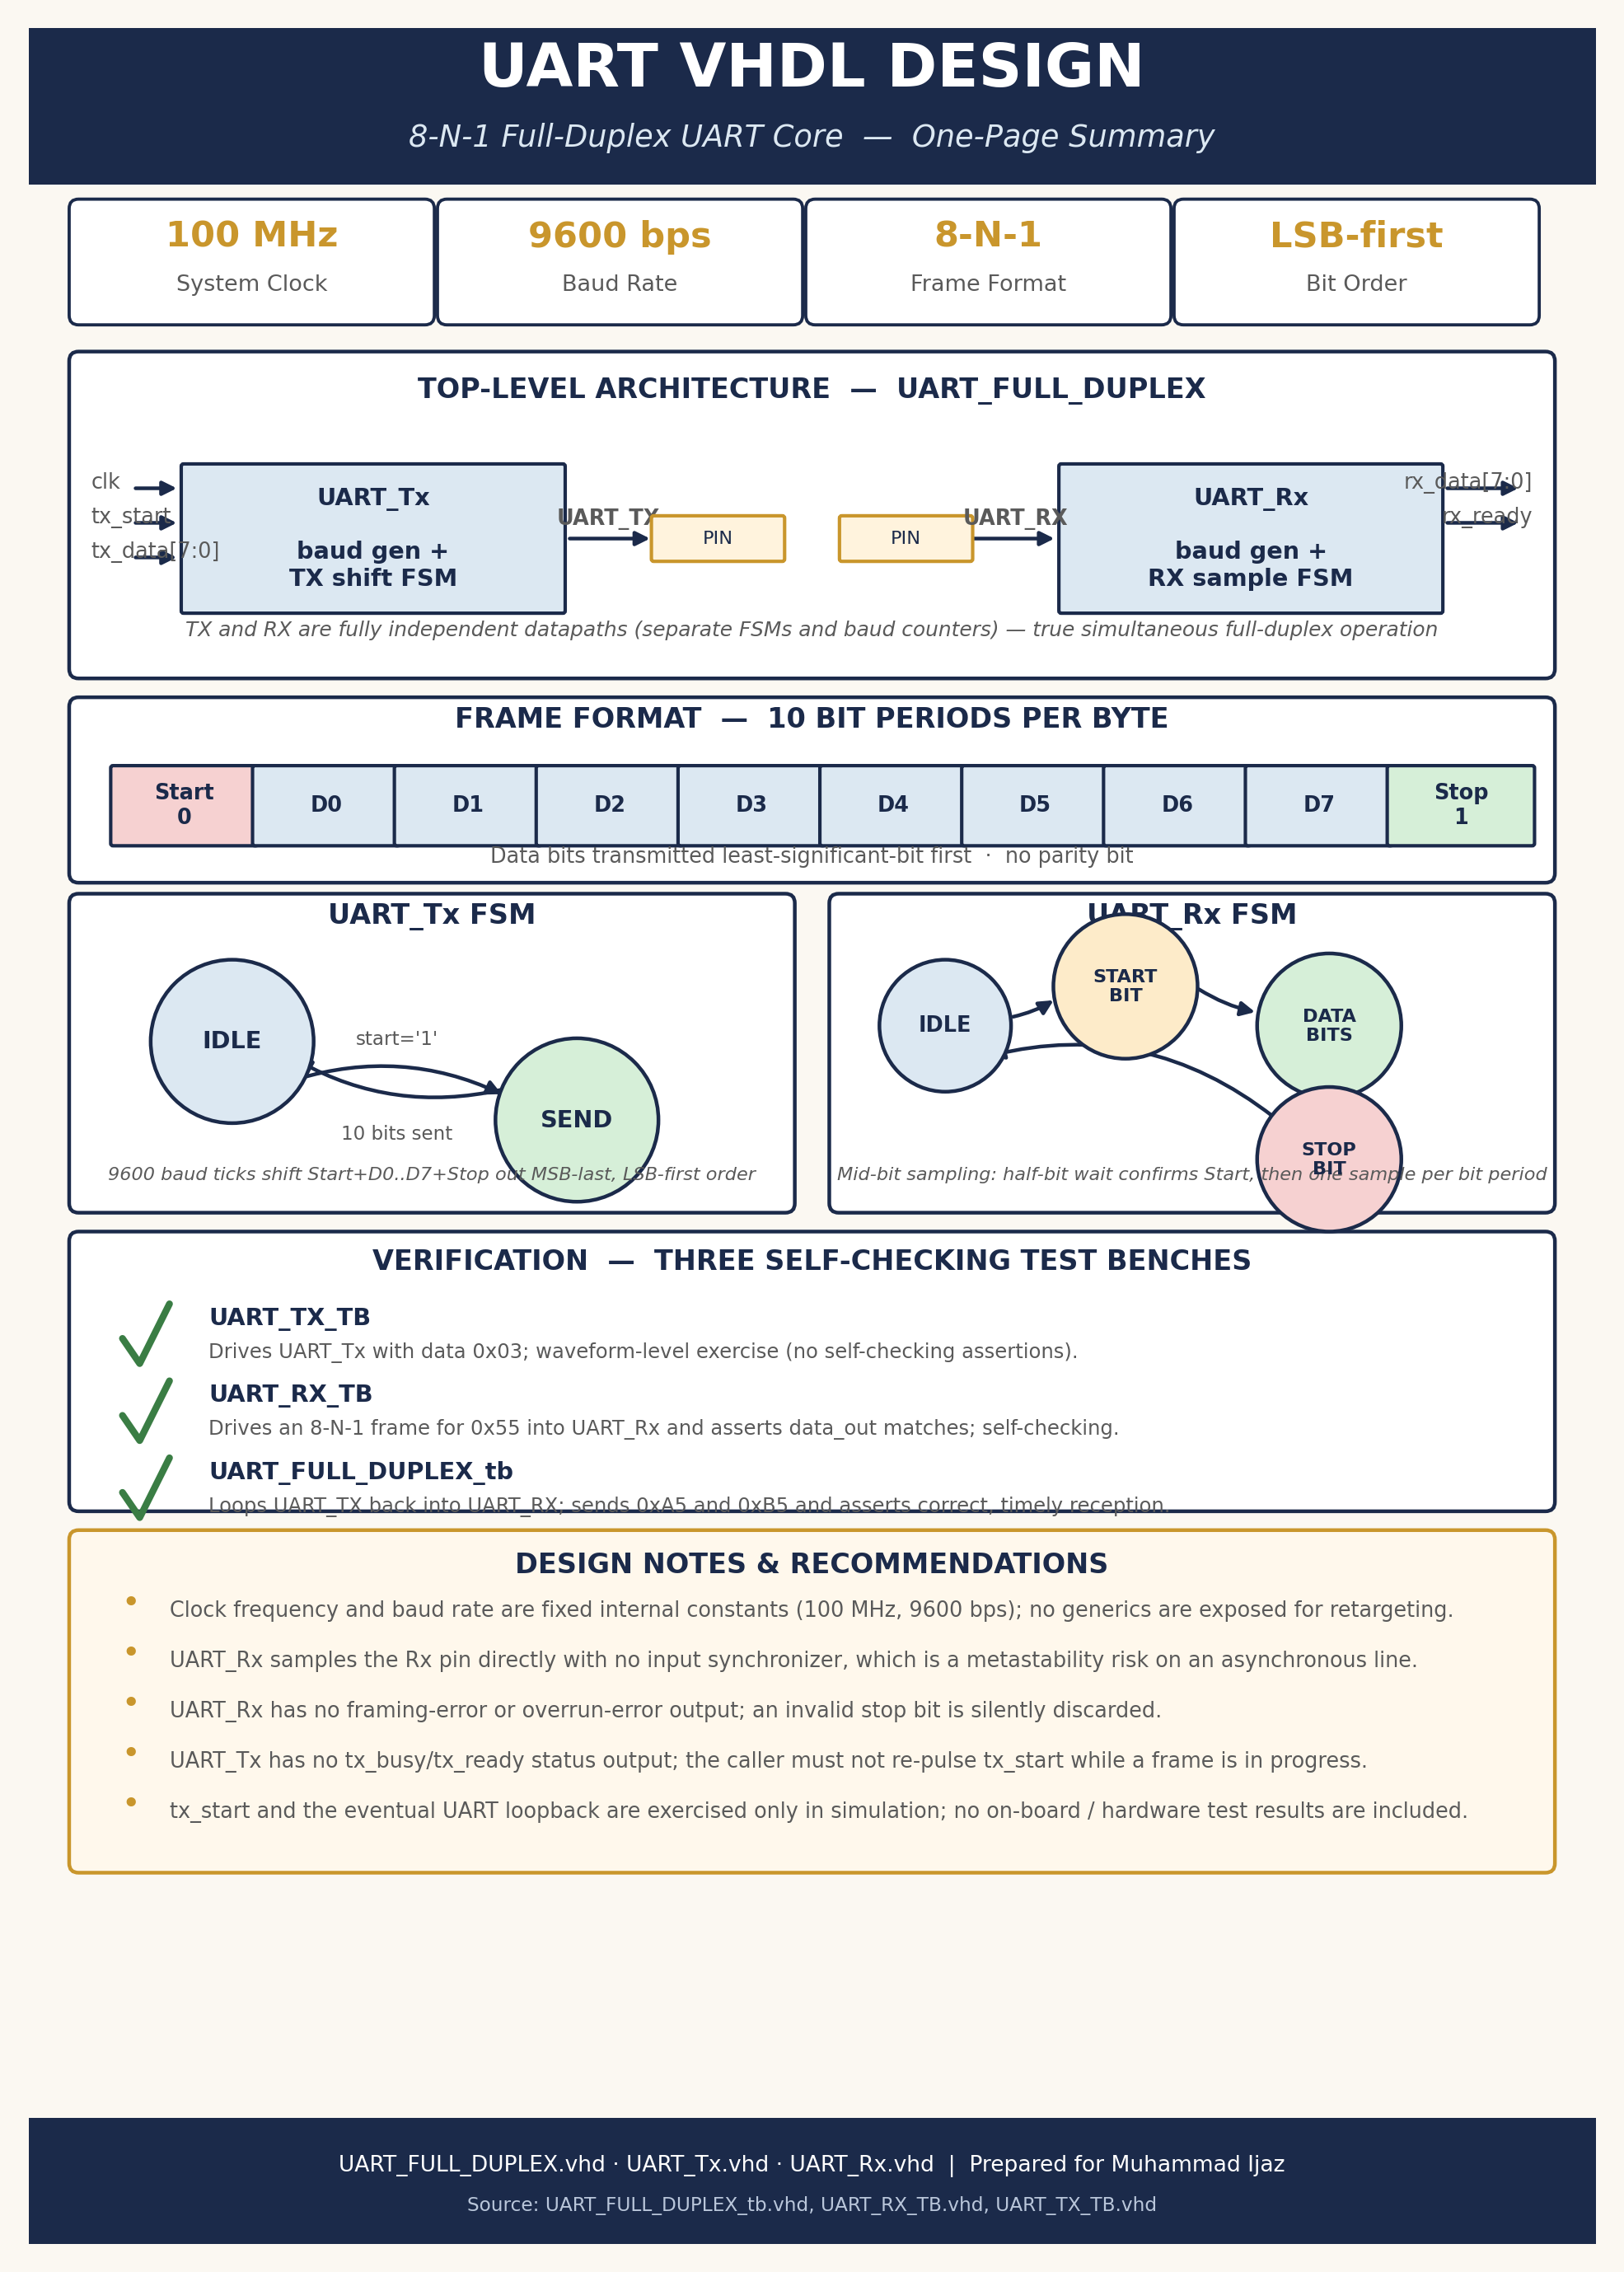
Figure 5. UART VHDL design, one-page sketchnote summary.

