23AD52C – DevOps & Agile Methodologies
MICRO PROJECT (23AD52C)
BUGSENSE – INTELLIGENT ERROR CATEGORISER AND DEBUGGING ASSISTANT
Submitted by
IJAZ AHAMED A (2403957624321008)
In partial fulfilment for the award of the degree of
BACHELOR OF TECHNOLOGY
In
DEPARTMENT OF ARTIFICIAL INTELLIGENCE AND DATA SCIENCE
NATIONAL ENGINEERING COLLEGE
(An Autonomous Institution, Affiliated to Anna University, Chennai)
K. R. NAGAR, KOVILPATTI: 628 503,
ANNA UNIVERSITY: CHENNAI 600 025
BONAFIDE CERTIFICATE

This is to certify that this project “BugSense – Intelligent Error Categoriser and Debugging Assistant” is the bonafide work of IJAZ AHAMED A (REGISTER NO: 2403957624321008) who carried out the project work under my supervision.
SIGNATURE
Course Instructor
Ms.P.Swarna Gowsalya M.E.,
Assistant Professor
Department of AIDS
National Engineering College,
(An Autonomous Institution)
K.R. Nagar, Kovilpatti.628503.

Submitted to the DevOps & Agile Methodologies (23AD52C) Viva-Voce Examination held at National Engineering College on ____________________.

ABSTRACT
Every programmer meets error messages, and beginners in particular often spend more time reading a stack trace than fixing the fault behind it. The messages are written for the compiler and not for the person, and the same few kinds of mistake appear again and again: a missing module, an undefined variable, a database that is not running. BugSense is a small web application built to shorten that gap. The user pastes an error, and the system names the category of the bug, marks how serious it usually is, and lists the debugging steps that normally solve it.
The application is written in Python with the Flask framework. A rule base of fourteen bug categories is matched against the pasted text. Each category earns points for the patterns it finds, and the highest score decides the result. Along with the category, the application picks out the programming language, the error type and the file and line number when they are present in the message. Every report is stored in an SQLite database so that the History and Dashboard pages can show which kinds of bugs are reported most often.
The project was planned in three short sprints, as is done in Agile teams, and the source is kept in Git and GitHub. A Jenkins pipeline runs the unit tests on every push, and Docker with Docker Compose packages the application so that it starts in the same way on any machine. New rules can be added to the rule base without changing the rest of the code, and the same interface could later be backed by a machine-learning model.

INTRODUCTION
Debugging takes a large share of a developer’s time. When a program crashes, the first thing on the screen is an error message, and understanding that message is usually the first obstacle. A line such as “Cannot read properties of undefined” tells an experienced developer exactly where to look, but a student seeing it for the first time may not know whether the problem is in the data, in the code or in the setup.
Most bugs belong to a limited number of families. A missing library, a wrong file path, an empty value, a closed port and a mistyped variable name account for a very large part of everyday errors. Since the families are few, the error text itself carries enough clues to place a bug in one of them, and each family has its own usual way of being investigated.
BugSense is built on this idea. The user submits the error text through a web page. The server compares it with a set of patterns, decides the most likely category, and sends back a short explanation of the probable cause together with an ordered list of steps to follow. The result also shows how confident the system is, so that a weak match is not mistaken for a certain one, and it names the other categories that came close.
The project is also an exercise in the DevOps and Agile practices covered in this course. The source is managed with Git, the work is divided into sprints with user stories, tests run automatically in Jenkins, and the finished application is packed into a Docker container. These parts are described in the sections that follow. Fig 1 shows how the main components are connected.
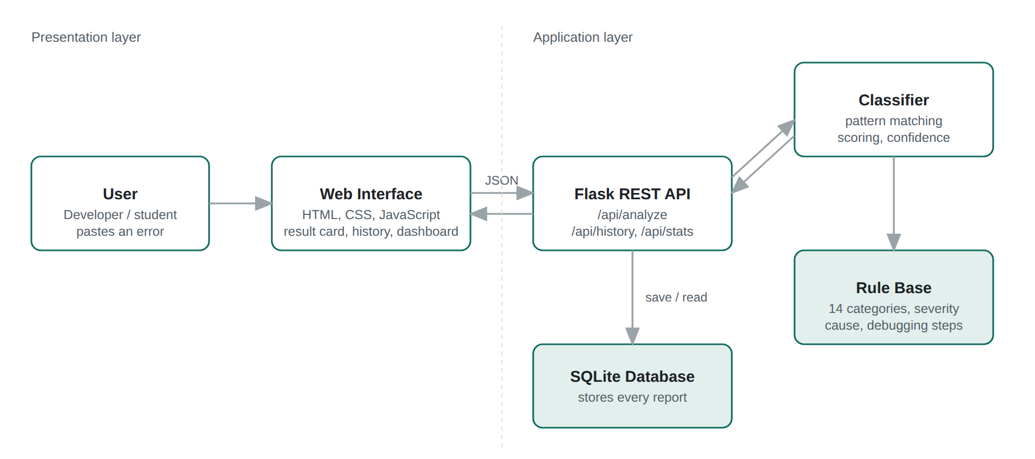
Fig 1: Architecture of BugSense
The browser never talks to the classifier directly. It sends the error text to the Flask API as JSON, the API calls the classifier, which reads the rule base, and the result is saved in SQLite before it is returned to the page.

ALGORITHM
The system follows the same sequence each time an error is submitted. The stages are listed below and Fig 2 shows them as a flowchart.
1. Input and Validation
The text from the input box is sent to the /api/analyze route as JSON. Spaces at the start and end are removed. If nothing is left, the server answers with status 400 and a message asking the user to paste an error.
2. Pattern Matching
Each of the fourteen rules holds a list of regular expressions and a weight for each one. The pasted text is searched, ignoring letter case, for every pattern. An exact error name such as ModuleNotFoundError carries a high weight, while general phrases like “timed out” or “docker” carry a low weight because they turn up in many unrelated messages.
3. Scoring
For every rule, the weights of the patterns that matched are added to give a score. Rules with a score of zero are dropped and the rest are sorted from highest to lowest.
4. Choosing the Category and Confidence
The rule with the highest score becomes the result. The confidence is calculated as:
confidence = min(0.98, 0.5 + 0.1 × top) × top / (top + 0.5 × second)
where top and second are the two highest scores. When one category clearly leads, the value is high. When the second category is close behind, the value drops, which warns the user that the message could have more than one meaning.
5. Extracting Details
The language is guessed from signatures in the text, for example a Traceback block for Python, .java:57 for Java or node_modules for JavaScript. The error type is the first word ending in “Error” or “Exception”. The file and line number are read from the last Python frame, from the Java frame, or from the file.js:42:18 style used by Node.
6. Building the Response
The severity, probable cause and debugging steps stored for the winning rule are put into the response along with the phrases that matched and up to two alternative categories. If no rule scored, the category is “Uncategorised” and four general steps are returned instead.
7. Storing and Display
A short record (time, language, category, severity, confidence and the first 140 characters of the message) is saved in the database. The JSON response is then returned and the page draws the result card.
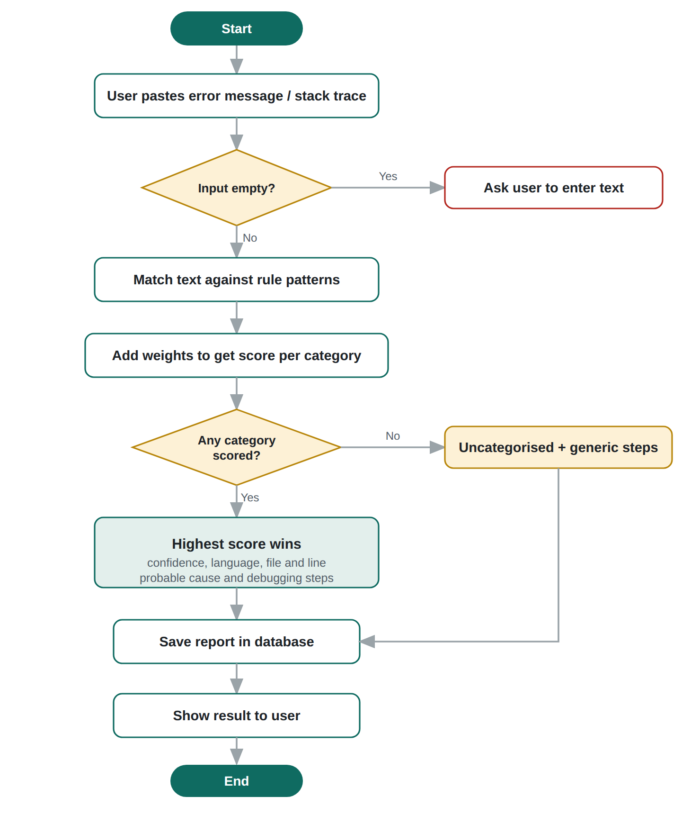
Fig 2: Flowchart of the error analysis process

Bug Categories Used
The rule base currently covers the fourteen categories in Table 1. The severity is a fixed value for each category. It shows how badly this kind of failure usually affects an application and not the damage in one particular case.
Category | Severity | Typical message
Syntax Error | Low | SyntaxError: invalid syntax
Data Parsing Error | Medium | JSONDecodeError: Expecting value
Type Error | Medium | unsupported operand type(s) for +: 'int' and 'str'
Null Reference Error | High | Cannot read properties of undefined
Name / Reference Error | Low | NameError: name 'total' is not defined
Import / Dependency Error | Medium | No module named 'requests'
Index / Key Error | Medium | IndexError: list index out of range
Arithmetic Error | Medium | ZeroDivisionError: division by zero
Network / Connection Error | High | connect ECONNREFUSED 127.0.0.1:27017
Database Error | High | no such table: users
Permission / Authentication Error | High | PermissionError: Permission denied
File I/O Error | Medium | FileNotFoundError: No such file or directory
Memory / Resource Error | Critical | RecursionError, heap out of memory
Build / Deployment Error | High | EADDRINUSE, port is already allocated
Table 1: Bug categories in the rule base

SOFTWARE REQUIREMENTS

1. Backend
The backend receives the error text, runs the classifier, stores the report and returns the result.
- Programming Language: Python 3.12
Frameworks / Libraries:
- Flask – web framework used for the pages and the REST routes
- re, sqlite3 (standard library) – pattern matching and report history
- Gunicorn – production web server used inside the Docker container
- unittest (standard library) – automated tests

2. Front-end
The front-end is a single page that lets the user paste an error and read the result. No JavaScript framework is used; the page talks to the API with the browser’s fetch function.
Technologies Used:
- HTML – structure of the page
- CSS – layout, colours and the severity labels
- JavaScript – sending the request and drawing the result
Interface Features:
- Text area for the error, with ready-made examples to try
- Category, severity, confidence bar and file/line details
- Probable cause and numbered debugging steps
- History page and Dashboard with a count for each category

3. Deployment
Deployment means making the application available to its users. Platform: local machine or any cloud server that has Docker installed.
Tools Used:
- GitHub – version control and storage of the project
- Jenkins – automated test, build and deploy pipeline
- Docker – packaging the application as a container image
- Docker Compose – starting the service and its data volume with one command
System Requirements:
- Operating System: Windows / Linux / macOS
- RAM: 4 GB minimum, 8 GB recommended when Docker and Jenkins run together
- Processor: Intel Core i3 or above
- Storage: At least 2 GB of free space for the Docker images

AGILE APPROACH
The work is organised as Scrum-style sprints of one week each. Requirements are written as user stories so that each piece of work can be traced to something a user wants. The stories are listed in Table 2.
ID | User story | Priority | Sprint
US1 | As a student, I want to paste an error message and see its category, so that I know what kind of bug I have. | High | 1
US2 | As a student, I want the debugging steps in order, so that I can try them one by one. | High | 1
US3 | As a developer, I want the file and line number picked out of the message, so that I can open the failing line quickly. | Medium | 1
US4 | As a user, I want to see how confident the system is, so that I do not trust a weak match. | Medium | 1
US5 | As a user, I want a web page for all this, so that I do not need to run code to get an answer. | High | 2
US6 | As an instructor, I want a dashboard of the most common errors, so that I know what to teach again. | Low | 2
US7 | As a team member, I want the application to start with one command, so that setup does not take time. | Medium | 3
Table 2: Product backlog
Sprint | Goal | Work items | Result at the end
1 | Working classifier | Rule base for fourteen categories, scoring and confidence, extraction of language and line number, unit tests | Classifier returns the category and steps for a pasted error
2 | Web application | Flask routes, web page, SQLite history, dashboard | Complete flow works in the browser
3 | DevOps and documentation | Git workflow, Dockerfile, Docker Compose file, Jenkinsfile, project report | Application can be built and started through the container
Table 3: Sprint plan
A story is counted as done only when the code is committed, the unit tests pass and the feature has been tried in the browser. A short review at the end of each sprint decided what moved into the next one.
One design choice came out of the sprint review of the classifier. Counting the number of matched patterns alone gave a wrong answer for a message like “TypeError: Cannot read properties of undefined”, because the word TypeError points to a type problem while the phrase after it describes an empty value. Giving each pattern a weight let the more specific phrase win, and the Type Error category is still shown as an alternative.

DEVOPS PIPELINE
Fig 3 shows the path a change takes from the developer’s machine to the running application. The Jenkins and Docker stages are shaded because they are the automated part.
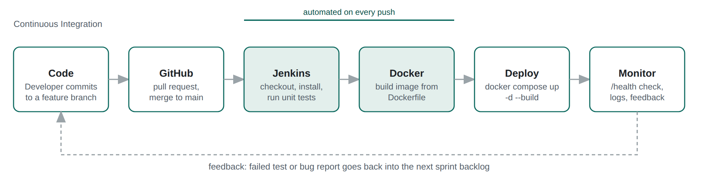
Fig 3: CI/CD pipeline of BugSense

Version Control
The project is kept in a Git repository with main as the stable branch. New work is done on a separate branch and merged after the tests pass. Commit messages describe what changed, for example “Add weights to classifier rules”, so the history can be read like a log of the project.

Continuous Integration with Jenkins
The Jenkinsfile in the root of the repository defines the pipeline. Jenkins reads it when the job is started and runs the stages in Table 4. If the test stage fails, the later stages do not run and nothing is deployed.
Stage | Command | Purpose
Checkout | git branch: main | Fetch the latest code from GitHub
Install | pip install -r requirements.txt | Install Flask and Gunicorn
Test | python -m unittest discover -s tests -v | Run the eleven unit tests
Build Image | docker build -t bugsense:latest . | Create the container image
Deploy | docker compose up -d --build | Start the new version
Table 4: Jenkins pipeline stages

Containerisation
The Dockerfile starts from a small Python image, installs the two requirements, copies the code and runs the application with Gunicorn on port 5000. The docker-compose.yml file builds this image, publishes port 5000 and mounts a named volume at /data so that the SQLite file is not lost when the container is replaced.

SOURCE CODE
The main files are given below. The complete project also contains rules.py, which holds the fourteen category definitions, the HTML template and the style sheet.
app.py
from flask import Flask, jsonify, render_template, request

import database
from classifier import analyze

app = Flask(__name__)
database.init_db()

@app.route("/")
def home():
return render_template("index.html")

@app.post("/api/analyze")
def api_analyze():
text = (request.get_json(silent=True) or {}).get("error", "")
try:
result = analyze(text)
except ValueError as exc:
return jsonify({"message": str(exc)}), 400
database.save_report(result, text)
return jsonify(result)

@app.get("/api/history")
def api_history():
return jsonify(database.recent())

@app.get("/api/stats")
def api_stats():
return jsonify(database.category_counts())

@app.get("/health")
def health():
return jsonify({"status": "ok"})

if __name__ == "__main__":
app.run(host="0.0.0.0", port=5000)
classifier.py
import re
from rules import RULES

ERROR_NAME = re.compile(r"\b([A-Z][A-Za-z]*(?:Error|Exception))\b|\b(E[A-Z]{4,})\b")

def detect_language(text):
if re.search(r"Traceback \(most recent call last\)|File \".+\", line \d+", text) \
or re.search(r"\b(ModuleNotFound|ZeroDivision|Indentation|NameError|KeyError|IndexError|"
r"AttributeError|FileNotFoundError|PermissionError|RecursionError|"
r"JSONDecodeError|IntegrityError|OperationalError|MemoryError)|sqlite3|NoneType|unsupported operand", text):
return "Python"
if re.search(r"\.java:\d+|Exception in thread|java\.(lang|io|util)\.", text):
return "Java"
if re.search(r"node_modules|\.(js|jsx|ts|tsx|mjs):\d+|ReferenceError|npm ERR!|Cannot read propert", text):
return "JavaScript"
if re.search(r"docker|Jenkins|bash|sh:|exit code", text, re.I):
return "Docker / Shell"
return "Unknown"

def find_location(text):
py = re.findall(r'File "([^"]+)", line (\d+)', text)
if py:
path, line = py[-1]
return f"{path.split('/')[-1]}, line {line}"
jv = re.search(r"\(([\w$]+\.java):(\d+)\)", text)
if jv:
return f"{jv.group(1)}, line {jv.group(2)}"
js = re.search(r"([\w./\\-]+\.(?:js|jsx|ts|tsx|mjs)):(\d+)(?::\d+)?", text)
if js:
return f"{js.group(1).split('/')[-1]}, line {js.group(2)}"
return "Not found in the message"

def analyze(text):
text = (text or "").strip()
if not text:
raise ValueError("Please paste an error message first.")

scored = []
for rule in RULES:
score, evidence = 0.0, []
for pattern, weight in rule["patterns"]:
m = re.search(pattern, text, re.I)
if m:
score += weight
evidence.append(m.group(0))
if score:
scored.append((score, rule, evidence))
scored.sort(key=lambda s: s[0], reverse=True)

name = ERROR_NAME.search(text)
base = {
"language": detect_language(text),
"location": find_location(text),
"error_type": (name.group(0) if name else "Not named"),
}

if not scored:
base.update(
category="Uncategorised", severity="Unknown", confidence=0.0,
cause="The message did not match any known pattern.",
steps=[
"Search the exact error text (without file paths) on the web.",
"Reproduce the problem with the smallest possible input.",
"Read the full stack trace from the bottom up; the last frame in your own code is usually the culprit.",
"Add logging around the failing function and run again.",
],
evidence=[], alternatives=[],
)
return base

top, rule, evidence = scored[0]
second = scored[1][0] if len(scored) > 1 else 0
confidence = min(0.98, 0.5 + 0.1 * top) * (top / (top + 0.5 * second))
base.update(
category=rule["category"], severity=rule["severity"],
confidence=round(confidence, 2), cause=rule["cause"], steps=rule["steps"],
evidence=evidence[:5],
alternatives=[s[1]["category"] for s in scored[1:3]],
)
return base
database.py
import os
import sqlite3
from datetime import datetime

DB_PATH = os.environ.get("BUGSENSE_DB", "bugsense.db")

def connect():
conn = sqlite3.connect(DB_PATH)
conn.row_factory = sqlite3.Row
return conn

def init_db():
with connect() as c:
c.execute(
"""CREATE TABLE IF NOT EXISTS reports (
id INTEGER PRIMARY KEY AUTOINCREMENT,
created_at TEXT NOT NULL,
language TEXT, category TEXT, severity TEXT,
confidence REAL, snippet TEXT)"""
)

def save_report(result, text):
snippet = " ".join(text.split())[:140]
with connect() as c:
c.execute(
"INSERT INTO reports (created_at, language, category, severity, confidence, snippet) "
"VALUES (?,?,?,?,?,?)",
(datetime.now().strftime("%d %b %Y, %H:%M"), result["language"],
result["category"], result["severity"], result["confidence"], snippet),
)

def recent(limit=20):
with connect() as c:
rows = c.execute("SELECT * FROM reports ORDER BY id DESC LIMIT ?", (limit,)).fetchall()
return [dict(r) for r in rows]

def category_counts():
with connect() as c:
rows = c.execute(
"SELECT category, COUNT(*) AS n FROM reports GROUP BY category ORDER BY n DESC"
).fetchall()
return [dict(r) for r in rows]
rules.py (excerpt)
# rules.py (one of the fourteen rules shown)
RULES = [
{
"category": "Null Reference Error",
"severity": "High",
"patterns": [
(r"Cannot read propert(y|ies) of (undefined|null)", 4),
(r"NullPointerException", 4), (r"'NoneType' object", 4),
(r"undefined is not an object", 3), (r"null pointer", 2.5),
(r"Cannot set propert(y|ies) of (undefined|null)", 4),
(r"is (null|undefined)", 1),
],
"cause": "The code tried to use an object that does not exist yet. "
"The value is null/None/undefined, usually because a lookup "
"failed or data has not loaded.",
"steps": [
"Identify which variable on the failing line is null or undefined.",
"Log the variable one step earlier to see where it first becomes empty.",
"Check asynchronous code: the value may be used before the request has finished.",
"Add a guard (if x is not None, x?.name, Optional) before using the object.",
"Return a sensible default from the function that produced the value instead of None.",
],
},
# ... remaining rules ...
]
tests/test_classifier.py
import os
import sys
import unittest

sys.path.insert(0, os.path.dirname(os.path.dirname(os.path.abspath(__file__))))
from classifier import analyze # noqa: E402

class ClassifierTests(unittest.TestCase):
def test_python_module_missing(self):
r = analyze("ModuleNotFoundError: No module named 'requests'")
self.assertEqual(r["category"], "Import / Dependency Error")
self.assertEqual(r["language"], "Python")

def test_js_undefined_property(self):
r = analyze("TypeError: Cannot read properties of undefined (reading 'name')\n"
" at getUser (/app/src/user.js:42:18)")
self.assertEqual(r["category"], "Null Reference Error")
self.assertEqual(r["location"], "user.js, line 42")

def test_zero_division(self):
r = analyze("ZeroDivisionError: division by zero")
self.assertEqual(r["category"], "Arithmetic Error")

def test_connection_refused(self):
r = analyze("Error: connect ECONNREFUSED 127.0.0.1:5432")
self.assertEqual(r["category"], "Network / Connection Error")

def test_database_missing_table(self):
r = analyze("sqlite3.OperationalError: no such table: users")
self.assertEqual(r["category"], "Database Error")

def test_port_in_use(self):
r = analyze("Error: listen EADDRINUSE: address already in use :::3000")
self.assertEqual(r["category"], "Build / Deployment Error")

def test_java_null_pointer_location(self):
r = analyze("Exception in thread \"main\" java.lang.NullPointerException\n"
"\tat com.shop.Cart.total(Cart.java:57)")
self.assertEqual(r["category"], "Null Reference Error")
self.assertEqual(r["language"], "Java")
self.assertEqual(r["location"], "Cart.java, line 57")

def test_unknown_message_is_uncategorised(self):
r = analyze("something strange happened")
self.assertEqual(r["category"], "Uncategorised")
self.assertTrue(len(r["steps"]) > 0)

def test_empty_input_rejected(self):
with self.assertRaises(ValueError):
analyze(" ")

def test_confidence_range(self):
r = analyze("IndexError: list index out of range")
self.assertGreater(r["confidence"], 0.5)
self.assertLessEqual(r["confidence"], 0.98)

def test_steps_present_for_every_match(self):
for msg in ["SyntaxError: invalid syntax", "KeyError: 'id'",
"PermissionError: [Errno 13] Permission denied",
"RecursionError: maximum recursion depth exceeded"]:
self.assertGreaterEqual(len(analyze(msg)["steps"]), 3, msg)

if __name__ == "__main__":
unittest.main()
Dockerfile
FROM python:3.12-slim
WORKDIR /app
COPY requirements.txt .
RUN pip install --no-cache-dir -r requirements.txt
COPY . .
EXPOSE 5000
CMD ["gunicorn", "-b", "0.0.0.0:5000", "app:app"]
docker-compose.yml
services:
web:
build: .
ports:
- "5000:5000"
environment:
- BUGSENSE_DB=/data/bugsense.db
volumes:
- bugsense-data:/data
restart: unless-stopped

volumes:
bugsense-data:
Jenkinsfile
pipeline {
agent any
stages {
stage('Checkout') {
steps { git branch: 'main', url: 'https://github.com/username/bugsense.git' }
}
stage('Install') {
steps { sh 'pip install -r requirements.txt' }
}
stage('Test') {
steps { sh 'python -m unittest discover -s tests -v' }
}
stage('Build Image') {
steps { sh 'docker build -t bugsense:latest .' }
}
stage('Deploy') {
steps { sh 'docker compose up -d --build' }
}
}
post {
failure { echo 'Build failed - check the console output of the failing stage.' }
}
}

DEPLOYING PROCEDURE

Git commands:
1. git config --global user.name
Command:
git config --global user.name "Ijaz Ahamed A"
Description: Sets the global username used for all Git commits.
Output:
2. git config --global user.email
Command:
git config --global user.email "your.email@example.com"
Description: Sets the global e-mail address used for all Git commits.
Output:
3. git init
Command:
git init
Description: Creates a new Git repository in the project folder.
Output:
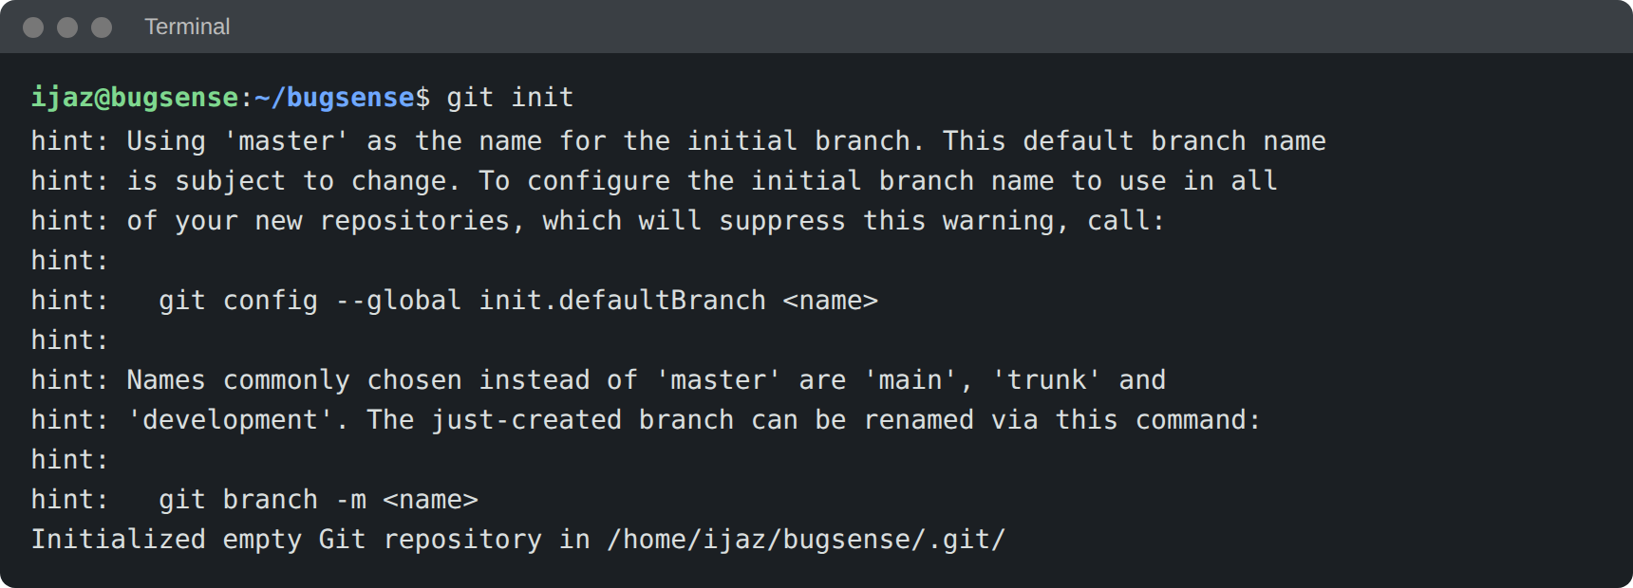
4. git add .
Command:
git add .
Description: Adds all project files to the staging area.
Output:
5. git commit -m "Initial commit"
Command:
git commit -m "Initial commit"
Description: Saves the staged files as the first commit with a message.
Output:
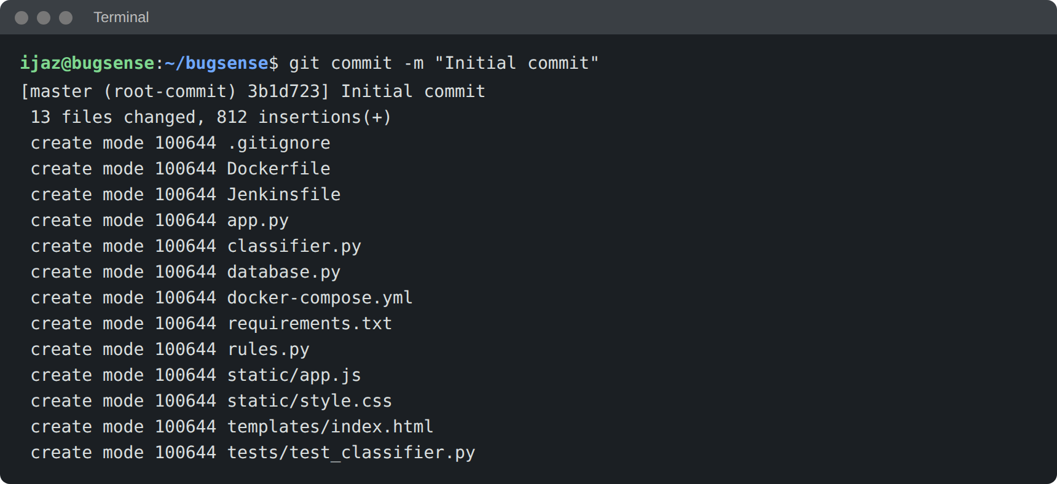
6. git branch -M main
Command:
git branch -M main
Description: Renames the current branch to main.
Output:
7. git remote add origin
Command:
git remote add origin https://github.com/username/bugsense.git
Description: Connects the local repository to the remote GitHub repository. Replace “username” with your GitHub account name.
Output:
8. git remote -v
Command:
git remote -v
Description: Lists the remote address, to confirm that the link was added.
Output:
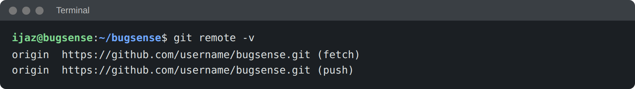

Running the unit tests
python -m unittest discover -s tests -v
Runs all the tests in the tests folder. Each test sends a sample error message to the classifier and checks the category, the language or the file location in the answer.
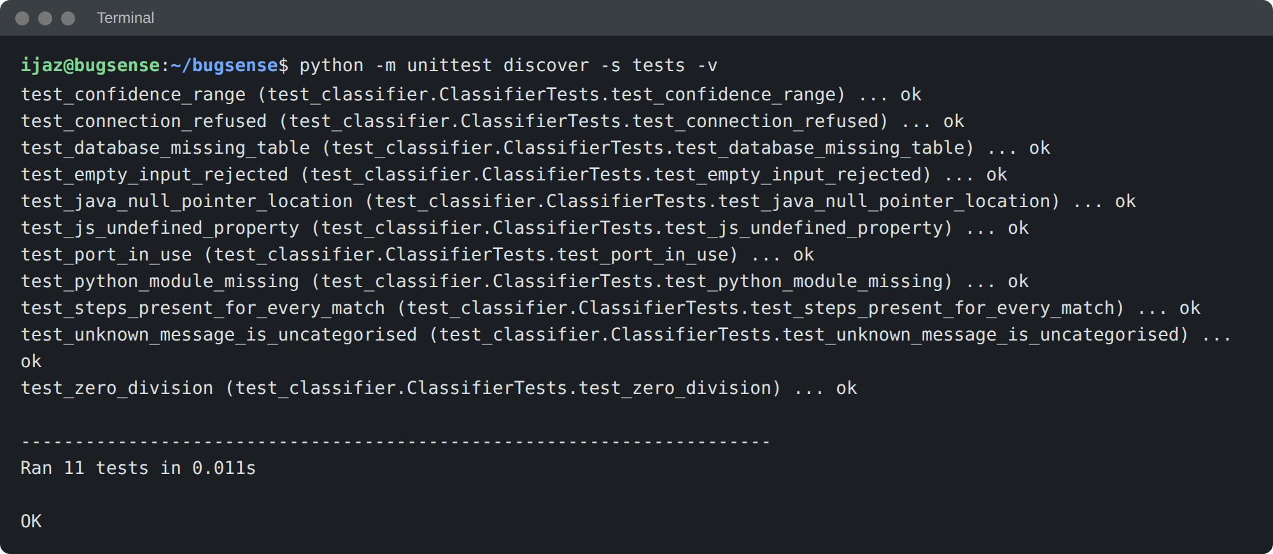

Running the application
pip install -r requirements.txt
python app.py
Starts the Flask server on port 5000. The application is then opened in the browser at http://localhost:5000.
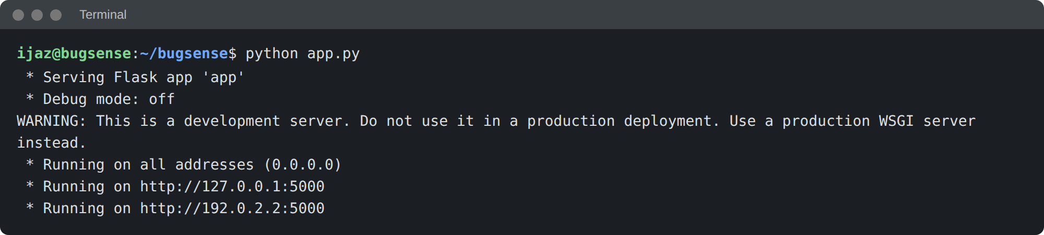

Docker commands:
1. docker compose up -d --build
Builds the image from the Dockerfile and starts the container in the background with the data volume attached.
2. docker ps
Lists the running containers. The BugSense service should appear with port 5000 mapped to the host.
3. curl http://localhost:5000/health
Calls the health route. A working container answers with {"status":"ok"}.

Jenkins job:
- Create a new item in Jenkins and choose Pipeline.
- Under Pipeline, select Pipeline script from SCM and choose Git.
- Enter the GitHub repository URL and the branch main.
- Set the Script Path to Jenkinsfile and save.
- Click Build Now. The stage view shows Checkout, Install, Test, Build Image and Deploy as they run.

OUTPUT
Home Page:
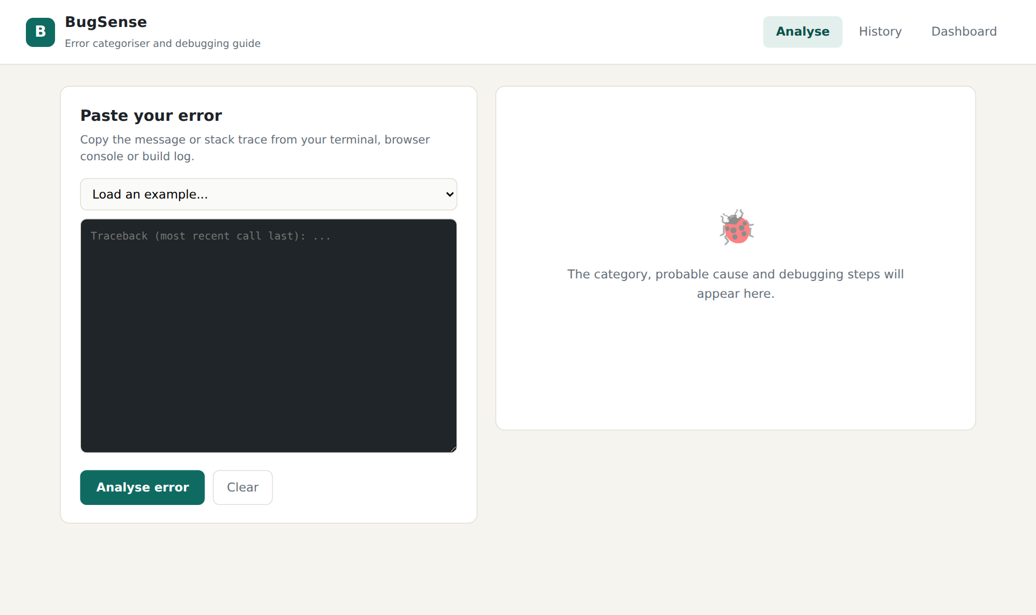
Fig 4: Home page of BugSense
- The page has an input area for the error and a ready-made list of examples.
- The right side stays empty until an error has been analysed.
JavaScript Error – Null Reference:
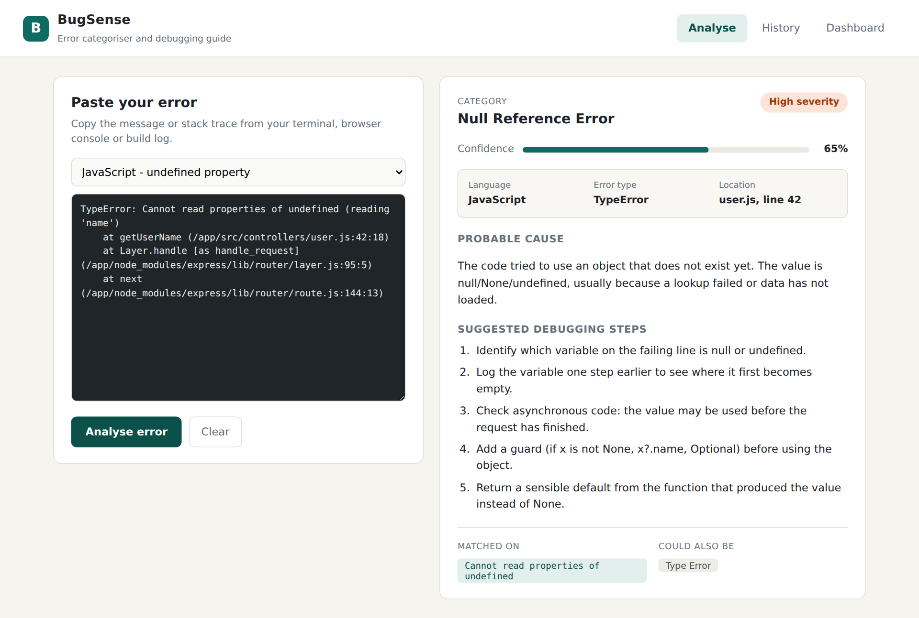
Fig 5: Analysis of a JavaScript stack trace
- The message is placed in the Null Reference category with high severity and 65% confidence.
- The file and line (user.js, line 42) are taken from the stack trace, and Type Error is shown as the alternative.
Python Error – Missing Module:
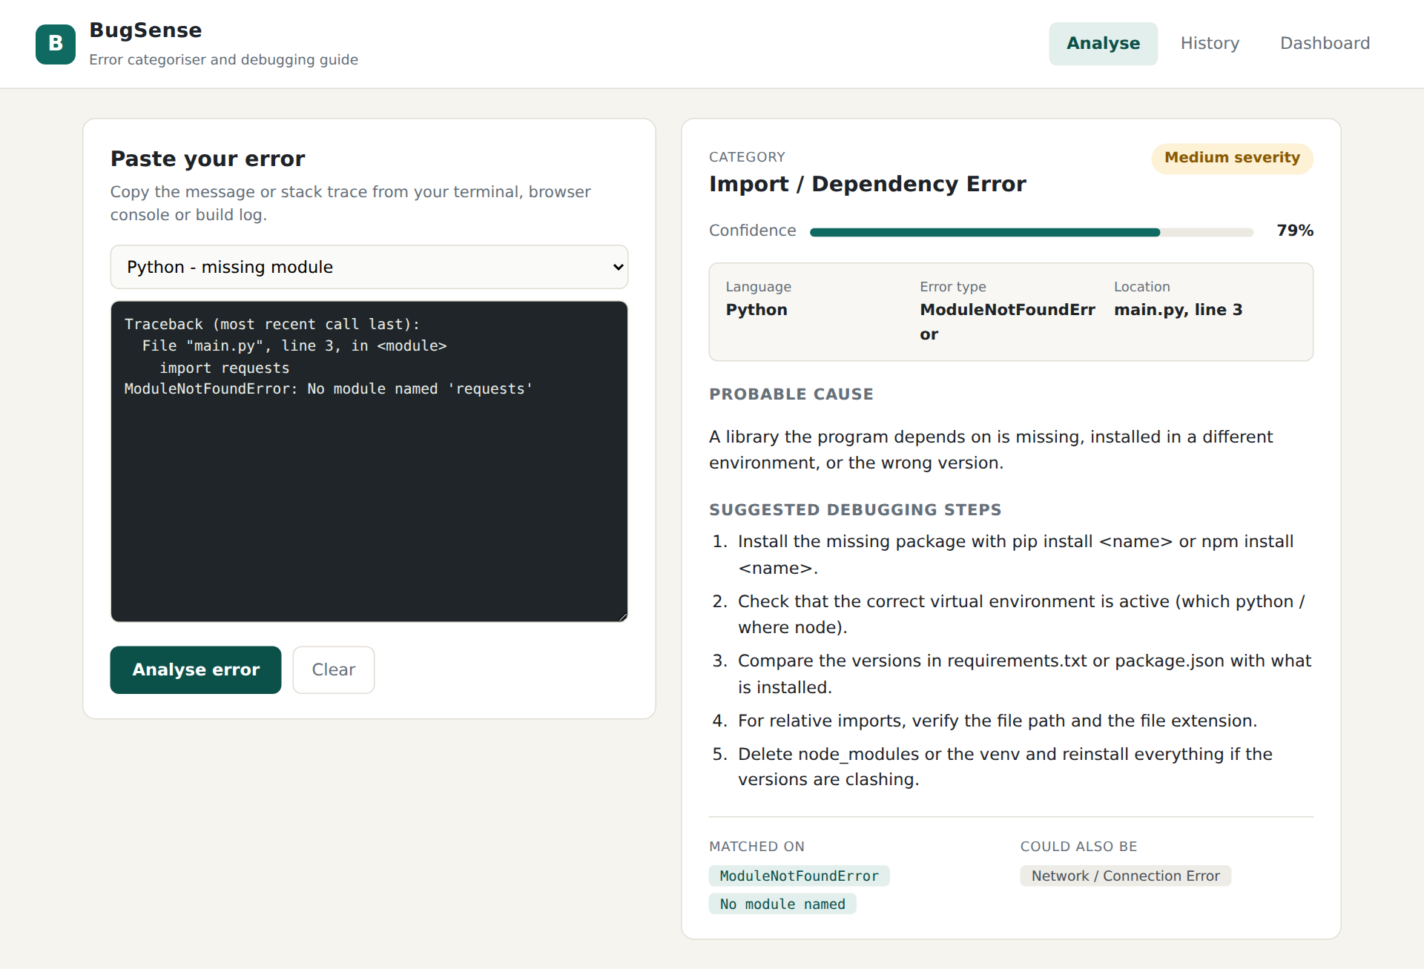
Fig 6: Analysis of a Python traceback
- The traceback is recognised as Python and the last frame (main.py, line 3) is reported.
- The steps start with installing the package and checking which virtual environment is active.
Docker Error – Port Already in Use:
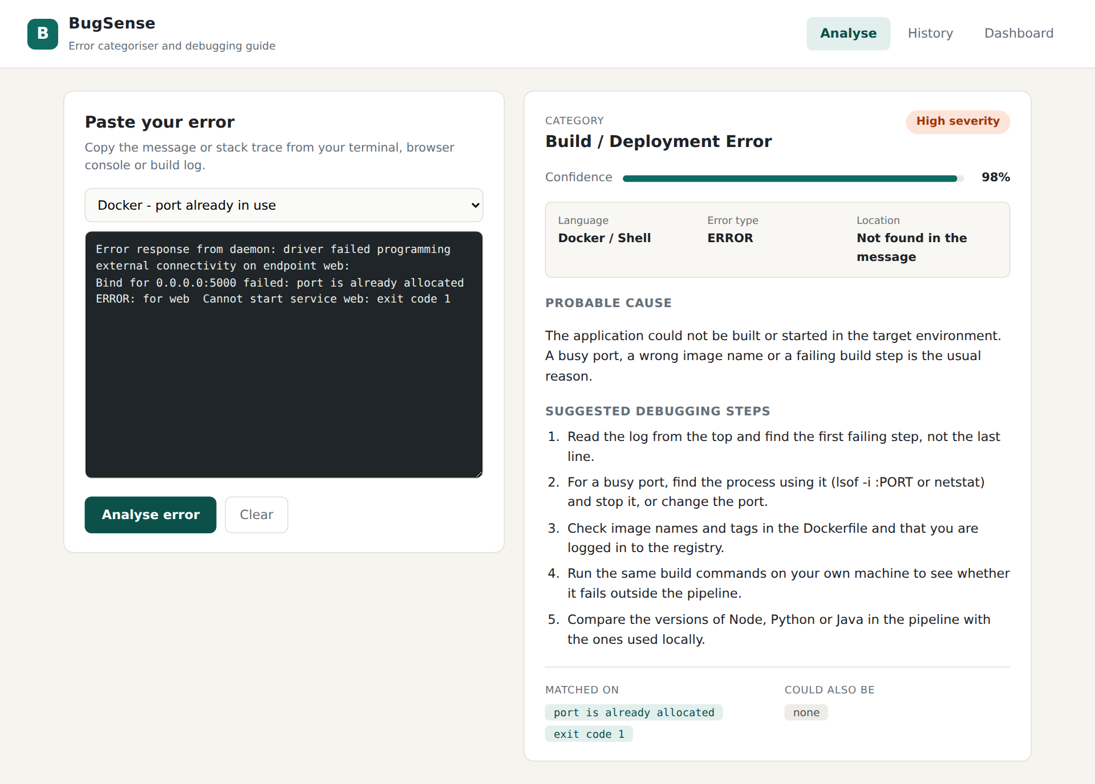
Fig 7: Analysis of a Docker start-up error
- The message is placed in the Build / Deployment category.
- The first step advises finding the process that already holds the port.
History:
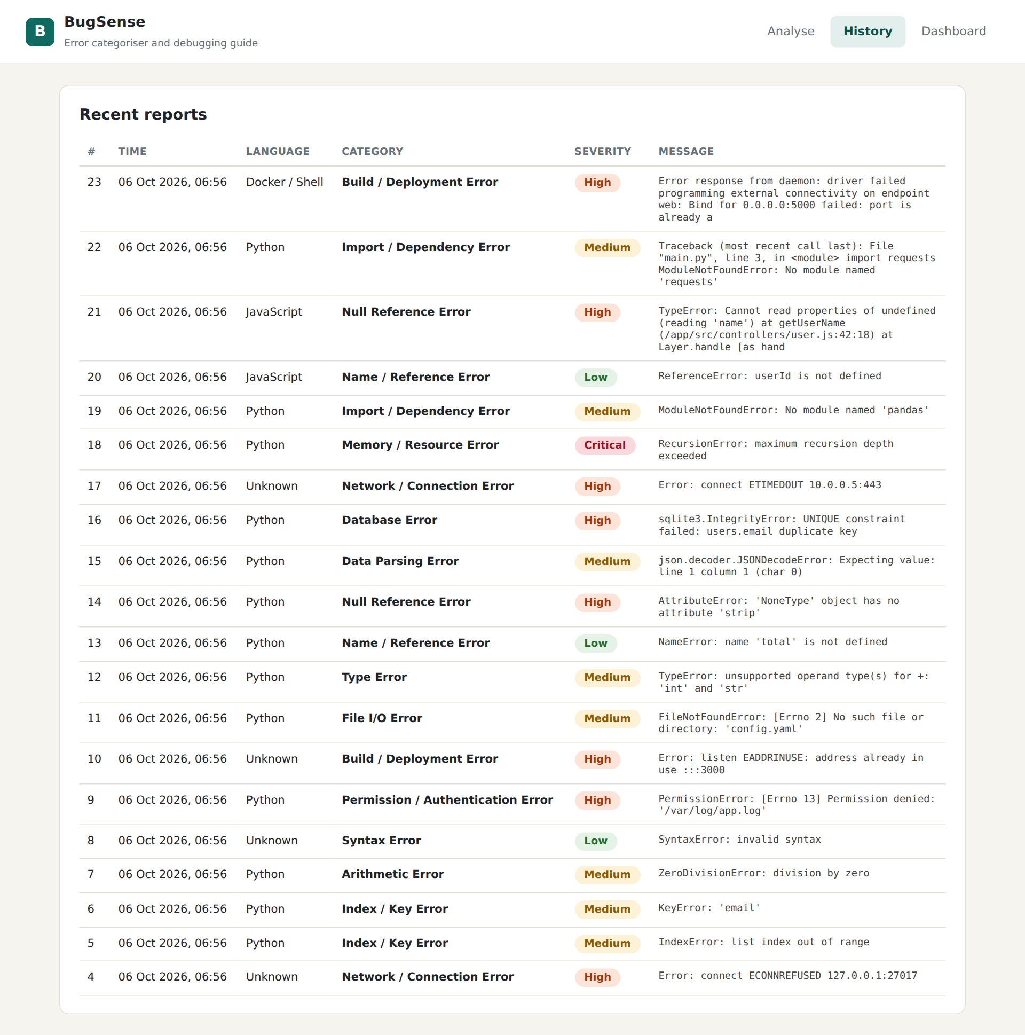
Fig 8: History of analysed errors
- Every analysed error is stored with its time, language, category and severity.
Dashboard:
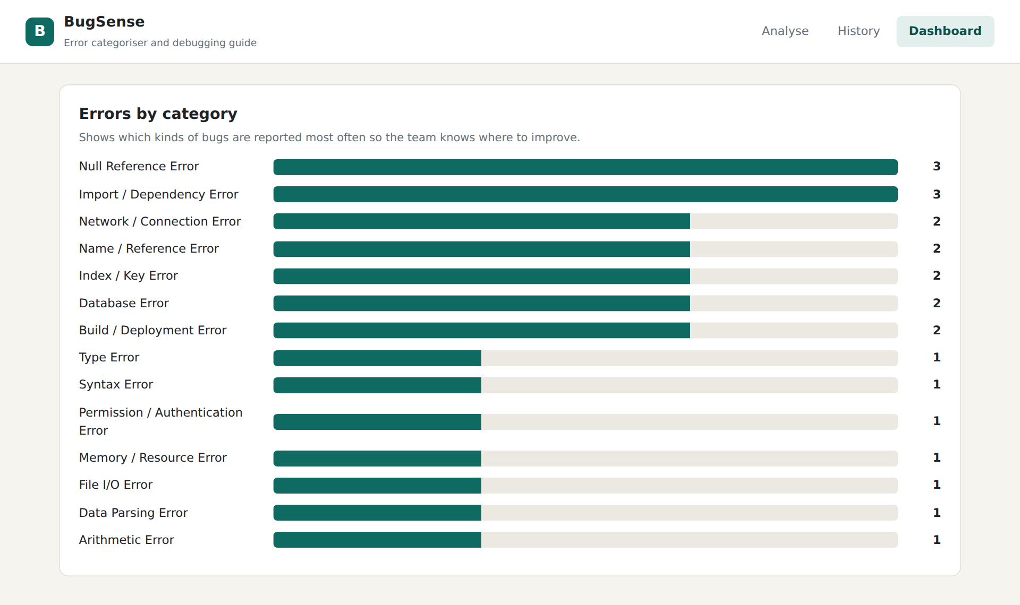
Fig 9: Dashboard showing the number of reports for each category
- The bars are drawn from the stored reports and show which kinds of bugs occur most often.

Test Results
Test | What it checks | Result
test_python_module_missing | Missing Python module gives Import / Dependency Error and Python as language | Pass
test_js_undefined_property | Undefined property gives Null Reference Error with file and line | Pass
test_zero_division | Division by zero gives Arithmetic Error | Pass
test_connection_refused | ECONNREFUSED gives Network / Connection Error | Pass
test_database_missing_table | Missing table gives Database Error | Pass
test_port_in_use | EADDRINUSE gives Build / Deployment Error | Pass
test_java_null_pointer_location | Java NullPointerException with language and line | Pass
test_unknown_message_is_uncategorised | Unknown text gives Uncategorised with general steps | Pass
test_empty_input_rejected | Blank input raises an error | Pass
test_confidence_range | Confidence stays between 0.5 and 0.98 | Pass
test_steps_present_for_every_match | Every matched category returns at least three steps | Pass
Table 5: Unit test results

CONCLUSION
The BugSense application shows that a large part of everyday debugging help can be given by a simple, readable rule base. Pasting an error into the page returns a category, a severity, a confidence value and an ordered list of steps within a moment, and the language and line number are picked out of the message so that the user can go straight to the failing code. The tests confirm that the classifier behaves as expected for typical Python, JavaScript, Java, database and Docker errors.
The project also gave practice with the tools and habits of DevOps and Agile work. The requirements were written as user stories and divided into sprints, the code is under Git, the tests are run by a Jenkins pipeline, and Docker with Docker Compose makes the application start in the same way on any machine.

Limitations and Future Work
- The classifier depends on patterns written by hand, so an unusual message may end up as Uncategorised. The reports stored in the database could be used to find such messages and write new rules.
- A machine-learning text classifier could be trained on the stored reports and compared with the rule base.
- User accounts and a feedback button (“was this helpful?”) would show which debugging steps really work.
- A browser or editor extension could send the error to BugSense without copying it.

References
- Flask documentation – https://flask.palletsprojects.com
- Python unittest documentation – https://docs.python.org/3/library/unittest.html
- Docker documentation – https://docs.docker.com
- Jenkins Pipeline documentation – https://www.jenkins.io/doc/book/pipeline/
- Pro Git book – https://git-scm.com/book
Evaluation
Problem Analysis & Solution Design (5) | Implementation (5) | Innovation and Problem Solving (5) | Documentation and Demonstration (5) | Total (20)

