JPC: A MOBILE TRICYCLE RESERVATION APP

A Capstone Project Proposal
Presented to the Faculty of the
College of Information and Computing Sciences
Cagayan State University
Aparri Campus

In Partial Fulfillment for the
Academic Requirement
for the degree
Bachelor of Science in Information Technology

By:
Borja, Pamela Joy D.
Magara, Christopher C.
Sambrano, Jasmin L.

June 2021
Approval Sheet
This capstone project titled, JPC:A Mobile Tricycle Reservation App, prepared and submitted by, Pamela Joy D. Borja, Christopher C. Magara and Jasmin L. Sambrano in partial fulfillment of the academic requirement for the degree Bachelor of Science in Information Technology - Web Track is hereby recommended for oral examination.
LEO P. PALIUANAN, MSIT
Adviser
Approved on Oral Examination with a grade of ___________________________.
PANEL OF EXAMINERS
Zasha P. Ontiveros
Chair

Billy S. Javier, DIT James Karl B. Agpalza, MSIT
Member Member

Jesty S. Agoto, MSIT Iolani Silvestre
Member Member

Accepted and approved in partial fulfillment of the requirements for the degree Bachelor of Science in Information Technology - Web Track.

JULIETA BABAS, DIT
College Dean

SIMEON R. RABANAL Jr., Ph.D.
Campus Executive Officer

Table of Contents
Title Page ---------------------------------------------------------------------------------------------------1
Approval Sheet---------------------------------------------------------------------------------------------2
Chapter 1: INTRODUCTION
The Problem and Its Background-----------------------------------------------------------------------5
Related Literature and Studies-------------------------------------------------------------------------- 8
Conceptual Framework --------------------------------------------------------------------------------- 11
Statement of the Problem--------------------------------------------------------------------------------13
Scope and Limitations----------------------------------------------------------------------------------- 14
Significance of the Study--------------------------------------------------------------------------------15
Definition of Terms-------------------------------------------------------------------------------------- 16
Chapter 2: METHODS AND PROCEDURES
Research Design----------------------------------------------------------------------------------------- 19
Locale of the Study--------------------------------------------------------------------------------------22
Participants of the Study--------------------------------------------------------------------------------23
Data Gathering Tools or Instruments----------------------------------------------------------------- 24
Data Gathering Procedure------------------------------------------------------------------------------ 28
Data Analysis---------------------------------------------------------------------------------------------29

References------------------------------------------------------------------------------------------------31

Appendices
- Communication Letters-------------------------------------------------------------------------33
- Hierarchical Input-Process-Output Diagram------------------------------------------------ 34
- Data Flow Diagram----------------------------------------------------------------------------- 35
- Context Diagram-------------------------------------------------------------------------------- 36
- Use Case Diagram-------------------------------------------------------------------------------37
- System Architecture-----------------------------------------------------------------------------38
- Database Design, Table Attributes and Domains------------------------------------------ 39
- Wire Frames or Physical Screens or Designs-----------------------------------------------43
- Consent Form ----------------------------------------------------------------------------------- 62
- Questionnaire ----------------------------------------------------------------------------------- 63
- Observation Field Notes ----------------------------------------------------------------------66
- Gantt Chart or Timeline of Activities ------------------------------------------------------ 67
- Curriculum Vitae ----------------------------------------------------------------------------- 68

CHAPTER I
INTRODUCTION
This chapter includes the background of the study, review of related literature, conceptual framework, and statement of the problem, scope and limitation, significance of the study and the definition of terms used.
The Problem and Its Background
In Aparri, tricycle is considered as the most important means of transportation. Tricycle also known as “trike” is a three-wheeled public utility vehicle consisting of a motorcycle and an attached passenger’s side car. Even in modernization, you can always find the tricycle as the regular mode of transport in barangays or barrios here in Aparri. For the cheap price of fare, a passenger can go to their destination without worrying how much money she could spent in a day.
Aside from fishing and farming as the main source of livelihood of Aparrianos, The total population of Aparri now is 65,000 and the total of registered tricycle drivers is 2,000. So, 3.8% of the population of Aparri is tricycle drivers. According to Huerta (2015), a tricycle can accommodate three to five passengers and baggage on the top or at the back. Within the side car, three people can fit and one or two passengers can normally ride behind the driver. With the crisis that we are facing right now, a tricycle can just accommodate only one passenger with a small fee – 15 to 30 pesos and the Municipality of Aparri has implemented a number coding for tricycles.
A study entitled “Tatlong Gulong ng Buhay: The Tricycle and their Lived Experiences During Pandemic” by Espiritu et.,al 2021 talked about the experiences of tricycle drivers during pandemic and how they cope up with the challenges. Various positive and negative experiences were shared. Most participants described how they have faced challenges and yet had the bravery to continue providing services despite the unpredictable pandemic expansion in order to safeguard their child's well-being—risking their life for their family. Their main argument is that they are terrified of the virus, but they are more worried of not having enough food on the table. These occurrences were all too common to them. The past existence as a tricycle driver was difficult, but in today's environment, the so-called new normal makes things considerably worse. The adaptations to lifestyle modifications and optimism in life were the most difficult problems that respondents faced throughout the pandemic. Adjustments are caused by the abrupt move from our typical daily lives to a so-called new normal. They are engaging in social separation by wearing appropriate facemasks and face shields. To deal with the problems of the pandemic, tricycle drivers developed coping techniques that helped them deal with their personal troubles. Respondents have an additional source of income to cover their daily costs and extra costs. They accept responsibility for providing the necessities for their family.
It is true that the pandemic makes a significant impact to the whole society especially to the tricycle drivers who are classified as daily wage earners. Before the pandemic, a tricycle can accommodate 3 to 5 passengers. Inside the tricycle, three passengers can fit and one to two passengers can normally ride behind the driver. With the crisis that we are facing right now, a tricycle can just accommodate only one passenger with a small fee – 15 to 30 pesos and the Municipality of Aparri has implemented a number coding for tricycles. It turns out that their income is not exact to buy financial and essential needs of the family. Also, it is risky for them. Owing to the fact that the spread of the virus is fast, they don’t know if their passenger is a carrier of the virus or not.
Here in Aparri, there is no present reservation or booking app for riding a tricycle. It is in traditional booking wherein the tricycle drivers’ will going to line up at terminals, it comes into “first come, first serve basis.” There are instances that they need to wait for passengers to ride. Long waiting time and standby by hours are being faced by the drivers. Also, for the tricycle commuters there are drivers’ who are exploitative. They tend to overprice the fare and some of them are “choosy.” As stated in the study of Ruther Manao entitled “Student Commuters’ Satisfaction” he mentioned the problems encountered in different places here in the Philippines by the commuters. Same situation is faced where drivers are tend to overcharge the fare and some of them are being contested as disrespectful to their passengers, refusing senior citizens, overloading and rejecting to take commuters without a justifiable cause. Also long waiting time at terminals are being experienced.
To address the problems and challenges mentioned above, we came up with an IT Solution wherein to develop a reservation or booking app for tricycle drivers and commuters. There are three entity in the proposed capstone. ^{1.}Administrator is the one who is responsible for viewing of users role. Admin are able to make any changes by updating, deleting and retrieve data. ^{2.} driver and ^{3.}passenger are the users of the Mobile Application. It aim to provide tricycle commuters and drivers with hassle-free booking of a ride and searching for a passenger, with a single tap from the passenger in just a minute a driver will accept and confirm your booking right away, the driver can minimize his time searching for a passenger while staying in their routes. Also for the safety of both drivers and passengers, they will have an electronic transactions that will help to enhance the contact tracing amid the pandemic. To increase the tricycle commuters’ satisfaction, the application aim to provide convenient and comfortable ride around the town of Aparri – it will minimize the long hailing queue for commuters as well as for drivers. To deal with the issues concerning about the overcharge fare and disrespectful drivers and passengers. In the application, fixed price of fare is already indicated and with a single tap of the users they can report (a passenger/a driver) if any of violations had been violated.

Review of Related Literature and Studies
Mobile Apps
According to Journal of Interaction Science (2013), advances in mobile technology encourage a wide range of applications to be employed by individuals in today's technological era. It is a trend now to use mobile phone. Mobile apps are software programs that you can download using your mobile devices such as mobile phone and tablet. Mobile apps is easy to use and download. The majority of smartphone apps are free. They profited from advertising, feature upgrades, and marketing. The value of mobile devices in allowing users to conduct tasks in a mobile situation has expanded dramatically in recent years.
Mobile apps ease the people in daily life and problem. Mobile apps are internet application designed to operate on smartphones and tablets. Many categories exist for mobile applications, including entertainment, communication, education, transportation, travel, lifestyle, medical, and finance. Mobile basically means portable and flexible like a mobile phone. According to WebWise Team, apps is abbreviated for application software. Mobile apps usually helps user by connecting them to the internet services without using a common device like laptop and desktop for much easier usage.
Mobile Apps are web applications designed to run on smartphones and other mobile devices. According to webopedia.com, mobile applications help users by connecting them to Internet services that are often only available on desktop or laptop. According to Daniel Walters, more than five billion mobile customers, or 77 percent of the world's population, are online.

Online Booking Reservation
Many individuals nowadays are preoccupied with their jobs. They spend the most of their time in front of a computer. The computer is one of the most significant things in our lives. Every household in the globe has their own internet connection since it makes it easy to perform research, e-payment, e-banking, e-shop, or any online booking to conduct a ticket reservation or an accommodation reservation. Online ticket booking is one of the most popular and rapidly expanding forms of internet commerce (e-commerce). They might be in the scope of a trip reservation, a hotel, movies, or a flight.
According to Simon Lenoir (2013) customers' lives are made easier by online book reservations. When a firm is available 24 hours a day, seven days a week, they never lose a consumer. The majority of travel businesses operate only during business hours. It gives clients the freedom to reserve their tickets without limit or difficulty. Customers can also check without the need for a service member to confirm the tickets. They may still make reservations at any time and from any location.
According to Simon Lenoir, more than 60% of travelers and passengers, according to Simon Lenoir, book their whole journey online. Customers' and bus operators' workloads can be reduced by using an online booking system. By doing things manually, an online booking system can decrease the quantity of paperwork. Manual systems are less efficient and systematic than automatic systems.
Transportation Booking System via Mobile Computing
Binti (2018) stated that the world is trending towards IT based technologies and whole country is not left behind. The nature of transport needs makes it a key player in any viable economy. Owing to the possibilities that IT offers and the need for improved services. Transportation could simply be defined as the movement of people and goods from one location to another. He defined Transportation booking system as a system that helps UniSZA’s students for booking a transportation through their own mobile or smartphone. Also he said that in Tembila, there is difficulties in finding transportation either for outing or rental. The students currently only can contact the driver using call and messaging only.

Conceptual Framework
The JPC: A Mobile Tricycle Reservation App is a tricycle hailing mobile application that aims to provide tricycle commuters and drivers with hassle-free booking of a ride and searching for a passenger, with a single tap from the passenger in just a minute a driver will accept and confirm your booking right away, the driver can minimize his time searching for a passenger while staying in their routes. The software utilizes the internet as well as smartphones.
INPUT
- Drivers Information
- Passenger Information
- Vehicle Information
- Transactions detail
PROCESS
- Data Gathering
- System Development using Waterfall Model
- Requirements
- Designing
- Developing
- Testing
- Deployment
- Maintenance
OUTPUT

JPC: A Mobile Tricycle Reservation App
FEEDBACK

Figure 1 The Input-Process-Output-Outcome Diagram
The Figure 1 illustrates the input-process-output of the study, wherein the input represents the data needed in developing the JPC: A Mobile Tricycle Reservation App. After evaluating the mobile application, feedbacks were solicited to help improve its features and functionalities.
The process involves around data gathering, data interpretation and analysis, and Waterfall Model, which is a Systems Development Life Cycle that has six (6) phases, namely: (1) Identifying the requirements, (2) Designing, (3) Developing, (4) Testing, (5) Deployment, and (4) Maintenance.
After which, the output will be the JPC: A Mobile Tricycle Reservation App for Aparri that the researchers thought could help the residents in reducing the time consume in long queue, difficult chance of riding during peak time, and limited trikes during unholy hours.

Statement of the Problem
This research project sought to answer the following questions:
- What are the practices, issues and problems encountered or confronted by the tricycle drivers and commuters with the current or existing manual system they have?
- What are the specific requirements and interventions being identified in providing solutions to the current practices, issues and problems when commuting?
- What is the extent of compliance of the proposed project using ISO 25010:2011 Software Quality Standards in terms of the following:
- Functionality and Suitability
- Performance and Efficiency
- Compatibility
- Usability
- Reliability
- Security
- Maintainability
- Portability
- Is there a significant differences between the assessment of IT-Experts and the intended Users of the proposed in terms of the following:
- Functionality and Suitability
- Performance and Efficiency
- Compatibility
- Usability
- Reliability
- Security
- Maintainability
- Portability
Significance of the Study
The study entitled “JPC: A Mobile Tricycle Reservation App will be beneficial to the following:
- To the Drivers – The app will lessen the time for searching and waiting for passengers.
- To the Tricycle Operators and Drivers’ Association of Aparri – To decrease the delays and standby hours of tricycle drivers.
- To the Passengers – With the use of the mobile application, the passenger can easily find an available transportation within short period of time.
- To the Whole Community of Aparri – To provide a safer and convenient commute around the town of Aparri.
- To the Researchers - It will help them improve their understanding of system design and programming/web development capabilities.
- To the Future Researchers – They can use this as references material to broaden their knowledge about this system if they are planning to conduct the same study.

Scope and Limitations
The study is mainly focuses on the development of the application for the tricycle commuters to do their bookings, specifically for tricycle drivers and commuters in Aparri, Cagayan only. There are three main users for their application which are ^{1.}Administrator, ^{2.} Driver and ^{3.} Passenger.
- Administrator – is the one who is responsible for viewing of user’s role. Admin are able to make any changes by updating, archives and retrieve data.
- Driver - will be able to register their service, can login and can approve the booking made by the passenger.
- Passenger - will be able to login, make a booking by filling the booking information provided by the app.

Definition of Terms
Administrator - or short term admin may refer to: Database administrator, a person who is responsible for the environmental aspects of a database Forum administrator. Use specialized software to store and organize data. The role may include capacity planning, installation, configuration, database design, migration, performance monitoring, security, troubleshooting, as well as backup and data recovery.
Coding - computer programming is the process of designing and building an executable computer program to accomplish a specific computing result or to perform a specific task. Programming involves tasks such as: analysis, generating algorithms, profiling algorithms' accuracy and resource consumption, and the implementation of algorithms in a chosen programming language (commonly referred to as coding).
Contact Tracing - in public health, contact tracing is the process of identifying persons who may have come into contact with an infected person ("contacts") and subsequent collection of further information about these contacts. By tracing the contacts of infected individuals, testing them for infection, isolating or treating the infected, and tracing their contacts, public health aims to reduce infections in the population.
Data Flow Diagram- is a graphical representation of data through an information system and modelling its process aspects. It shows what kind of information will be input to an output from the system, how the data will advance through the system, and where the data will be stored.
Database- is a structure that stores organized information such as inputted books and borrower’s information.
Driver - also known as chauffeur is a person employed to drive a passenger motor vehicle, especially a luxury vehicle such as a large sedan or limousine. Originally, such drivers were often personal employees of the vehicle owner, but this has changed to specialist chauffeur service companies or individual drivers that provide both driver and vehicle for hire.
Flowchart- is a visual representation of the sequence of steps and decision needed to perform a process. Each step in the sequence is noted within a diagram shape. Steps are linked by connecting lines and directional arrows.
HIPO- HIPO for hierarchical input process output is a “popular 1970’s system analysis and design and documentation technique” for representing the modules of a system as a hierarchy and for documenting each module.
Information Technology - is the use of computers to store or retrieve data and information. IT is typically used within the context of business operations as opposed to personal or entertainment technologies.
Internet - is the global system of interconnected computer networks that uses the Internet protocol suite (TCP/IP) to communicate between networks and devices. The Internet carries a vast range of information resources and services, such as the inter-linked hypertext documents and applications of the World Wide Web (WWW), electronic mail, telephony, and file sharing
IPO - a functional graph that identifies the inputs, outputs, and required processing tasks required to transform inputs into outputs.
Mobile Application - also referred to as a mobile app or simply an app, is a computer program or software application designed to run on a mobile device such as a phone, tablet, or watch. Apps were originally intended for productivity assistance such as email, calendar, and contact databases, but the public demand for apps caused rapid expansion into other areas such as mobile games, factory automation, GPS and location-based services, order-tracking, and ticket purchases, so that there are now millions of apps available.
Online Booking - or E Booking (electronic booking), making a reservation or appointment for a service via the internet.
Pandemic - is an epidemic of an infectious disease that has spread across a large region, for instance multiple continents or worldwide, affecting a substantial number of people.
Passenger - is a person who travels in a vehicle but bears little or no responsibility for the tasks required for that vehicle to arrive at its destination or otherwise operate the vehicle. The vehicles may be bicycles, buses, passenger trains, airliners, ships, ferryboats, and other methods of transportation.
Reservation - is an arrangement made in advance to have available slot.
System - is a group of interacting or interrelated elements that act according to a set of rules to form a unified whole. A system, surrounded and influenced by its environment, is described by its boundaries, structure and purpose and expressed in its functioning. Systems are the subjects of study of systems theory.

CHAPTER II
METHODS AND PROCEDURES
This chapter includes the research design, participants of the study, locale of the study, data gathering tools or instrument, data gathering procedure, and data analysis tools to be used in this study.
Research Design
The study will make use of systems development and descriptive research design. The waterfall software development framework was used to show the researcher’s way of implementing the Application. The model covers the process in the making of the study. This includes gathering and collection of information needed, designing technical architecture, testing and deployment of the application.
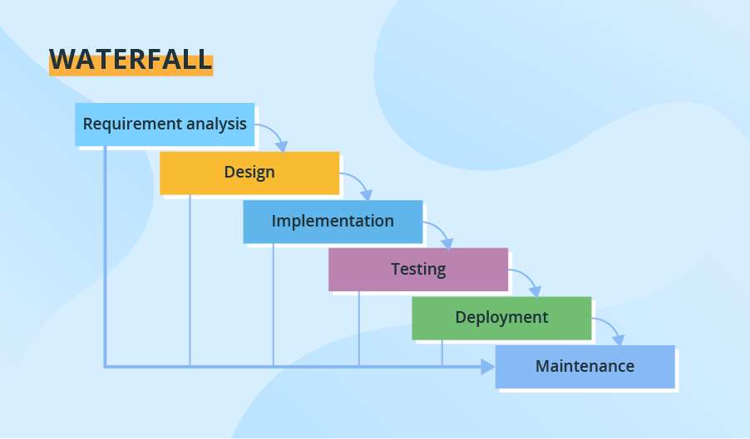
Figure 1 Waterfall Software Development Model

Waterfall Software Development Model
The figure above shows how the researchers will develop the application. Each step should be completed and repeated in parallel with the system requirements and user demands. As a result, the planning work should be handled to guarantee that the planned work is completed adequately without having to repeat the process.
Requirement and Analysis Phase
This phase is the first stage which includes the tasks that go into defining the needs or conditions to satisfy for a new product, as well as identifying the software development stakeholder. This phase is critical for defining the high-level scope, first requirement stack, and architectural vision. Analyze user demands and define core functionality, including the creation of a complete list of functional and non-functional requirements.
System Design Phase
Design is where the technical of the application comes into play. Designing the technical architecture entails selecting hardware and software that will best suit the system and its future requirements. Each application's inputs, processes, and outputs will be documented.
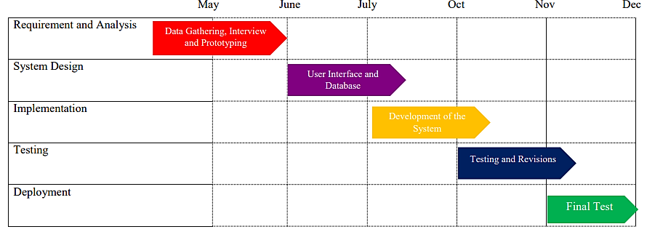Figure 2 Implementation Phase

Implementation Phase
The figure above shows how the researchers will implement the system. It includes detailed design specification for the system development, and coding.
Testing Phase
The system is tested at this phase, and the developed application is installed for the user to utilize. Things change throughout time, and a specific portion of a software may require maintenance.
Deployment of the System Phase
The system is deployed at the user side, after it has undergone through testing. After the deployment of the system, routine maintenance work is carried out. If the user requests adjustments or enhancements after the system has been deployed, the entire process is restarted.
Maintenance Phase
Software maintenance is the modification of a software product after it has been delivered to rectify flaws, enhance performance, or adapt the product to a changed environment.

Locale of the Study
The study will be conducted in Aparri, Northern Cagayan Province, Philippines. Particularly, the study focused on collection of data from tricycle drivers and tricycle commuters of Aparri.

Participants or Respondents of the Study
The participants of the study will be ten (10) TODA Operator, fifteen (15) tricycle drivers, thirty (30) tricycle commuters residing at Aparri, Cagayan, and fourteen (14) IT Experts to evaluate the overall features of the app with the total of sixty-nine (69) participants. The researchers will use random sampling to ensure the reliability and validity of the study. The general intent of the study is to determine the significant difference between the present manual system and the developed one.
Table 1 Participants of the Study
Participants | Frequency | Percentage
IT Experts | 14 | 14%
Toda Operator | 10 | 10%
Tricycle Owners | 15 | 15%
Passengers | 30 | 30%
Total | 69 | 100%

Data Gathering Tools and Instruments
The study made use of the following data gathering tools and instruments.
- Observation Field Notes - is the process of collecting data and information directly by observing people and places at the sites. The researchers’ uses observation field notes to observe in order to obtain any information regarding the process, practices, issues and existing problems in traditional way of riding a tricycle. The observation field notes is attached in appendices.
- Internet Research –The researchers will make use this method in searching and gathering information pertaining to the different problems encountered in the study that we’re obtained as reliable resources through internet.
- Evaluation Questionnaire - the assessment questionnaire used for assessing the extent of compliance of the developed app is the ISO 25010:2011 was adopted from the latter standard (International Standards Organization, 2019). The tool has been reported to be reliable and has been used internationally for analyzing various information systems and online platforms. The questionnaire is consist of two parts, Part I is consist of the basic information of the participants and Part II is the 5-point likert scale following the ISO 25010:2011 software quality. The copy of the questionnaire is attached at the appendices.

Hardware tools to be used
The researcher will make use of standard PC desktop or laptop with Microsoft Windows 10 operating system with the recommended minimum specification:
- RAM 4GB
- Processor Intel Core i3 2.7 GHZ and,
- Hard Disk Drive at least 500 GB.
Hardware Specification of the Proposed Project
The proposed project will make use of a standard PC desktop or laptop to run properly. With the following minimum specifications:
- Microsoft Windows 10 Operating System
- RAM of 8 GB
- Processor Intel Core i3 2.7 GHZ and,
- Hard Disk Drive at least 500 GB

Software Tools to be used
Programming Language: PHP – (PDO)
PHP is a server scripting language, and a powerful tool for making dynamic and interactive Web pages. PHP is a widely-used, free and efficient alternative to competitors such as Microsoft’s ASP. PHP 7 is the latest stable release
Front-End Language: HTML, JavaScript, BootStrap 4 and JQuery
HTML is the standard markup language for creating Web pages. JavaScript is the world’s most popular programming language. JavaScript is the programming language of the Web.
Database Management System: XAMPP/ SQL
XAMPP is a free and open-source cross-platform web server solution stack package developed by Apache Friends, consisting mainly of the Apache HTTP Server, MariaDB database and interpreters for script written in the PHP and Perl programming languages.
Software Specification of the Proposed Project
XAMPP – It is an open-source package of web solutions that includes Apache distribution for many servers and command-line executable along with modules such as Apache server, MariaDB, PHP, and Perl.
BROWSERS – A browser is an application program that provides a way to look at and interact with all the information on the World Wide Web. A Web browser is a client program that uses HTTP (Hypertext Transfer Protocol) to make requests of Web servers throughout the Internet on behalf of the browser user.
Online-hosting Requirements of the Proposed Project
Domain/Hosting – A domain host is an internet service that manages your domain name, such as example.com. Domain hosts use of Domain Name System (DNS) records to connect your domain name with email, websites and other web services.
WEB.com.ph - is a Filipino company that provides reliable IT infrastructure and web solutions.
Data Gathering Procedure
The following steps were followed in the collection of the data.
- A formal request was made via communication for the actual collecting of data. The copy of the letter is attached in appendices.
- The project objectives were presented, as well as the purpose of the study and its benefits to the participants. Their agreement was made through a form, and their significant involvement in the study will be reported.
- Prior to the development of the app, the researchers will be the one to gather information thru field notes (See Appendix J) to support the validity and reliability of the data. The researchers also consulted in the internet, books and tutorials that are conducive in developing the app.
- The app was subjected for initialization after integrating all the modules and processes.
- The participants were given a day to test the app. Questionnaires will be distributed to the TODA operators, tricycle owners, and passengers to evaluate the app in terms of satisfaction and acceptability. The assessment questionnaire used for assessing the extent of compliance of the developed app is the ISO 25010:2011. Random sampling will be used by the researchers to choose the population to use for a study. Data will be tabulated, analysis of these will be made and the results will be presented.

Data Analysis
The data obtained was tabulated, processed and presented through descriptive statistics. Frequency counts, percentages and weighted means accounted on the assessment of the app using the following 5-point Likert Scale:
Table 1: Measurement Extent of Compliance of the Developed App following the ISO 25010:2011 Software Quality
Numerical Inputs | Weighted Mean | Verbal Interpretation
5 | 4.21 – 5.00 | High Extent
4 | 3.41 – 4.20 | Extent
3 | 2.61 – 3.40 | Moderate Extent
2 | 1.81 – 2.60 | Low Extent
1 | 1.00 – 1.80 | Very Low Extent

Likert Scale - It functions by having a person complete a questionnaire that requires them to indicate the extent to which they agree or disagree with a series of statements.
Weighted Mean - The proponents will be use the mean to measure the ratings of the respondents regarding on the performance and effectiveness of the proposed system.
Weighted Mean (WM) = Σfx1+x2+ ….. + xnN Where: f(x1+x2+ ….. + xn)
N= Represents the summation of all means of each criterion.
N = number of criteria
Percentage - This is used to determine the qualitative ratio of the data gathered. is a number or ratio expressed as a fraction of 100.
Percentage (P)= FN*100
Where:
F = frequency of a numeric rating for some given criteria.
N=represents the total number of the respondents

REFERENCES
[1] N. Binti, “Transportation Booking System via Mobile Computing”, 2018, pp. 1. https://myfik.unisza.edu.my/www/fyp/fyp17sem2/report/040101.pdf
[2] N. Espiritu, et al., “Tatlong Gulong ng Buhay: The Tricycle Drivers and their Lived Experiences during Pandemic”, pp. 822-827, January 2021. https://www.researchgate.net/publication/349064426_Tatlong_Gulong_ng_Buhay_The_Tricycle_Drivers_and_their_Lived_Experiences_During_the_Pandemic
[3] T. Umali, “Tricycle-hailing App to ease Commuting at Night”, Open Gov Asia, February 2019. https://opengovasia.com/tricycle-hailing-app-to-ease-commuting-at-night/
[4] R.G Antonet, “Zambo City set to Launch Tricycle Booking Application”, Pna Gov, October 2020. https://www.pna.gov.ph/articles/1118038
[5] J.M Huerta, “Tricycle Ride in the Philippines”, The Daily Roar, January 2014. https://thedailyroar.com/culture/a-tricycle-ride-in-the-philippines/
[6] S. Lenoir, “Why Should Tour & Activity Operators Offer Online Bookings”, Redzy, February 2013. https://www.rezdy.com/blog/why-should-tour-activity-operators-offer-online-bookings/
[7] D. Walters, “The Advantages of Mobile Apps”, Infomedia, July 2011. http://infomedia.com/blog/the-advantages-of-mobile-apps/
[8] R. Harrison, et al., “Usability of mobile applications” Journal of an Interaction Science, 2013, pp. 10. http://www.journalofinteractionscience.com/content/1/1/1
[9] C. San Jose, “New Tricycle Hailing App provide ridesm delivery or pabili services for Pasig Residents”, NOLISOLI, October 2020. https://nolisoli.ph/88521/mytoda-tricycle-ride-hailing-app-pabili-pasig-csanjose-20201028/

APPENDICES
This includes the Communication Letters, Hierarchical Input-Process-Output Diagram, Data Flow Diagram, Context Diagram, Use Case Diagram, System Architecture, Database Design, Table Attributes and Domains, Wire Frames or Physical Screens or Designs, Consent Form, Questionnaire, Field Notes, Gantt Chart or Timeline of Activities and Curriculum Vitae.

- Communication Letters

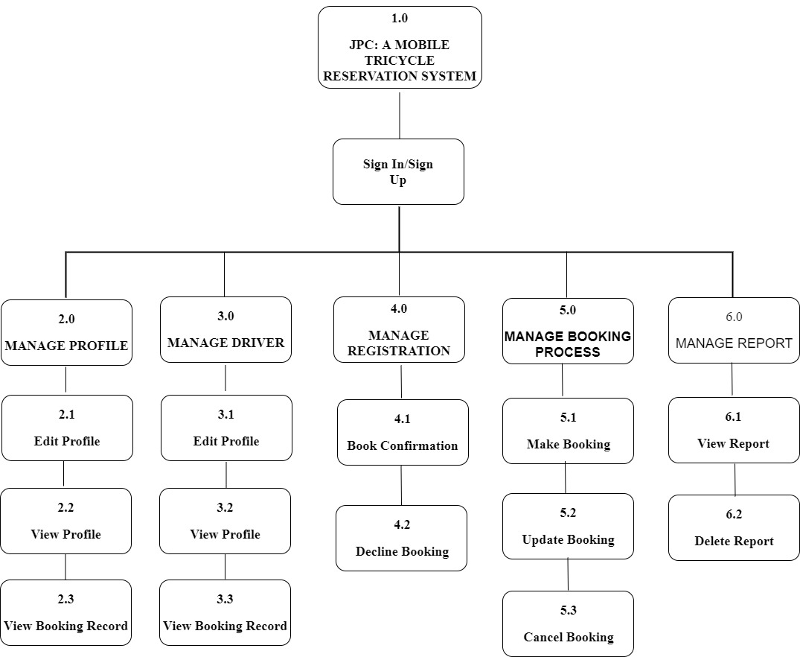
- Hierarchy-Input-Output-Process
Figure 2 The HIPO Diagram (Hierarchy-Input-Process Output Diagram)
The Figure 2 illustrates the hierarchy input-process-output of the study, wherein they are classified with levels.
The main module control module which is the JPC: A Mobile Tricycle Reservation App, it accepts transactions, determine transaction type and calls one for its six subordinates: Level 2.0 Manage Profile, Level 3.0 Manage Driver Level 4.0 Manage Registration Level 5.0 Manage Booking Process and Level 6.0 Manage Report.
The lower-level modules are the processing steps that the Application must perform.

- Data Flow Diagram
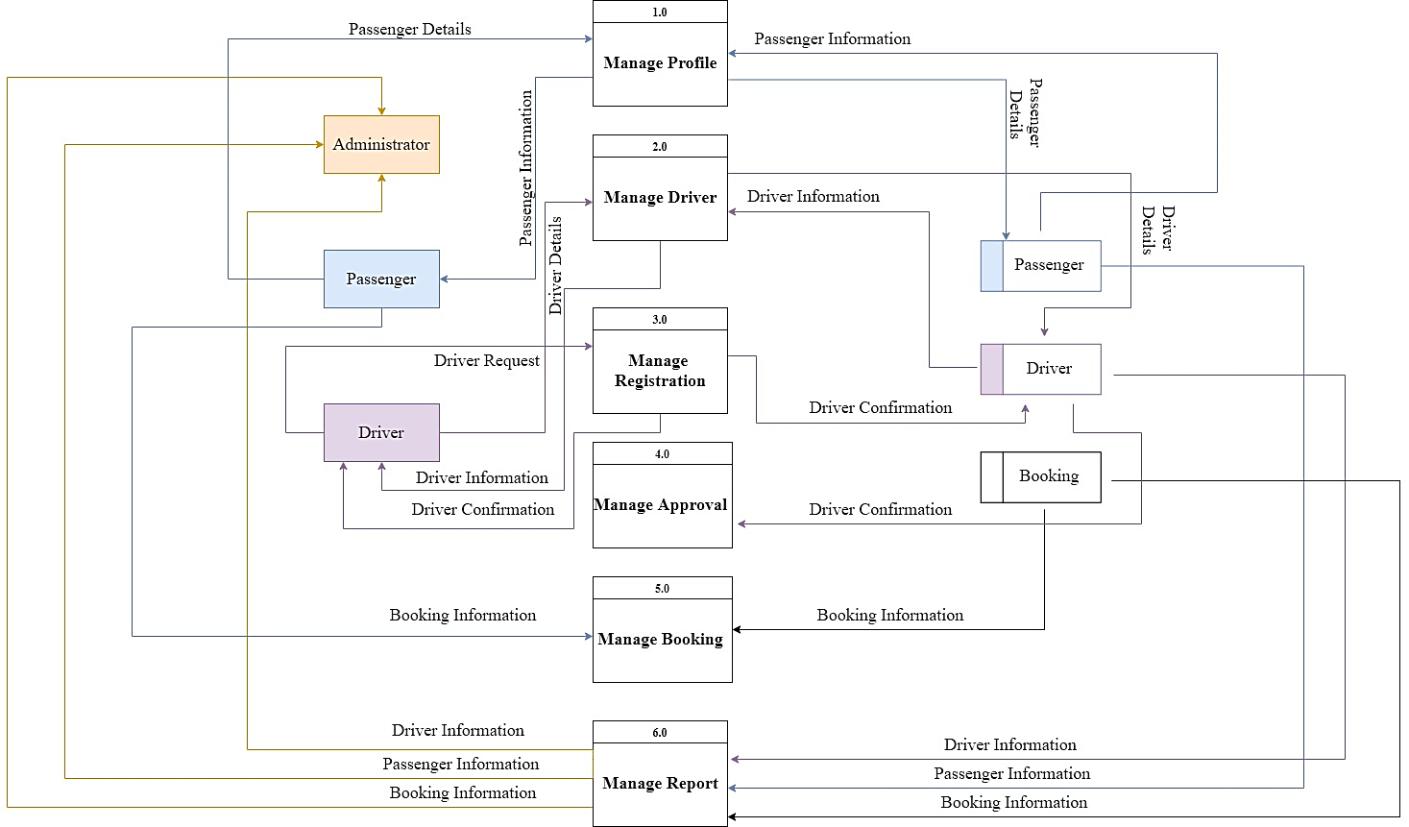
Figure 5 The Context Diagram
Figure 5 depicts an in-depth process flow of the system based on the Context Diagram that was previously discussed. This is where the systems’ detailed functionality will be expanded in order to better understand what the system can do.
JPC: A Mobile Tricycle Reservation App has six processes: Passenger Profile, Driver Profile, Registration, Approval, Booking, and Report. Administrator, passenger, driver, and booking are the four data stores involved.
- Context Diagram
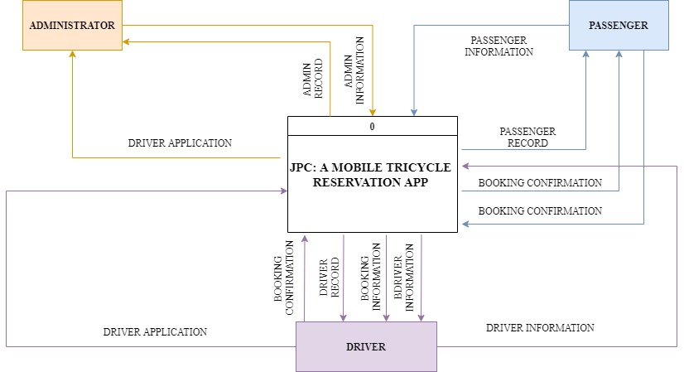
Figure 3 The Context Diagram
The Figure 3 shows the Context Diagram for JPC: A Mobile Tricycle Reservation App. Since the App is involve with three entity which are Admin, Tricycle Driver and Passenger, the context diagram will explain much about the flow between those three entity and what are they are capable of to do with their own authorization.

- USE CASE DIAGRAM
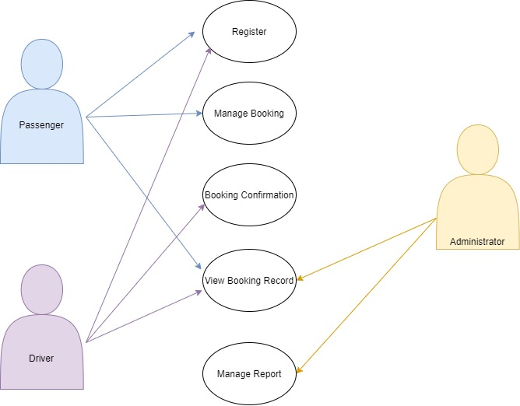
Figure 4 Use Case Diagram
The user engaged in utilizing the system are depicted in the figure above. First, the Administrator will manage the report and can view booking records of both users. Passenger will register to the system, manage booking and can view booking records. The driver will also register to the system, confirm bookings and view booking records.

- System Architecture
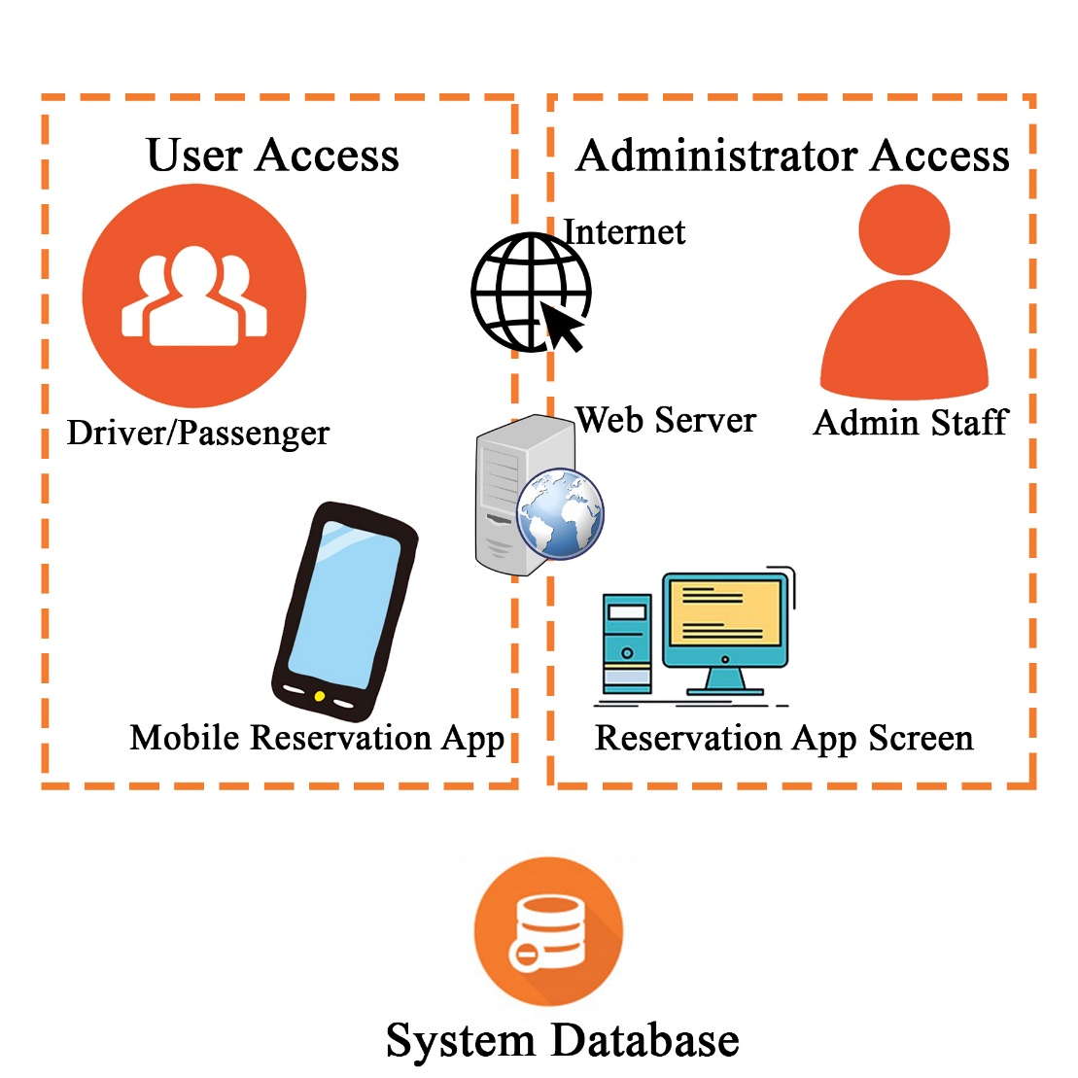

Figure 6 The System Architecture of the Project
The Architectural Diagram above depicts the “JPC: A Mobile Tricycle Reservation App.” The process of the app is that the Driver and Passenger can register to the Mobile Application. The Admin is the one who can accept drivers’ registration request if and only if the driver requirements are complete. After registering, the driver and passenger can use the mobile app by entering their username and password. The transaction record is automatically saved in the database.

- Database Design, Table Attributes and Domaina
Database Name: DB_JPC

Table 1 Registration of the Passenger
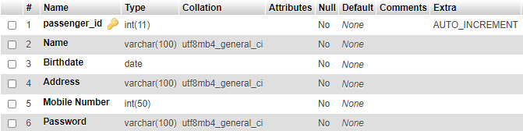
Table 1 will store the information of the passenger.
Table 2 Passenger Reservation Details
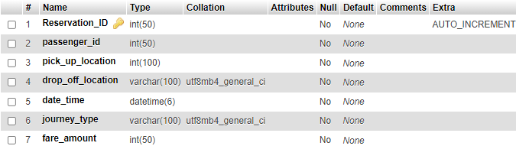

Table 2 will store the reservation details made by the passenger.

Table 3 Passenger Reservation Status

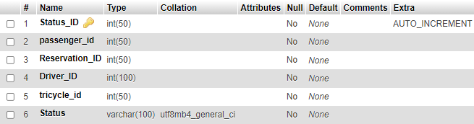

Table 3 will store the status of reservation made by the passenger.

Table 4: Reservation Drivers Details
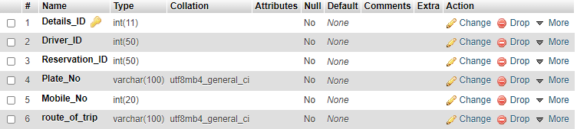
Table 4 will store the details of the driver that the passenger reserved.
Table 5 Drivers’ Information

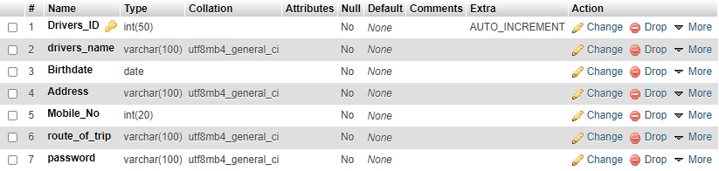

Table 5 will store the information of the driver.

Table 6 Tricycle Details

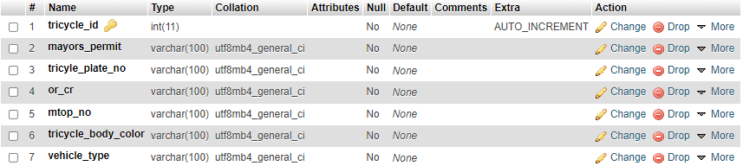
Table 6 will store the information of the tricycle.
Table 7 Admin Information

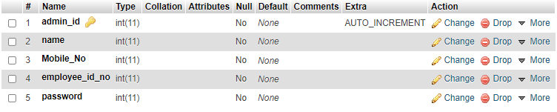
Table 7 will store the information of the admin.

Table 8 Reports

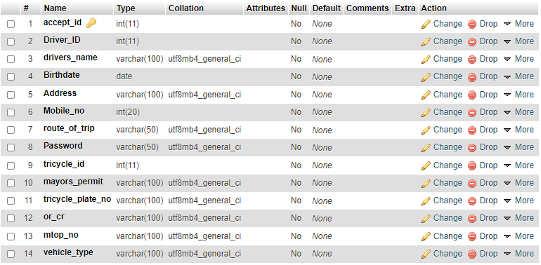
Table 8 will store and holds the transaction record of the users.

- Wire Frames or Physical Screens or Designs
WIREFRAMES
ADMIN
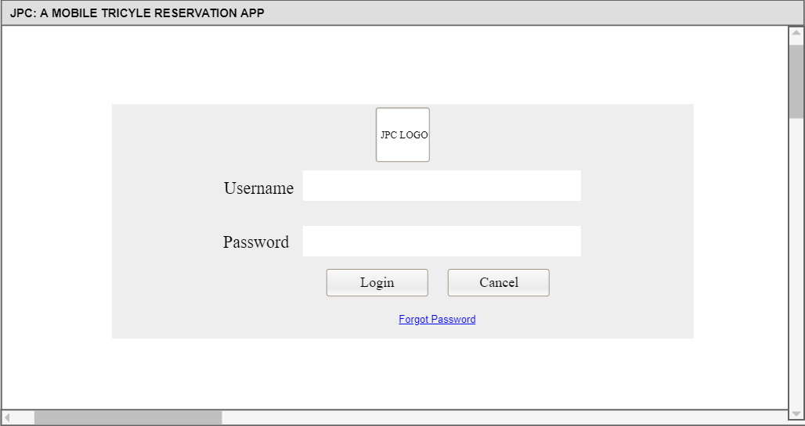
Figure 1 Login Page
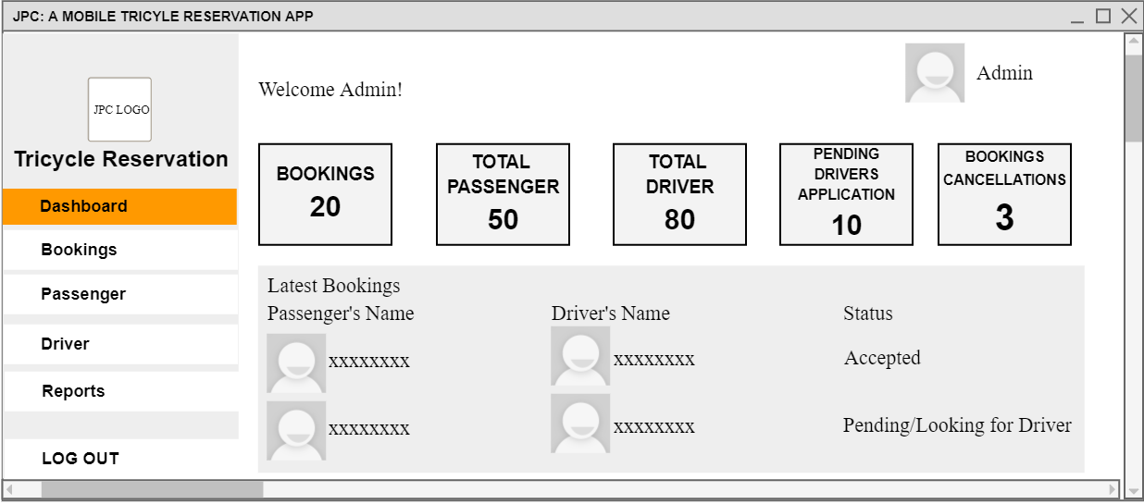
Figure 2 Dashboard
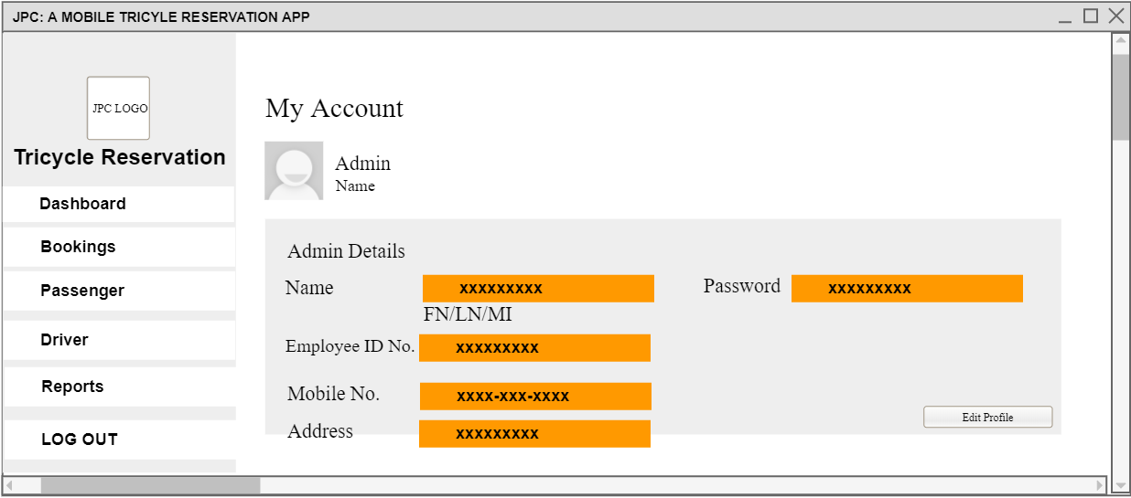
Figure 3 My Account Admin Details
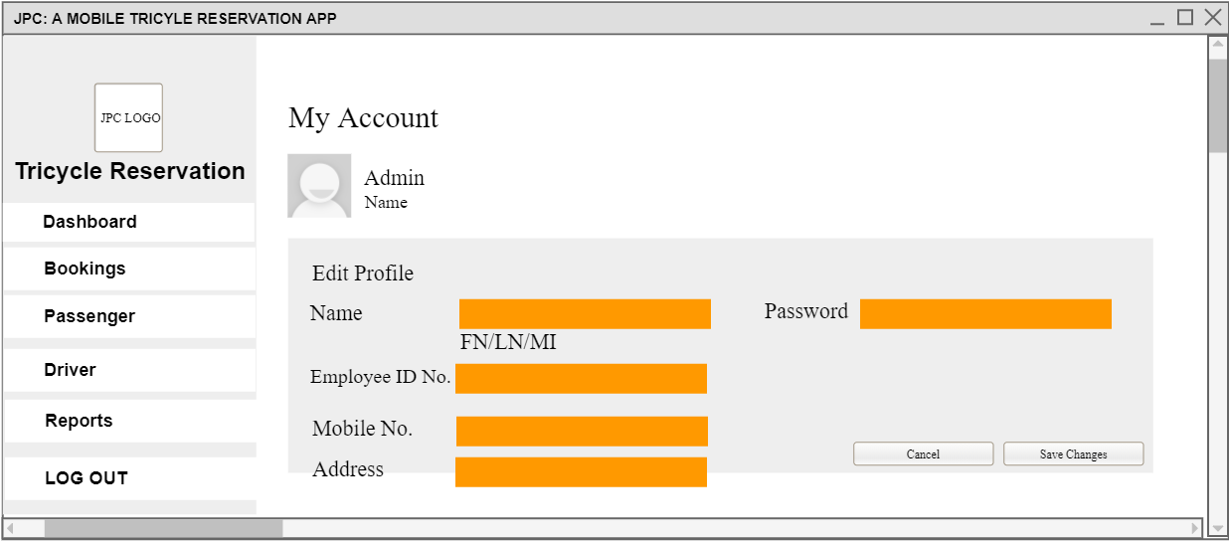
Figure 4 My Account Edit Profile

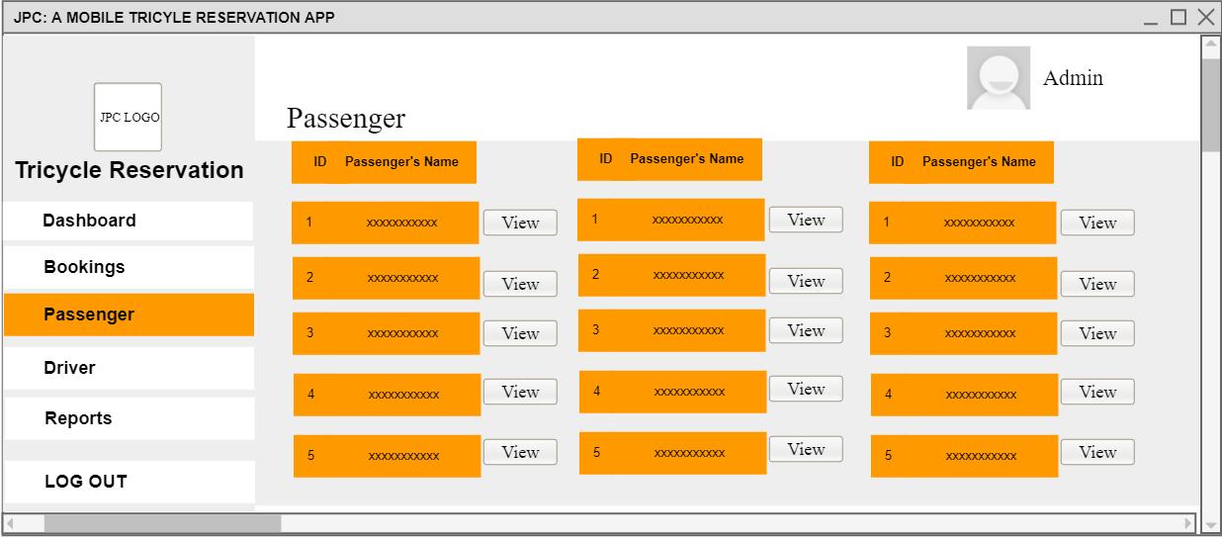
Figure 5 Passenger
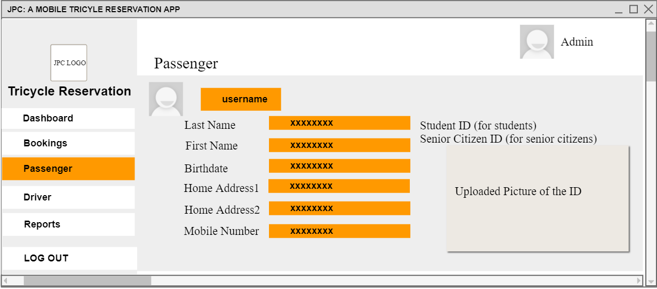
Figure 6 View Passenger Information
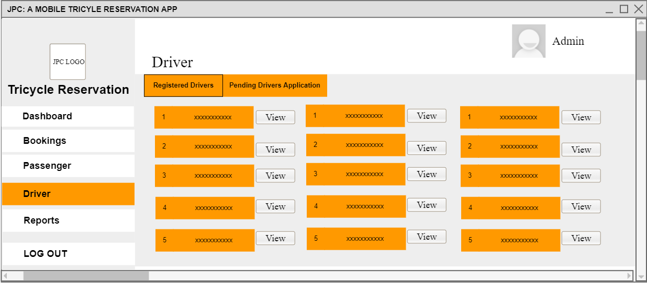
Figure 7 Registered Drivers
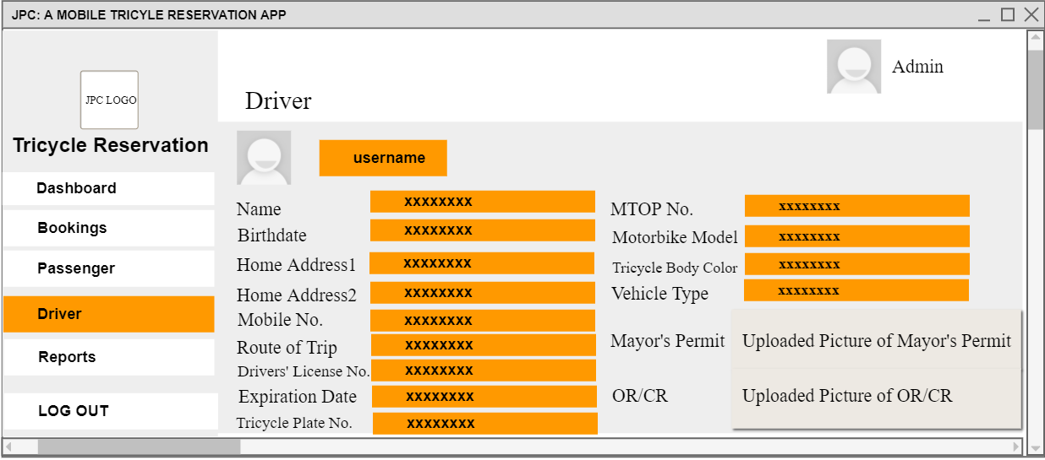
Figure 8 View Registered Drivers Details

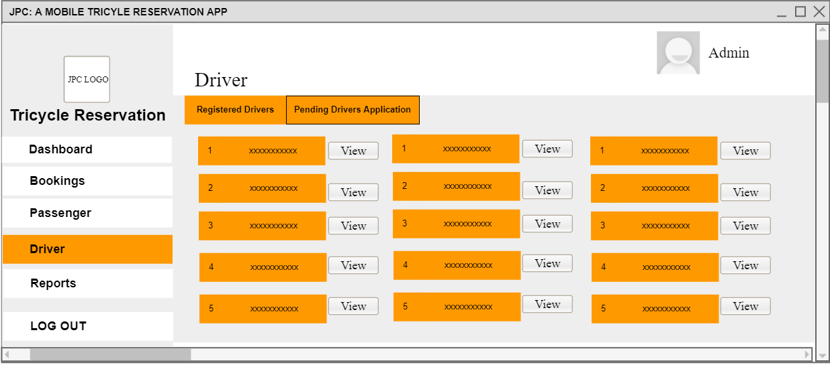
Figure 9 Pending Drivers’ Application
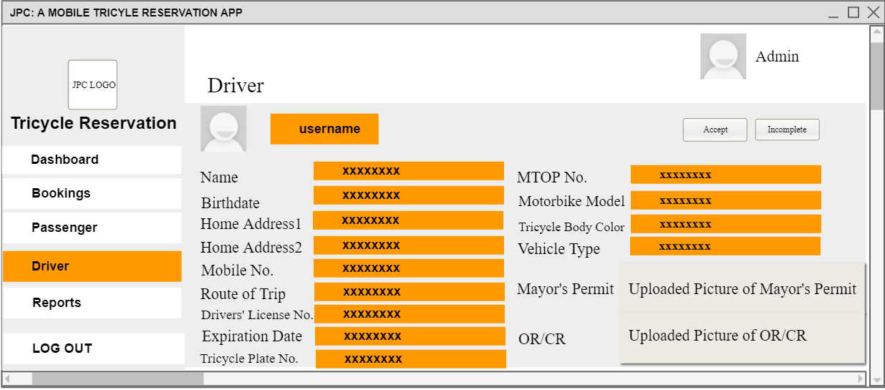
Figure 10 View Pending Drivers’ Application
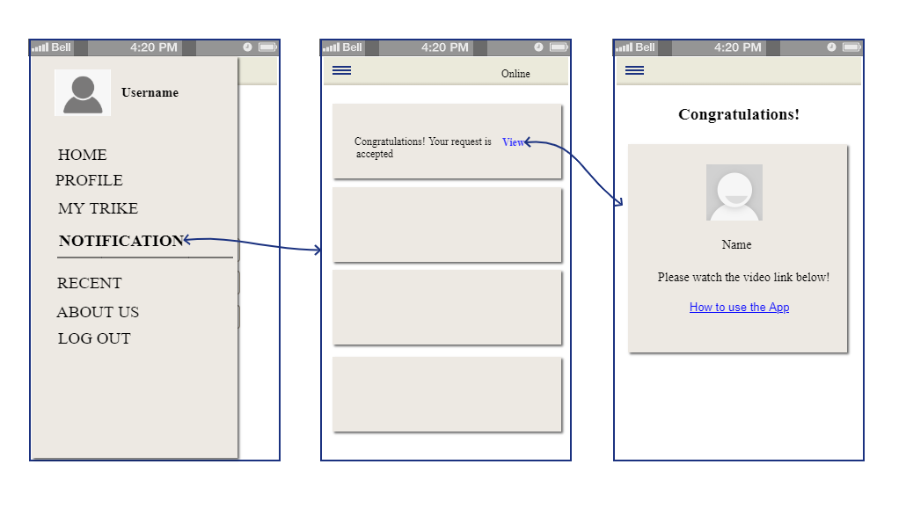
Figure 11 Accepted Application
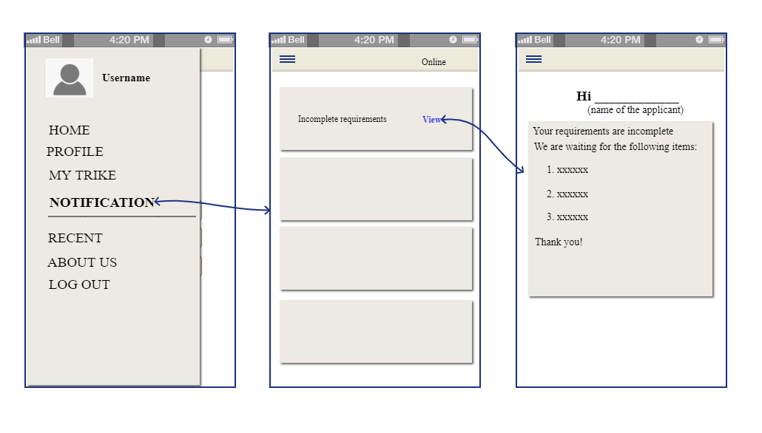
Figure 12 Incomplete Requirements
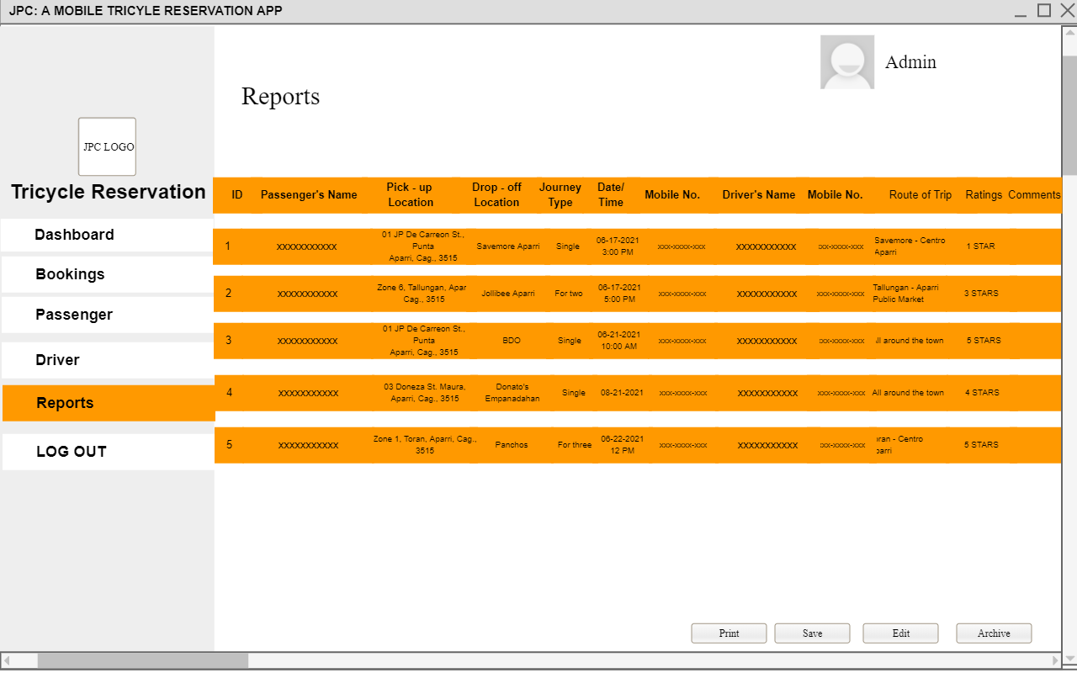
Figure 13 Reports

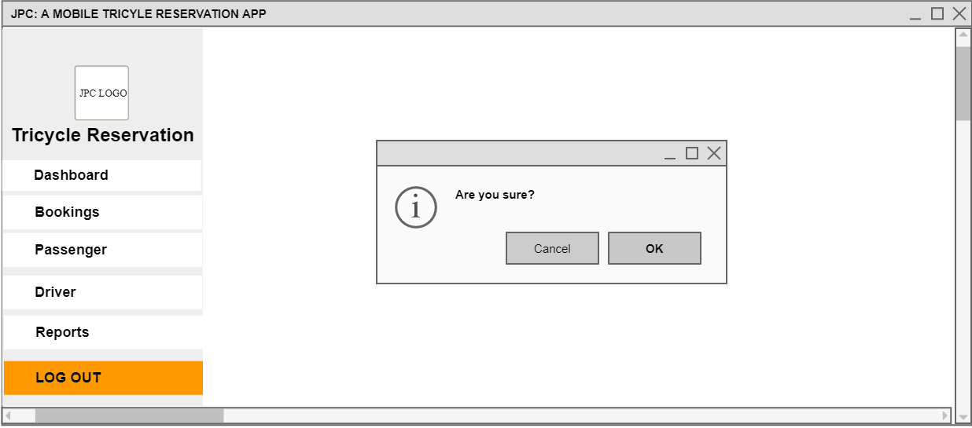
Figure 14 Logout (CANCEL)
Figure 15 Back to Dashboard
Figure 16 Logout (OK)
Figure 17 Back to Login Page

DRIVER
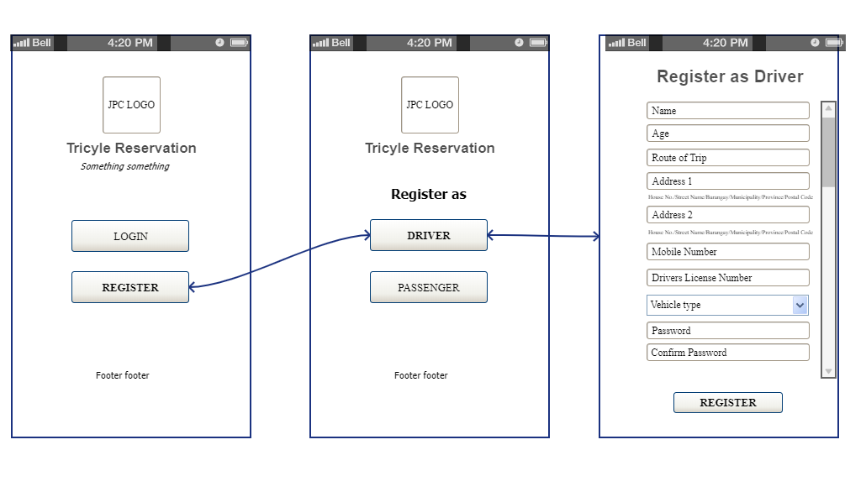
Figure 18 Registration Page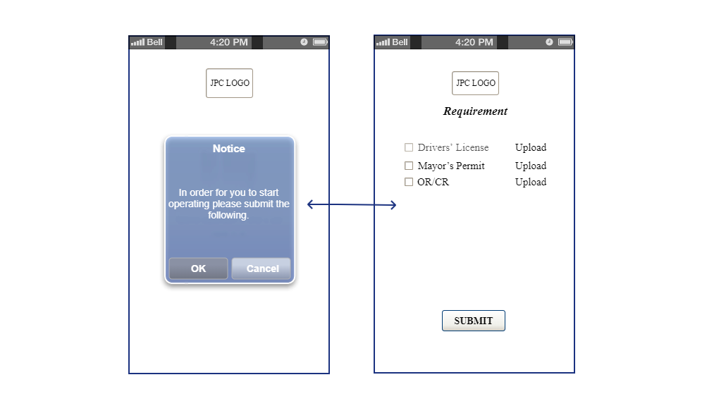Figure 19 Registration Page
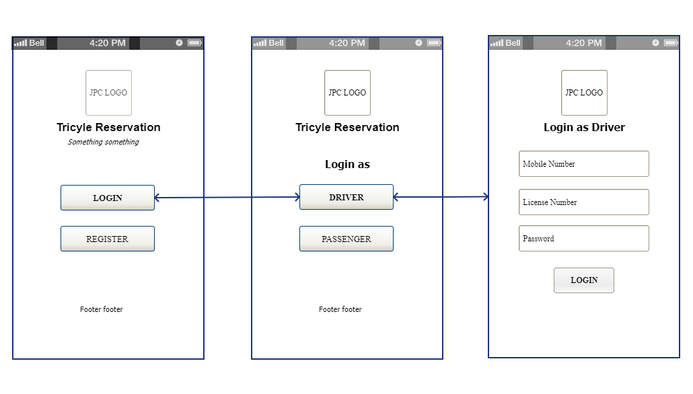
Figure 20 Login Page
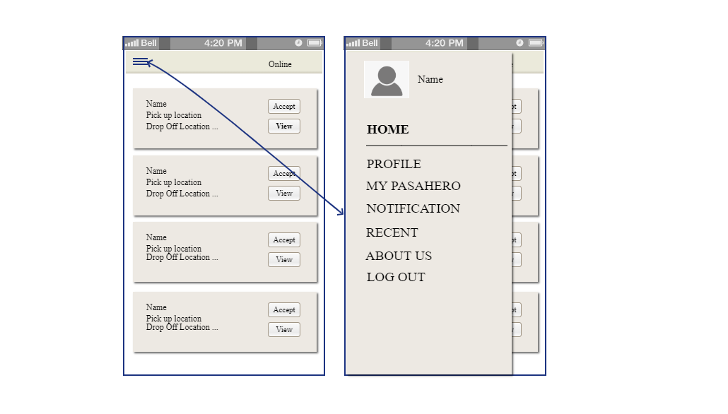
Figure 21 Home Page
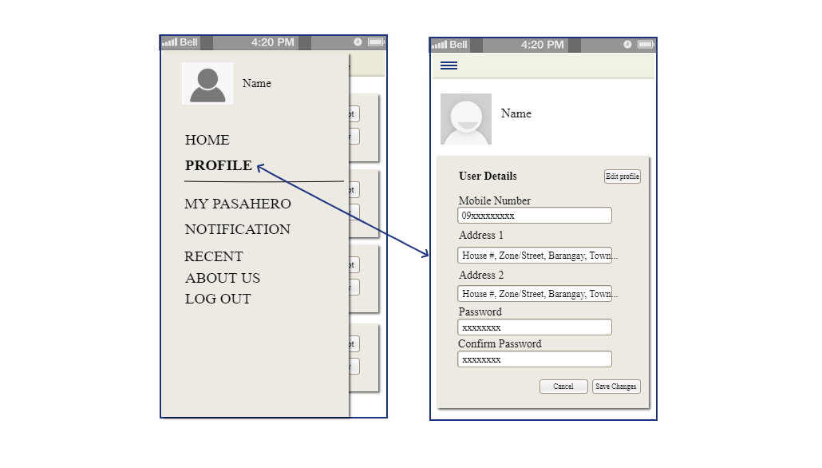
Figure 22 Profile
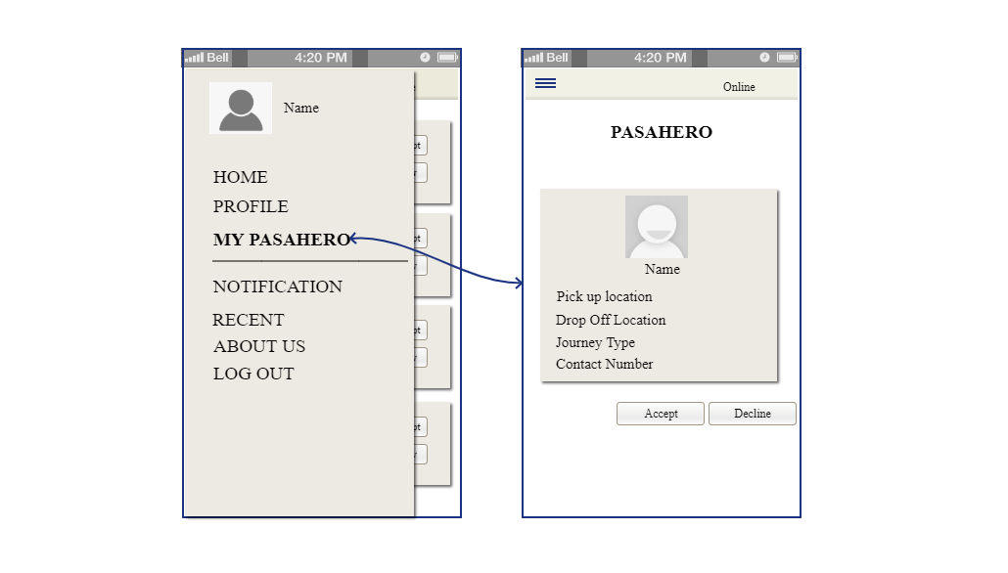
Figure 23 Accepting/Declining Passengers
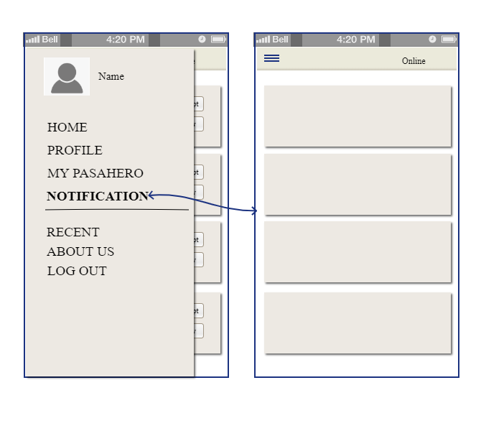
Figure 24 Notification Page
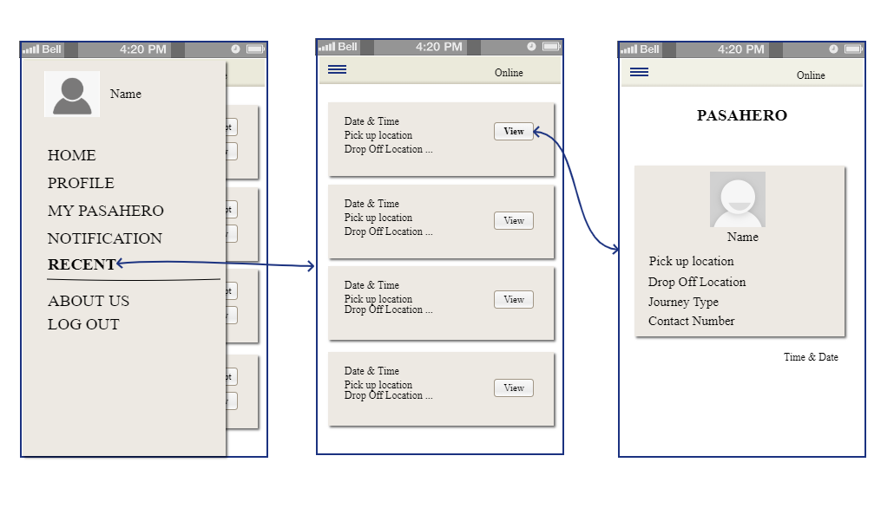
Figure 25 Recent/Transaction History
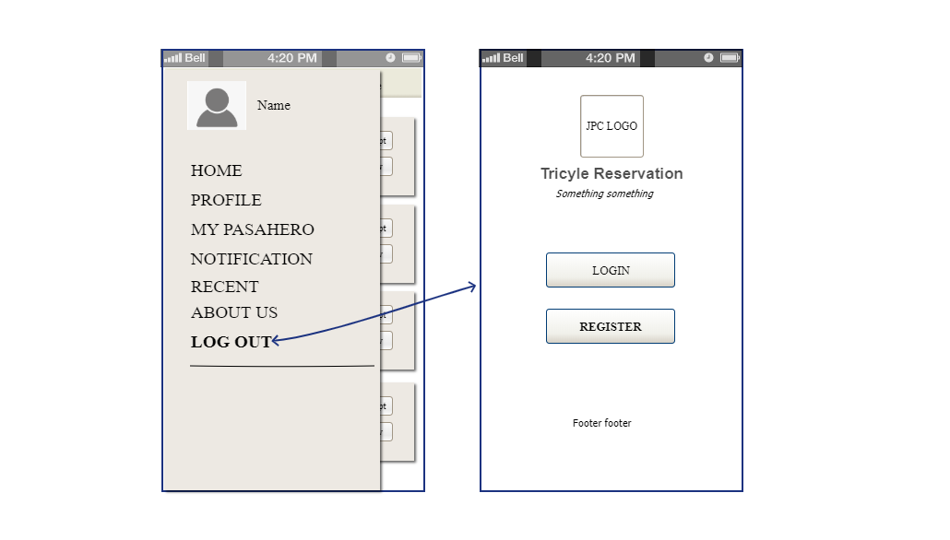
Figure 26 Logout Page
PASSENGER
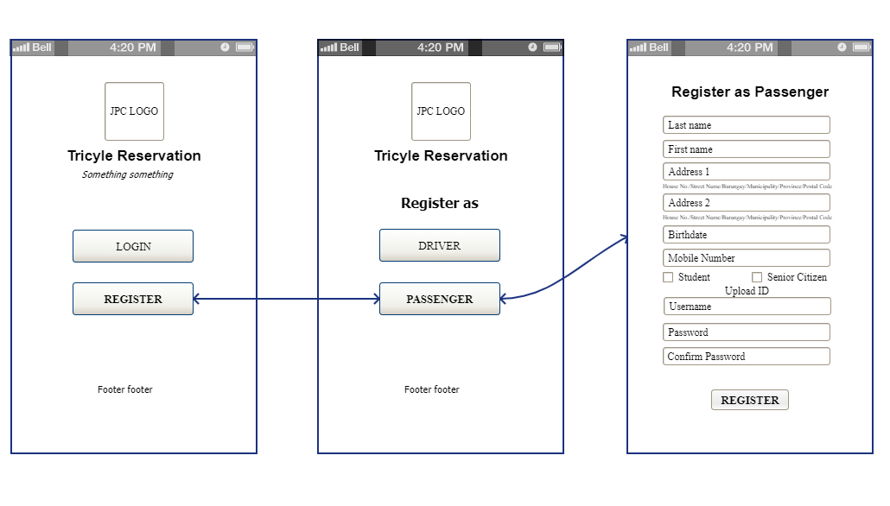
Figure 27 Registration Page
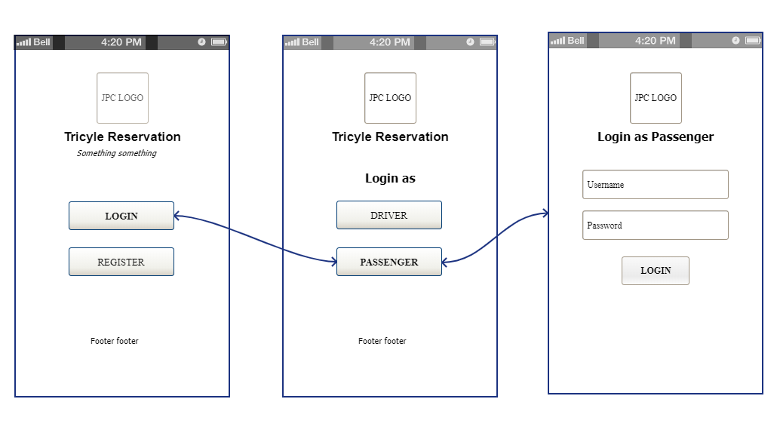
Figure 28 Login Page
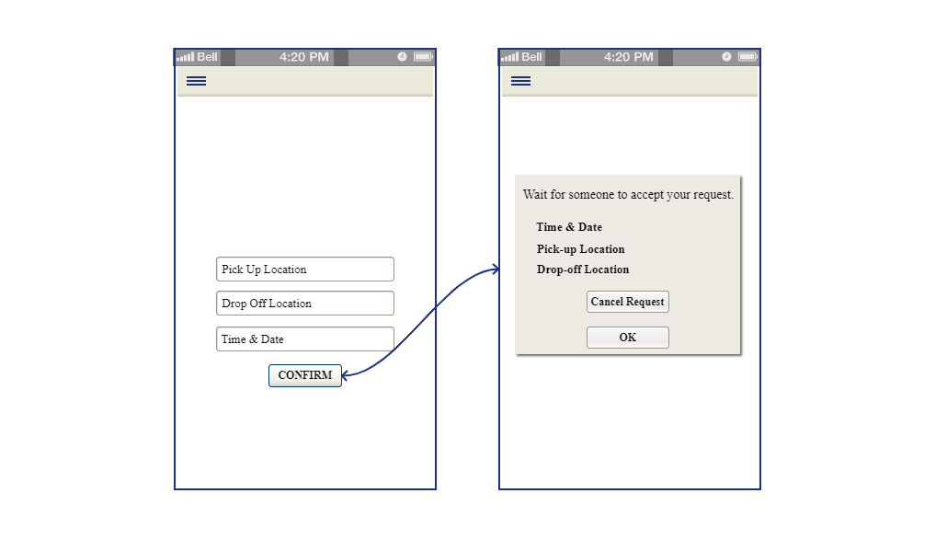
Figure 29 Home Page
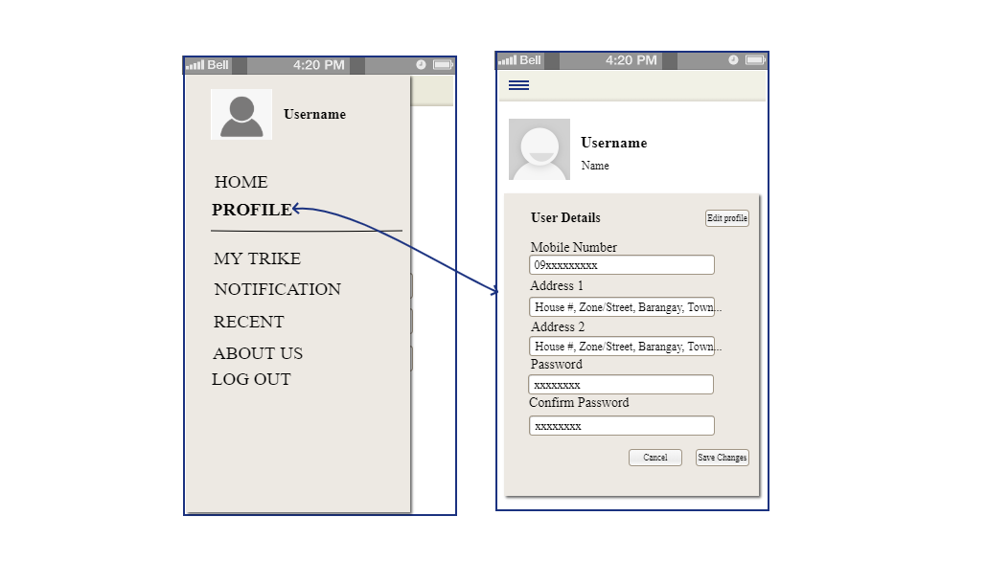
Figure 30 Profile
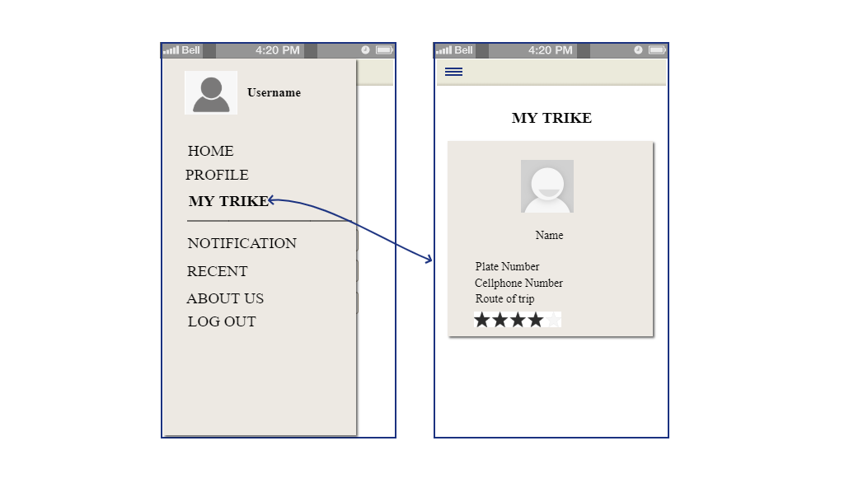
Figure 31 Drivers Details
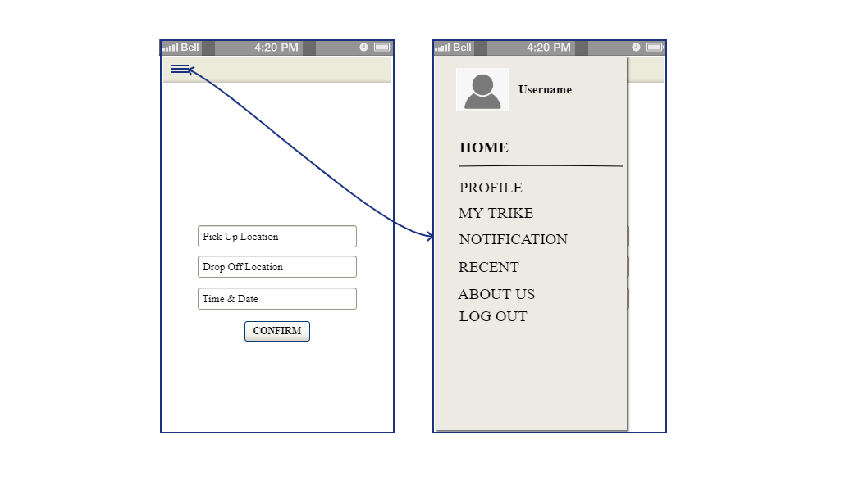
Figure 32 Notification Page
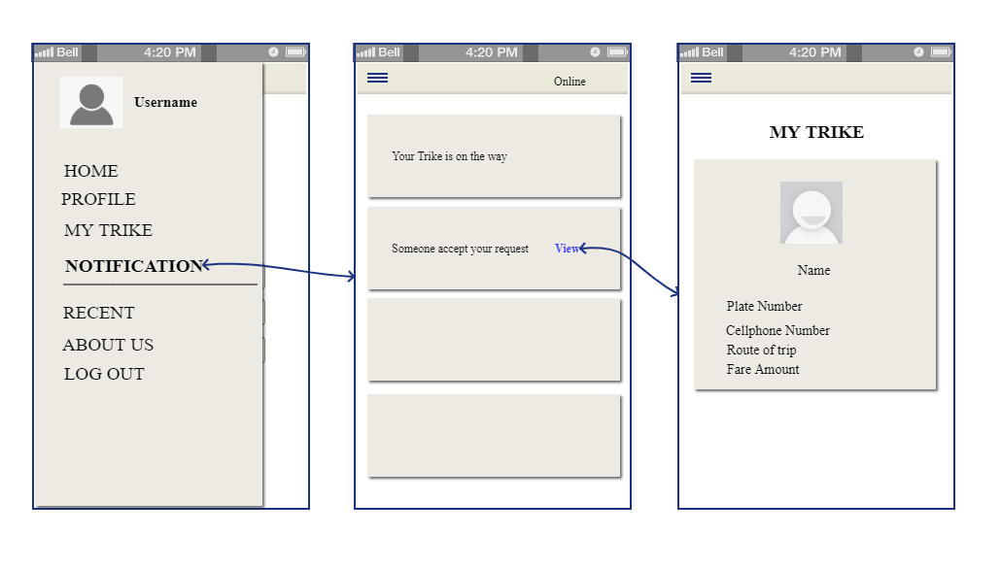
Figure 33 Notification Page
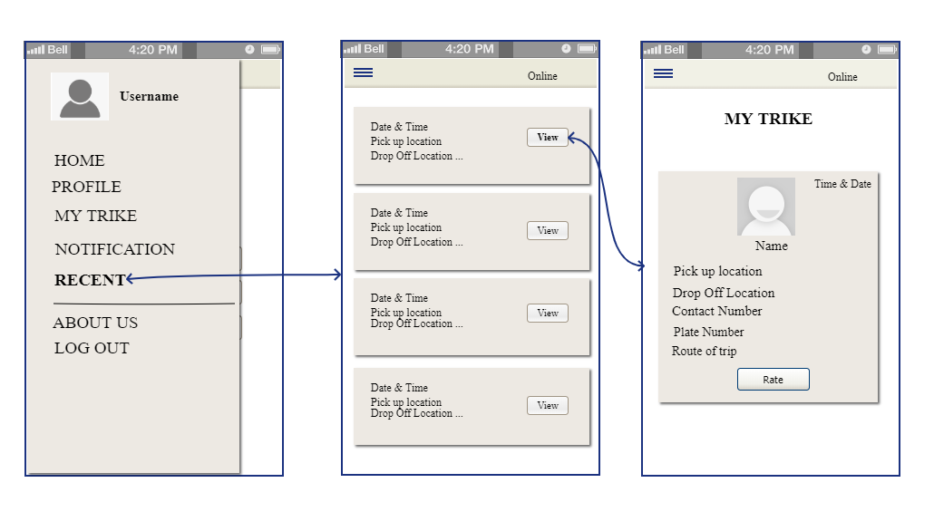
Figure 34 Recent/Transaction History
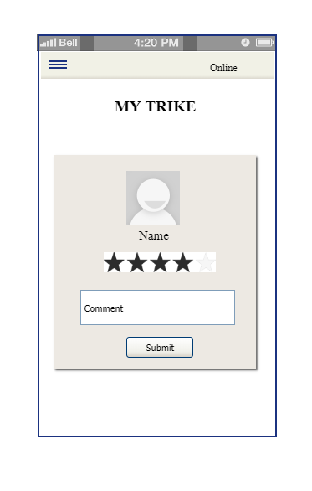
Figure 35 Rate a Driver
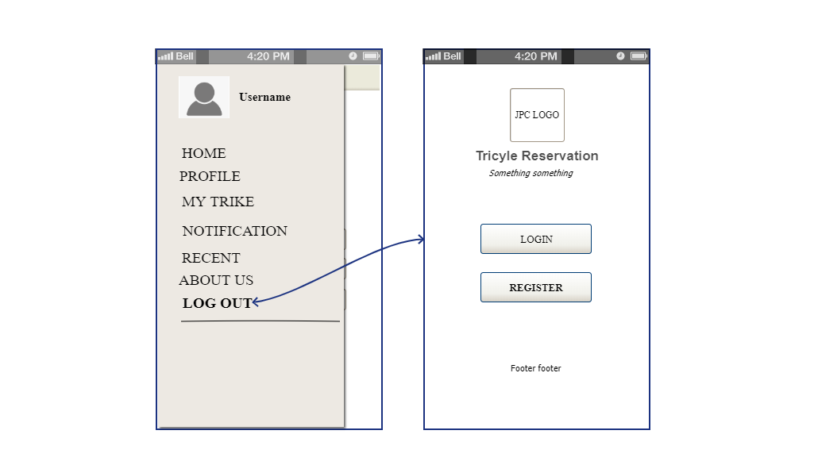
Figure 36 Logout Page
- Consent Form

- Questionnaire
EVALUATION TOOL
JPC: A MOBILE TRICYCLE RESERVATION APP
Part I: Basic Information
Name (optional):
Sex: ____Male ____Female | Do you have smartphone?  ____Yes ____No
Respondent Type: ____User ____IT Expert | Do you have access to internet?  ____Yes ____No

Part II: Assessment of the Extent of Compliance to ISO 25010:2011 Software Quality
5 – very high extent 4 – high extent 3 – moderate extent 2 – low extent 1 – very low extent
- Functionality Suitability | 5 | 4 | 3 | 2 | 1 | Comments
- The information is effective and helpful to complete what is needed.
- The system/website has all the functions and capabilities needed.
- The system/website provides error messages /notifications that are clearly understandable.
- Performance Stability | 5 | 4 | 3 | 2 | 1 | Comments
- The same function (e.g. booking, editing and viewing) be used by more than one person at the same time with efficiency.
- The software/website support group’s devices with application upgrades or browser updates.
- The software/website or project forms, tables, data grids or webpage contents are being displayed and viewed real-time without carrying runtime errors.
- Compatibility | 5 | 4 | 3 | 2 | 1 | Comments
- The software/website is compatible with input/output standards, Programming language and Database standards.
- The system/website is compatible and responsive to any device in any type of resolution.
- The system/website is accessible and compatible on Windows, Mac and open source platforms.
- Usability | 5 | 4 | 3 | 2 | 1 | Comments
- The system/website can operate 24/7 even outside human interaction.
- The system/website menus, links, and buttons are working properly on specified use.
- The system/website allows me to efficiently complete any process or transaction with faster turn-around.
- Reliability | 5 | 4 | 3 | 2 | 1 | Comments
- Information provided/posted on the system/website are current and reliable.
- The information provided by the system/website is easy to understand.
- Clear information (such as online help, on-screen messages, and other documentation) are present and provided with the system/website.
- Security | 5 | 4 | 3 | 2 | 1 | Comments
- The system/website security features covers Admin System access, Feature access, Database field access, Master file changes and Standing data.
- The reports produced by the system/website are detailed and protected by access levels.
- Each user have a personal password, users have different permission levels and security management system logs, data and security of the database.
- Maintainability | 5 | 4 | 3 | 2 | 1 | Comments
- The system/website is easy to maintain even without technical support.
- The system/website provides administrative control panel that allows information to be updated real-time in its windows forms, tables or web pages.
- The system/website has a comprehensive & user-friendly that includes help & support and user’s guide.
- Portability | 5 | 4 | 3 | 2 | 1 | Comments
- The system/website can be transferred to any workstation and/ or webhost or any platform.
- The system/website is accessible at all types of devices or workstation.
- The system/website can be easily transferred without fear of system failure and/or data loss.
Signature of Respondent ________________________________ Date __________________

- Observation Field Notes
The municipality of Aparri sits at the mouth of the Cagayan River, the longest river in the Philippines, about 55 miles north of Tuguegarao, the provincial capital. And from this the major transportation of the people of aparri is tricycle. The most popular means of transportation in the municipality. These vehicles have been around for quite some time that banning them is really impossible.
Tricycle or sometimes called as “trike” is a three-wheeled public utility vehicle consisting of a motorcycle and an attached passenger’s side car. The motorcycle is on the left side and a side car on the right side. These trikes can be found everywhere in the country except on major or main roads. They are painted colorfully and built in a variety of styles which differ from barangay to barangay. The regular trike can accommodate three to five passengers and luggage can be placed on the roof. Three people can fit inside the side car and usually one or two passengers can ride behind the driver. Jeepneys have fixed routes so the big advantage of the trike is that it will bring you to every desired place.
Fare starts from 9.00 (but now being increase to maximum of 40 due to pandemic) and up, depending on the locality and the distance to be ridden. They are always available, cheap and fast. If you want to pay the lowest fare, you will wait until the trike is filled up with passengers. But if you want the tricycle exclusively, just tell the driver you want a “special” ride. He will charge a little extra but it’s more comfortable to ride alone. But, we encountered some problem to ride a trike's. Like, some of the drivers have a negative attitude, other tricycle driver's don't want to ride you because your location is so far, but some of the driver's will take you but your fare will increase. And others who will pick you but the driver find another passenger before they ride you to your destination.
- Gantt Chart or Timeline of Activities
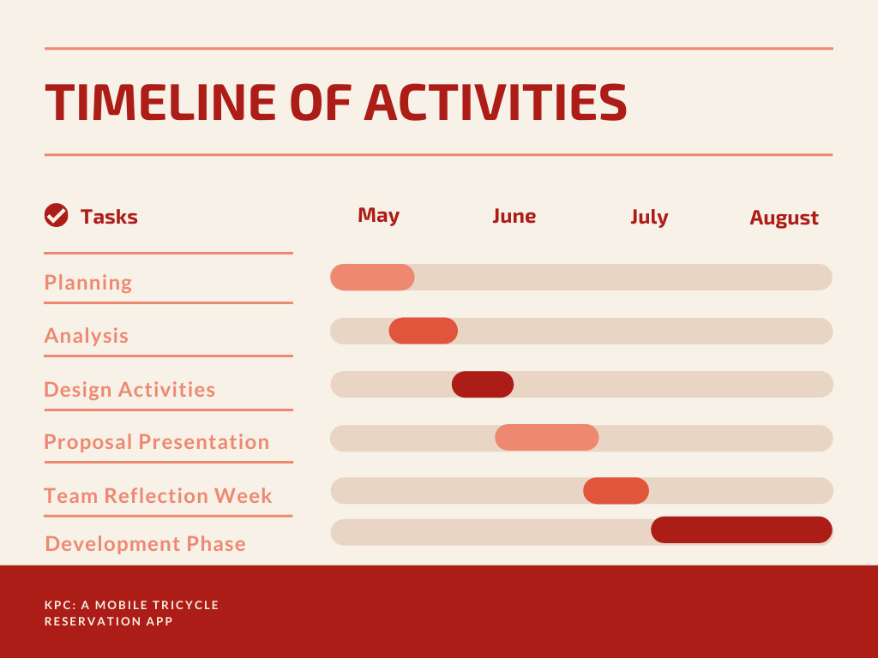
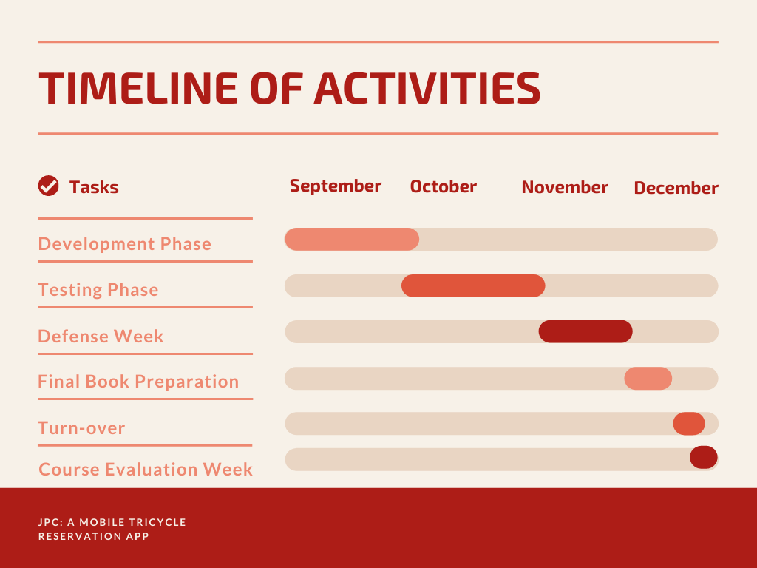

- Curriculum Vitae


PAMELA JOY D. BORJA
Tallungan, Aparri, Cagayan
pamelajoyborja44@gmail.com
099458620277

CAREER AIMS

- To seek a position of significant responsibility which utilizes broad range of my abilities.
- To find a fulfilling employment wherein I could practice and further develop knowledge, skills, and abilities in the field of ICT.
- To work in an office that would enhance my potential and promote growth.
QUALIFICATIONS

Qualified by the ability to develop support and work in a culturally diverse environment.
Communicate with enthusiasm with utmost proficiency and motivate others to meet goals and objectives.
Can work in any place suitable and can work with minimum supervision.
Proficient in computer programs such as MS WORD, MS EXCEL, and MS POWERPOINT.

PERSONAL BACKGROUND

Age: 21
Sex: Female
Civil Status: Single
Birthdate: December 17, 1999
Birthplace: Tallungan, Aparri, Cagayan
Citizenship: Filipino
Religious Affiliation: Roman Catholic
Father’s Name: Albert Borja
Occupation: N/A
Mother’s Name: Jean Borja
Occupation: Cashier
SKILLS

- Oriented in Microsoft Application such us:
- Microsoft Office Word
- Microsoft Publisher
- Microsoft Powerpoint Presentation
- Microsoft Excel
- Capable of creating and editing files and presentation using different Microsoft Windows. And also printing files in different Microsoft Windows.
EDUCATIONAL ATTAINMENT

Tertiary Level: Cagayan State University – Aparri Campus
College of Information and Computing Sciences
Bachelor of Science in Information Technology
3rd Year
Senior High School: Aparri School of Arts and Trades
Maura, Aparri, Cagayan
Technical Vocational Livelihood
Information Communication Technology
School Year 2017-2018
Junior High School: Aparri School of Arts and Trades
Maura, Aparri, Cagayan
School Year 2012- 2016

Elementary: Tallungan Elementary School
School Year 2006- 2012

I hereby certify that the above information is true and correct to the best of my knowledge.

Pamela D. Borja
Researcher


CHRISTOPHER C. MAGARA
Dodan, Aparri, Cagayan
magarachritopher17@gmail.com
+639551982862
CAREER AIMS

- To work in an organization that can utilize my skills in Computer.
- To obtain a responsible career in life where I could optimally utilized my education qualification as well as gained professional experience for making significant contribution in a progressive and dynamic organization.
- To enhance my potentials and promote growth.
QUALIFICATIONS

Qualified by ability to interact and effectively communicate with people from diverse backgrounds, highlighting teamwork and problem solving.
Proficient in computer programs such as MS WORD, MS EXCEL, MS POWERPOINT, and MS PUBLISHER.
PERSONAL BACKGROUND

Age: 21
Sex: Male
Height: 5’8
Civil Status: Single
Birthdate: January 19, 2000
Birthplace: Dodan, Aparri, Cagayan
Citizenship: Filipino
Religion: Roman Catholic
Father’s Name: Efren Magara
Occupation: Farmer
Mother’s Name: Lilybeth Magara
Occupation: OFW
SKILLS

- Oriented in Microsoft Applications such as;
- Microsoft Office Word
- Microsoft Publisher
- Microsoft Powerpoint
- Microsoft Excel
- Capable of creating and editing files and presentation using different Microsoft Windows. And also printing files in different Microsoft Windows.
EDUCATIONAL ATTAINMENT

Tertiary Level: Cagayan State University – Aparri Campus
College of Information and Computing Sciences
Bachelor of Science in Information Technology
3rd Year

Senior High School: Aparri East National Highschool
Accounting, Business and Management School Year 2017-2018

Junior High School: Aparri East National Highschool
School Year 2015- 2016

Elementary: Dodan Elementary School
School Year 2011- 2012

I hereby certify that the above information is true and correct to the best of my knowledge.

Christopher C. Magara
Researcher



JASMIN L. SAMBRANO
Punta, Aparri, Cagayan
jsmnsambrano@gmail.com
+639605811150

CAREER AIMS

- To work in an organization that can utilize my skills in Computer.
- To obtain a responsible career in life where I could optimally utilized my education qualification as well as gained professional experience for making significant contribution in a progressive and dynamic organization.
- To enhance my potentials and promote growth.
QUALIFICATIONS

Qualified by ability to interact and effectively communicate with people from diverse backgrounds, highlighting teamwork and problem solving.
Proficient in computer programs such as MS WORD, MS EXCEL, MS POWERPOINT, and MS PUBLISHER.
PERSONAL BACKGROUND

Age: 21
Sex: Female
Height: 4’11
Civil Status: Single
Birthdate: February 5, 2000
Birthplace: Aparri, Cagayan
Citizenship: Filipino
Religious Affiliation: Roman Catholic
Father’s Name: Jerry A. Sambrano
Occupation: Deceased
Mother’s Name: Madylane L. Sambrano
Occupation: None
SKILLS

- Oriented in Microsoft Applications such as;
- Microsoft Office Word
- Microsoft Publisher
- Microsoft Powerpoint
- Microsoft Excel
- Capable of creating and editing files and presentation using different Microsoft Windows. And also printing files in different Microsoft Windows.

EDUCATIONAL ATTAINMENT

Tertiary Level: Cagayan State University – Aparri Campus
College of Information and Computing Sciences
Bachelor of Science in Information Technology
3rd Year
Senior High School: Aparri School of Arts and Trades
Technical Vocational Livelihood
Information Communication Technology
School Year 2017-2018

Junior High School: Aparri School of Arts and Trades
School Year 2015- 2016

Elementary: Punta Elementary School
School Year 2011- 2012

I hereby certify that the above information is true and correct to the best of my knowledge.

Jasmin L. Sambrano
Researcher

