KARNATAK LAW SOCIETY’S

**GOGTE INSTITUTE OF TECHNOLOGY**

UDYAMBAG, BELAGAVI – 590008

(An autonomous Institution under Visveswaraya Technological University, Belagavi)

**(APPROVED BY AICTE, NEW DELHI)**

*Course Activity Report on*

……………..

*Submitted in the partial fulfillment for the academic requirement of*

***3rd Semester B.E.***

***in***

***Aeronautical Engineering***

*Submitted by*

|  |  |
| --- | --- |
| Basira Peerzade | 2GI… |
| Chinmayi … | 2GI… |

GUIDE

Prof. ____

Asst. Prof/Prof.

2022-2023

**GOGTE INSTITUTE OF TECHNOLOGY**

UDYAMBAG, BELAGAVI – 590008

(An autonomous Institution under Visveswaraya Technological University, Belagavi)

**(APPROVED BY AICTE, NEW DELHI)**

**Department of Computer Science and Engineering**



**CERTIFICATE**

This is to certify that the Internship Project work titled “…” carried out by students **Basira Peerzade** and **Chinmayi …** bearing **USNs:** **2GI…** and **2GI…** has submitted in partial fulfillment for the requirements for the 3rd semester B.E. in **AERONAUTICAL ENGINEERING, KLS Gogte Institute of Technology, Belagavi.** It is certified that all the corrections/suggestions indicated have been incorporated in the report. The course project report has been approved as it satisfies the academic requirements prescribed for the said degree.

Date: ../../2023

Place: Belagavi Signature of Guide

Prof.

Dept of AE

KLS Gogte Institute of Technology

**TABLE OF CONTENTS**

1. PROBLEM STATEMENT
2. APPROACH
3. TECHNOLOGY STACK
4. FUNCTIONALITIES
5. FLOW DAIGRAM
6. WEBSITE IMAGES
7. RESPONSIVE WEBSITE IMAGES
8. CONCLUSION

**PROBLEM STATEMENT**

To develop an interface for children/students to access study materials.

**APPROACH**

An opensource approach without login authentication of users that helps both the ADMIN(Teachers) and STUDENTS to access the content. The admins can upload, delete, or make changes. the students can view it online or download the notes for future use.

The medium provided for admins is "GOOGLE DRIVE" which is associated with their e-mail id's.

**TECHNOLOGY STACK**

1. HTML
2. CSS
3. JavaScript
4. Bootstrap-5
5. Google Drive

**FUNCTIONALITIES**

1. Anyone can access anytime
2. User friendly
3. Easy to upload, delete or modify documents/resources
4. Responsive

**FLOW DIAGRAM**

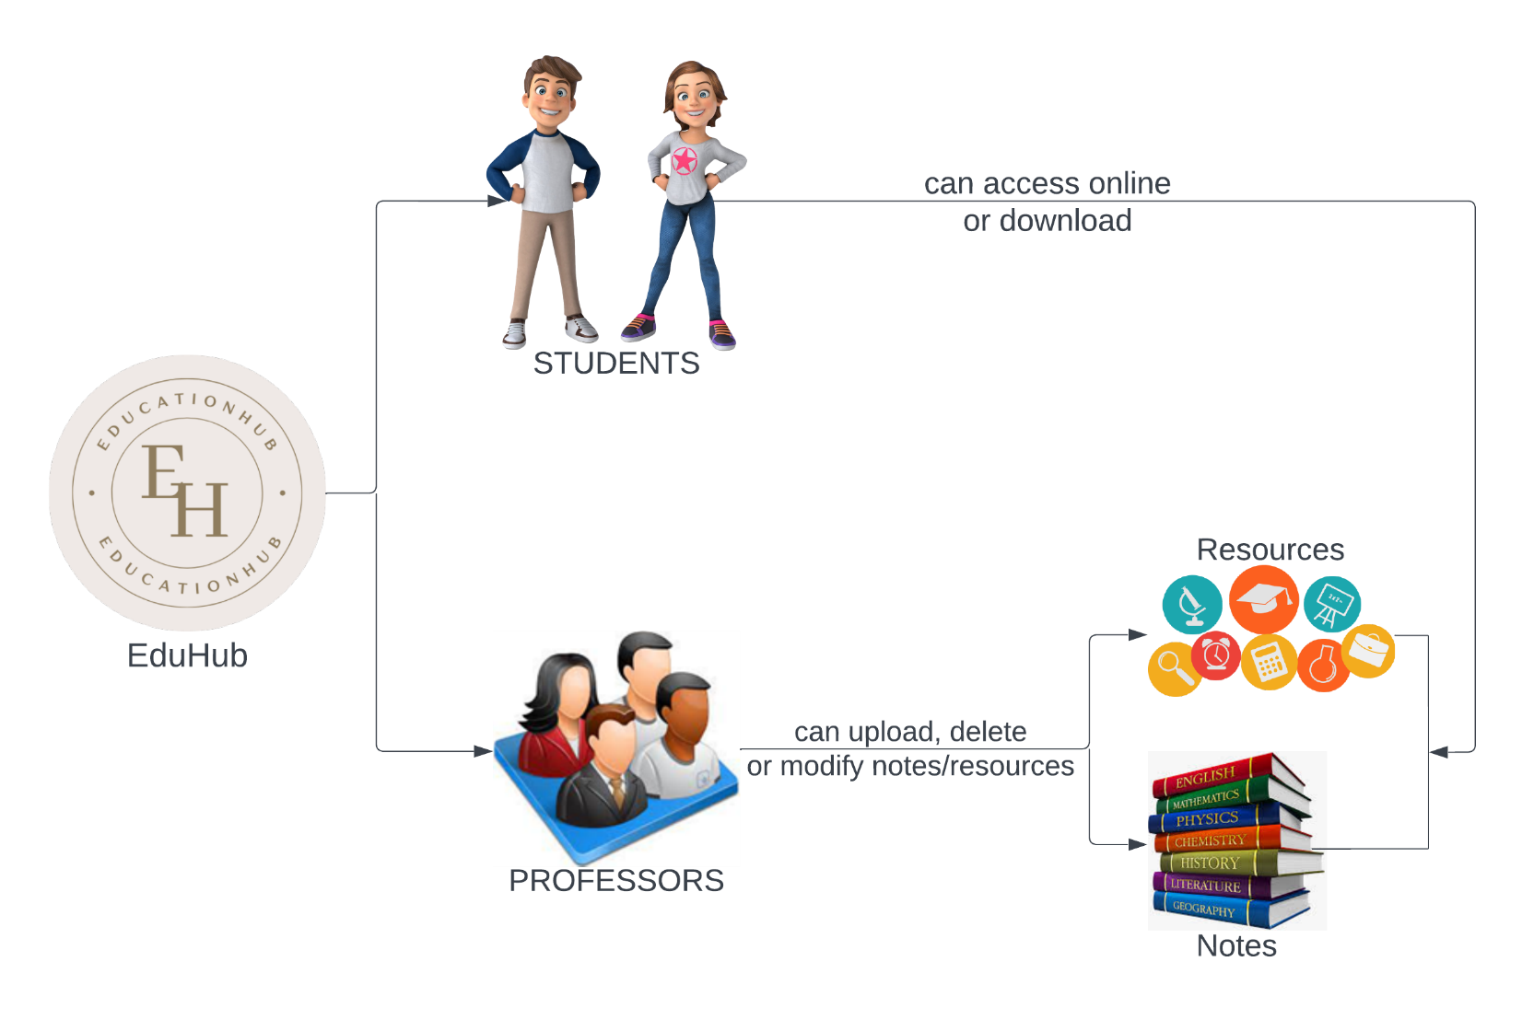

**WEBSITE IMAGES**

Home Page:

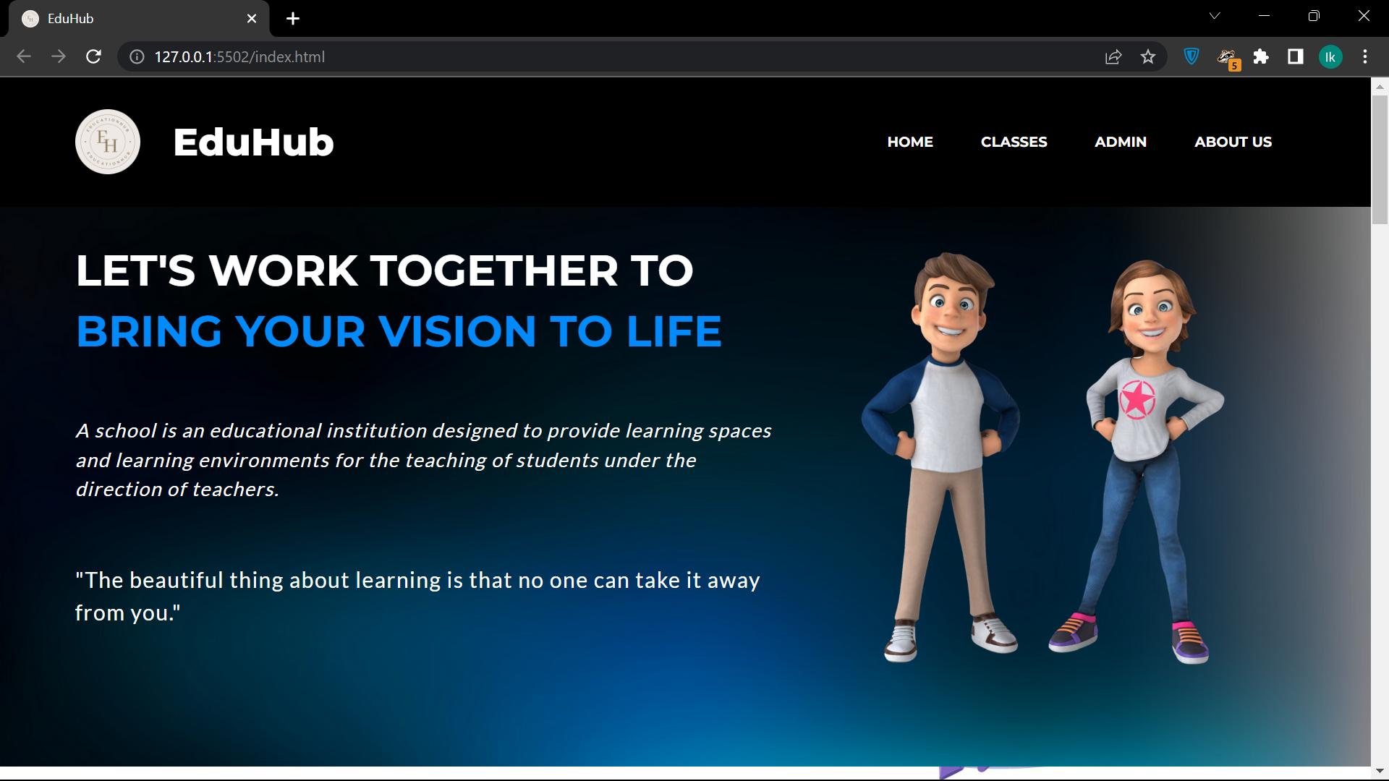

Classes Page:

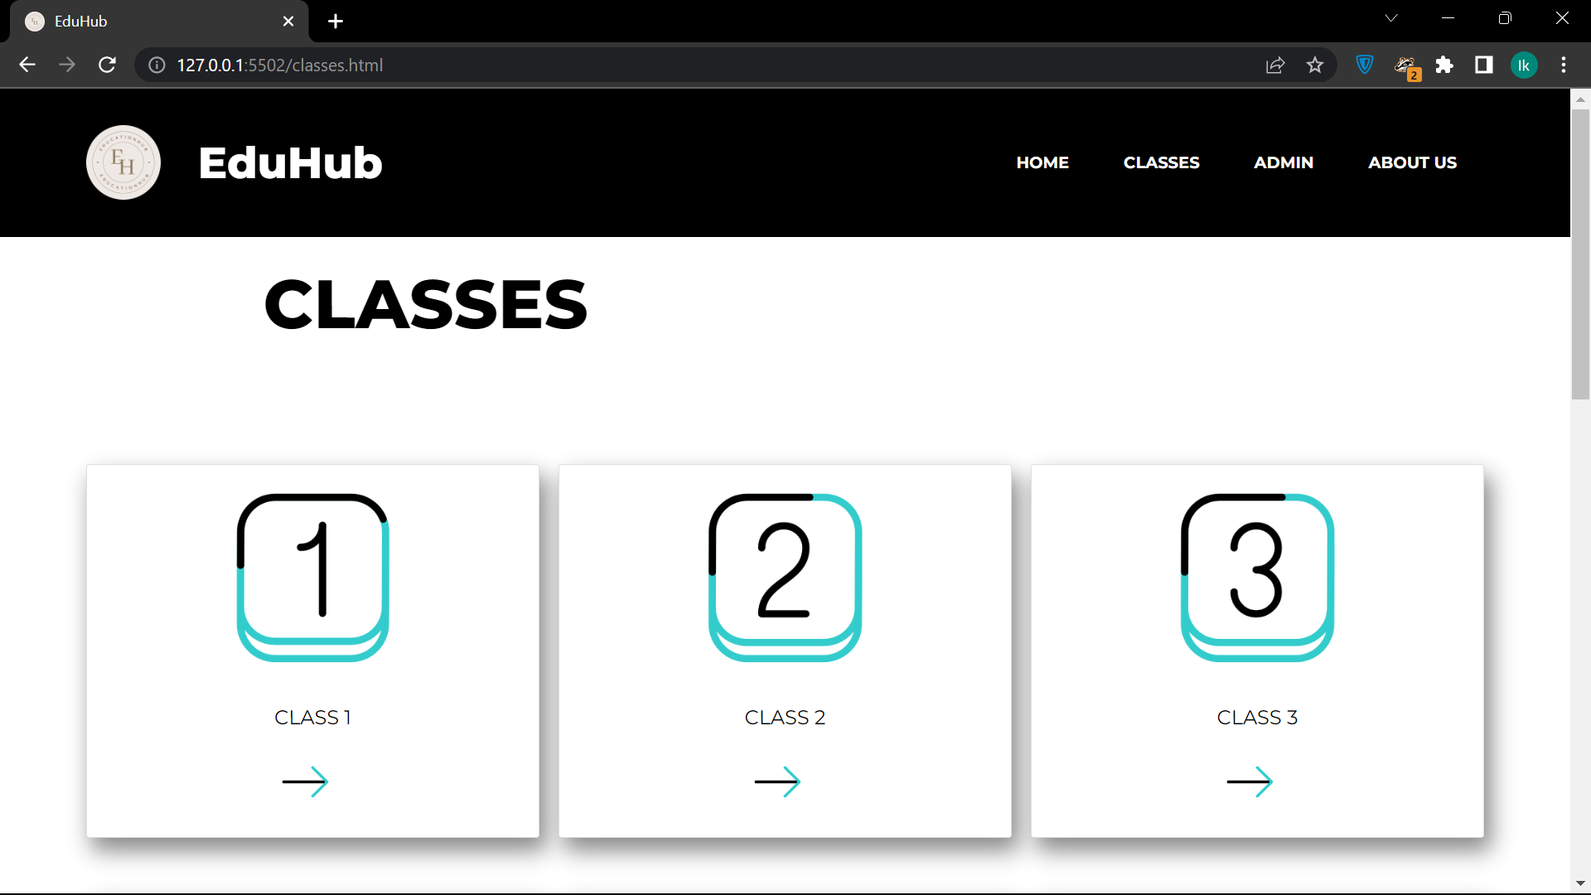

Admin Page:

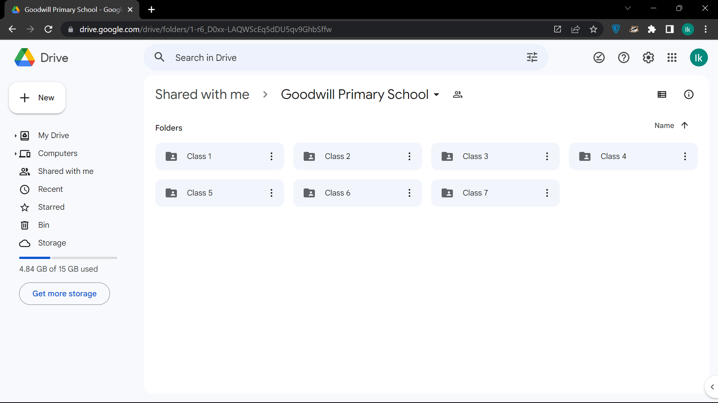

About Us Page:

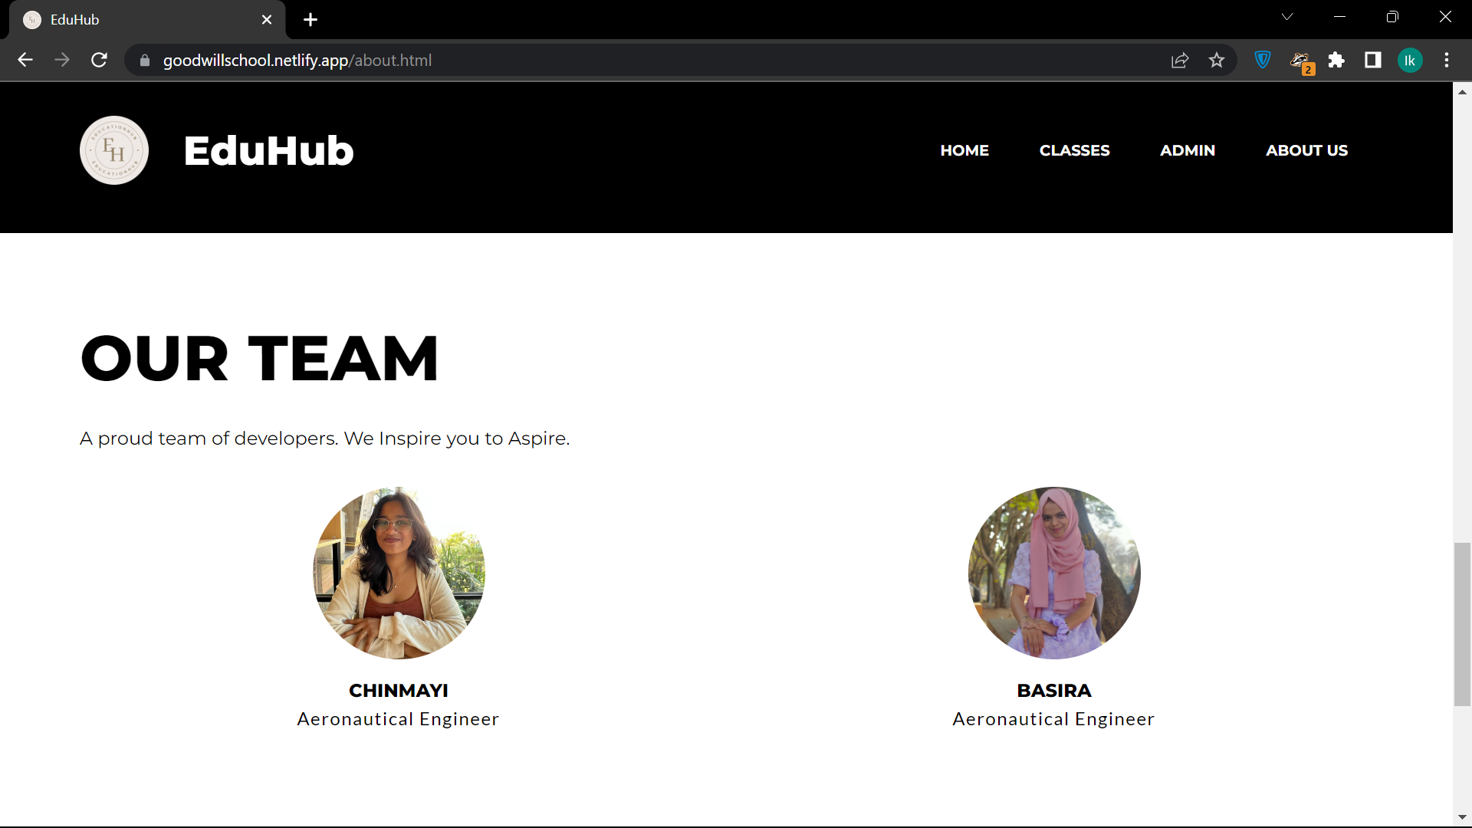

**RESPONSIVE WEBSITE IMAGES**

Home Page:

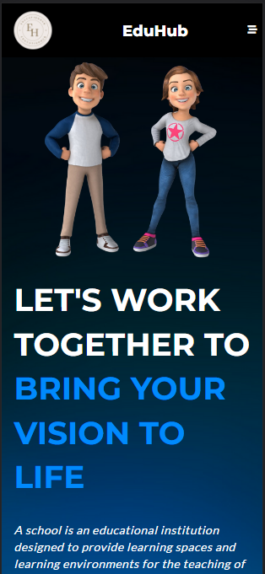 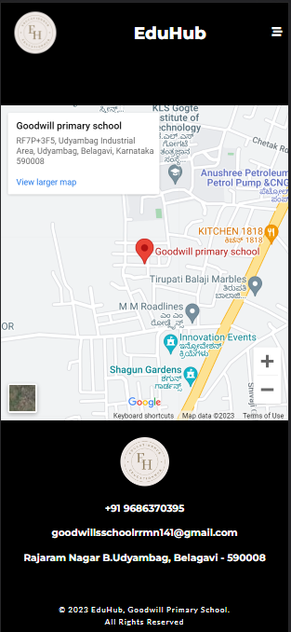

Classes Page:

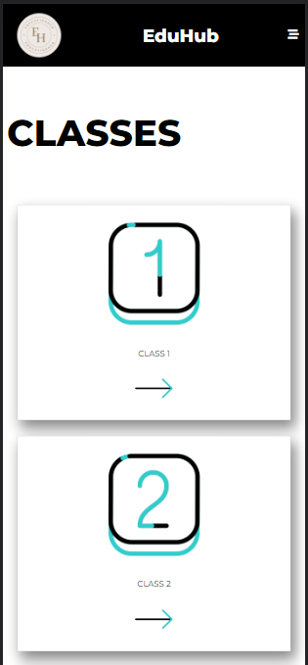 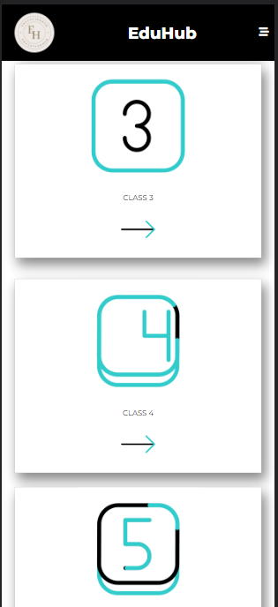 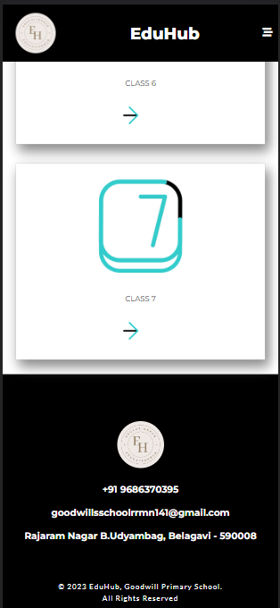

Admin Page:

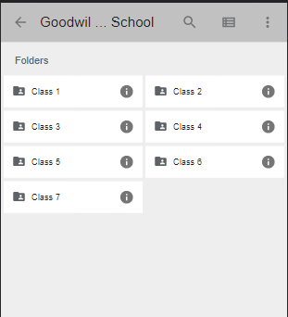

About Us Page:

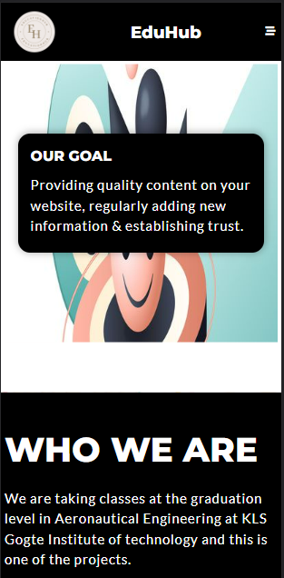 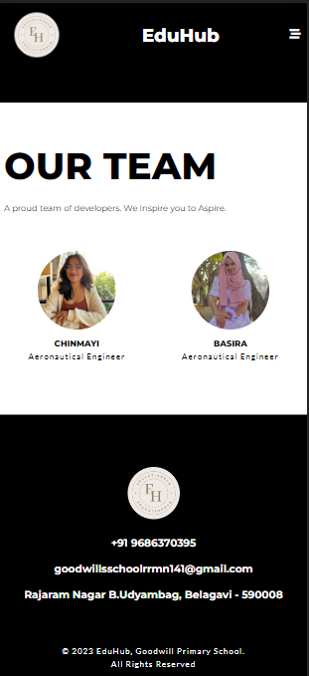

**CONCLUSION**

A website for the needy which acts as an interface with the professors and students to share notes or resources to study. Will help whosoever to study and provide a medium for providing study materials.

A responsive website and an app which can be accessed on any device giving a user-friendly experience.