EDA, or Exploratory Data Analysis, is the process of analysing and visualising data to
understand its structure, patterns, relationships, and anomalies.
It is done to know in and out of data, to decide what course of action to follow,
how our data is related, behaviour of data etc.
Categorical or numerical.
EDA:
• Univariate Analysis (numerical column / categorical column)
• Bivariate Analysis
(numerical-numerical, categorical-categorical, numerical-categorical)
• Multivariate Analysis
UNIVARIATE ANALYSIS [Numerical column]
• Min, Max, Avg, Std.
• Null values
• Percentiles
• Outliers
• Histogram
UNIVARIATE ANALYSIS [Categorical column]
• Null values
• Pie chart or frequency count
BIVARIATE ANALYSIS [Numerical - Numerical]
• Scatter plot
• Covariance
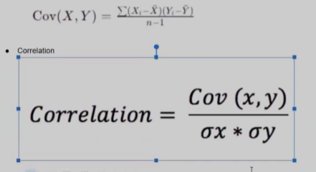
BIVARIATE ANALYSIS [Categorical - Categorical]
• Contingency Table
BIVARIATE ANALYSIS [Numerical - Categorical]
• Numerical analysis along categorical column

