**LibreNMS Network monitoring Tools on CentOS 8**

[root@localhost ~]# dnf -y update



[root@localhost ~]# dnf -y install <https://dl.fedoraproject.org/pub/epel/epel-release-latest-8.noarch.rpm>

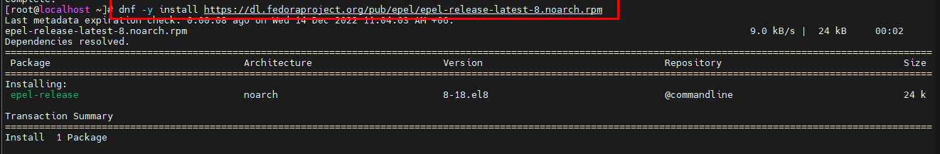

[root@localhost ~]# dnf -y install <https://rpms.remirepo.net/enterprise/remi-release-8.rpm>

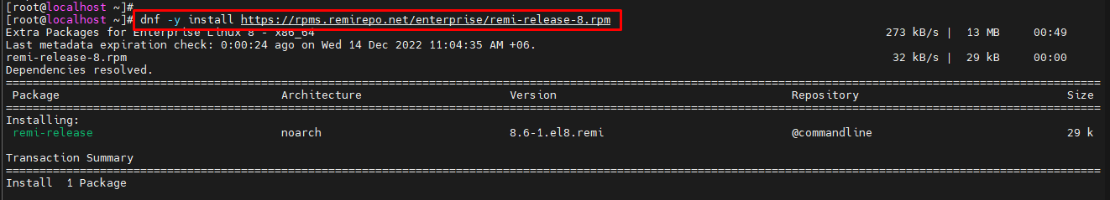

[root@localhost ~]# dnf module enable php:remi-8.1

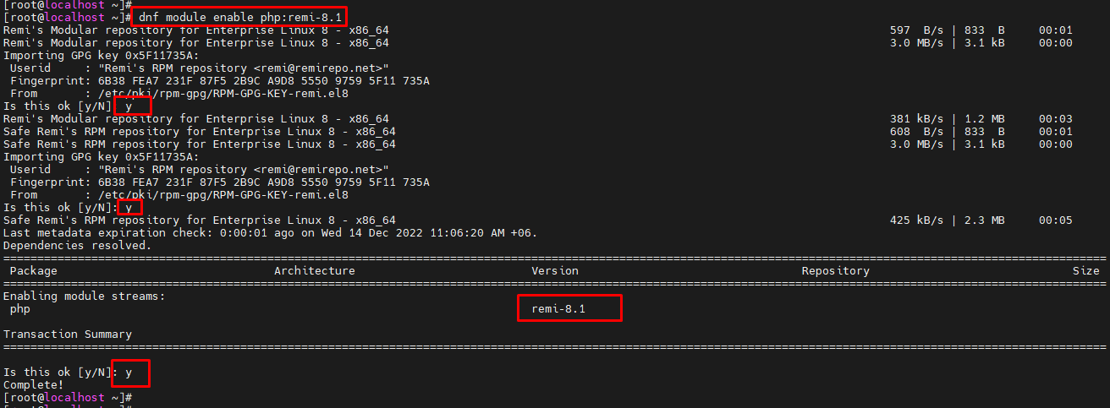

[root@localhost ~]# dnf install bash-completion cronie fping git ImageMagick mariadb-server mtr net-snmp net-snmp-utils nginx nmap php-fpm php-cli php-common php-curl php-gd php-json php-mbstring php-process php-snmp php-xml php-zip php-mysqlnd python3 python3-PyMySQL python3-redis python3-memcached python3-pip rrdtool unzip –y

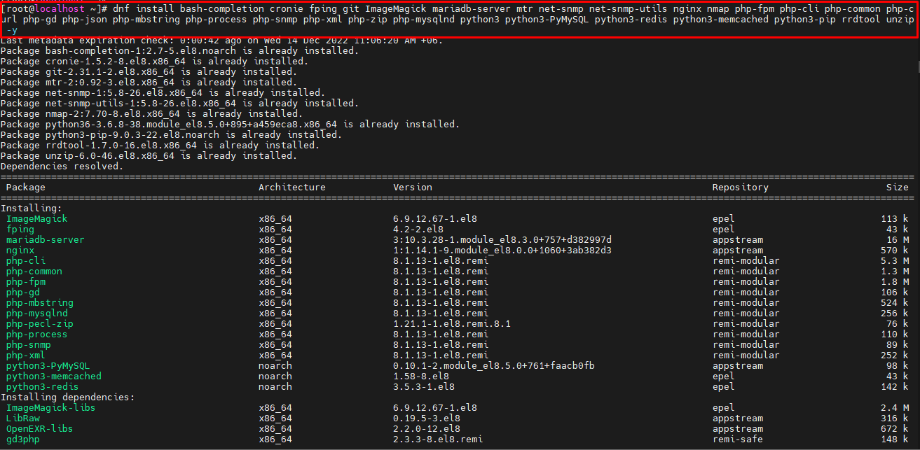

[root@localhost ~]# useradd librenms -d /opt/librenms -M -r -s /usr/bin/bash

[root@localhost ~]# cd /opt && git clone <https://github.com/librenms/librenms.git>

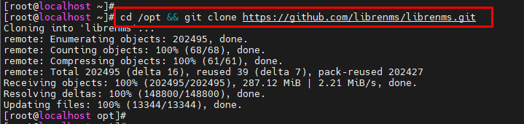

[root@localhost opt]# chown -R librenms:librenms /opt/librenms

[root@localhost opt]# chmod 771 /opt/librenms

[root@localhost opt]# setfacl -d -m g::rwx /opt/librenms/rrd /opt/librenms/logs /opt/librenms/bootstrap/cache/ /opt/librenms/storage/

[root@localhost opt]# setfacl -R -m g::rwx /opt/librenms/rrd /opt/librenms/logs /opt/librenms/bootstrap/cache/ /opt/librenms/storage/

[root@localhost opt]# sudo yum install gcc python3-devel

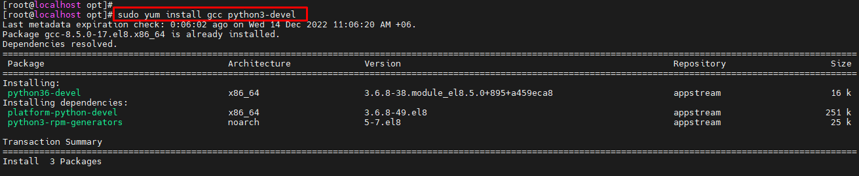

[root@localhost opt]# su - librenms

[librenms@localhost ~]$ ./scripts/composer_wrapper.php install --no-dev

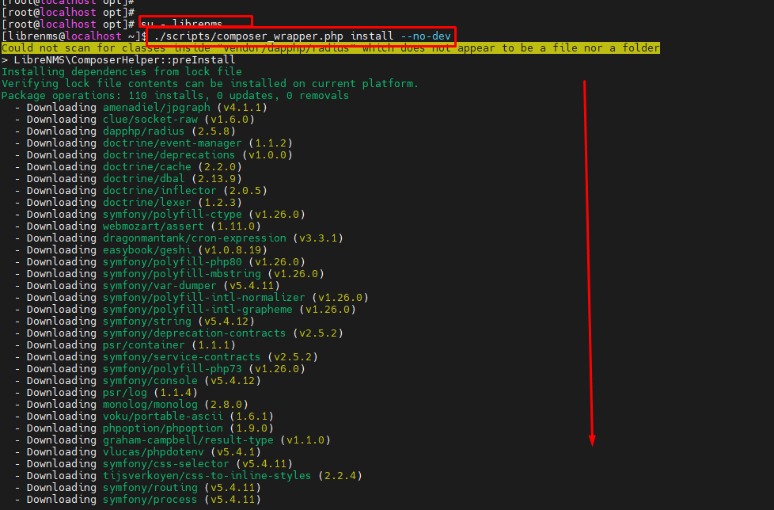

[librenms@localhost ~]$ exit

logout

[root@localhost opt]#

[root@localhost opt]# systemctl start mariadb

[root@localhost opt]# systemctl enable mariadb



[root@localhost opt]# mysql_secure_installation

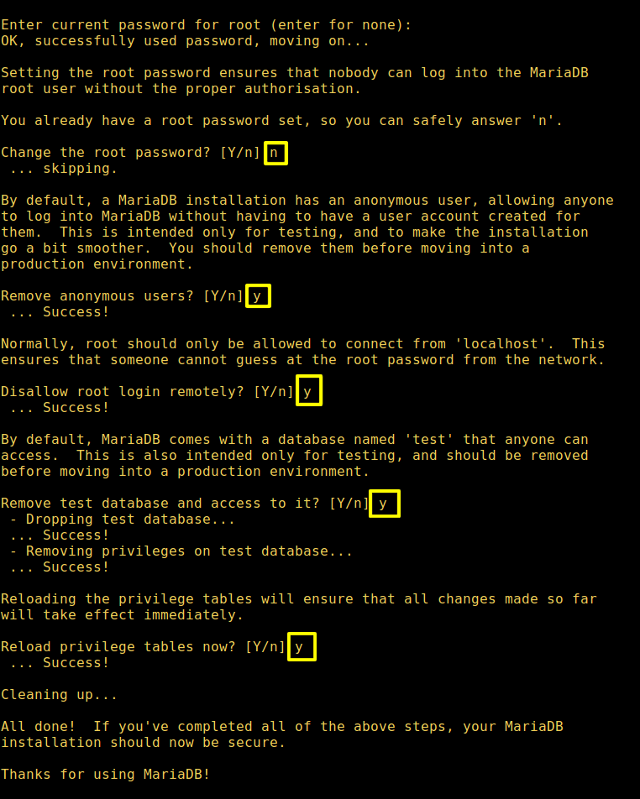

[root@localhost opt]# mysql -u root –p

Enter password:

MariaDB [(none)]> CREATE DATABASE librenms CHARACTER SET utf8 COLLATE utf8_unicode_ci;

Query OK, 1 row affected (0.001 sec)

MariaDB [(none)]> CREATE USER 'librenms'@'localhost' IDENTIFIED BY 'password';

Query OK, 0 rows affected (0.001 sec)

MariaDB [(none)]> GRANT ALL PRIVILEGES ON librenms.* TO 'librenms'@'localhost';

Query OK, 0 rows affected (0.001 sec)

MariaDB [(none)]> FLUSH PRIVILEGES;

Query OK, 0 rows affected (0.001 sec)

MariaDB [(none)]> exit

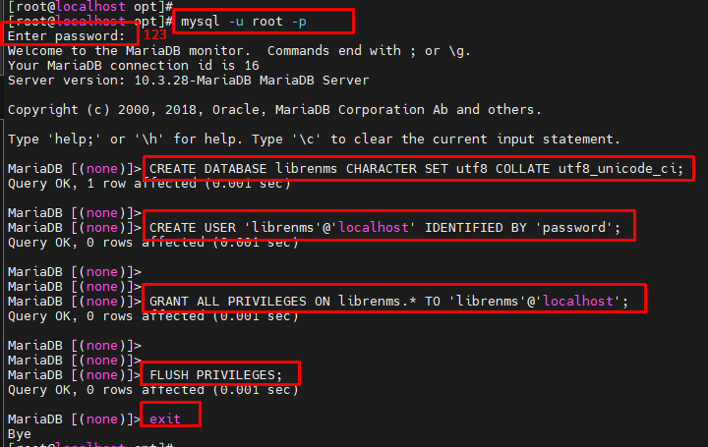

[root@localhost opt]# vim /etc/my.cnf.d/mariadb-server.cnf

innodb_file_per_table=1

lower_case_table_names=0

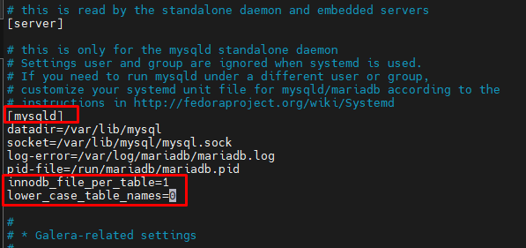

[root@localhost opt]# systemctl restart mariadb

[root@localhost opt]# cp /etc/php-fpm.d/www.conf /etc/php-fpm.d/librenms.conf

[root@localhost opt]# vim /etc/php-fpm.d/librenms.conf

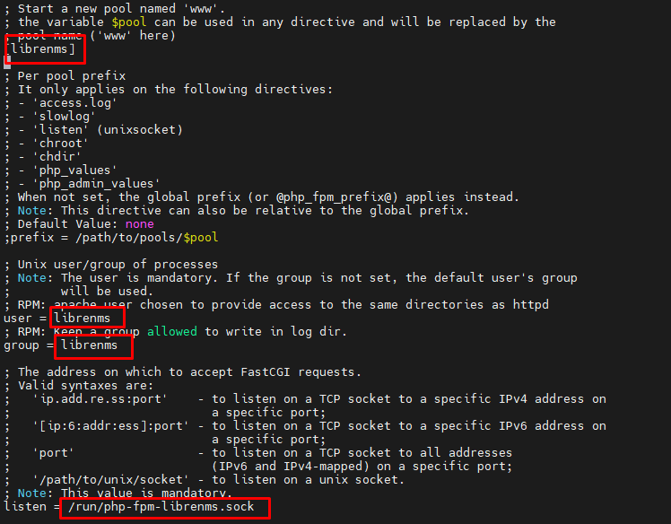

[root@localhost opt]# vim /etc/nginx/conf.d/librenms.conf

server {

listen 80;

server_name 10.200.10.56;

root /opt/librenms/html;

index index.php;

charset utf-8;

gzip on;

gzip_types text/css application/javascript text/javascript application/x-javascript image/svg+xml text/plain text/xsd text/xsl text/xml image/x-icon;

location / { try_files $uri $uri/ /index.php?$query_string;

}

location ~ [^/]\.php(/|$) { fastcgi_pass unix:/run/php-fpm-librenms.sock;

fastcgi_split_path_info ^(.+\.php)(/.+)$;

include fastcgi.conf;

}

location ~ /\.(?!well-known).* {

deny all;

}

}

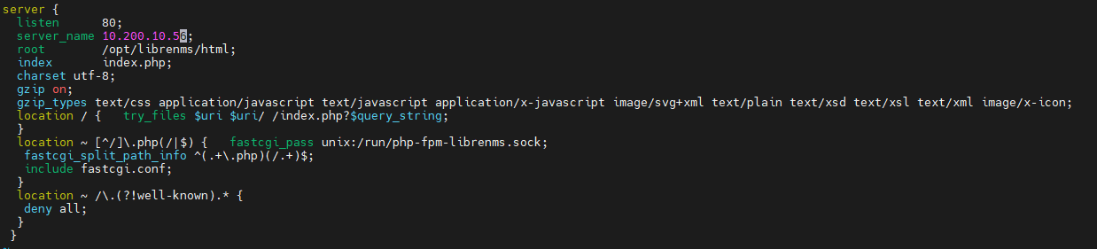

[root@localhost opt]# vim /etc/nginx/nginx.conf

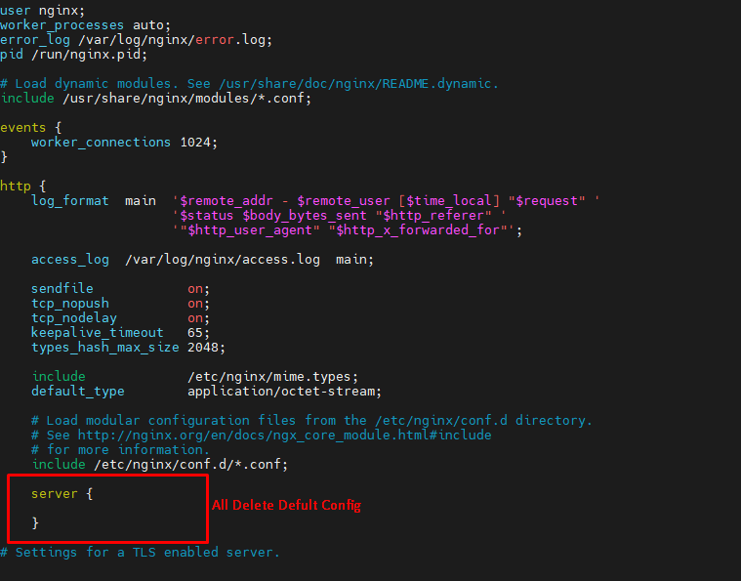

[root@localhost opt]# systemctl start nginx

[root@localhost opt]# systemctl enable nginx

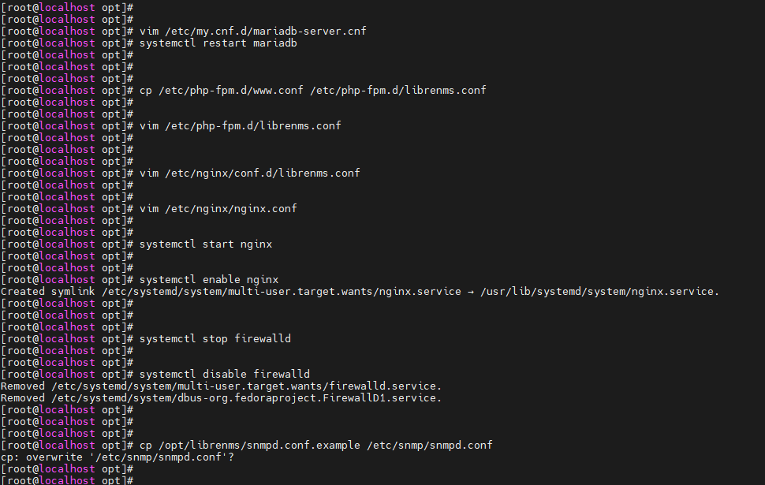

[root@localhost opt]# systemctl stop firewalld

[root@localhost opt]# systemctl disable firewalld

[root@localhost opt]# cp /opt/librenms/snmpd.conf.example /etc/snmp/snmpd.conf

cp: overwrite '/etc/snmp/snmpd.conf'? y

[root@localhost opt]# vim /etc/snmp/snmpd.conf

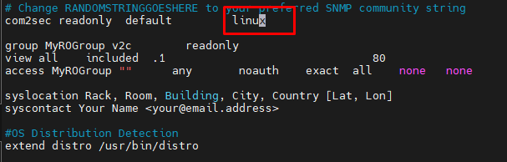

[root@localhost opt]# curl -o /usr/bin/distro <https://raw.githubusercontent.com/librenms/librenms-agent/master/snmp/distro>



[root@localhost opt]# chmod +x /usr/bin/distro

[root@localhost opt]# systemctl enable snmpd

[root@localhost opt]# systemctl restart snmpd

[root@localhost opt]# cp /opt/librenms/librenms.nonroot.cron /etc/cron.d/librenms

[root@localhost opt]# vim /etc/php.ini

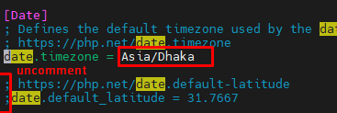

[root@localhost opt]# systemctl restart php-fpm

[root@localhost opt]# semanage fcontext -a -t httpd_sys_rw_content_t '/opt/librenms/logs/librenms.log(/.*)?'

[root@localhost opt]# restorecon -RFv /opt/librenms/logs/librenms.log



[root@localhost opt]# sudo chown -R librenms:librenms '/opt/librenms'

[root@localhost opt]# sudo setfacl -d -m g::rwx /opt/librenms/bootstrap/cache /opt/librenms/storage /opt/librenms/logs /opt/librenms/rrd

[root@localhost opt]# sudo chmod -R ug=rwX /opt/librenms/bootstrap/cache /opt/librenms/storage /opt/librenms/logs /opt/librenms/rrd

[root@localhost opt]# semanage fcontext -a -t httpd_sys_rw_content_t '/opt/librenms/bootstrap/cache(/.*)?'

[root@localhost opt]# semanage fcontext -a -t httpd_sys_rw_content_t '/opt/librenms/storage(/.*)?'

[root@localhost opt]# semanage fcontext -a -t httpd_sys_rw_content_t '/opt/librenms/logs(/.*)?'

[root@localhost opt]# semanage fcontext -a -t httpd_sys_rw_content_t '/opt/librenms/rrd(/.*)?'

[root@localhost opt]# restorecon -RFv /opt/librenms

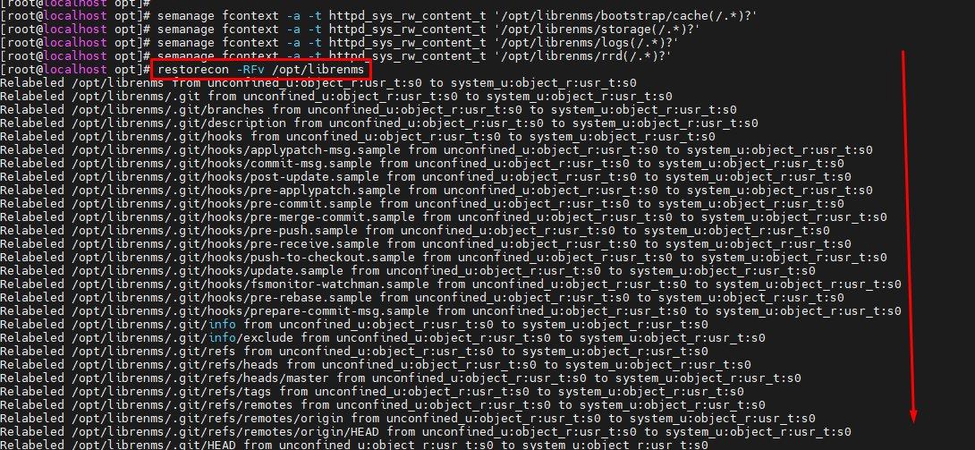

[root@localhost opt]# systemctl restart php-fpm

[root@localhost ~]# vim /opt/librenms/.env

APP_KEY=base64:SZiwnchmznsoei2ozqycsgoWsmXjL+KS6gx5vJAlScM=

DB_HOST=localhost

DB_DATABASE=librenms

DB_USERNAME=librenms

DB_PASSWORD=password

#APP_URL=

NODE_ID=63995b7aaf479

VAPID_PUBLIC_KEY=BEqjnJ2wx79gfqBtBX-bbTlyJ9tNSLq0WVfjUSwzvHyKmxAcSaX0soYKJj1FFH7AES7NwR0DRq0Z0Mw7hxiiJhA

VAPID_PRIVATE_KEY=nWrtBb4YM7S08fK5EwBaIXkrss5h5xbXYtPttvOsiyI

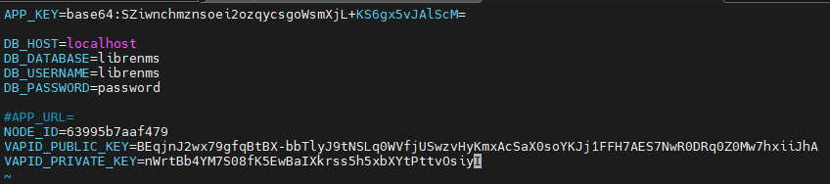

[root@localhost opt]# systemctl restart php-fpm

////All Confvig File Location

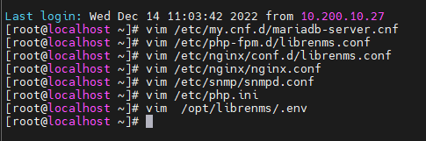

**Device Add**

[root@localhost librenms]# sudo su – librenms

[librenms@localhost ~]$ ./lnms device:add -2 -c linux -r 161 -t udp 10.200.10.56

Added device 10.200.10.56 (3)

[librenms@localhost ~]$

**Source Link:**

<https://www.youtube.com/watch?v=ELSr22sqPOM&ab_channel=Let%27sDoRnD>

https://www.centlinux.com/2021/02/install-librenms-network-monitoring-tool-centos-8.html

https://www.linuxyogi.com/centos/how-to-install-librenms-on-centos-7/

<https://docs.librenms.org/Installation/Installation-CentOS-7-Nginx/>

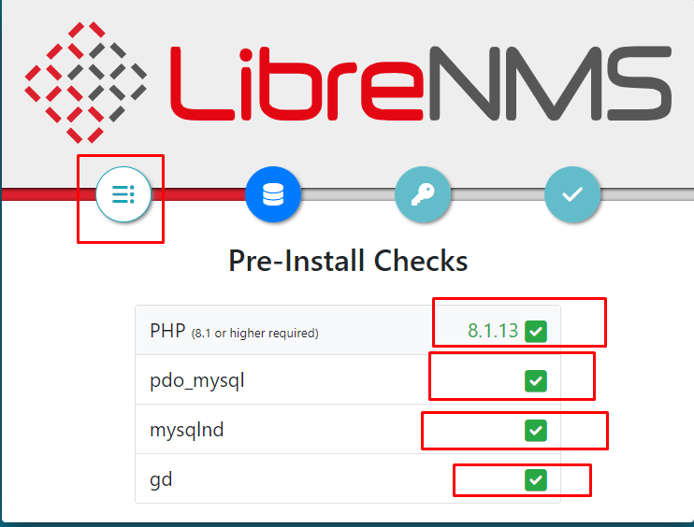

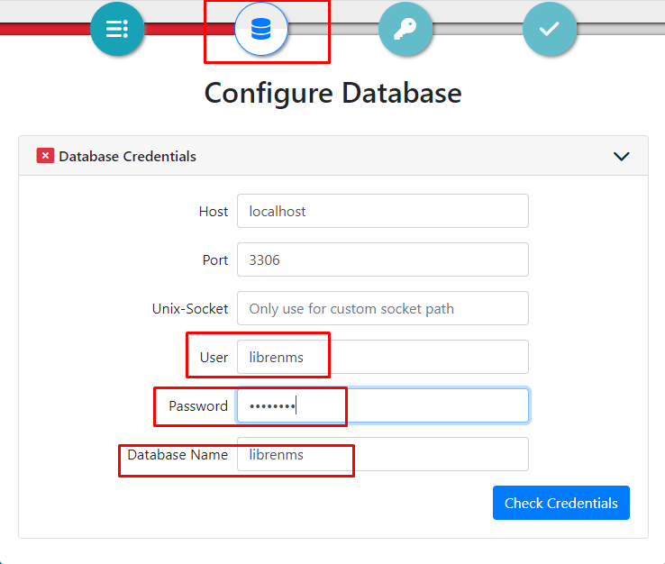

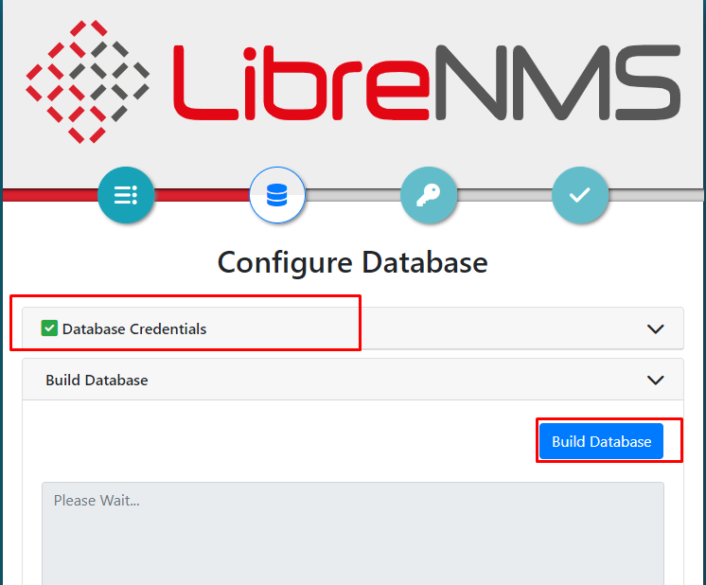

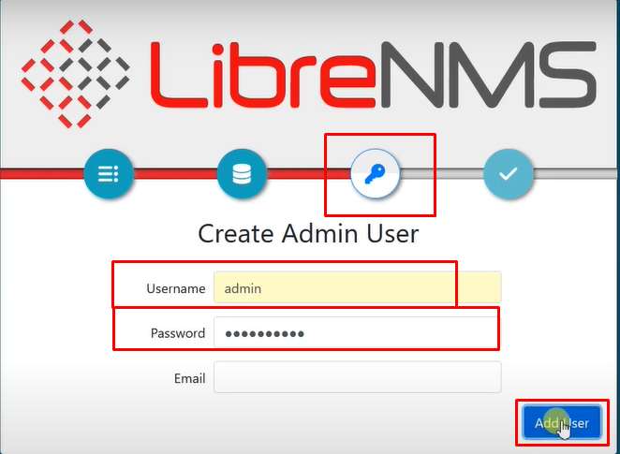

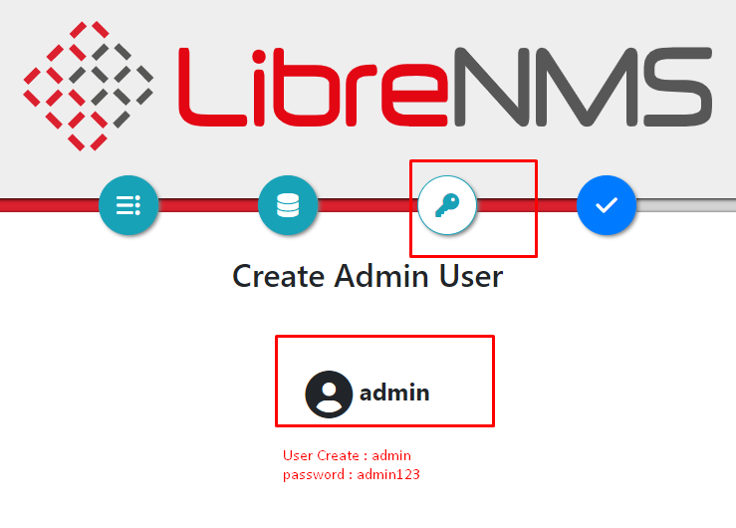

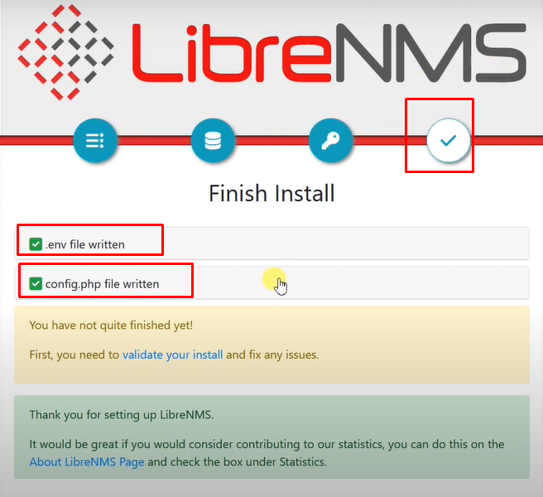

Email Notification Set :

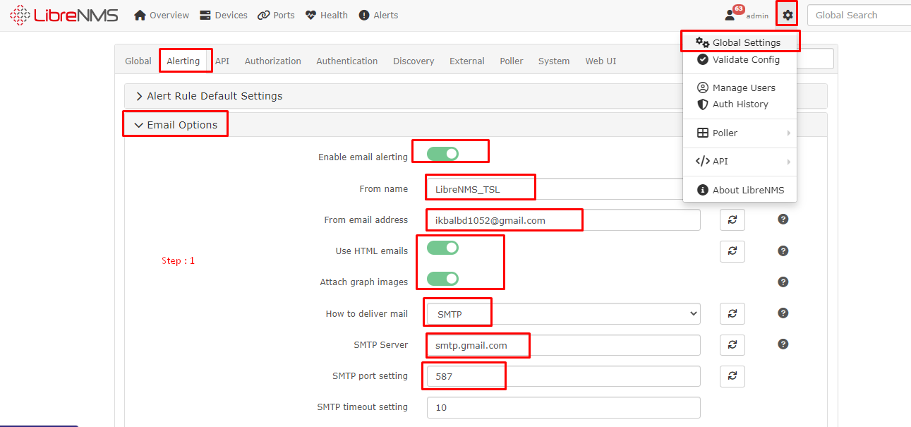

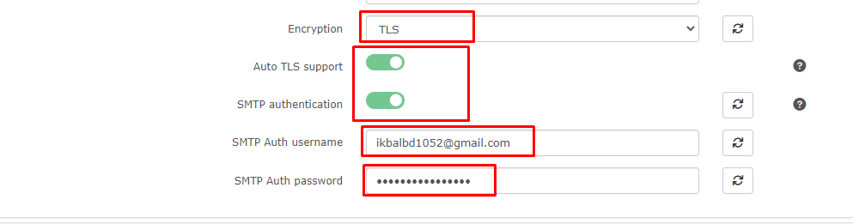

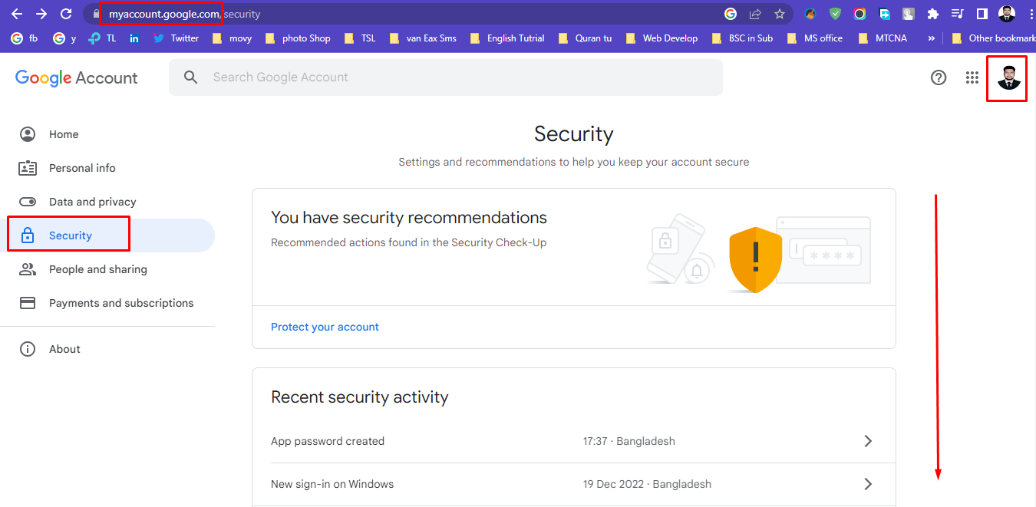

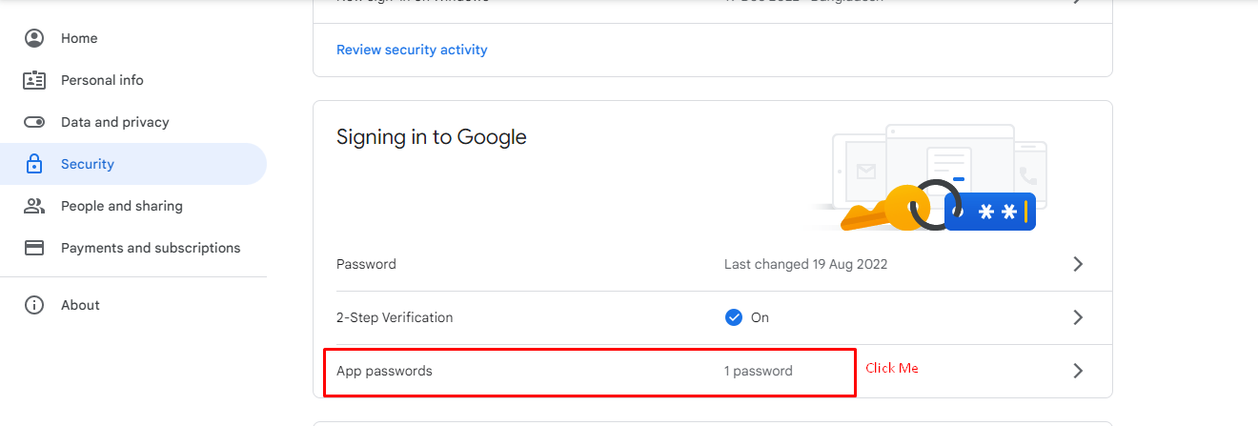

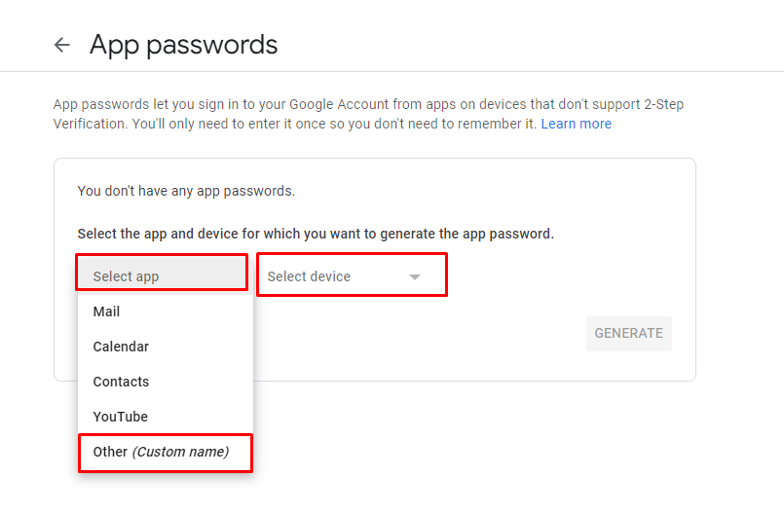

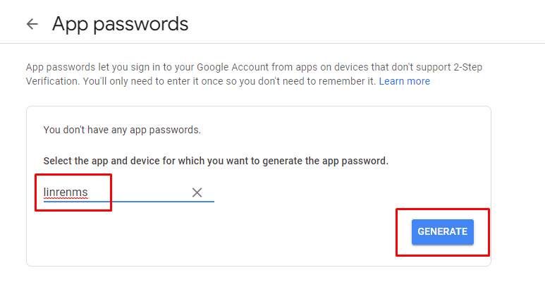

SMTP Auth password :

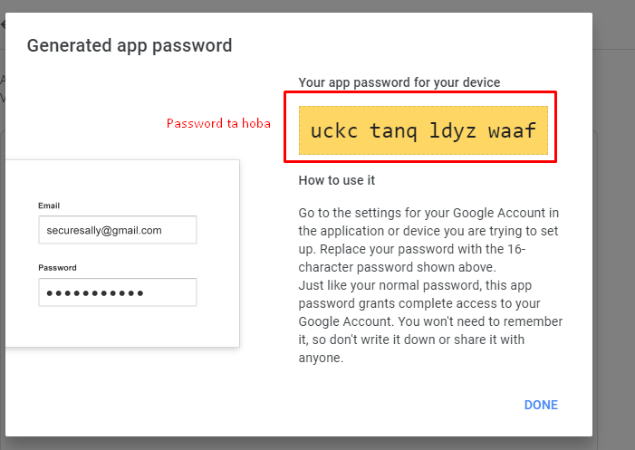

Alert Transport

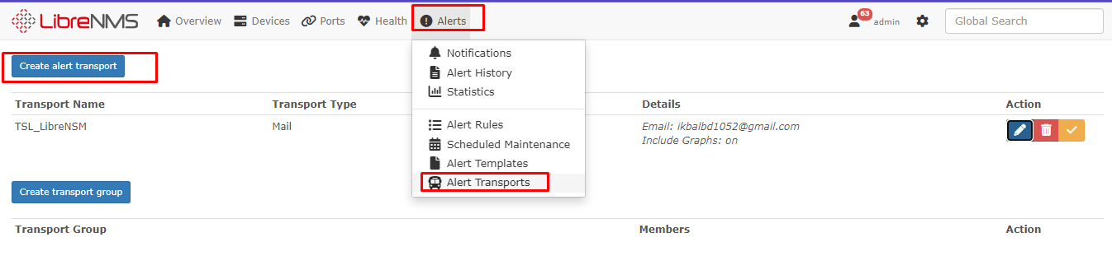

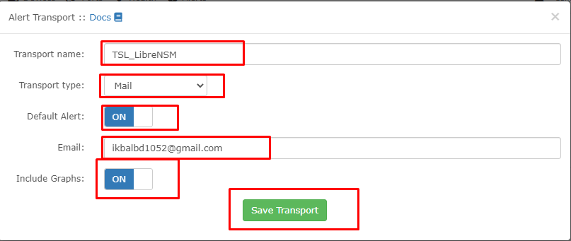

Alert rule collection

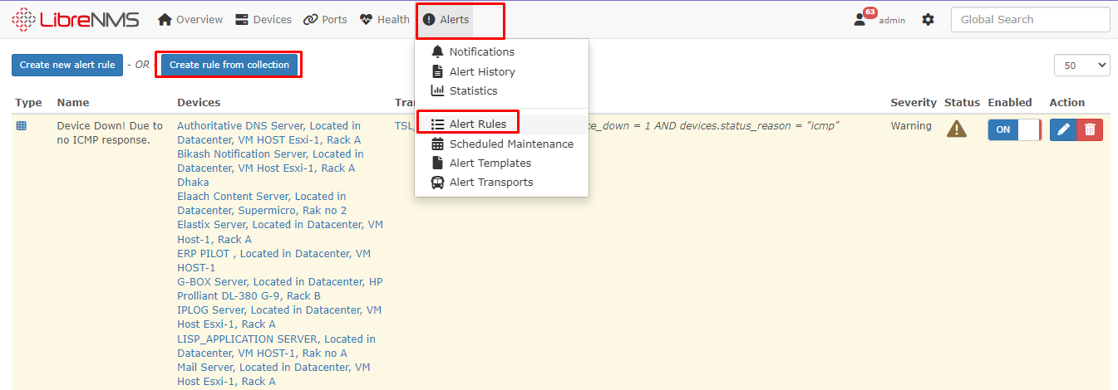

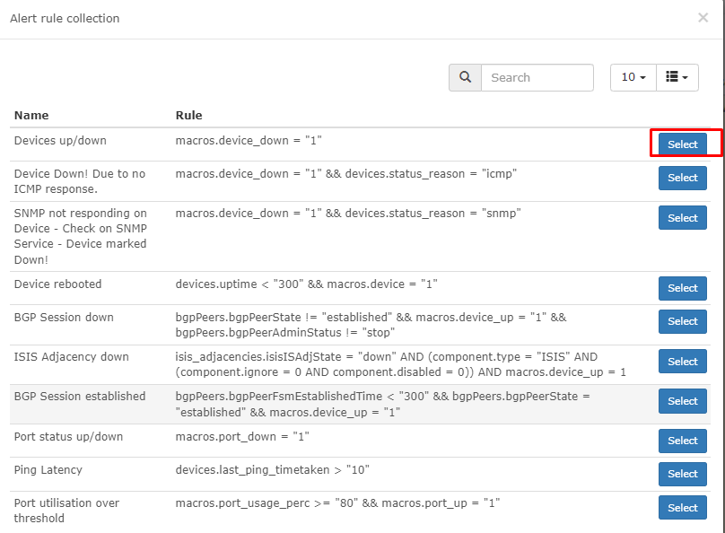

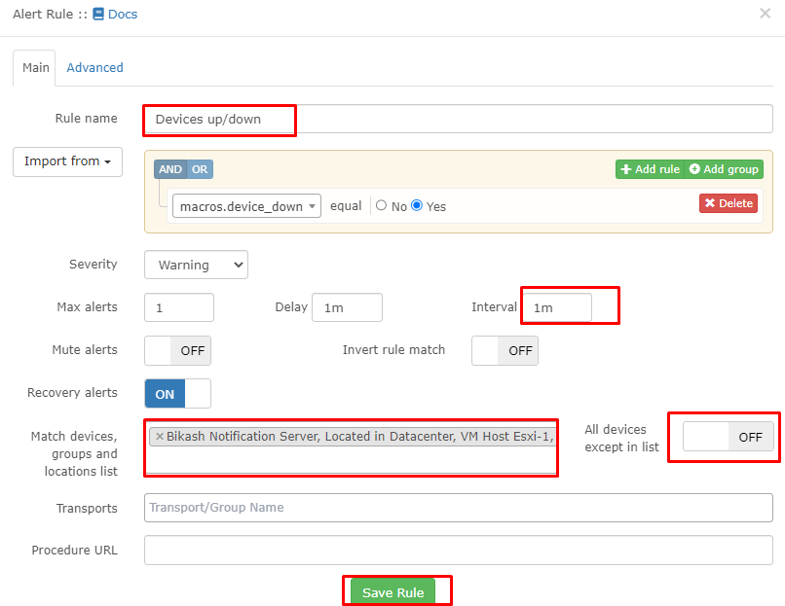

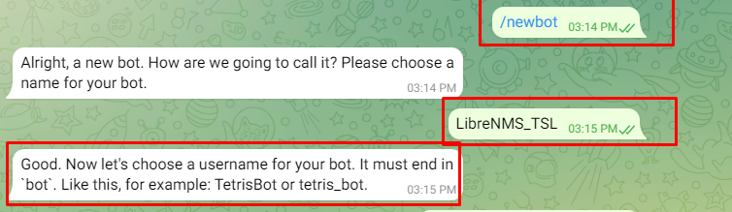

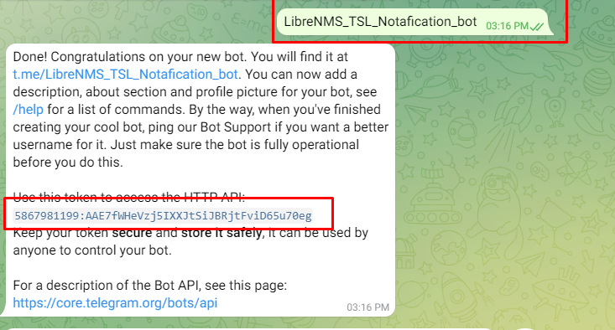

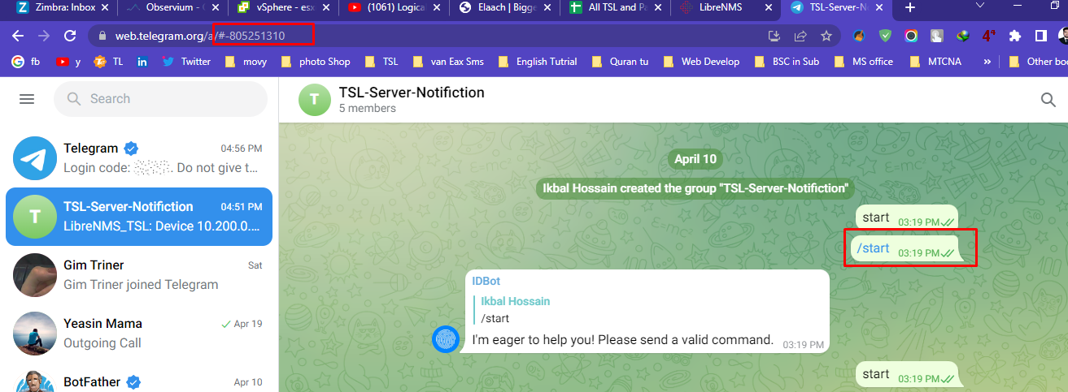

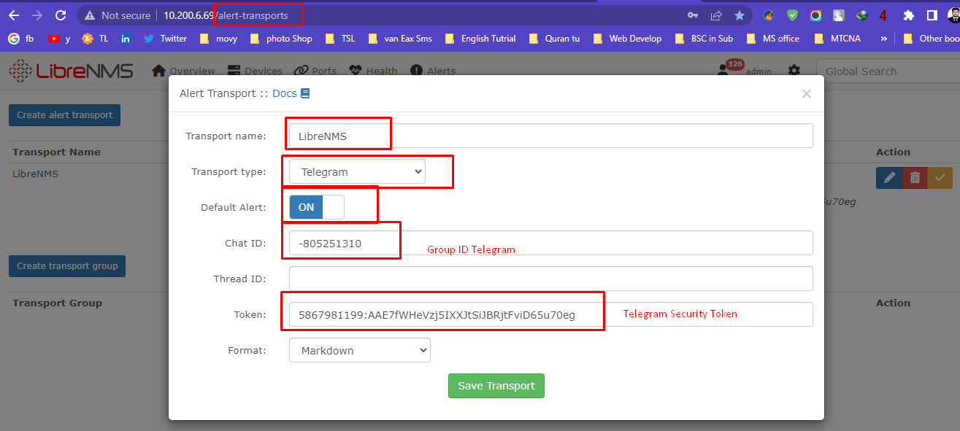

**Notification Alert:**

Device Down

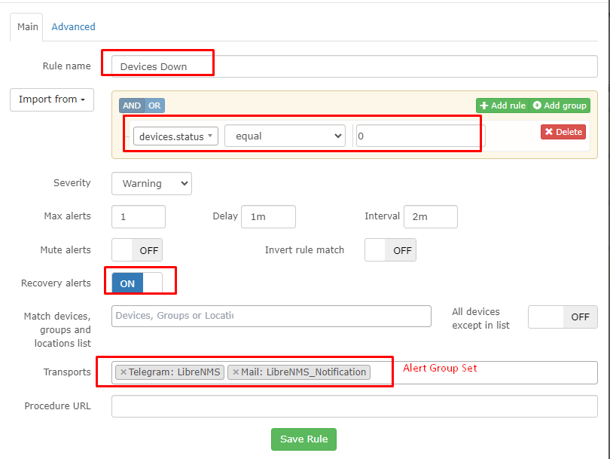

Alerts => Alert Templates => Create new alert template

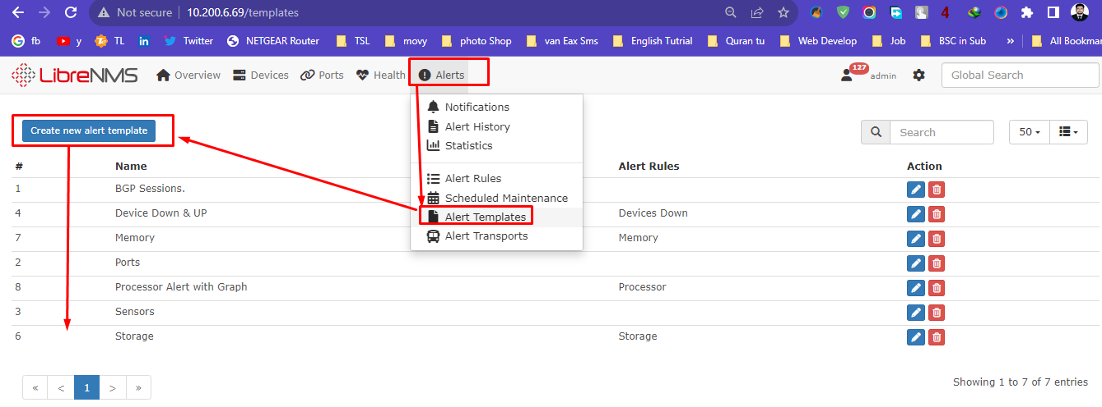

**Device Down template code**

<html>

<body>

<div style="font-family:Helvetica;">

<h2 span style="color:green;">{{ $alert->title }}</h2>

<b>Device Name:</b> {{ $alert->hostname }}

<b>Severity: </b>{{ $alert->severity }}

@if ($alert->state == 0) Time elapsed: {{ $alert->elapsed }} @endif

<b>Timestamp: {{ $alert->timestamp }}

Rule: @if ($alert->name) {{ $alert->name }} @else {{ $alert->rule }} @endif

@foreach ($alert->faults as $key => $value)</b>

<b>Physical Interface:</b> {{ $value['ifDescr'] }}

<b>Interface Description:</b>{{ $value['ifAlias'] }}

<b>Interface Speed:</b> {{ ($value['ifSpeed']/1000000000) }} Gbs

<b>Inbound Utilization:</b> {{ (($value['ifInOctets_rate']*8)/$value['ifSpeed'])*100 }}

<b>Outbound Utilization:</b> {{ (($value['ifOutOctets_rate']*8)/$value['ifSpeed'])*100 }}

@endforeach

</div>

</body>

</html>

**Storage**

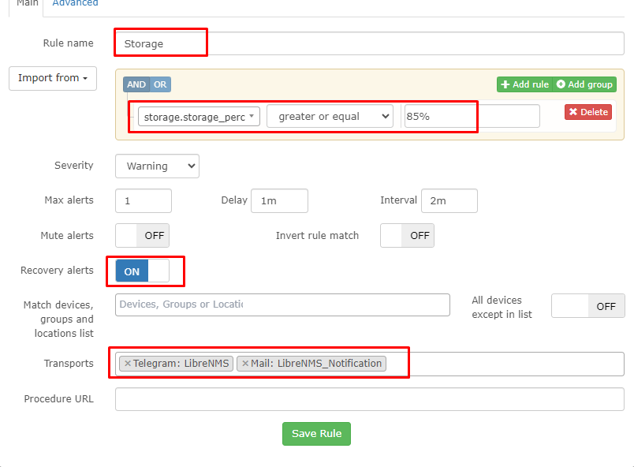

{{ $alert->title }}

Device Name: {{ $alert->hostname }}

Severity: {{ $alert->severity }}

Uptime: {{ $alert->uptime_short }}

@if ($alert->state == 0) Time elapsed: {{ $alert->elapsed }} @endif

Timestamp: {{ $alert->timestamp }}

Location: {{ $alert->location }}

Description: {{ $alert->description }}

Features: {{ $alert->features }}

Notes: {{ $alert->notes }}

Server: {{ $alert->sysName }}

@foreach ($alert->faults as $key => $value)

Mount Point: {{ $value['storage_descr'] }}

Percent Utilized: {{ $value['storage_perc'] }}

@endforeach

**Memory**

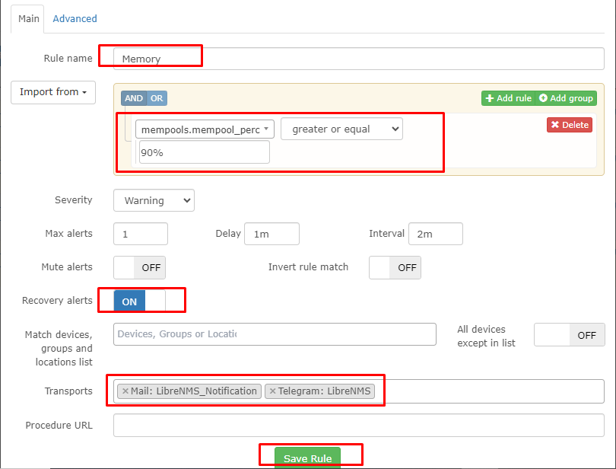

**Memory**

{{ $alert->title }}

Device Name: {{ $alert->hostname }}

Severity: {{ $alert->severity }}

Uptime: {{ $alert->uptime_short }}

@if ($alert->state == 0) Time elapsed: {{ $alert->elapsed }} @endif

Timestamp: {{ $alert->timestamp }}

Location: {{ $alert->location }}

Contact: {{ $alert->contact }}

Description: {{ $alert->description }}

Notes: {{ $alert->notes }}

Server: {{ $alert->hostname }}

@foreach ($alert->faults as $key => $value)

Memory Description: {{ $value['mempool_descr'] }}

Percent Utilized: {{ $value['mempool_perc'] }}

@endforeach