**Observium server install RHEL-8 / CentOS 8**

**Repositories**

Add EPEL, OpenNMS and REMI repositories, and switch to REMI's PHP 7.4 packages.

yum install https://dl.fedoraproject.org/pub/epel/epel-release-latest-8.noarch.rpm

yum install http://yum.opennms.org/repofiles/opennms-repo-stable-rhel8.noarch.rpm

yum install http://rpms.remirepo.net/enterprise/remi-release-8.rpm

yum install yum-utils

dnf module enable php:remi-7.4

[root@localhost ~]# yum install net-snmp-utils fping mariadb-server mariadb rrdtool subversion whois ipmitool graphviz -y

**Packages**

Install the packages required for Observium

[root@localhost ~]# yum install wget httpd php php-opcache php-mysqlnd php-gd php-posix php-pear cronie net-snmp \

net-snmp-utils fping mariadb-server mariadb rrdtool subversion whois ipmitool graphviz \

ImageMagick php-sodium python3 python3-mysql python3-PyMySQL

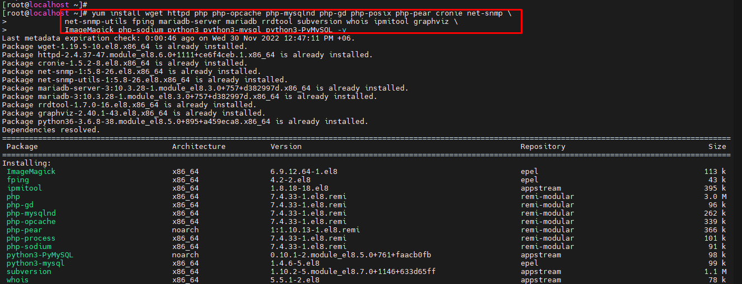

Set Python3 to be the default Python version

[root@localhost ~]# alternatives --set python /usr/bin/python3

If you want to monitor libvirt virtual machines, install libvirt

[root@localhost ~]# yum install libvirt

## Download Observium

First, create a directory for Observium to live in:

[root@localhost ~]# mkdir -p /opt/observium && cd /opt

### Observium Community Edition

If you would like to install the Community Edition, please install using the most recent .tar.gz release.

Download the latest .tar.gz of Observium and unpack:

[root@localhost opt]# wget http://www.observium.org/observium-community-latest.tar.gz

[root@localhost opt]# tar zxvf observium-community-latest.tar.gz

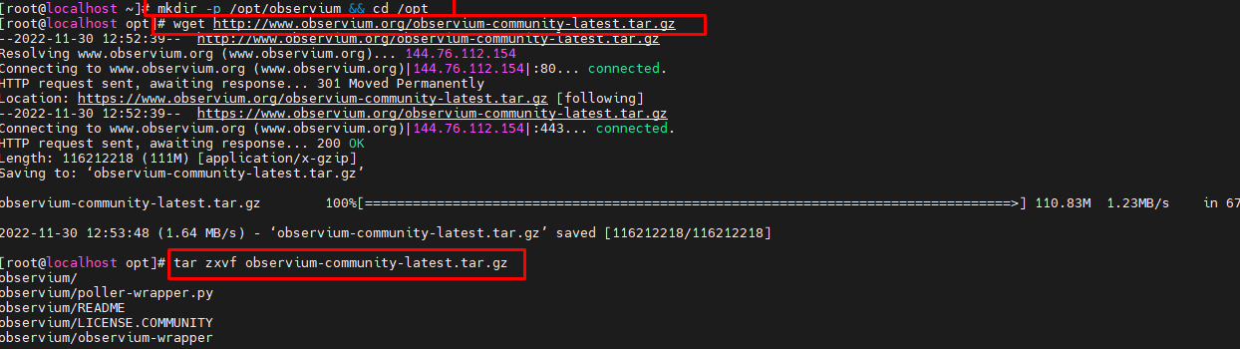

[root@localhost ~]# yum install @mariadb –y

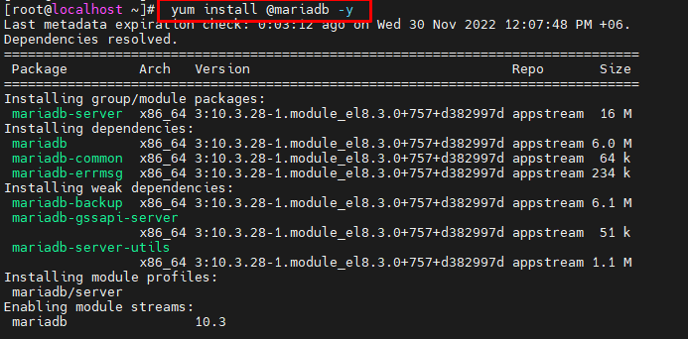

[root@localhost ~]# yum install mariadb-server -y

[root@localhost ~]# systemctl start mariadb

[root@localhost ~]# mysql_secure_installation

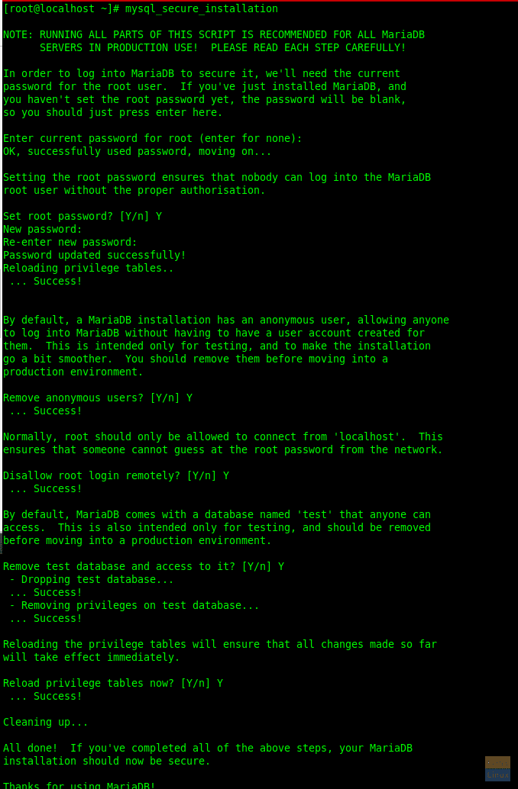

[root@localhost ~]# systemctl enable mariadb.service

[root@localhost opt]# systemctl enable mariadb

[root@localhost opt]# systemctl start mariadb

[root@localhost opt]# mysql -u root -p

MariaDB [(none)]> CREATE DATABASE observium DEFAULT CHARACTER SET utf8 COLLATE utf8_general_ci;

Query OK, 1 row affected (0.005 sec)

MariaDB [(none)]> CREATE USER 'observium'@'localhost' IDENTIFIED BY 'password';

Query OK, 1 row affected (0.005 sec)

MariaDB [(none)]> GRANT ALL PRIVILEGES ON observium.* TO 'observium'@'localhost' IDENTIFIED BY '<observium db password>';

Query OK, 0 rows affected (0.047 sec)

MariaDB [(none)]> drop user omer@localhost;

Query OK, 0 rows affected (0.002 sec)

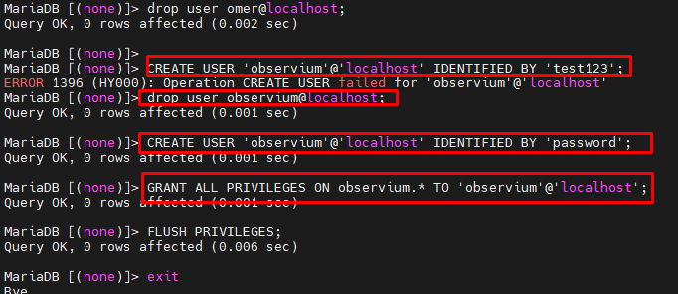

## System

Create the rrd directory to store RRDs in:

[root@localhost observium]# mkdir rrd

[root@localhost observium]# chown apache:apache rrd

If the server will be running only Observium, change /etc/httpd/conf.d/observium.conf and add the following to the end :

[root@localhost observium]# vim /etc/httpd/conf.d/observium.conf

<VirtualHost *>

DocumentRoot /opt/observium/html/

ServerName your Server IP (10.200.10.50)

CustomLog /opt/observium/logs/access_log combined

ErrorLog /opt/observium/logs/error_log

<Directory "/opt/observium/html/">

AllowOverride All

Options FollowSymLinks MultiViews

Require all granted

</Directory>

</VirtualHost>

Create logs directory for apache

[root@localhost ]#cd /opt/observium

[root@localhost observium]# mkdir logs

[root@localhost observium]# chown apache:apache /opt/observium/logs

**Add a first user, use level of 10 for admin:**

[root@localhost]# cd /opt/observium

./adduser.php <username> <password> <level>

[root@localhost observium]#./adduser.php admin admin@123 10

Add a first device to monitor:

./add_device.php <hostname> <community> v2c

[root@localhost observium]#./add_device.php 10.200.10.50 redhat v2c

Do an initial discovery and polling run to populate the data for the new device:

./discovery.php -h all

./poller.php -h all

## SELinux

Explaining SELinux and how to make Observium work within it is beyond the scope of this guide, so we will disable it. If you are competent enough to maintain SELinux, then that is possible too, but is an even more unsupported configuration than RHEL/CentOS themselves.

Firstly, disable SELinux. You can do this temporarily with the following command:

[root@localhost ~]# vim /etc/sysconfig/selinux

SELINUX=disabled

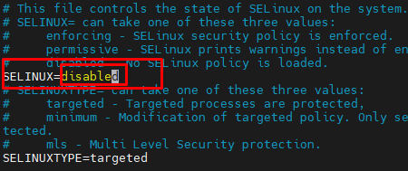

setenforce 0

We need to disable SELinux permanently, so you also need to change /etc/selinux/config so that the SELINUX option is set to permissive

SELINUX=permissive

**Cron**

Add cron jobs, create a new file /etc/cron.d/observium with the following contents:

**Cron Usage**

The below example includes a username, so will only work in /etc/crontab or /etc/cron.d/observium. It will **NOT** work in a user crontab edited with crontab -e without removing the username.

[root@localhost ~]# vim /etc/cron.d/observium

# Run a complete discovery of all devices once every 6 hours

33 */6 * * * root /opt/observium/discovery.php -h all >> /dev/null 2>&1

# Run automated discovery of newly added devices every 5 minutes

*/5 * * * * root /opt/observium/discovery.php -h new >> /dev/null 2>&1

# Run multithreaded poller wrapper every 5 minutes

*/5 * * * * root /opt/observium/poller-wrapper.py >> /dev/null 2>&1

# Run housekeeping script daily for syslog, eventlog and alert log

13 5 * * * root /opt/observium/housekeeping.php -ysel

# Run housekeeping script daily for rrds, ports, orphaned entries in the database and performance data

47 4 * * * root /opt/observium/housekeeping.php -yrptb

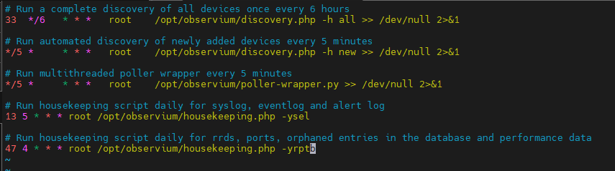

And reload the cron process:

[root@localhost ~]# systemctl reload crond

[root@localhost opt]# cd observium/

[root@localhost observium]# cp config.php.default config.php

[root@localhost observium]# vim config.php

$config['db_user'] = 'observium';

$config['db_pass'] = 'password';

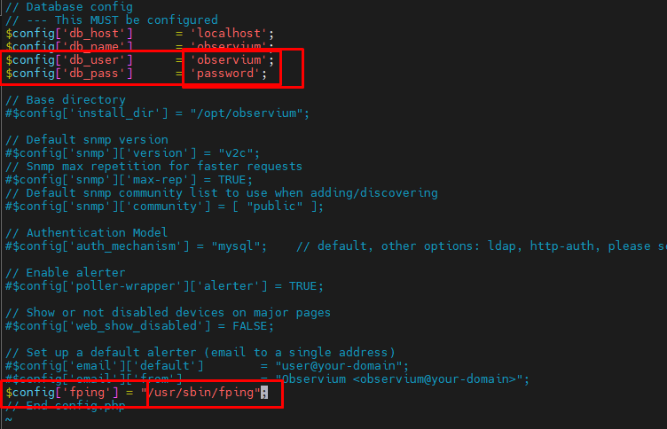

[root@localhost observium]# which fping

/usr/sbin/fping

$config['fping'] = "/usr/sbin/fping";

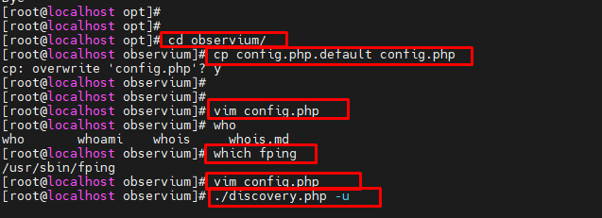

[root@localhost observium]# ./discovery.php -u

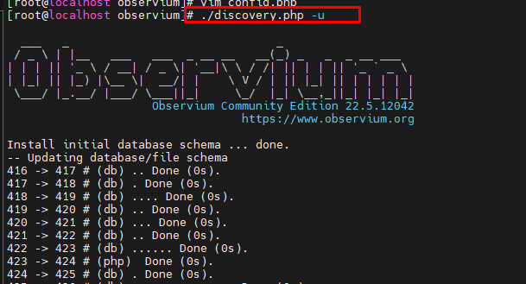

[root@localhost observium]# mysql -u root -p

MariaDB [(none)]> show databases;

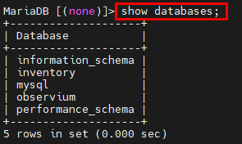

MariaDB [(none)]> use observium

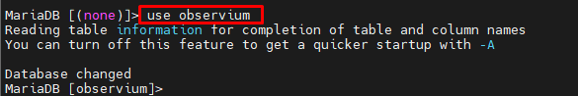

MariaDB [observium]> show tables;

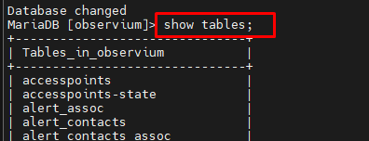

[root@localhost observium]# mkdir rrd

[root@localhost observium]# chown apache:apache rrd

[root@localhost observium]# mkdir logs

[root@localhost observium]# chown apache:apache /opt/observium/logs

[root@localhost observium]# vim /etc/php.ini

date.timezone =Asia/Dhaka

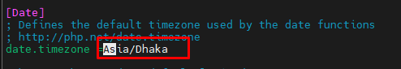

[root@localhost observium]# systemctl restart httpd

[root@localhost observium]# systemctl status httpd

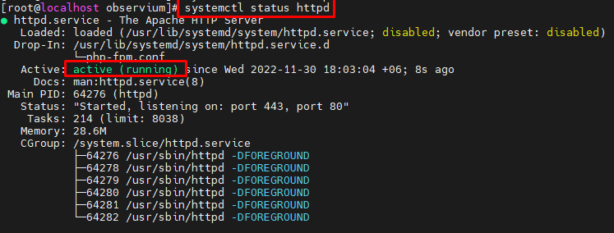

[root@localhost observium]# ./adduser.php admin admin@123 10

User admin added successfully.

[root@localhost observium]# cp /opt/observium/snmpd.conf.example /etc/snmp/snmpd.conf

[root@localhost observium]# vim /etc/snmp/snmpd.conf

rwcommunity redhat 10.200.10.52

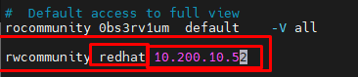

[root@localhost observium]# systemctl restart snmpd.service

[root@localhost observium]# systemctl start snmpd

[root@localhost observium]# systemctl status snmpd

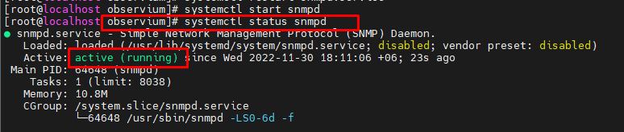

[root@localhost observium]# systemctl reload crond

[root@localhost observium]# systemctl enable httpd

[root@localhost observium]#firewall-cmd --permanent --zone=public --add-service=http

[root@localhost observium]# firewall-cmd --reload

success

[root@localhost observium]# firewall-cmd --permanent --zone=public --add-service=http

success

[root@localhost observium]# firewall-cmd --reload

success

[root@localhost observium]# ./add_device.php 10.200.10.52 redhat v2c

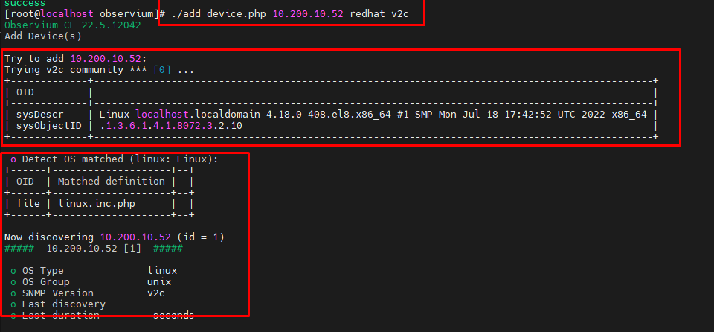

## Final Points

Let's set the httpd to startup when we reboot the server:

[root@localhost observium]# systemctl enable httpd

[root@localhost observium]# systemctl start httpd

Permit HTTP through the server's default firewall

[root@localhost observium]# firewall-cmd --permanent --zone=public --add-service=http

[root@localhost observium]# firewall-cmd --reload

**Source**

<https://docs.observium.org/install_rhel/#rhel-centos-7>

<https://www.youtube.com/watch?v=zQXVDc_zxw0&t=503s&ab_channel=IPCoreNetworks>

