**LanCache Config Ubuntu 20.04**

root@ubuntu:~# mkfs.xfs /dev/sda

root@ubuntu:~# mkdir -p /mnt/data

root@ubuntu:~# mount /dev/sda /mnt/data

root@ubuntu:~# vim /etc/fstab

/dev/sda /mnt/data ext4 defaults 0 0

root@ubuntu:~# mount -a

root@ubuntu:~# reboot

root@ubuntu-PowerEdge-R420:~# bash <(curl -s <https://raw.githubusercontent.com/MrFlacko/lancache-script/main/script.sh>)

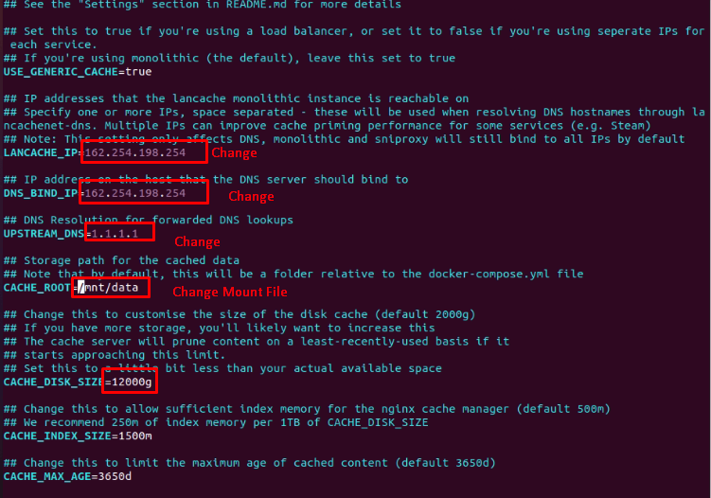

root@ubuntu-PowerEdge-R420:~# vi /var/lib/lancache/.env

**AnyDesk Config Ubuntu**

root@ubuntu:~# wget -qO - https://keys.anydesk.com/repos/DEB-GPG-KEY | sudo apt-key add –

root@ubuntu:~# echo "deb http://deb.anydesk.com/ all main" | sudo tee /etc/apt/sources.list.d/anydesk-stable.list

root@ubuntu:~# deb http://deb.anydesk.com/ all main

root@ubuntu:~# sudo apt update

root@ubuntu:~# sudo apt install anydesk -y

**KVM Install**

root@ubuntu:~# apt install virt-manager -y

root@ubuntu:~# sudo apt install qemu-system-x86 qemu-system libvirt-clients libvirt-daemon-system uml-utilities screen bridge-utils virtinst libvirt-daemon openssh-server -y

root@ubuntu:~# sudo systemctl status libvirtd

root@ubuntu:~# sudo systemctl enable --now libvirtd

root@ubuntu:~# grep -E --color '(vmx|svm)' /proc/cpuinfo

root@ubuntu:~# sudo systemctl status libvirtd

root@ubuntu:~# systemctl restart libvirtd