**Blue Team Shooting Sports Action Pistol August 26th, 2025**

**COURSE DESIGNER:** Ike Starnes

|  |
| --- |
| **START POSITION: See written stage briefings.** |

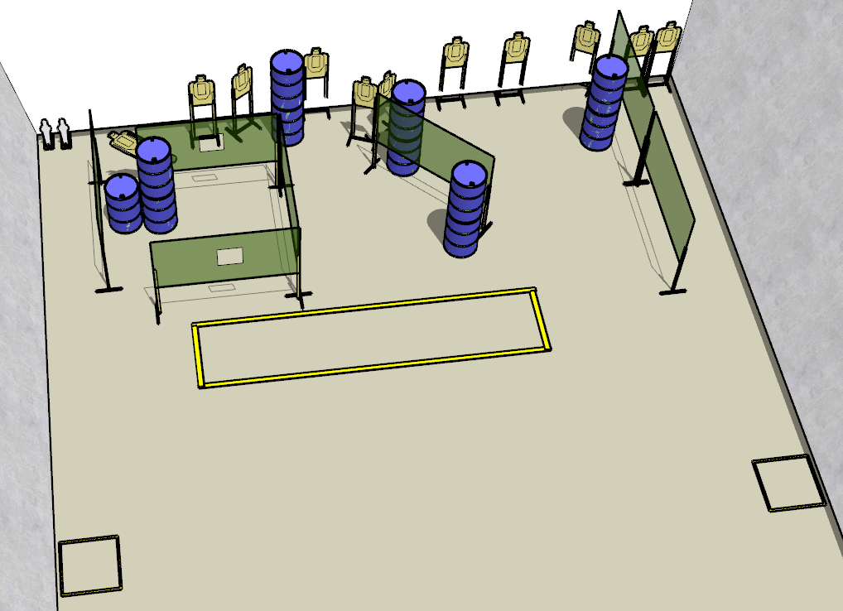

**Written Stage Briefing:**

**Stage 1 – Walk This Way -** is a 24-round, 120 point, Comstock Long Course. There are 11 cardboard targets and 2 steel targets. The best 2 hits per cardboard target will be scored.  
**Handgun start position** Both feet inside the left shooting box. The handgun is **loaded** and holstered.

**PCC start position** Both feet inside the left shooting box. PCC is **loaded** with stock touching belt.

On the audible start signal, engage targets from within the shooting area.  
Popper 2 activates the swinger which is not visible at rest.