**Blue Team Shooting Sports Action Pistol August 26th, 2025**

**COURSE DESIGNER:** Ike Starnes

|  |
| --- |
| **START POSITION: See written stage briefings.** |

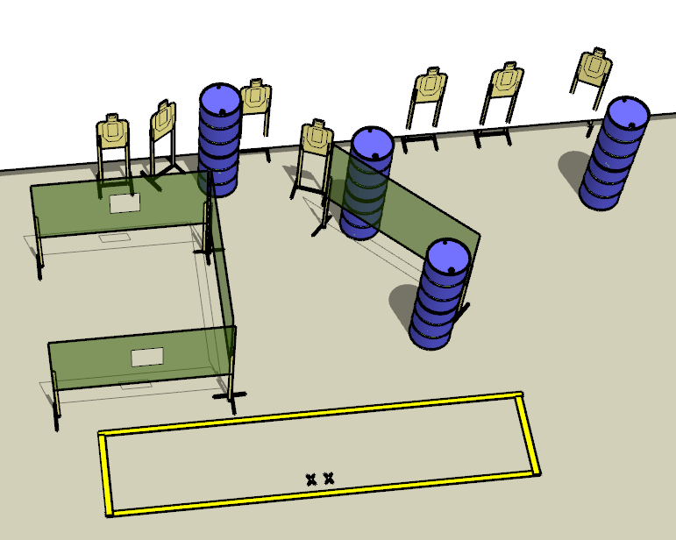

**Written Stage Briefing:**

**Stage 3 – Janie's Got a Gun -** is a 14-round, 70 point, Comstock Medium Course. There are 7 cardboard targets. The best 2 hits per cardboard target will be scored.  
**Handgun start position** Both feet on the Xs. The handgun is **unloaded** and holstered.

**PCC start position** Both feet on the Xs. PCC is **unloaded** held with both hands with stock touching belt.

On the audible start signal, engage targets from within the shooting area.  
You must make a mandatory reload before firing your final shot.