Competitive Shooters of Lake Norman USPSA January 16th, 2026
COURSE DESIGNER: Rocky Perillo
START POSITION: See written stage briefings.

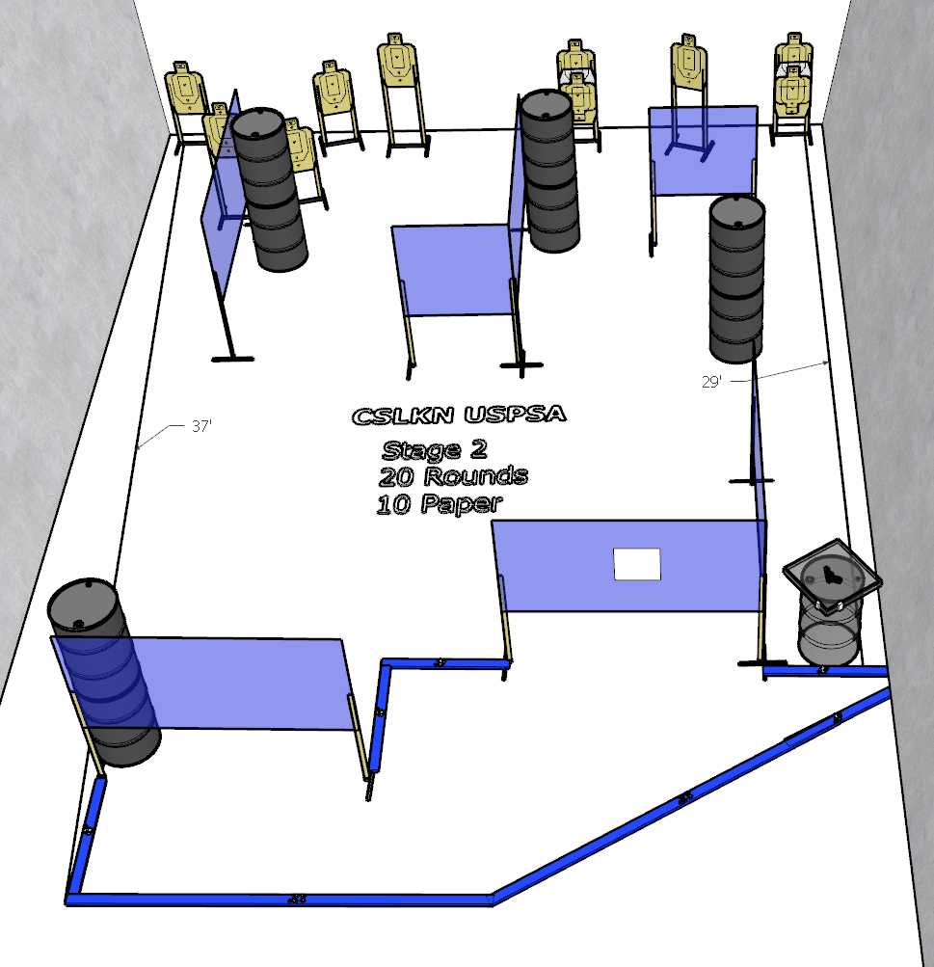

Written Stage Briefing:

Stage 2 – No friends for little Joey
Comstock
20 rounds. 10 paper targets. Some no shoots.
Gun is loaded and placed unpropped on barrel.
On the audible start signal, engage targets from within the shooting area.

