Competitive Shooters of Lake Norman USPSA January 16th, 2026
COURSE DESIGNER: Rocky Perillo
START POSITION: See written stage briefings.

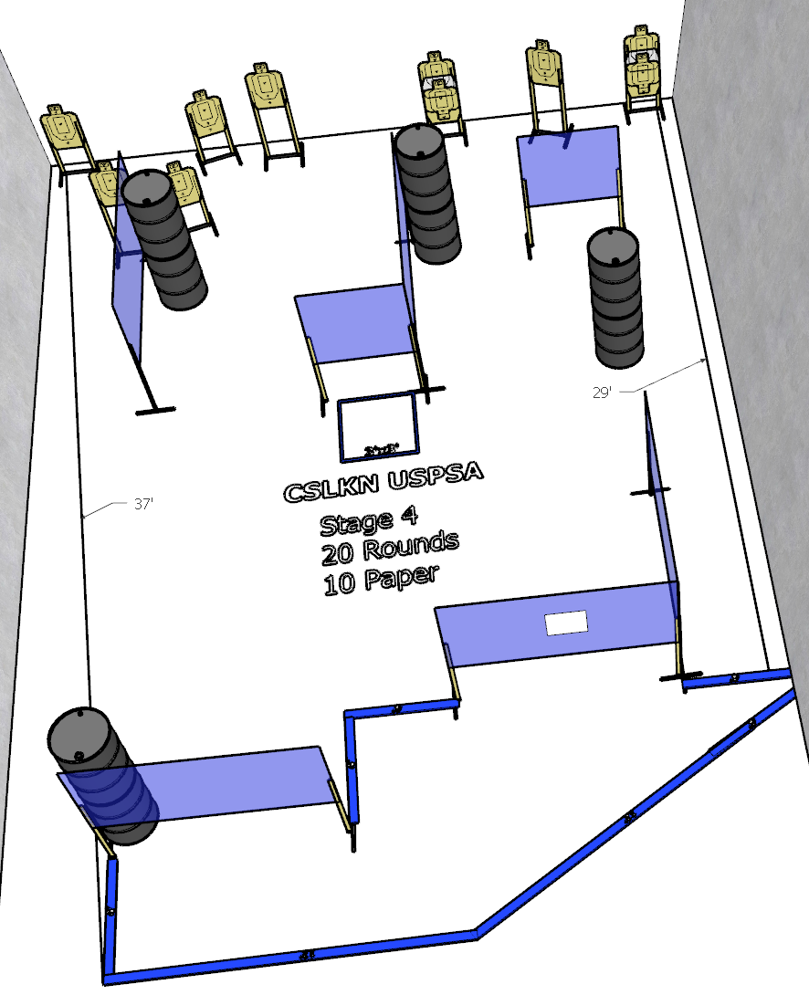

Written Stage Briefing:

Stage 4 – God bless Nick Shirley
Comstock
20 rounds. 10 paper targets. Some no shoots.
Start Both feet inside the forward shooting box.
Handgun loaded and holstered, wrists below belt
PCC loaded, stock touching belt
On the audible start signal, engage targets from within the shooting area.

