Competitive Shooters of Lake Norman USPSA October 16th, 2025
COURSE DESIGNER: Rocky Perillo
START POSITION: See written stage briefings.
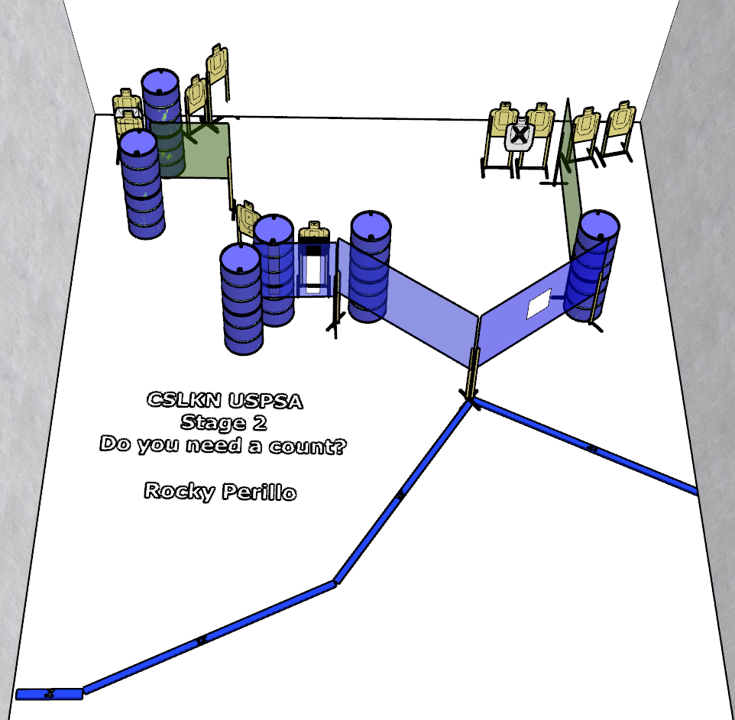

Written Stage Briefing:

Stage 2 - Do you need a count? - is a 20-round, 100 point, Comstock Course. There are 10 cardboard targets and some no shoots. The best 2 hits per cardboard target will be scored.
Handgun start position Anywhere. The handgun is loaded and holstered.
PCC start position Anywhere. PCC is loaded with stock touching belt.
On the audible start signal, engage targets from within the shooting area.

