Competitive Shooters of Lake Norman USPSA October 16th, 2025
COURSE DESIGNER: Rocky Perillo
START POSITION: See written stage briefings.
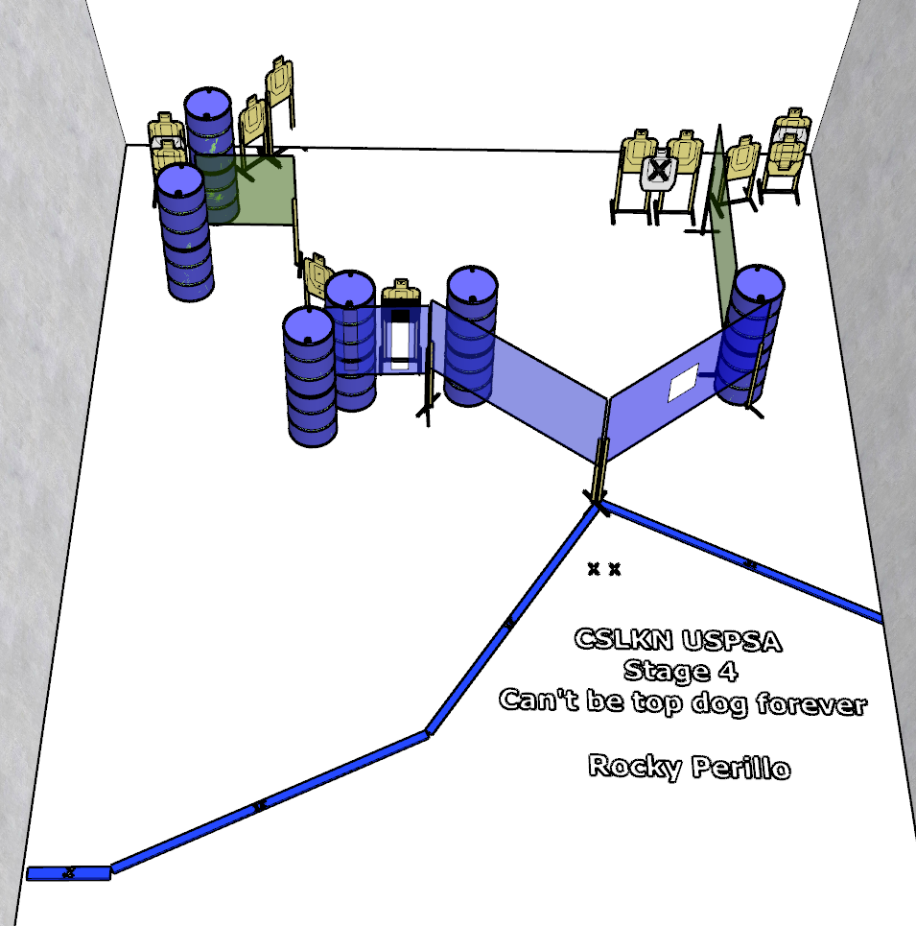

Written Stage Briefing:

Stage 4 - Can't be top dog forever - is a 22-round, 110 point, Comstock Course. There are 11 cardboard targets and some no shoots. The best 2 hits per cardboard target will be scored.
Handgun start position Feet on Xs. The handgun is loaded and holstered.
PCC start position Feet on Xs. PCC is loaded with stock touching belt.
On the audible start signal, engage targets from within the shooting area.

