Competitive Shooters of Lake Norman USPSA November 13th, 2025
COURSE DESIGNER: Ike Starnes
START POSITION: See written stage briefings.

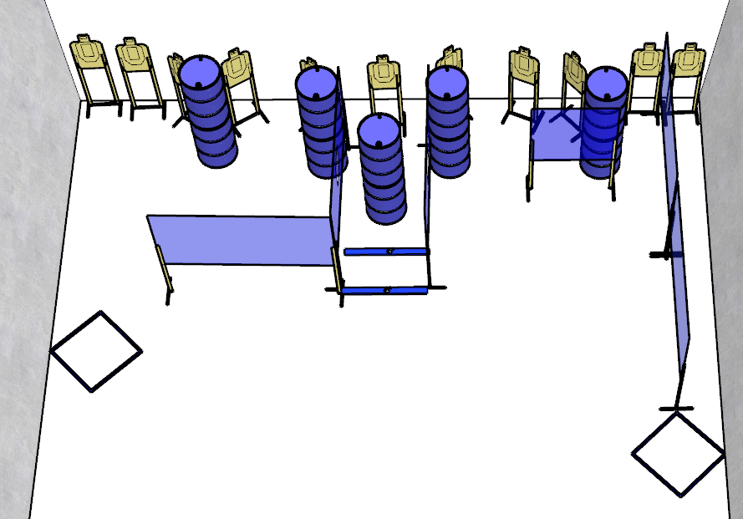

Written Stage Briefing:

Stage 4 - For Ridiculing You Earlier, I Apologize - is a 22-round, 110 point, Comstock Course. There are 11 cardboard targets and some noshoots. The best 2 hits per cardboard target will be scored.
Handgun start position Anywhere. The handgun is loaded and holstered.
PCC start position Anywhere. PCC is loaded with stock touching belt.
On the audible start signal, engage targets from within the shooting area.

