Competitive Shooters of Lake Norman USPSA November 18th, 2025
COURSE DESIGNER: Ike Starnes
START POSITION: See written stage briefings.
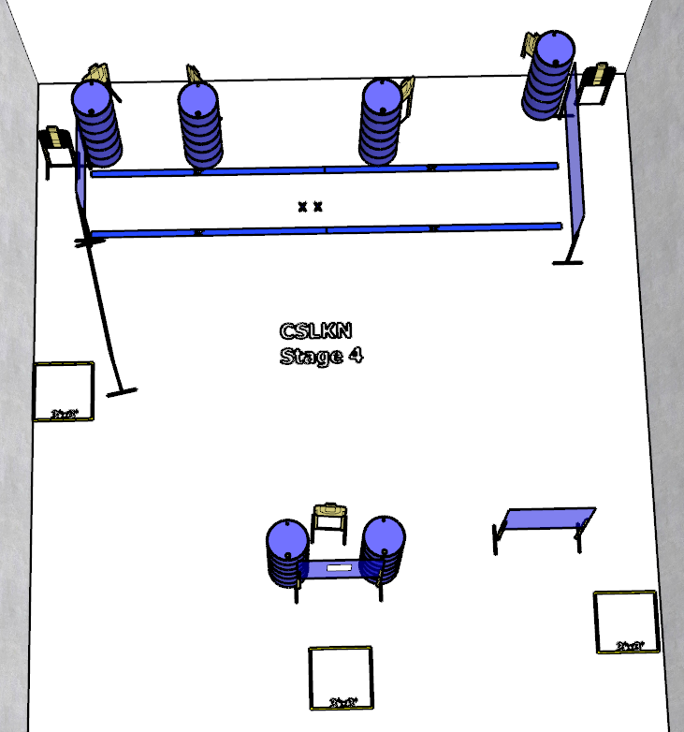

Written Stage Briefing:

Stage 4 – Is you is, or is you ain't, my constituency? - is a 21-round, 105 point, Comstock Course. There are 7 cardboard targets. The best 3 hits per cardboard target will be scored.
Handgun start position Feet on Xs. The handgun is unloaded and holstered.
PCC start position Feet on Xs. PCC is unloaded with stock touching belt.
On the audible start signal, engage targets from within the shooting area.

