Competitive Shooters of Lake Norman USPSA December 11th, 2025
COURSE DESIGNER: ncgearguy05
START POSITION: See written stage briefings.
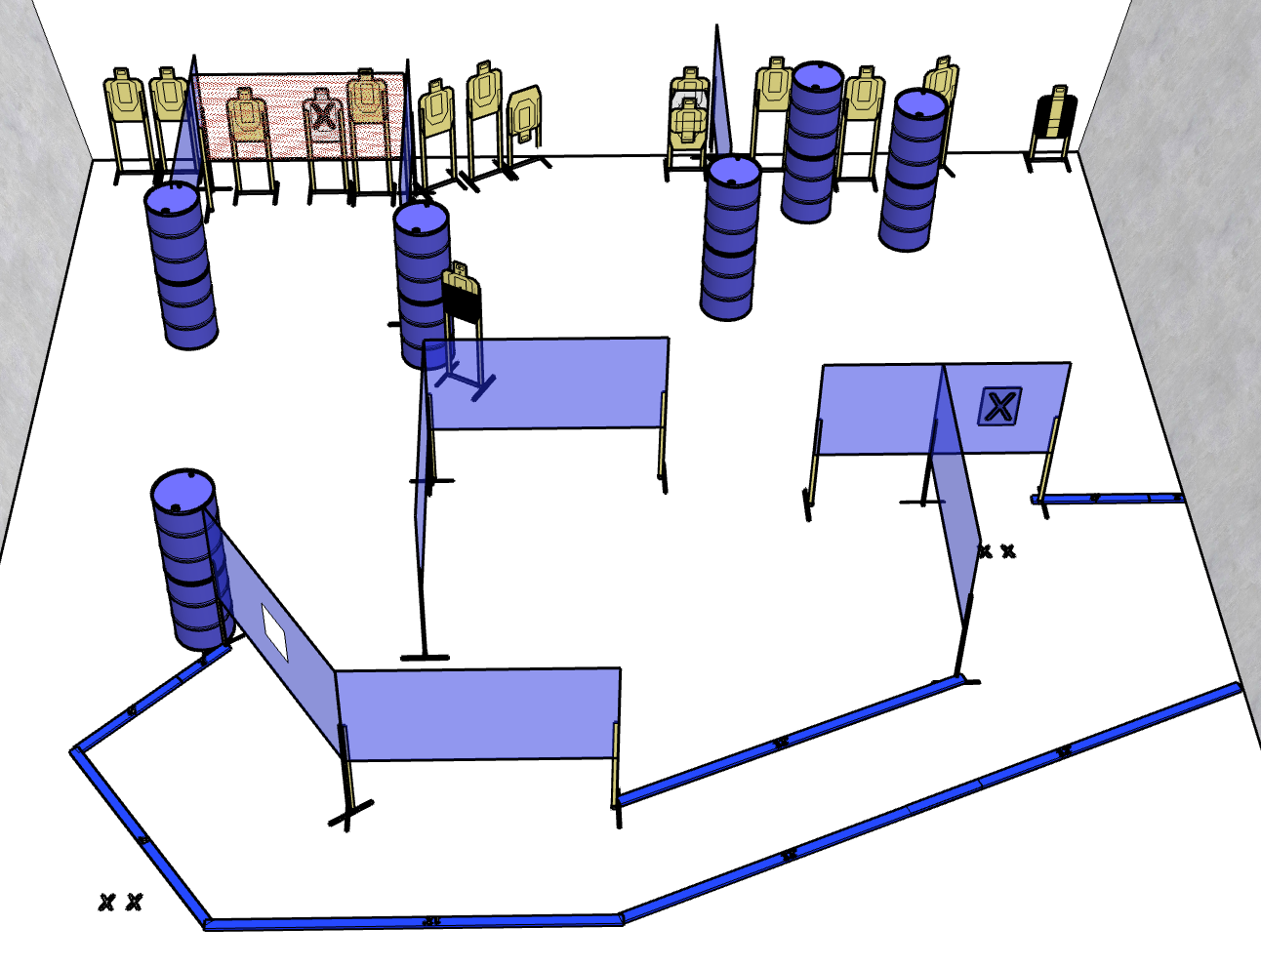

Written Stage Briefing:

Stage 1 - Good dags. Do you like dags? - is a 140 point Comstock course. There are 14 paper targets and some noshoots. The 2 best hits per target will be scored.

Handgun start position is loaded and holstered with both feet on XX's, both hands touching mark on wall, facing directly down range.
PCC start position is loaded with both feet on XX's, held in both hands, stock on belt, with muzzle touching mark on wall, facing directly down range.

Procedure: On the audible start signal, engage targets from within the shooting area.
The orange netting is classed as soft cover.

