Competitive Shooters of Lake Norman USPSA December 11th, 2025
COURSE DESIGNER: ncgearguy05
START POSITION: See written stage briefings.

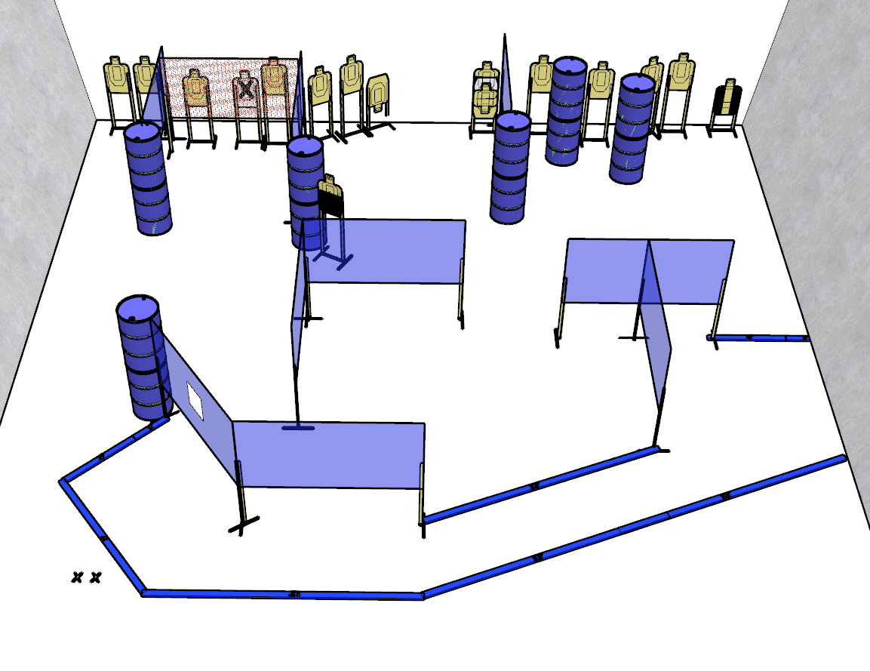

Written Stage Briefing:

Stage 3 - Get the dog, Tommy - is a 150 point Comstock course. There are 15 paper targets and some noshoots. The 2 best hits per target will be scored.

Handgun start position is both feet on XX's, writs below belt, handgun loaded and holstered.
PCC start position is both feet on XX’s, PCC loaded with stock touching belt.

Procedure: On the audible start signal, engage targets from within the shooting area.
The orange netting is classed as soft cover.

