Competitive Shooters of Lake Norman USPSA December 11th, 2025
COURSE DESIGNER: Ryan Christenson
START POSITION: See written stage briefings.

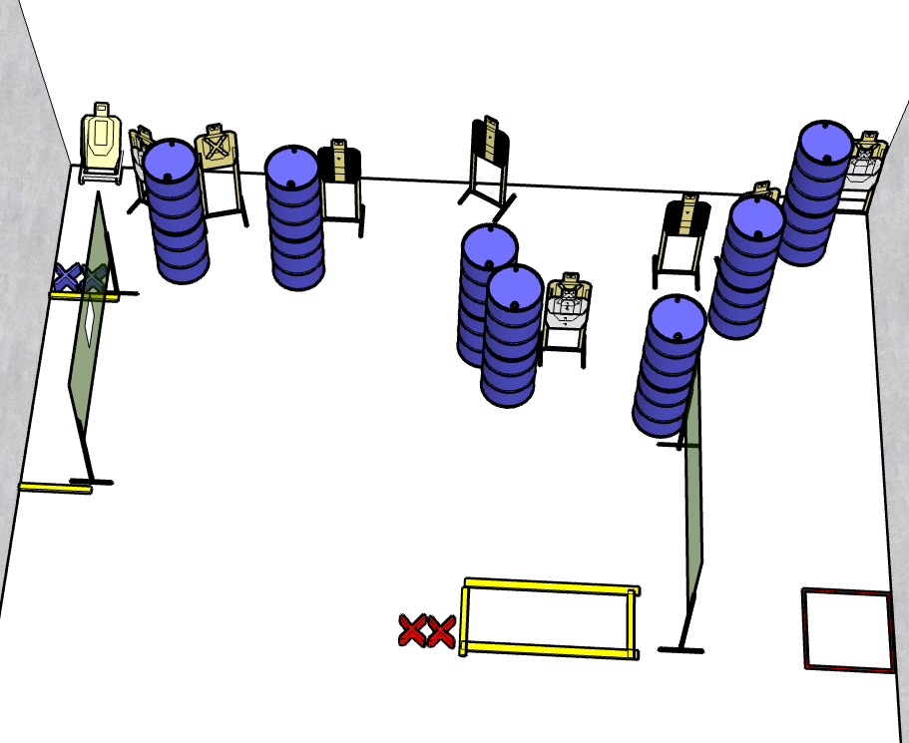

Written Stage Briefing:

Stage 4 - Oh, you love a dog, don't you Tommy

Rounds - 27-rounds
Points - 135 points
Targets - 9 cardboard targets and some noshoots.
Scoring: Comstock, best 3 hits score
Handgun start position Both feet on blue X’s. The handgun is unloaded and holstered.
PCC start position Both feet on blue X’s. PCC is unloaded with stock touching belt.
Procedure: On the audible start signal, engage targets from within the shooting area.

