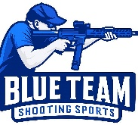
Blue Team Shooting Sports A.S.S.S. February 10th. 2026
COURSE DESIGNER: Ike Starnes

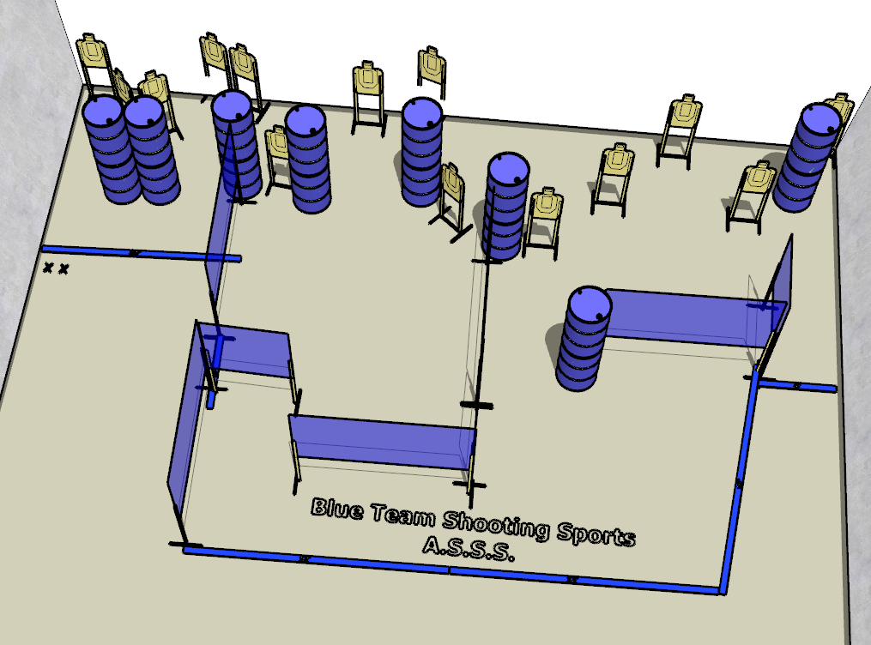

Written Stage Briefings:

Stage 2 – What ain't no country I ever heard of - is a 28-round, 140 point, Comstock Course. There are 14 cardboard targets. The best 2 hits per cardboard target will be scored.
Handgun start position Feet on left Xs. The handgun is loaded and holstered.
PCC start position Feet on left Xs. PCC is loaded with stock touching belt.
On the audible start signal, engage all targets from within the shooting area.

