
Blue Team Shooting Sports A.S.S.S. February 10th. 2026
COURSE DESIGNER: Ike Starnes

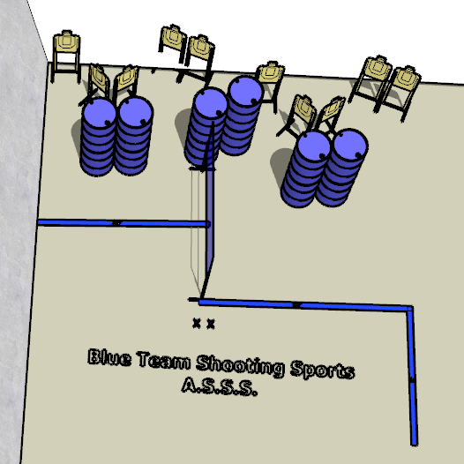

Written Stage Briefings:

Stage 3 – Say what again! - is a 20-round, 100 point, Comstock Course. There are 10 cardboard targets. The best 2 hits per cardboard target will be scored.
Handgun start position Feet on Xs. The handgun is loaded and holstered.
PCC start position Feet on Xs. PCC is loaded with stock touching belt.
On the audible start signal, engage either the left array or the right array, then make a mandatory reload and engage the remaining array.

