Blue Team Shooting Sports Action Pistol November 25th, 2025
COURSE DESIGNER: Ike Starnes
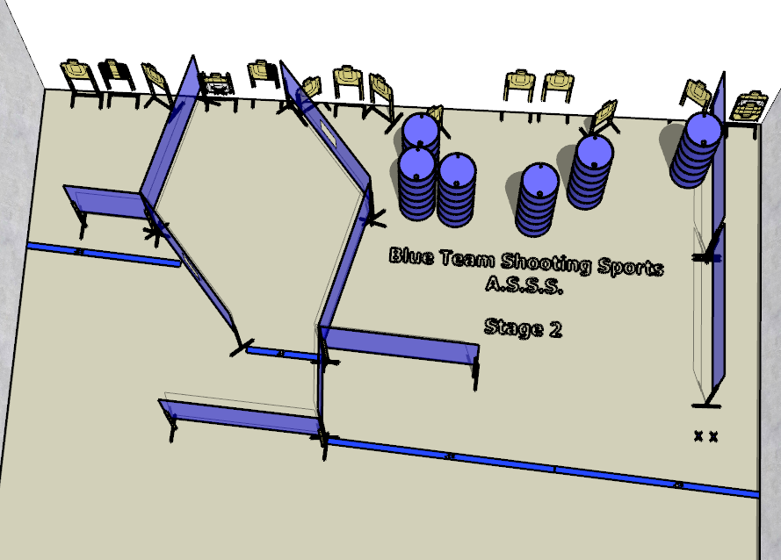

Written Stage Briefing:

Stage 2 - I'd buy that for a dollar! - is a 30-round, 150 point, Comstock Course. There are 15 cardboard targets and some noshoots. The best 2 hits per cardboard target will be scored.
Handgun start position Feet on Xs with wrists below belt. The handgun is unloaded and holstered.
PCC start position Feet on Xs. PCC is unloaded with stock touching belt.
On the audible start signal, engage all targets from within the shooting area.

