Blue Team Shooting Sports Action Pistol November 25th, 2025
COURSE DESIGNER: Ike Starnes
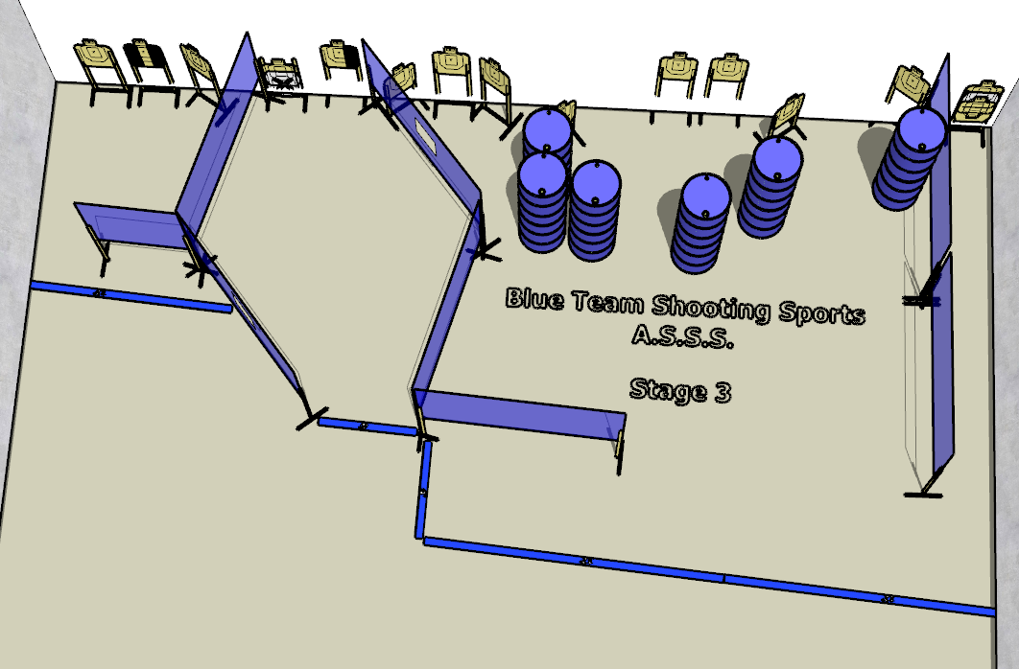

Written Stage Briefing:

Stage 3 -Dead or alive, you're coming with me - is a 30-round, 150 point, Comstock Course. There are 15 cardboard targets and some noshoots. The best 2 hits per cardboard target will be scored.
Handgun start position Feet on Xs, hands touching wall. The handgun is loaded and holstered.
PCC start position Feet on Xs. PCC is loaded, with muzzle touching wall.
On the audible start signal, engage all targets from within the shooting area.

