Blue Team Shooting Sports Action Pistol December 9th, 2025
COURSE DESIGNER: Ike Starnes
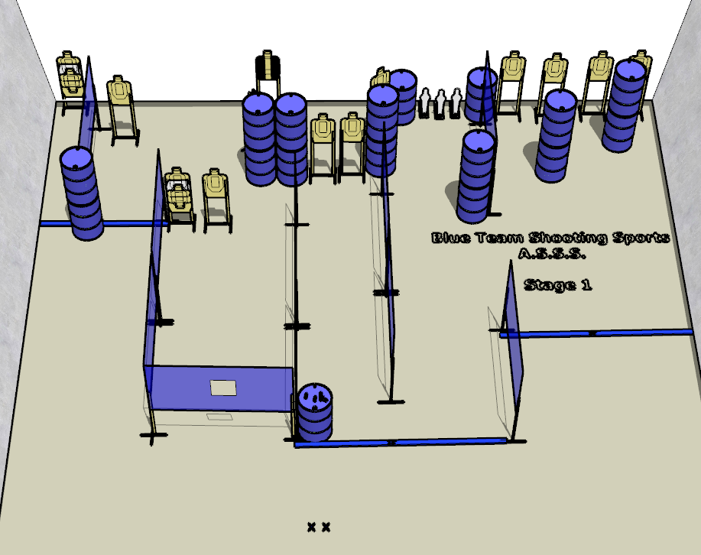

Written Stage Briefing:

Stage 1 – My suggestion is to keep your distance - is a 33-round, 165 point, Comstock Course. There are 15 cardboard targets, 3 steel targets and some noshoots. The best 2 hits per cardboard target will be scored. Steel must fall to score.
Handgun start position Feet on Xs. The handgun is unloaded and un-propped on the barrel.
PCC start position Feet on Xs. PCC is unloaded and un-propped on the barrel.
All magazines to be used on the stage must be placed on the barrel prior to the start signal.
On the audible start signal, engage all targets from within the shooting area.

