Blue Team Shooting Sports Action Pistol December 9th, 2025
COURSE DESIGNER: Ike Starnes

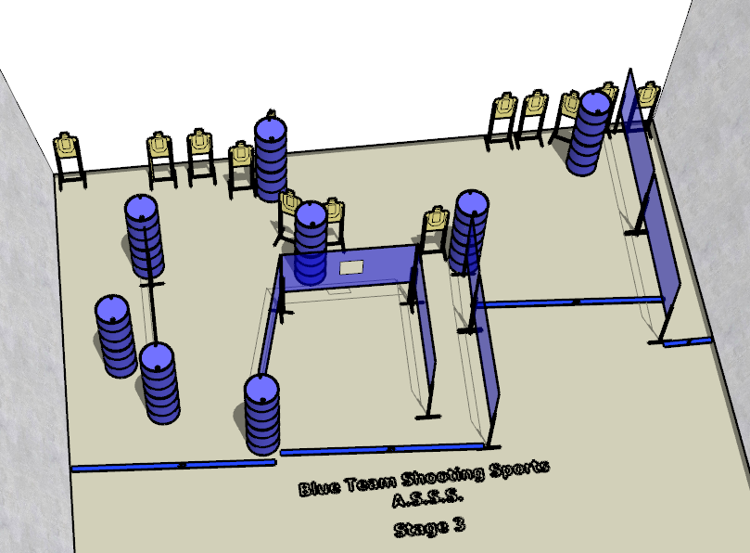

Written Stage Briefing:

Stage 3 – I don’t have an attitude; I’ve shut down. - is a 26-round, 130 point, Comstock Course. There are 13 cardboard targets and some noshoots. The best 2 hits per cardboard target will be scored.
Handgun start position Anywhere. The handgun is loaded and holstered.
PCC start position Anywhere. PCC is loaded with stock touching belt.
On the audible start signal, engage all targets from within the shooting area.

