Stage 1 – They don't know what the @#*k they're doing
COURSE DESIGNER: Ike Starnes
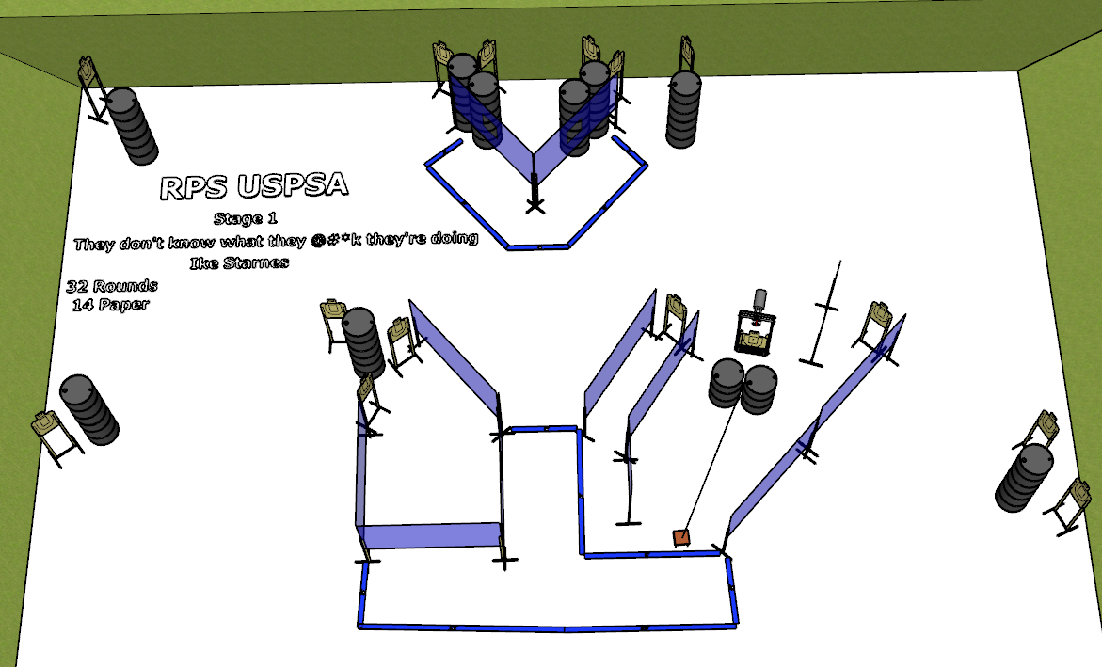

Written Stage Briefing:
Stage 1 – They don't know what the @#*k they're doing - is a 32 round, 160 point, Comstock course. There are 15 cardboard targets. The best 2 hits per static cardboard target will be scored. The best 4 hits on the Bobber will be scored.
Start position is anywhere. Handgun loaded and holstered. PCC loaded, stock on belt.
Bobber target is activated by the Bigfoot stomp pad and remains visible at rest.

Setup Notes:
10 Single Wall Stands
6 Double Wall Stands
7 Full Walls
3 Port Wall
2 Half Walls
14 Target stands / 28 target sticks
1 Bobber
1 Bigfoot stomp pad and cables
20+ barrels


