Stage 6 – I don't think he knows what he said either.
COURSE DESIGNER: Rocky Perillo
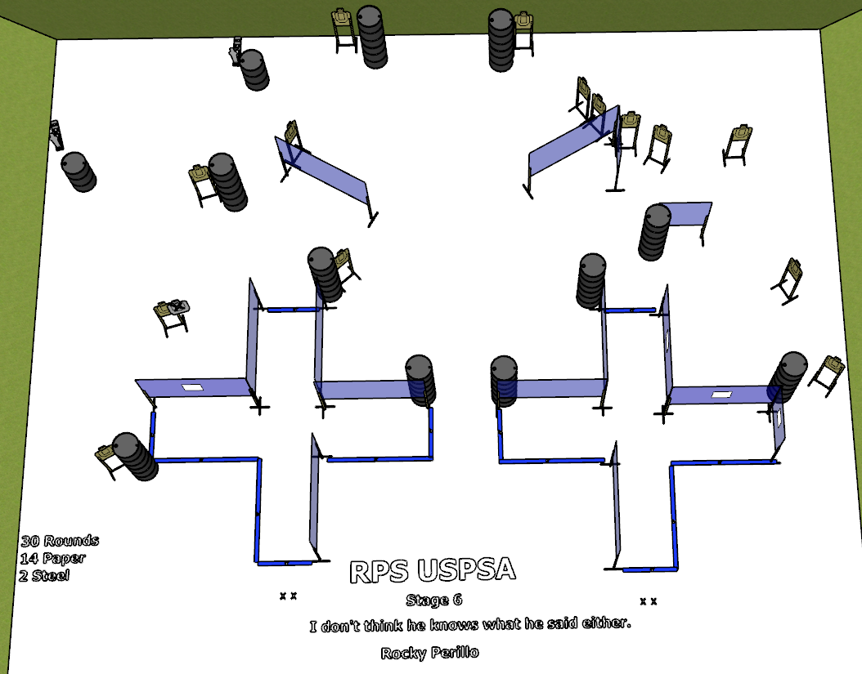

Written Stage Briefing:
Stage 6 – I don't think he knows what he said either. - is a 30 round, 150 point, Comstock course. There are 14 cardboard targets and 2 steel targets. The best 2 hits per cardboard target will be scored.
Start position is both feet on the Shooting Sports Innovations Xs.
Handgun loaded and holstered, wrists below belt.
PCC loaded, stock on belt.

Setup Notes:
18 Single Wall Stands
5 Double Wall Stands
9 Full Walls
3 Port Walls
1 Half Wall
1 Half Port
1 Half Wall
14 Target stands / 28 target sticks
2 Mini Poppers and Bases
22+ barrels


