Stage 1 - Oops, I Did It Again
COURSE DESIGNER: Ike Starnes

SCORING: Comstock 32 rounds.
TARGETS: 16 cardboard targets
SCORED HITS: 2 Best hits per carboard will be scored.

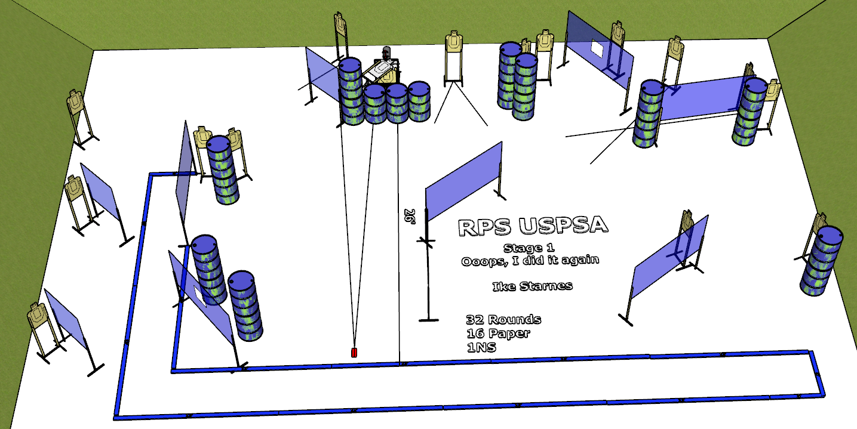

Written Stage Briefing:

Stage 1 - Ooops, I Did It Again - is a 32 round, 160 point, Comstock course. There are 16 cardboard targets. The best 2 hits per cardboard target will be scored.
Start position Anywhere.
Handgun: Loaded and holstered, wrists below belt.
PCC: Loaded, stock touching belt.

Targets USA Bigfoot stomp pad activates the bobber, which remains visible at rest.

On the audible start signal, engage targets from within the shooting area.

USPSA / NROI Range Commands:
- Make Ready
- Are you ready?
- Standby
- If finished, unload and show clear.
- If clear, hammer down and holster
- Range is clear

Setup Notes:
18 Single Wall Stands
4 Full Walls
2 Port Walls
2 Half Walls
15 Target stands / 30 target sticks
1 Bobbers + activation hardware and target sticks
1 Swinger + activation hardware and target sticks
1 Targets USA Bigfoot Stomp Pad
22+ barrels

