Stage 5 - You Drive Me Crazy
COURSE DESIGNER: John Royer / Outdoor Dynamics

SCORING: Comstock 32 rounds.
TARGETS: 13 cardboard targets, 2 steel targets
SCORED HITS: 2 Best hits per carboard will be scored. Steel must fall to score.

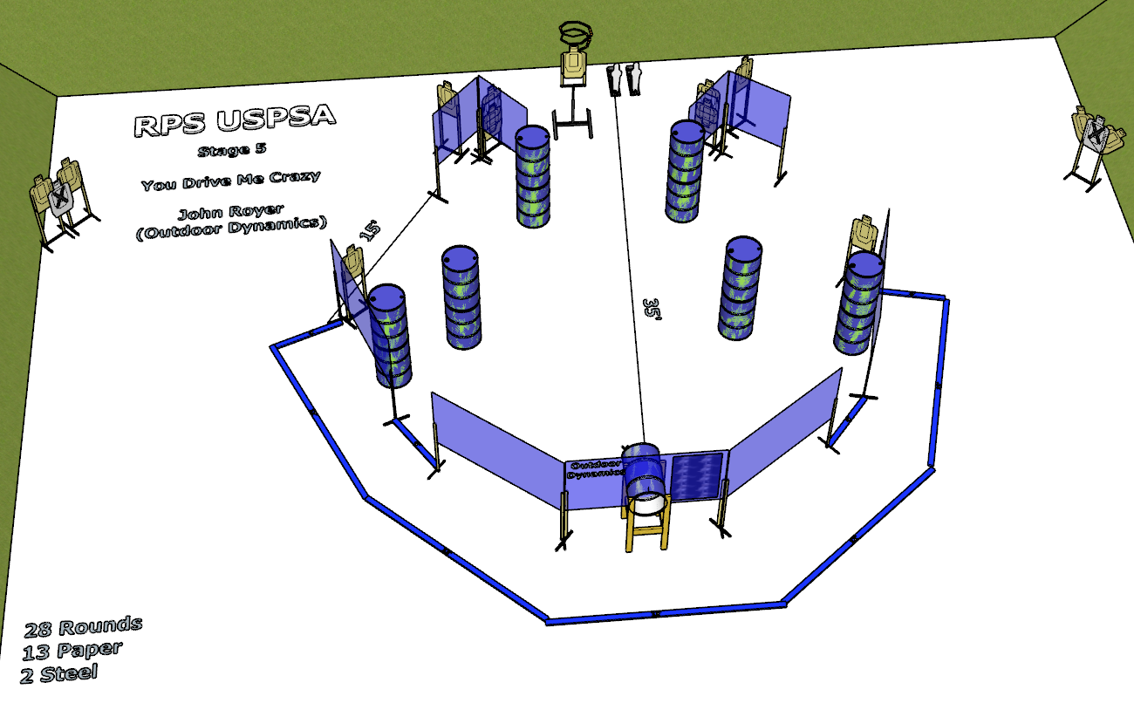

Written Stage Briefing:

Stage 5 - You Drive Me Crazy- is a 28 round, 140 point, Comstock course. There are 13 cardboard targets and 2 steel targets. The best 2 hits per cardboard target will be scored. The steel must fall to score.
Start position Both feet on the Shooting Sports Innovations Xs.
Handgun: Unloaded and holstered, wrists below belt.
PCC: Loaded, stock touching belt.

Popper 2 activates the drop turn target which is not visible at rest.

On the audible start signal, engage targets from within the shooting area.

USPSA / NROI Range Commands:
- Make Ready
- Are you ready?
- Standby
- If finished, unload and show clear.
- If clear, hammer down and holster
- Range is clear

Setup Notes:
10 Single Wall Stands
4 Double Wall Stands
4 Full Walls
4 Half Walls
1 Special Wall
9 Target stands / 18 target sticks
1 Drop Turn + activation hardware and target sticks
1 popper
1 popper base
1 Activator popper + cables
12+ barrels

