Stage 6 – (Hit That No Shoot) Baby One More Time
COURSE DESIGNER: Ryan Christenson

SCORING: Comstock 30 rounds.
TARGETS: 15 cardboard targets
SCORED HITS: 2 Best hits per carboard will be scored.

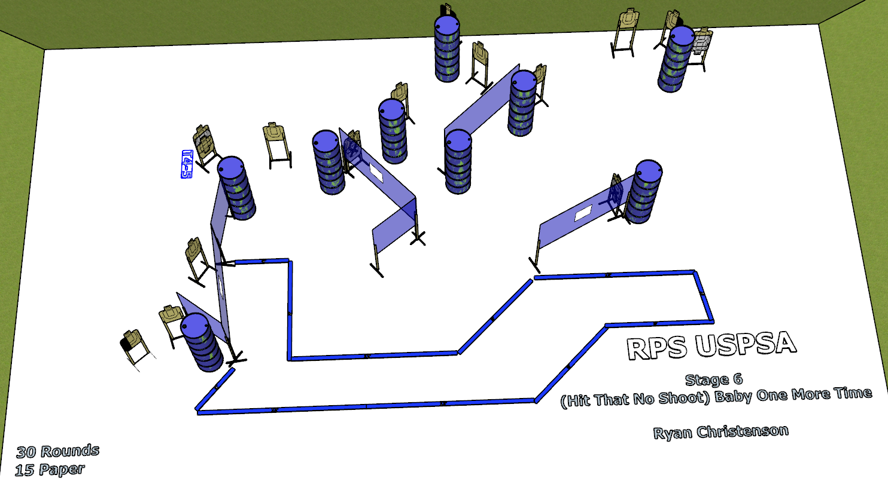

Written Stage Briefing:

Stage 6 – (Hit That No Shoot) Baby One More Time- is a 30 round, 150 point, Comstock course. There are 15 cardboard targets. The best 2 hits per cardboard target will be scored.
Start position Anywhere
Handgun: Loaded and holstered, wrists above shoulders.
PCC: Loaded, stock touching belt, strong hand wrist above shoulders.

On the audible start signal, engage targets from within the shooting area.

USPSA / NROI Range Commands:
- Make Ready
- Are you ready?
- Standby
- If finished, unload and show clear.
- If clear, hammer down and holster
- Range is clear

Setup Notes:
8 Single Wall Stands
3 Double Wall Stands
1 Full Walls
3 Half Walls
3 Port Walls
14 Target stands / 28 target sticks
18+ barrels

Be very careful with T 4-5, might have to move it into the berm

