Stage 7 – If You Seek Amy
COURSE DESIGNER: Allen Terrell*

SCORING: Comstock 29 rounds.
TARGETS: 14 cardboard targets, 1 steel target
SCORED HITS: 2 Best hits per carboard will be scored. Steel must fall to score.

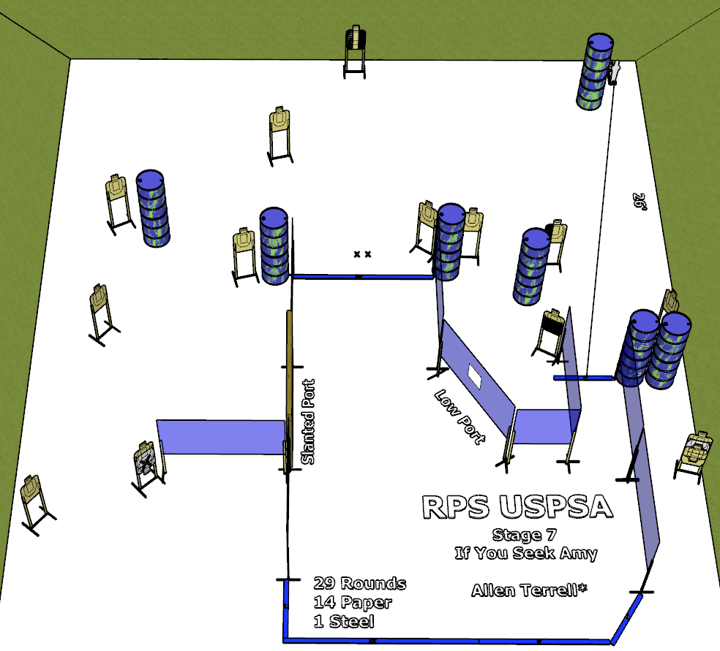

Written Stage Briefing:

Stage 7 - If You Seek Amy - is a 29 round, 145 point, Comstock course. There are 14 cardboard targets, 1 steel target and some No Shoots. The best 2 hits per cardboard target will be scored. Steel must fall to score.
Start position Both feet on the Shooting Sports Innovations Xs, facing generally downrange.
Handgun: Unloaded and holstered.
PCC: Unloaded, stock touching belt.

Rule 8.2.3: A course of fire must never require or allow a competitor to touch or hold a handgun, loading device or ammunition after the “Standby” command and before the “Start Signal” (except for unavoidable touching with the lower arms).

On the audible start signal, engage targets from within the shooting area.

USPSA / NROI Range Commands:
- Make Ready
- Are you ready?
- Standby
- If finished, unload and show clear.
- If clear, hammer down and holster
- Range is clear

Setup Notes:
7 Single Wall Stands
6 Double Wall Stands
1 Triple Wall Stand
8 Full Walls
1 Port Wall (convert to low port)
1 Half Wall
1 Slanted Port Wall
13 Target stands / 26 target sticks
1 Popper Base
1 Mini Popper
1 Starting Xs
12+ barrels

