Stage 1 – Naw, I’m doing just fine, Clark
COURSE DESIGNER: David Burton / Ike Starnes

SCORING: Comstock 40 rounds.
TARGETS: 20 cardboard targets
SCORED HITS: 2 Best hits per carboard will be scored.

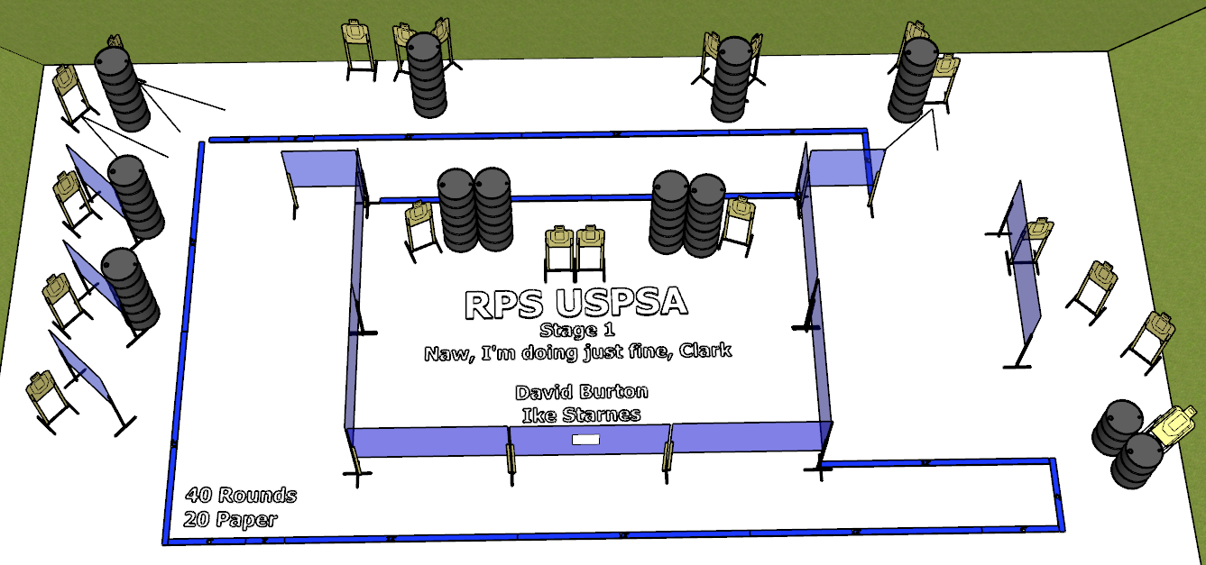

Written Stage Briefing:

Stage 1 – Naw, I’m doing just fine, Clark - is a 40 round, 200 point, Comstock Course. There are 20 cardboard targets. The best 2 hits per cardboard target will be scored.
Start position Anywhere facing downrange.
Handgun: Loaded and holstered, wrists below belt.
PCC: Loaded, held in both hands, stock touching belt.

On the audible start signal, engage targets from within the shooting area.

USPSA / NROI Range Commands:
- Make Ready
- Are you ready?
- Standby
- If finished, unload and show clear.
- If clear, hammer down and holster
- Range is clear

Setup Notes:
4 Single Wall Stands
8 Double Wall Stands
7 Full Walls
1 Port Wall
2 Half Walls
20 Target stands / 40 target sticks
22+ barrels

