Stage 4 – Is your house of fire, Clark?
COURSE DESIGNER: John Royer / Outdoor Dynamics

SCORING: Comstock 40 rounds.
TARGETS: 19 cardboard targets
SCORED HITS: 2 Best hits per static carboard will be scored. 3 Best hits on Moving Targets will be scored.

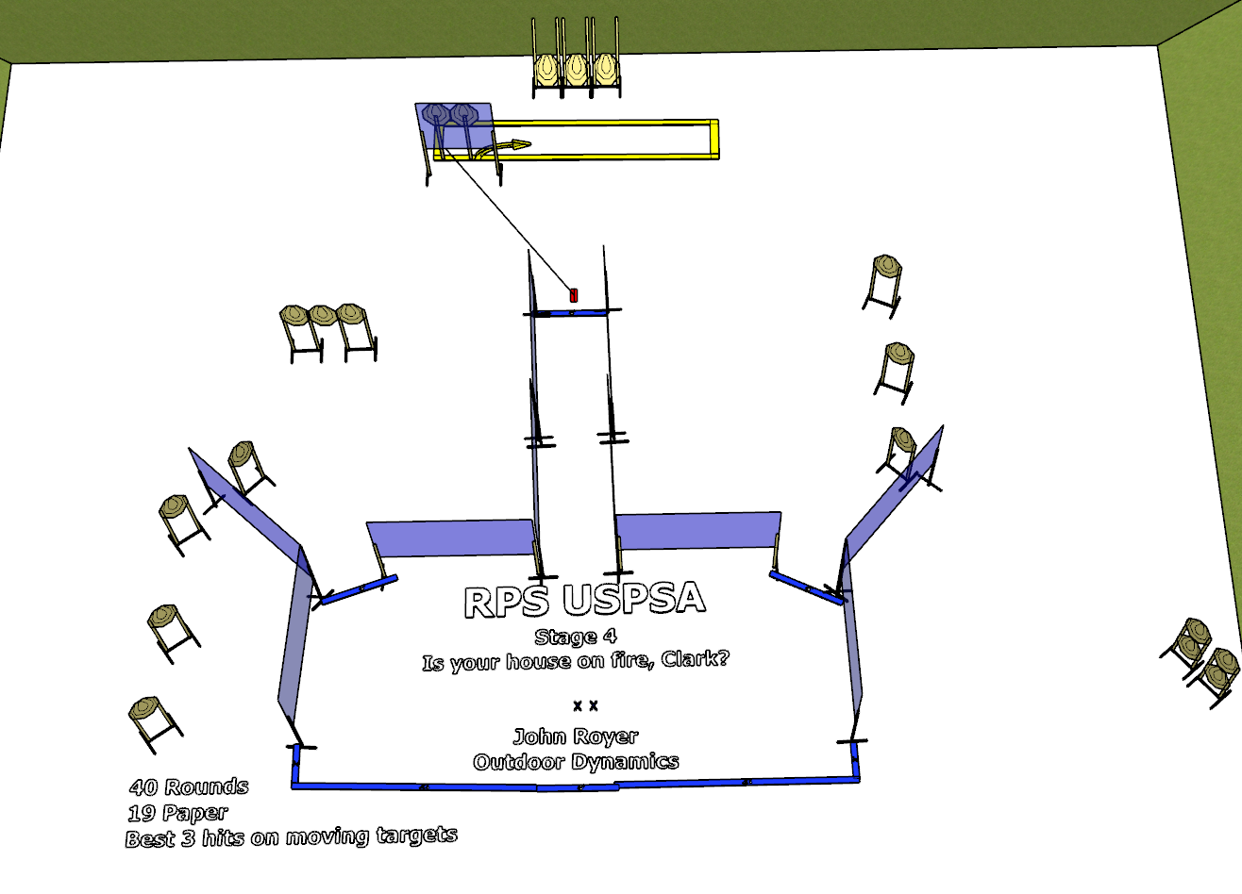

Written Stage Briefing:

Stage 4 – Is your house of fire, Clark? - is a 40 round, 200 point, Comstock Course. There are 19 cardboard targets. The best 2 hits per static cardboard target will be scored. The best 3 hits on the Moving Targets will be scored.
Start position Both feet touching the Shooting Sports Innovations Xs.
Handgun: Loaded and holstered, wrists below belt.
PCC: Loaded, stock touching belt.

On the audible start signal, engage targets from within the shooting area.

The Moving Targets are activated by the stomp pad and remain visible at rest.

USPSA / NROI Range Commands:
- Make Ready
- Are you ready?
- Standby
- If finished, unload and show clear.
- If clear, hammer down and holster
- Range is clear

Setup Notes:
10 Single Wall Stands
6 Double Wall Stands
10 Full Walls
1 Half Wall
14 Target stands / 30 target sticks
1 Roller Coaster + activation cables
1 Bigfoot

