INTERNSHIP TECHNICAL REPORT

Student: John Doe

Corporation: X Company

DATA 7890
Project Documentation
In partial fulfillment of the Internship Requirement

Semester (e.g. Fall 2025)
Department of Computer Science
Bowling Green State University, Ohio

Executive Summary

Write about 2-5 paragraphs (Max 400 words) describing an overview of your internship project, tasks, the problem you target to solve, the obtained result, and importance of the results. Highlight your work and contributions. This is THE MOST important part of your document. You start writing it first. However, when you have completed the rest of your document, you need to re-visit this summary and adjust it to reflect better your thoughts in this report.

The font in this report is Times New Romans, the size is 12, and the line-space is 1. There must be one line space between the paragraphs. Your report should comply with this template, otherwise it will be returned to you for changes.

The Report should have the following items:
- First Page [Required, using the given format*]
- Executive Summary [Required]
- Table of Contents [Required, using the given format**]
- Body contents, at least 4 pages [Required]
- Reference [if applicable]
- Appendix [Optional]
- Acknowledgement [Optional]

.
* The format of the first page should not be changed. Only changes allowed are: Your Name and the Company/Institution name.

** The format of the Table of Contents (ToC) must remain, which reflects the structure of your report. To update the ToC, right click on it, then select “Update Field”, then “Update entire table”. FYI, all Section Rubrics have Heading tags, which ToC automatically follows

Table of Contents

1. Introduction and Overview 1
2. Project I 1
2.1. Background and Scope 1
2.2. Rationale and Goals 1
2.3. Methods and Tools 1
2.4. Results and Analysis 1
2.5. Challenges and Learning Outcomes 1
3. Project II 1
4. Examples and Analysis 1
4.1. Case Studies 2
4.2. Examples 3
4.3. Discussions and Analysis 4
5. Learning From the Internship Program 4
6. Conclusions 4
7. References 4
Appendix and Extra Materials 5
Acknowledgement 5

[ This page is left intentionally blank for printing purpose ]

Introduction and Overview
In this section, you should provide an overview of your internship, the name and location of the enterprise and division you worked with, the size of the team, and any general information that helps your reader to follow your report.

Remember that your introduction should appeal the readers to continue read the rest of the document.

Throughout your report, you can use Figures and Tables to describe your project. A conventional method for such is giving in Section 4 of this template under Case Studies.

Project I
In this section, briefly describe your first task in this internship. The sub-sections are to help you and structure your report. If you need to add or modify the sub-sections, you may do so if it helps you. However, you must address the issues the below sub-sections are highlighting.

Background and Scope

Rationale and Goals

Methods and Tools

Results and Analysis

Challenges and Learning Outcomes

Project II
If you have worked on multiple projects during your internship, describe each of them accordingly. In this case, just copy and paste the structure given to you under Project 1. If you have multiple tasks under a single project, you may use change the name of Project to Task I, II, III, etc. However, you worked only on one project, then remove this section.

Examples and Analysis
This section can be removed if not needed. However, any case studies, test cases, simulations, results and analysis, and their important can be described in this section. Use multiple sub-sections with appropriate rubrics to reflect your arguments and analysis.

Case Studies
Describe few cases, which can reflect as examples of your project. Any test cases, simulations, results and analysis, and their important should be described in this section.

If you have any table, use the format of Table 1, where the table number is on the top of the table, and a short description follows immediately after the number. The size and the rows and columns as well as the content clearly depend on you report.

Table 1: The sizes of the three matrices used in the sequential, pure OpenMP, pure MPI, and hybrid OpenMP-MPI models

Sizes of the three matrices used in each model.
Matrix | Rows | Columns
A | 5000 | 2000
B | 2000 | 2500
C | 5000 | 2500

You may use figures and tables to show the result and discuss what are the important of these results. For example, Figure 1 show the speed up of the programs executions with 8 processors and different matrix sizes for three different methods.

Figure 1: Speed up comparisons between different scheduling and methods.

You can copy figures and tables from any sources, but you must give the reference to those, as shown in Figure 2 and Table 2 below, in order to prevent plagiarism.

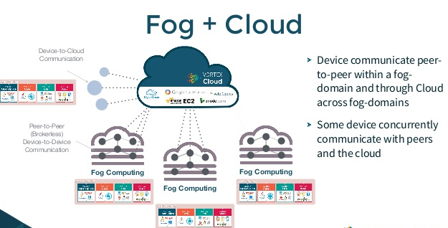
Figure 2: Overview of Fog and Cloud connection [24]

Table 2: Technology Comparison of ZigBee, Bluetooth, and Wi-Fi [27]
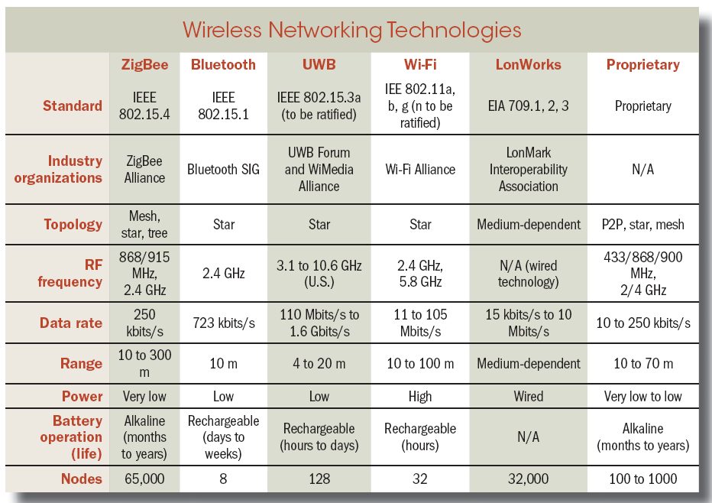

Examples
Examples are often concrete and short, whereas case studies have deeper contents and much more data. While case studies and examples could reflect the same issue, they can be different. Choose what you want.

Discussions and Analysis
If you need to add some overall discussions and analysis of your work, this could be a good place, otherwise remove it.

Learning From the Internship Program
This section should describe the learning outcomes of your internship. In general, it should reflect what courses and projects from DS/BGSU helped you to achieve your goal. If needed, use sub-sections like 5.1, 5.2, etc. or itemize your description with appropriate rubrics.

Conclusions
Tell your audience briefly:
- what you have down and why it is important
- what is your contribution
- what is the lessons learned from this project

References
If any references, list them in index format where the index number indicates where first in the document that index has been referred to: e.g.

- Wilkinson, B., Allen, M., 2005, "Parallel Programming, Techniques and Applications Using Networked Workstations and Parallel Computers", Prentice Hall, Second addition
- MPI Totorials, http://www.lam-mpi.org/tutorials/
- Cloud Computing: Principles and Paradigm, Edited by Rajkumar Buyya, James Broberg and Andrzej Goscinski, John Wiley & Sons, Inc., 2011

Appendix and Extra Materials
In this section, you may add materials such as extra info, etc., which you think it is important but should not be directly in main document. You may remove this section if not needed.

Acknowledgement
If you need to thank or acknowledge someone, people, etc., you may do here.

