App icon and Splash Screen asset generator for HoloLens apps

Updated 2/26/18 By Kian Ng

The tile and icon asset generator provides a set of Adobe Photoshop actions and templates that you can use to generate the 6 recommended app assets that follow the [Submitting HoloLens app guidelines](https://developer.microsoft.com/en-us/windows/mixed-reality/submitting_an_app_to_the_windows_store) and also [Windows 10 tile and icon asset guidelines](https://msdn.microsoft.com/en-us/library/windows/apps/mt412102.aspx).

**Update**: UWP has changed the default icon to Scale200, so you don’t need the other sizes. Ignore the amount of icons shown in the screenshot, they are for reference only.

## Requirements

* Adobe Photoshop CC 2015 and above

## Installation

1. The AppIcon folder contains several files:
   * Placeholder assets Pngs
   * A Working_Files directory that contains:
     + This readme
     + Photoshop action file: Mixed Reality v1.1.atn
     + Logo-TileLargeMedium.psd
     + Logo-TileSmall.psd
     + Logo-TileWide.psd
     + SplashScreen.psd
     + StoreLogo.psd
2. Launch Adobe Photoshop.
3. Locate the Actions window. If you don’t see it, here’s how to enable it: In the main menu, select **Window** > **Actions**. (Alternatively, you can press Alt + F9.)  
   The Actions Window appears:

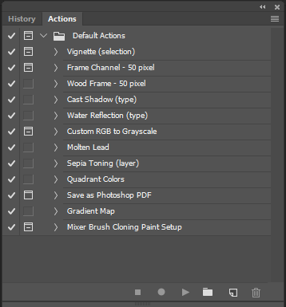

1. Click the hamburger menu in the upper-right corner of the Actions window and select **Load actions...**

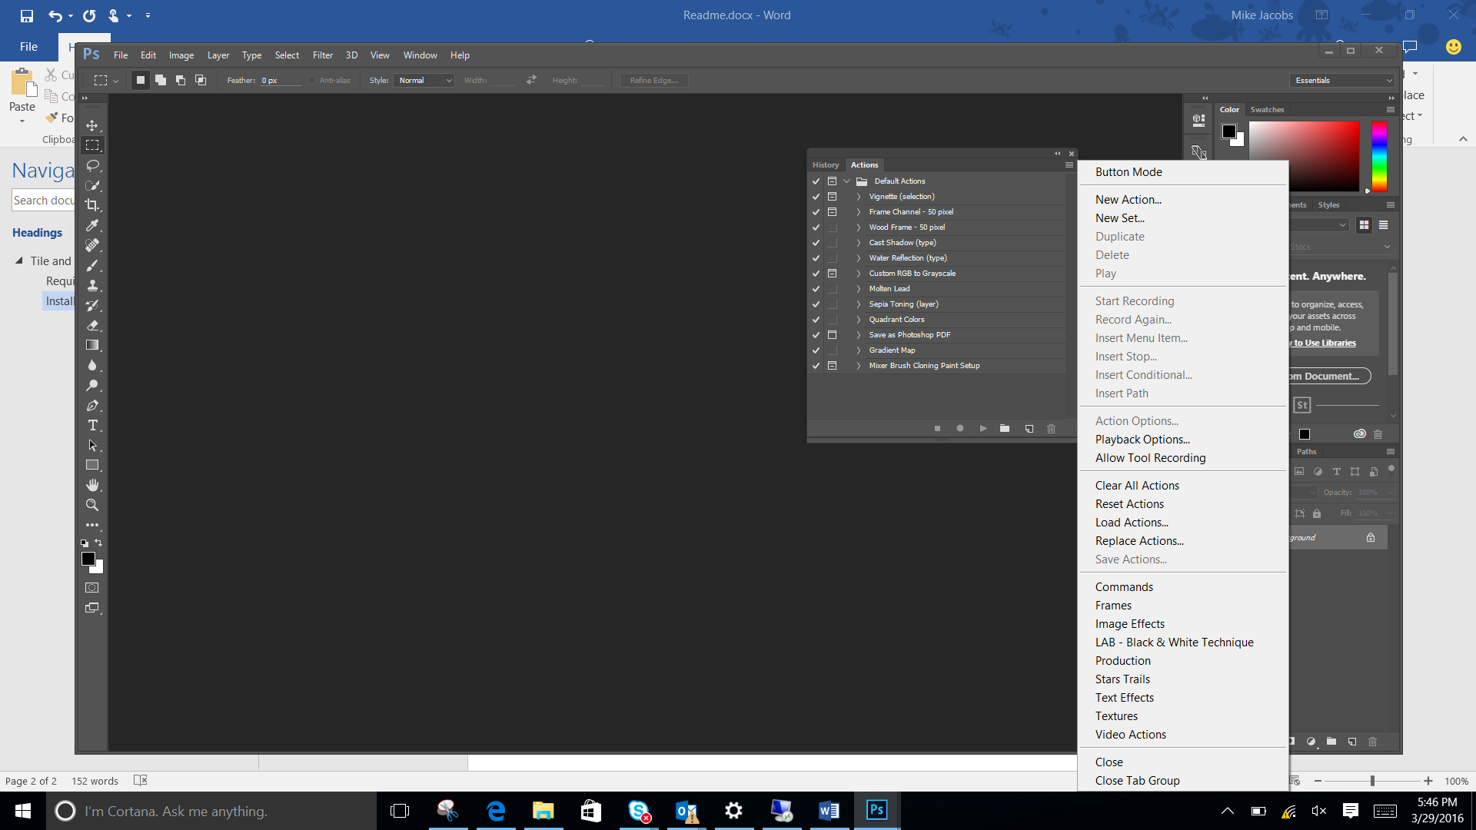

A file dialog appears.

* + - Navigate to the location where you extracted the Tile and icon asset generator and select the ATN file : Mixed Reality v1.1.atn  
      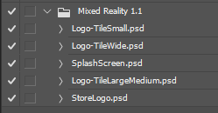

1. Create a directory to contain the generated images: **C:\images**

Now you’re ready to start generating assets.

## Usage

The tile and icon asset generator includes 5 template files: , one for each tile and icon asset type:

* + - Logo-TileLargeMedium.psd
    - Logo-TileSmall.psd
    - Logo-TileWide.psd
    - SplashScreen.psd
    - StoreLogo.psd

Each template file contains rulers representing all the recommended boundaries (based on our [Submitting HoloLens app guidelines](https://developer.microsoft.com/en-us/windows/mixed-reality/submitting_an_app_to_the_windows_store) and also [Windows 10 tile and icon asset guidelines](https://msdn.microsoft.com/en-us/library/windows/apps/mt412102.aspx)).

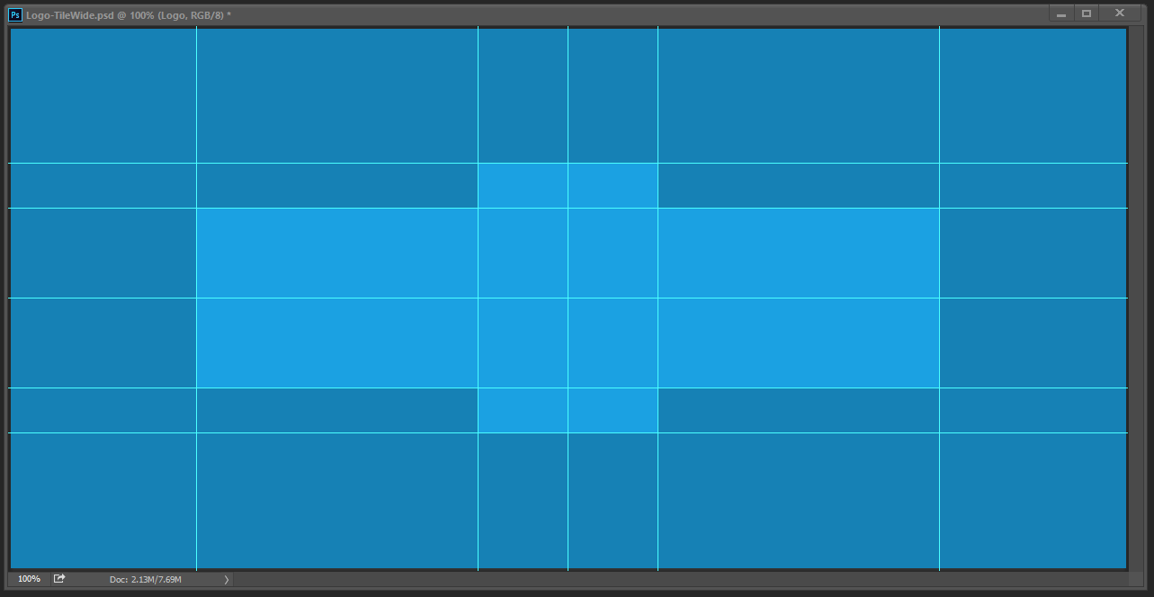

In pretty much all cases, it’s recommended that you keep your logo confined to the middle 4 boxes.

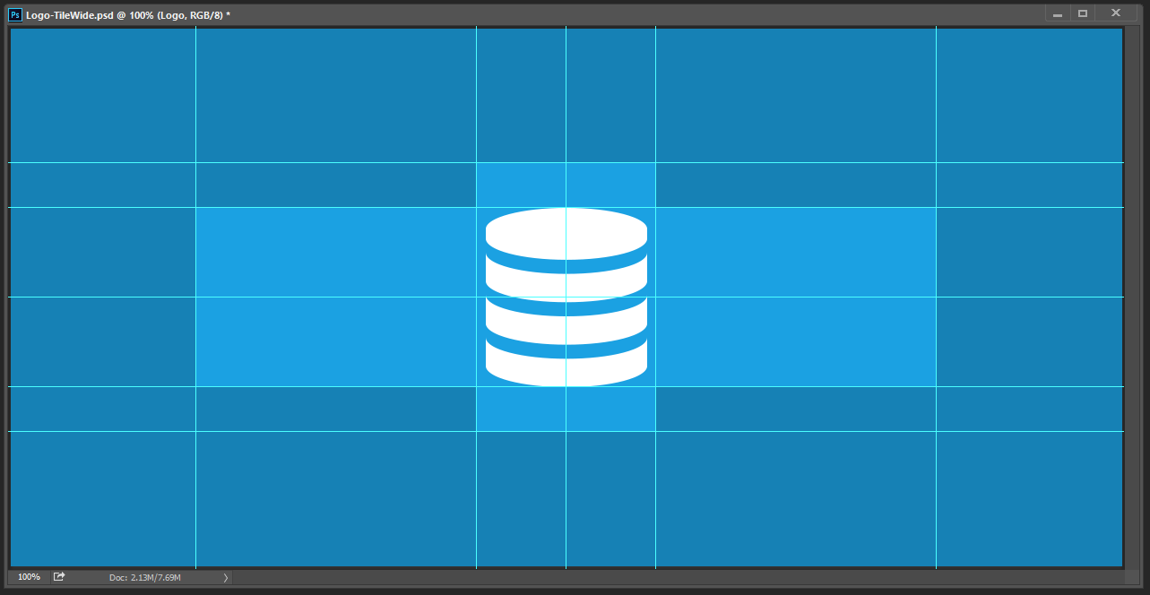

However, if your logo is wide, you can use the 2 square areas to the left and right of the center 4. Or, if your logo is tall, you can use the 2 square areas above and below the center 4.

Sticking to these boundaries will ensure your logo looks great everywhere within Windows. Unless you intend to have full bleed branding on your assets, which in that case you can ignore the rulers.

For the best image quality, we recommend using a vector-based image for your logo, so that it can be re-sized without compromising its quality.

1. Open one or more of the Photoshop template files, one for each asset that you want to create.
2. Edit the template file, adhering to the boundaries (unless you want a full-bleed asset).
3. For each Photoshop template file, run the corresponding Photoshop Action (i.e. Run the Logo-TileLargeMedium.psd action on the Logo-TileLargeMedium.psd template file).  
     
     
   Photoshop generates the image assets and copies them to the output folder:
   * On Windows: Photoshop outputs to the C:\images directory.
   * Copy the image files from the output folder to your Exported folder within your application project.

Unity

If your project is based off the new template, you will see a folder called AppIcons in the Asset folder. Then Unity is already setup with all the placeholder assets. All you need to do is replace the existing icons with the new one that you just exported from previous steps. Push your changes and submit a new pull request and you are done!

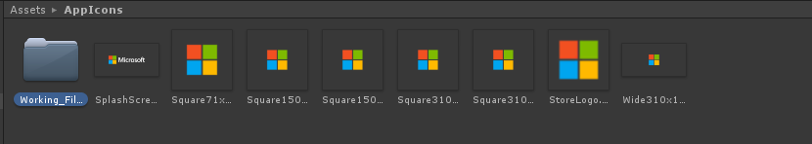

If you don’t see the AppIcons folder or your Unity project hasn’t been setup for this yet., then follow the steps below:

1. Create a new folder in Unity project under Assets folder.
2. Drag and drop all your app icon and splash screen assets over.
3. Select all the assets, and check **Alpha Is Transparency** box in the Inspector on the right. Hit apply to batch apply the new change.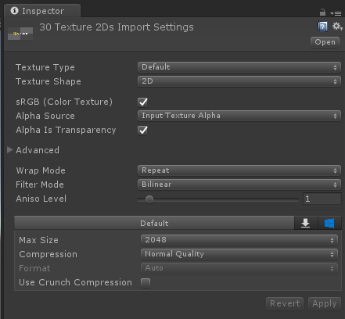
4. Open Build Settings, make sure UWP is selected 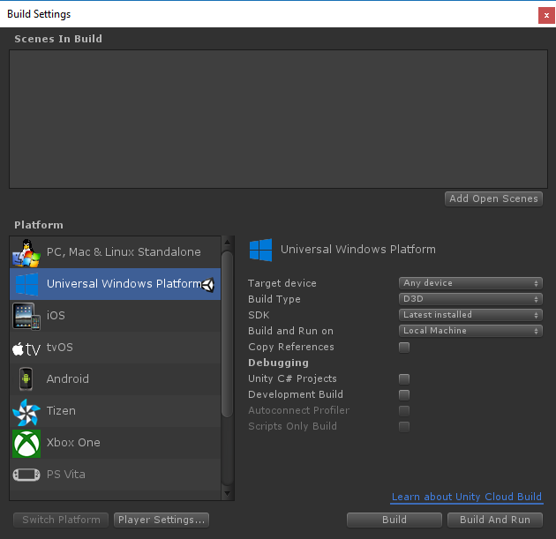
5. Open Player Settings
6. On the UWP tab, open Icon section. On Store Logo section, drag and drop the appropriate asset and scale over. 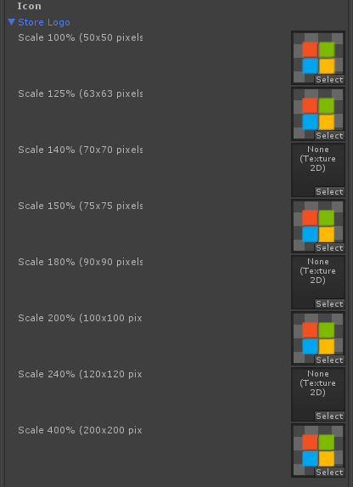
7. Next, fill in all the appropriate sections under Universal 10 Tiles and Logos . Ignore Square 44 sicne its not needed.
8. 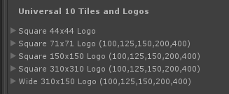
9. If you need to specify custom tile background color, you need to pick the background color and change **Foreground text** to **Light**. 
10. Next open the Splash Screen section. Uncheck Show Unity Logo.
11. Fill in the Windows section with the right assets. 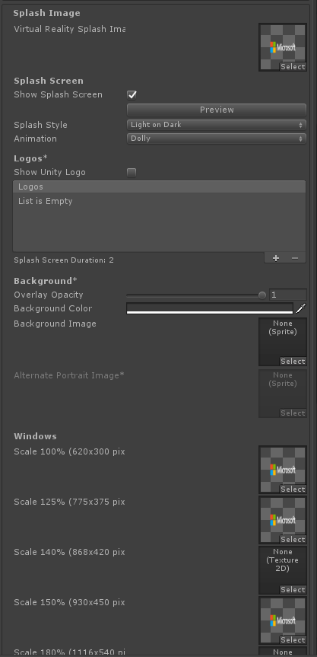
12. Fill in the Windows Holographic with your highest resolution Splash screen asset. 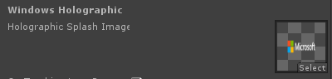
13. If you splash screen assets have no background color, the default background is white. Check **Overwrite background color** box and pick another color. 

**NOTE**: There are many ways to set the assets, so explore with various section to get your intended output. This guide is just showing the most common scenario only.

**Testing your changes**

To see your new changes on device, you **must** deploy a new Unity build via Visual Studio and then restart the device before you can see the changes. Unfortunately you must do this with every asset change.

Submit your new changes and create a pull request. You’re done!