Information:
Your homework has now been checked; no correction was needed except in Question 2.4. The homework is very related to what you have seen in the class Exercise today (specifically 2.1 Fitting a non-linear regression by hand).
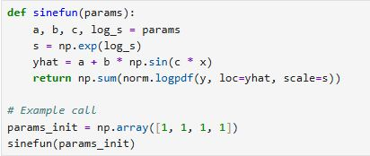
- From the van Bertalanffy growth function: you can already notice that there are 3 parameters (L_{inf}, k, and t₀) and 1 variable (x). That is why you were given only 3 parameter values in Question 1.2. However, to plot this your defined function must return a function that includes x as seen in the growth function formula, so that this function will be defined for any given x values. For instance, is your growth function is called GF. Then for some: x-values = 34,23,12,13,53,22,33,45,34,23,19; the GF(x), can be derived and plotted, provided that in GF the 3 parameters are already defined.

- When you want to build an optimization function, the parameters of interest become 4 because of s as seen in the picture above. Remember the 4th given parameter is NOT s but log_s, so you have to exponentiate it to have s (again see picture above). By now you should know what is y and what is x for you. Age is x and tl is y (the variables you plotted in Question 1.1).

- yhat is the GF(x) given any x and the 4 parameter values.

- Finally, the only correction here is Question 2.4, it should be Plot fits (with CIs), because 2.5 asks about the intervals of 2.4. Also you are only plotting 2 models instead of 3 (reason: the third model was skipped).

