Laboratorio 6
Contenido
Provision an Azure SQL Database 3
Create Server 3
Create Database Basic 4
Compute + Storage 7
Create Database Networking 8
Create Database Additional Settings 9
Create the test workload 10
Conectar BD en SSMS 10
Script Order History 11
Enable and configure Query Store 12
Analyze execution plans and add a missing index 13
Actual Execution Plan 13
Statistics Query 14
Execution Plan 15
Clustered Index Scan OrderHistory 15
IndexScan RowNumbers 16
Missing Index 16
Index 16
Logical Reads 16
Create Cover Index 16
Index Seek 17
Use DMVs to find the most expensive queries 17
CPU Time 17
5 Tablas 18
Optimizer Recommendation 19
Simulate and detect a plan regression with Query 20
Set up regression 20
Cause Regression 21
Query Store GUI 21
Forzar Plan 22
Verify plan forcing 23
Apply a Query Store hint 24
Partitions Query 24
Query Store Hint Plan 24
Find Query_id 25
Aply MAXDROP 26
Clear Hint 26
Identify and resolve blocking 27
3 Windows 27
Investigate Head Blocker 27
Window 1 Rollback 28
Window 2 Executed 28

Provision an Azure SQL Database

Create Server
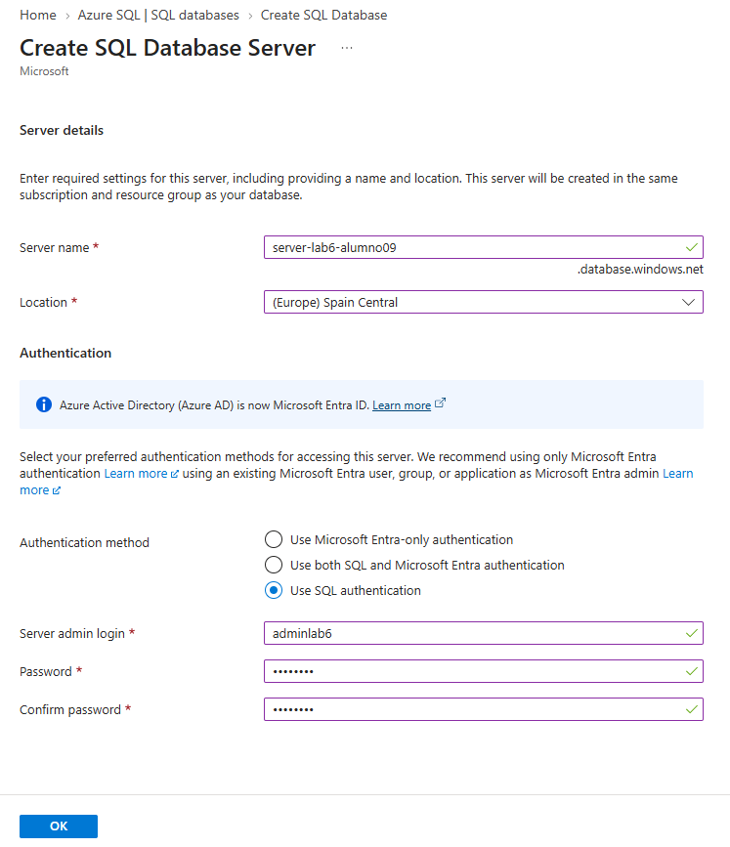
Contraseña: @Dmin123

Create Database Basic
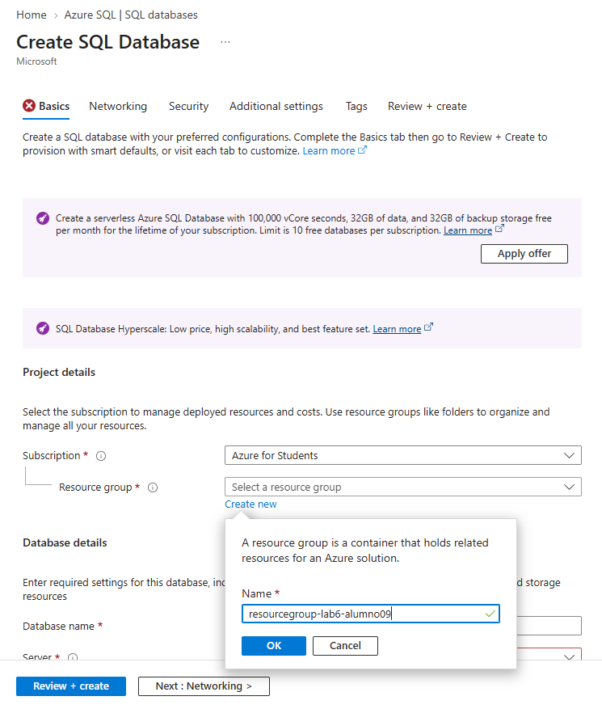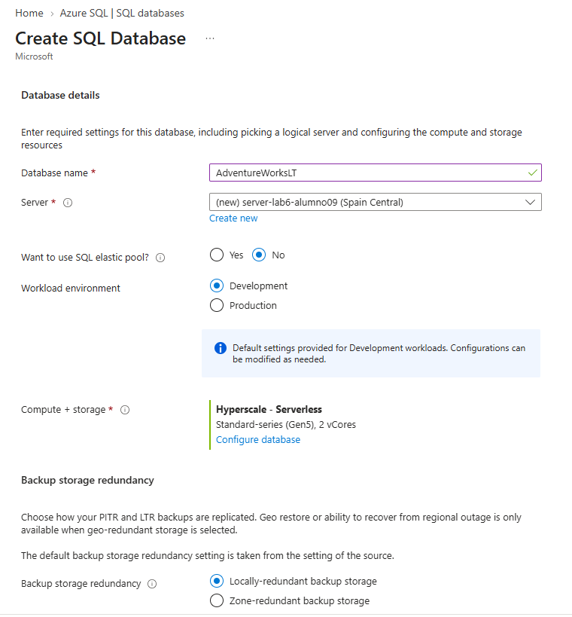

Compute + Storage
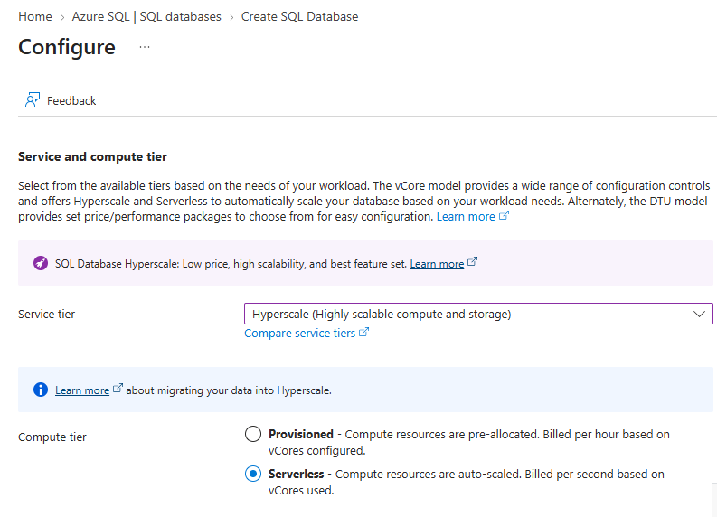

Create Database Networking
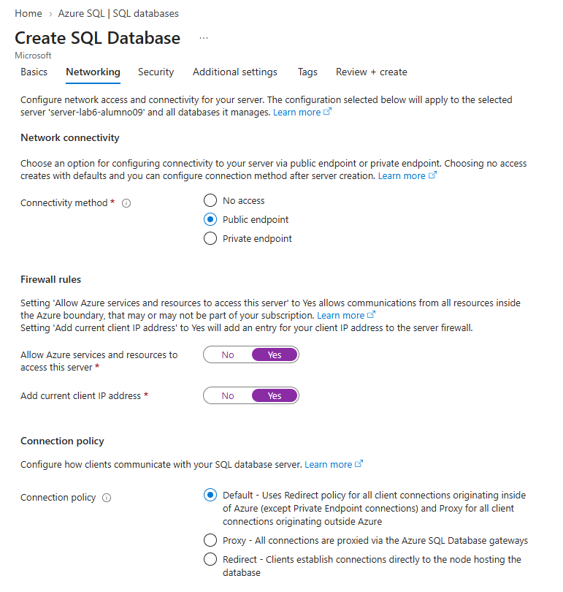

Create Database Additional Settings
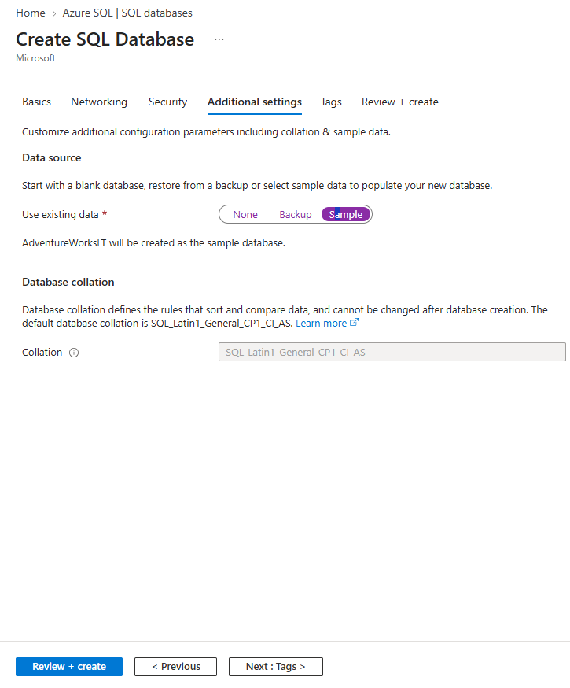

Create the test workload

Conectar BD en SSMS
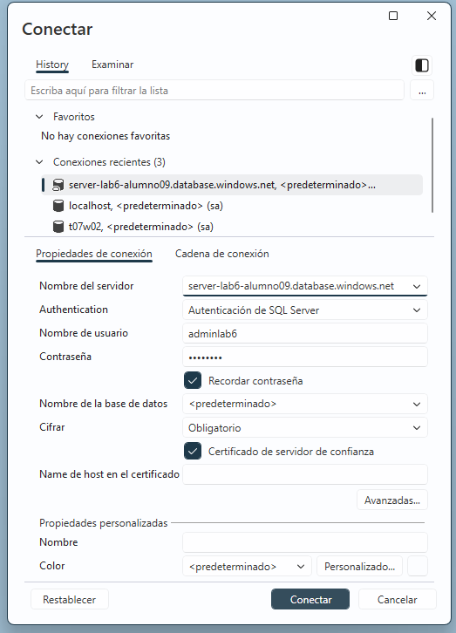

Script Order History
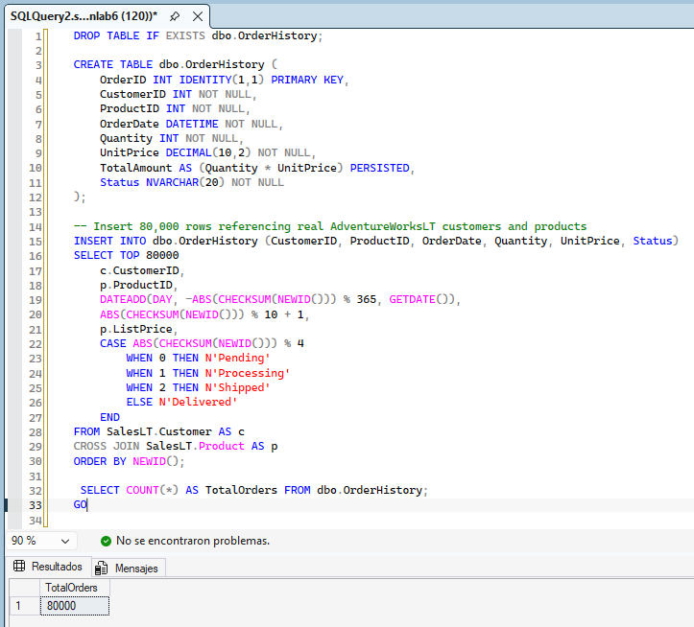

Enable and configure Query Store
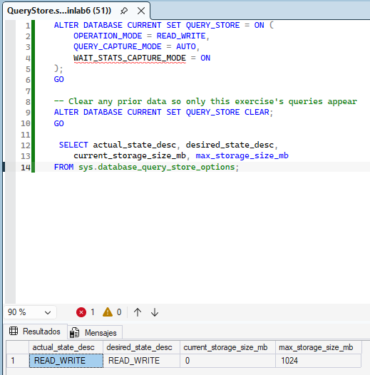

Analyze execution plans and add a missing index

Actual Execution Plan
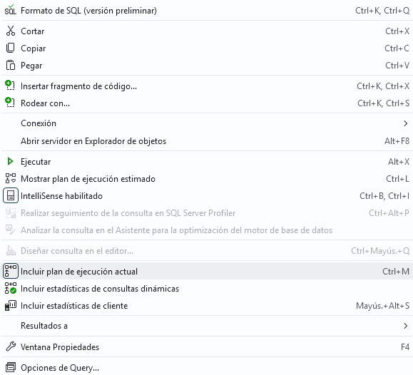

Statistics Query
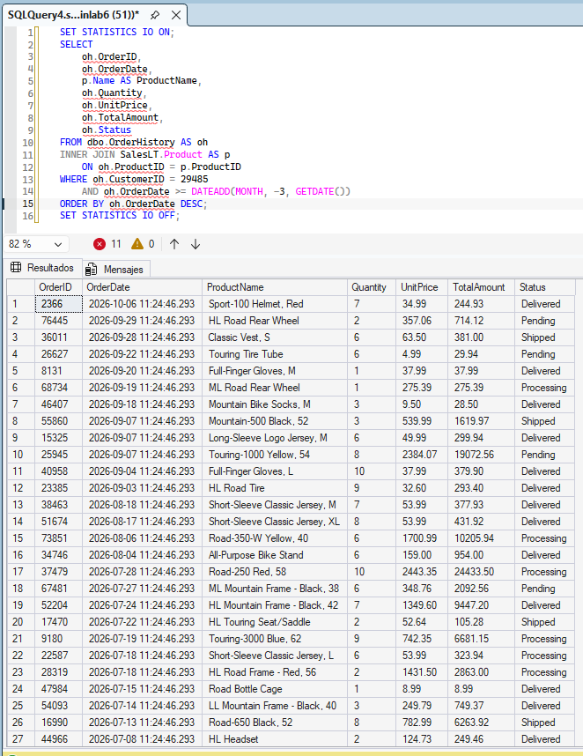

Execution Plan
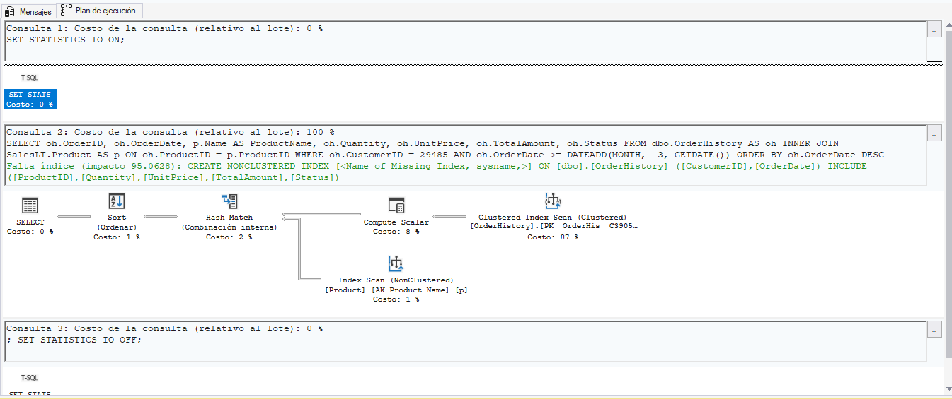

Clustered Index Scan OrderHistory
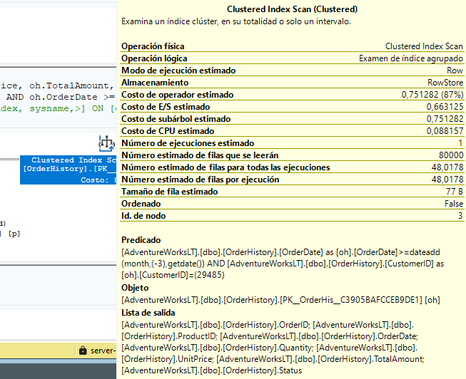

IndexScan RowNumbers
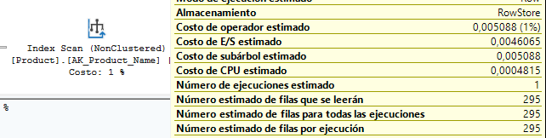

Missing Index

Index
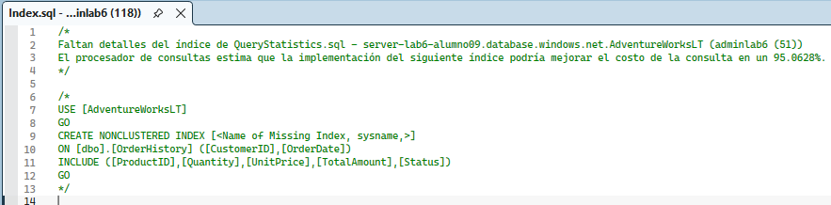

Logical Reads
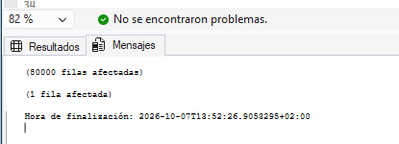

Create Cover Index
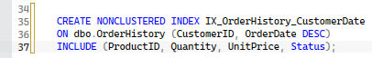

Index Seek
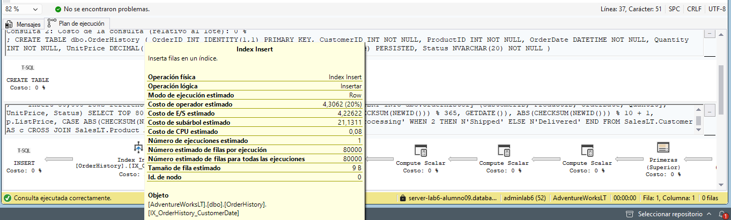

Use DMVs to find the most expensive queries

CPU Time
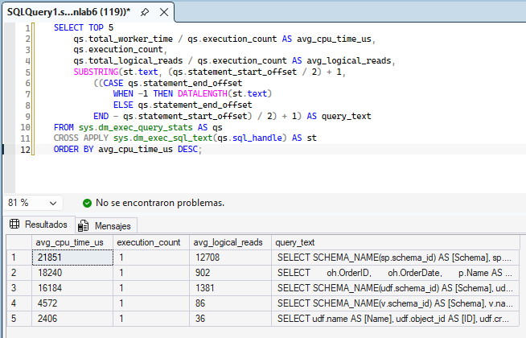

5 Tablas
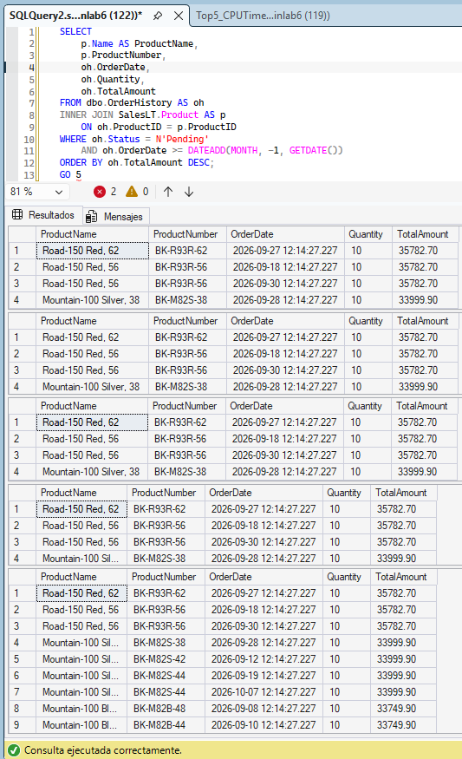

Optimizer Recommendation
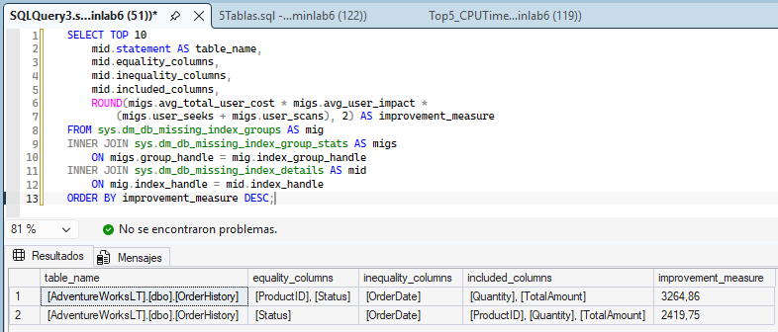

Simulate and detect a plan regression with Query

Set up regression
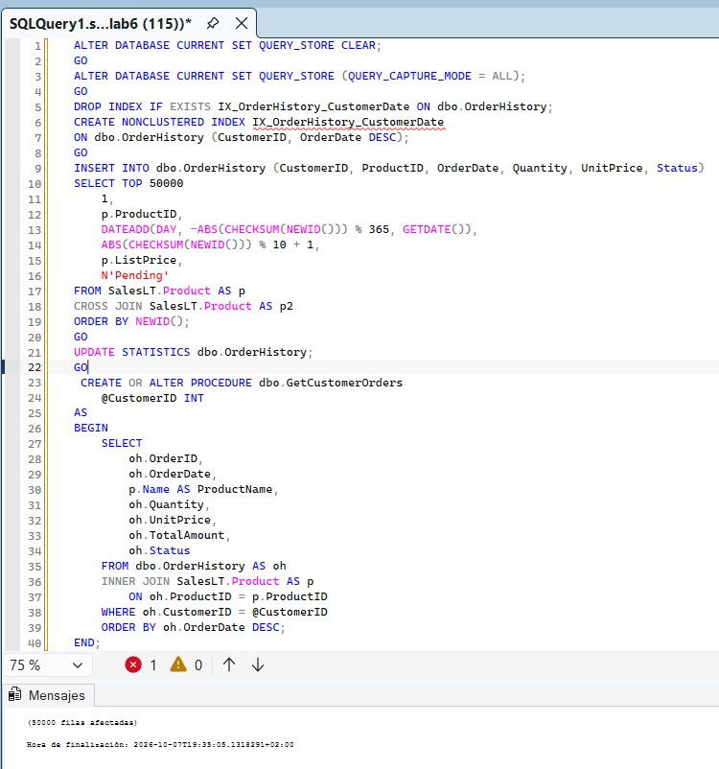

Cause Regression
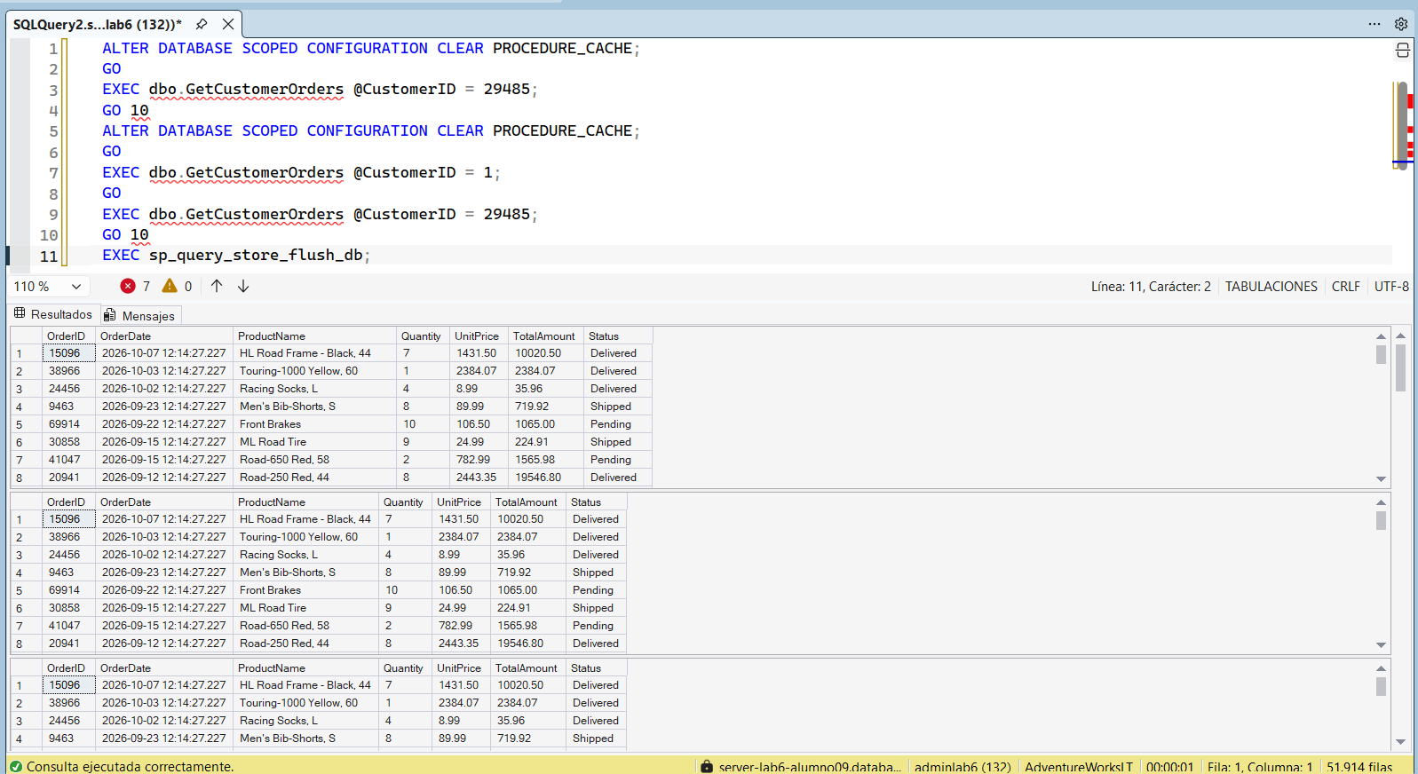

Query Store GUI
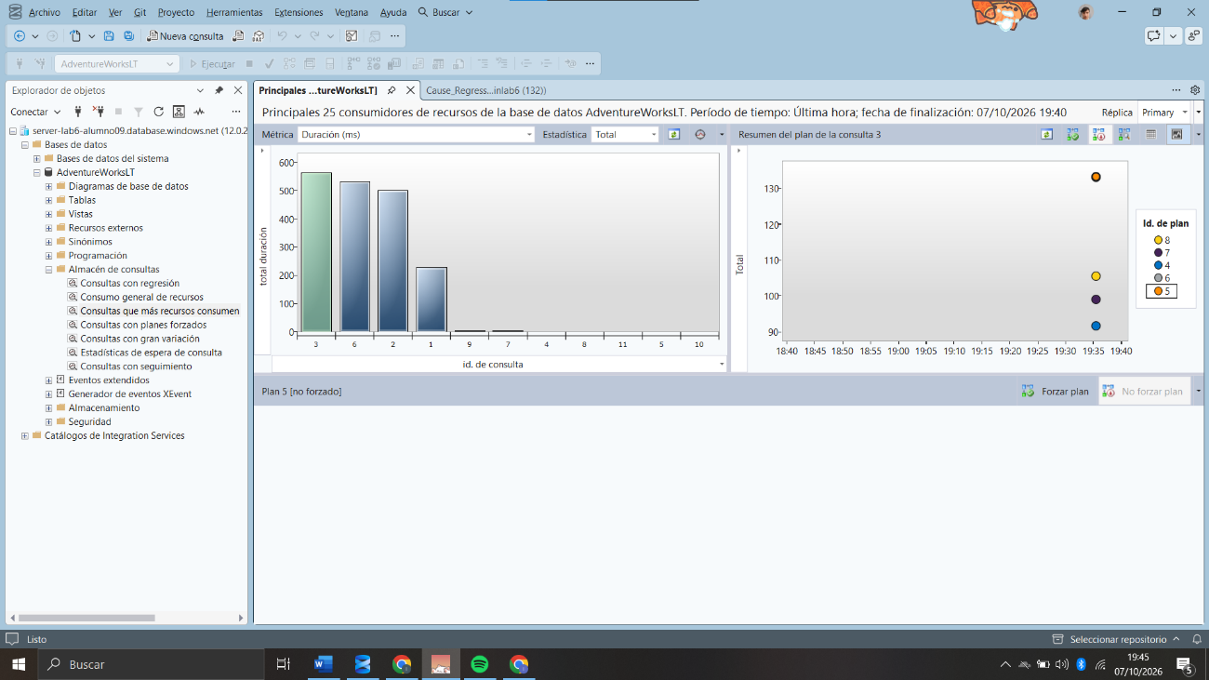

Forzar Plan
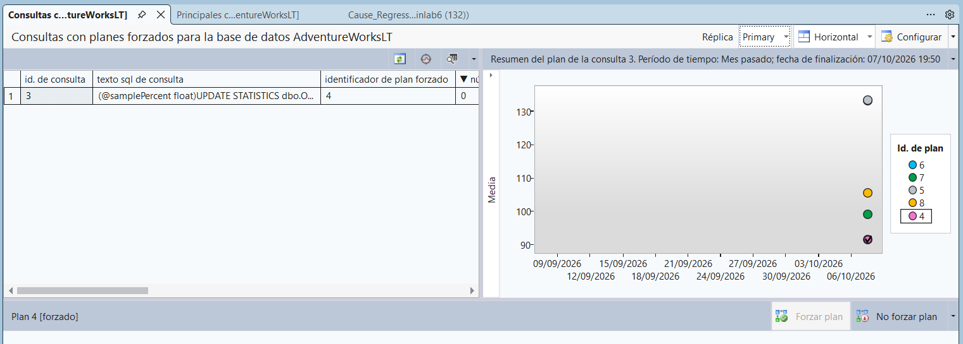

Verify plan forcing
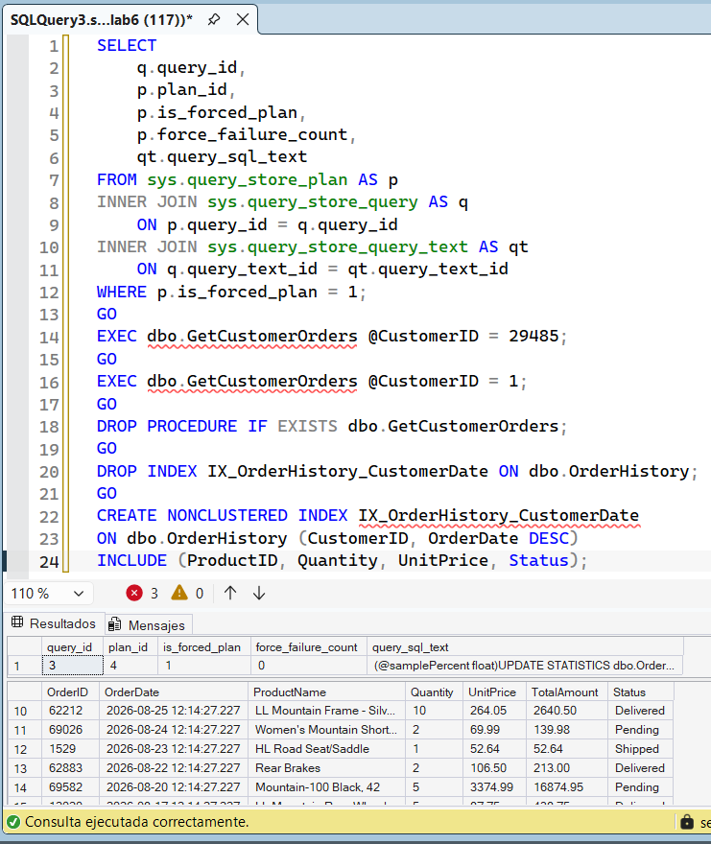

Apply a Query Store hint

Partitions Query
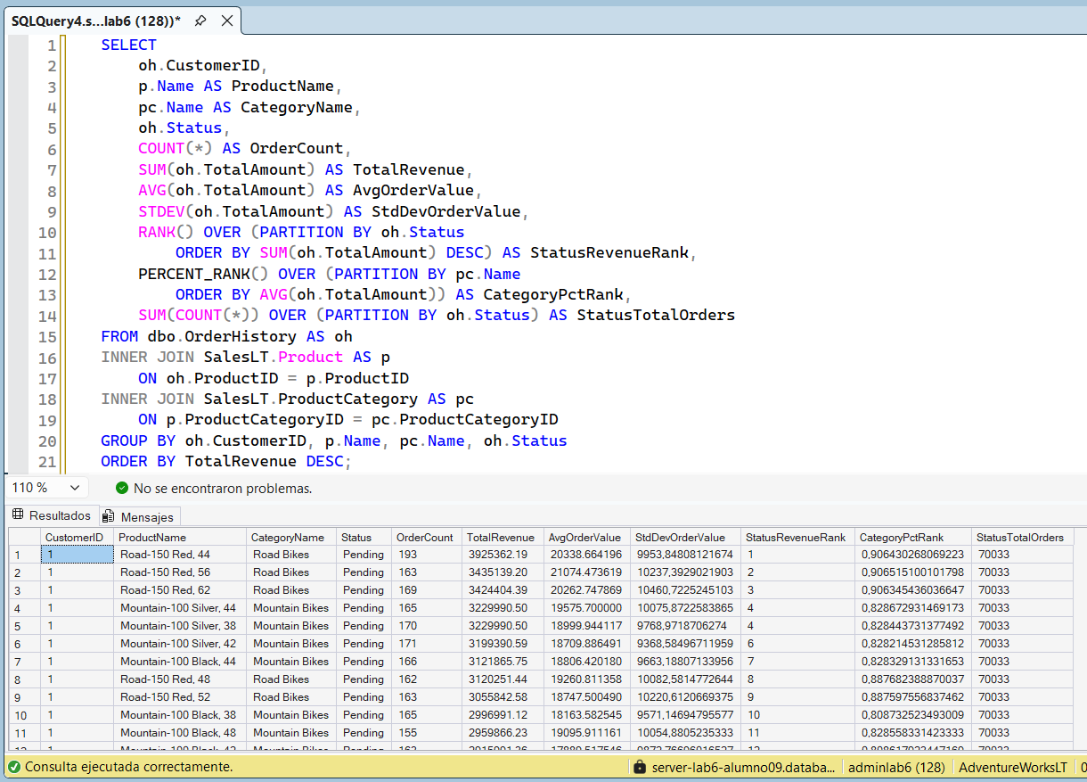

Query Store Hint Plan
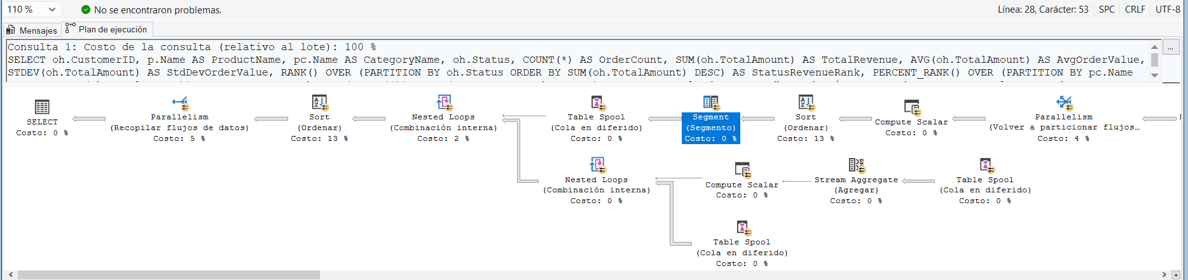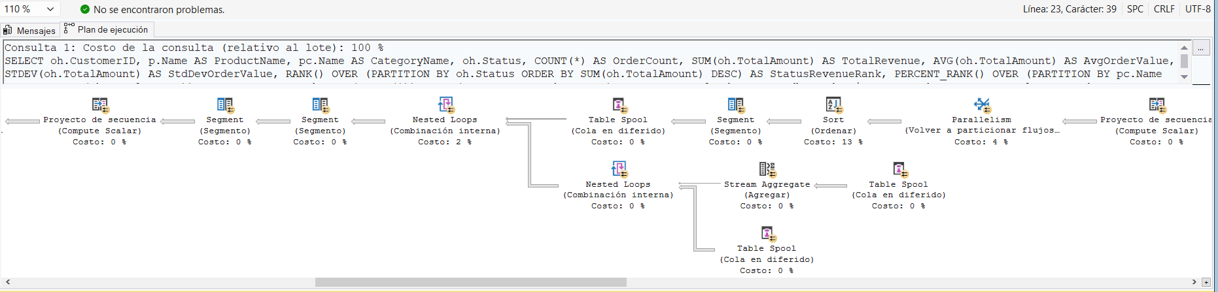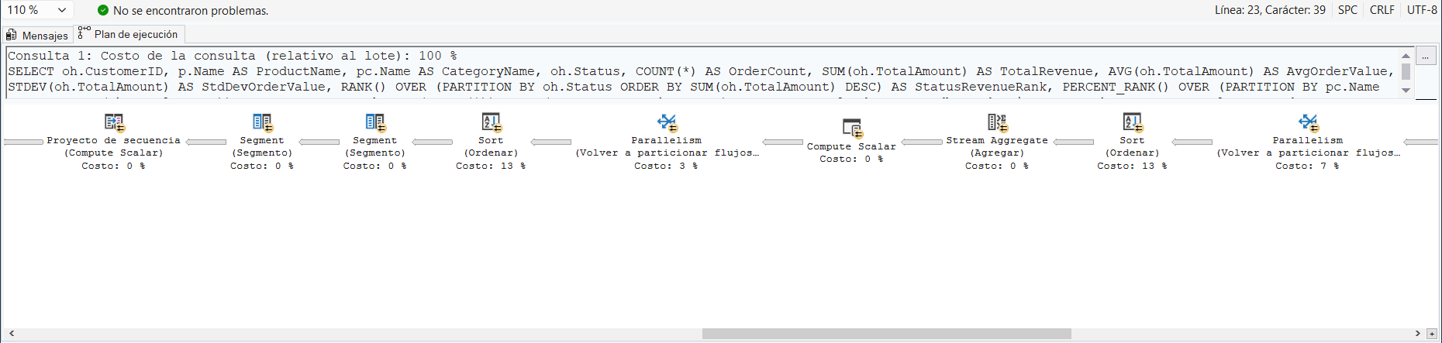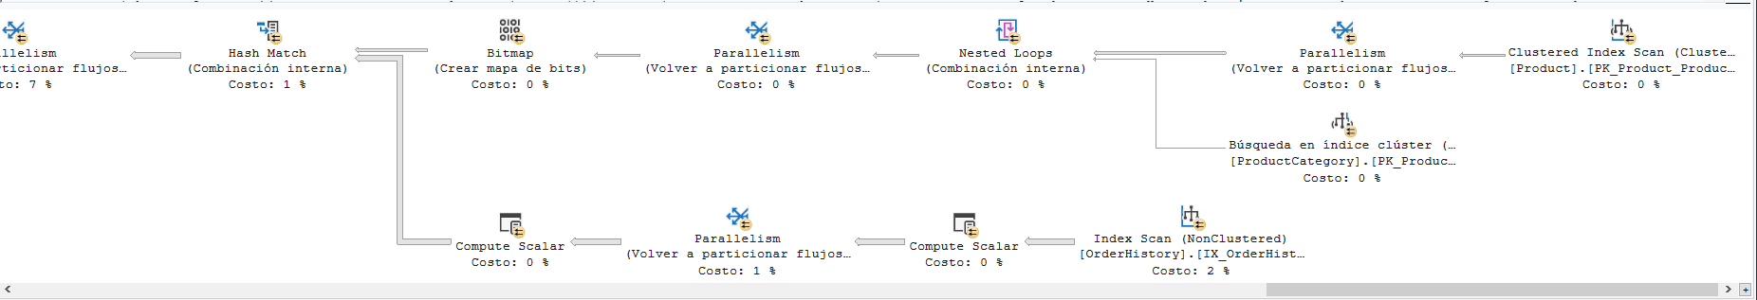

Find Query_id
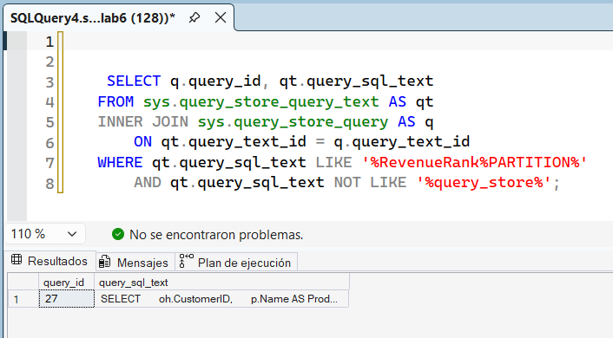

Aply MAXDROP
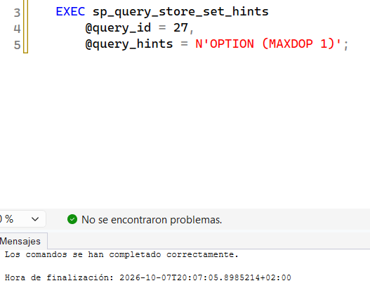

Clear Hint
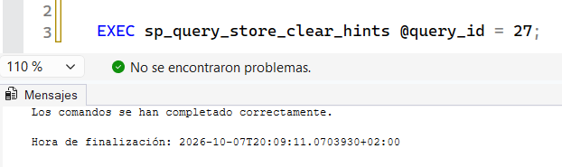

Identify and resolve blocking

3 Windows
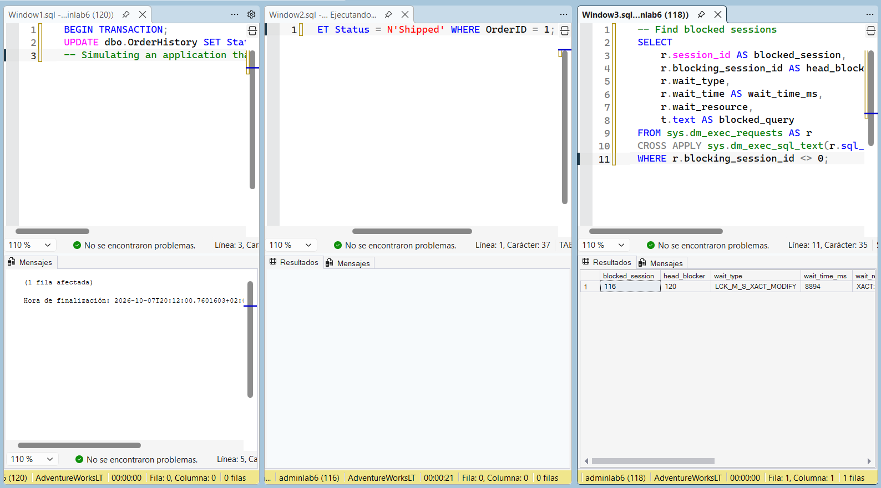

Investigate Head Blocker
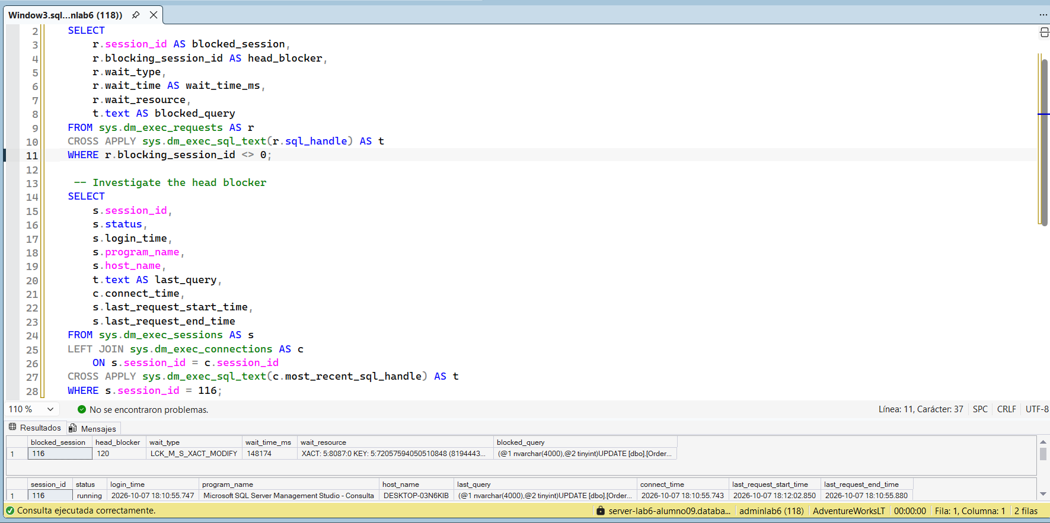

Window 1 Rollback
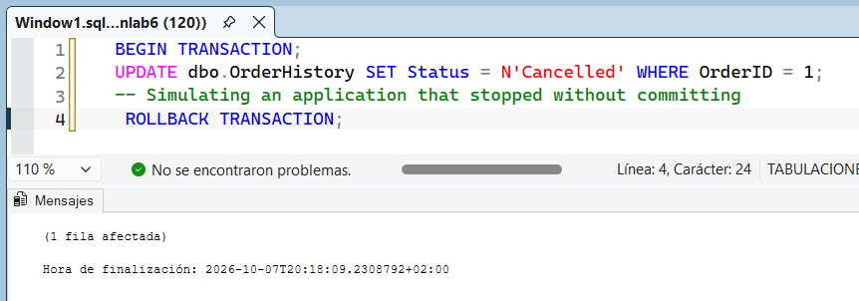

Window 2 Executed
